2018
N4 Physics Questions
Lockerbie Academy
6/1/2018
Dynamics and Space

Speed and Acceleration

Average and Instantaneous Speed
1. Which of the following are instantaneous speeds and which are average speeds?
A A car’s speed between Aberdeen and Dundee.
B The speed of a tennis ball as it leaves the racquet.
C The reading on a car speedometer.
D The speed of a roller-coaster at the bottom of a loop.
E The speed of an athlete over a 100 metre race.

2. A pupil is given a 50 metre measuring tape, a stop watch and the help of some friends. Describe how she could find the speed of one of her friends as she runs a race.

3. A pupil uses light gates and a computer to measure the speed of a trolley.
The trolley has a card 0·1 metres long attached to it.


light gate
computer interface
vehicle
photocell
card of known length

Describe how the light gate and computer is used to calculate the speed of the trolley.

4. In which of the two questions above (question 2 and 3) is the instantaneous speed measured and in which is the average speed measured?

5. State an equation that links speed, distance and time.

6. Calculate the missing values in the table below.

Speed | Distance | Time
(a) | 10 metres | 4 seconds
(b) | 500 metres | 10 seconds
2 metres per second | 30 metres | (c)
0·5 metres per second | 60 metres | (d)
8 metres per second | (e) | 120 seconds
0·2 metres per second | (f) | 3 minutes

7. An ice hockey player strikes the puck and it moves off at 10 metres per second. Calculate the time it will take to travel
8 metres.

8.
(a) A speed skater completes a 500 metre course in 35 seconds. Calculate the average speed the skater travelled at.

(b) Speed skaters also compete in races which are 10 000 metres long. Calculate the time it would take the skater to complete the course if they travelled at an average speed of 12·5 metres per second.

9. A car travels a distance of 2000 metres along a motorway in 60 seconds. Calculate the average speed of the car.

10. Someone standing on the Earth’s equator will travel 28·8 kilometres in
1 minute due to the spin of the Earth. Calculate the speed they are travelling at in metres per second.

11. A cyclist pedals for 50 minutes at a speed of 12 metres per second. Calculate the distance she will have travelled.

12. Calculate the time it will take a train travelling at an average speed of
80 kilometres per hour to complete a journey 60 kilometres long.
Speed-Time Graphs
13. Look at the speed time graphs below. State which shows an object at rest, travelling at a constant speed, slowing down and speeding up.
speed
time
B
speed
time
D
speed
time
A
speed
time
C

14. The speed time graph below shown the motion of a car over 8 seconds.
4
2
6
10
8
12
0
1
2
3
speed in metres per second
time in seconds
4
5
6
7
8

(a) State the speed of the car after:
(i) 2 seconds;
(ii) 6 seconds.

(b) Calculate the distance travelled by the car over the 8 seconds of its motion.
15. A speed time graph is shown below for the motion of a cyclist.
time in seconds
40
0
5
10
15
20
25
30
35
speed in metres per second
1
2
3
4
5

(a) Describe the motion of the cyclist over the 40 seconds.

(b) Calculate the total distance travelled by the cyclist.

(c) Calculate the average speed of the cyclist over the 40 seconds.

16. A sprinter warming up for a race produces the following speed-time graph. Calculate the distance they travelled during the warm-up.
time in seconds
speed in metres per second
0
4
8
12
5

17. The graph opposite shows how the speed of a cyclist changes with time.
time in seconds
speed in metres per second
0
40
50
5

(a) Describe the motion of the cyclist over the
50 seconds.

(b) Calculate the distance travelled by the cyclist.
Extension Questions
18. Pupils photograph a car travelling along the road outside their school. The camera they use takes photographs every 0·2 seconds.

The first and third photographs are shown below.
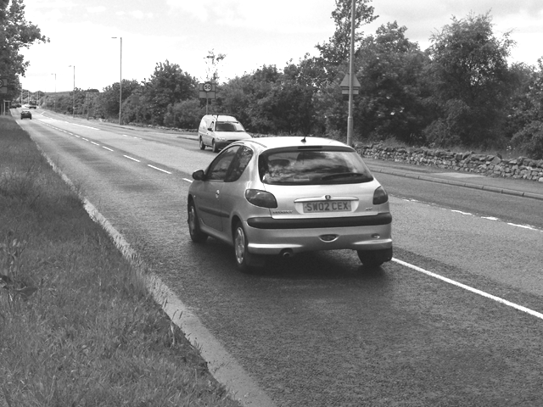
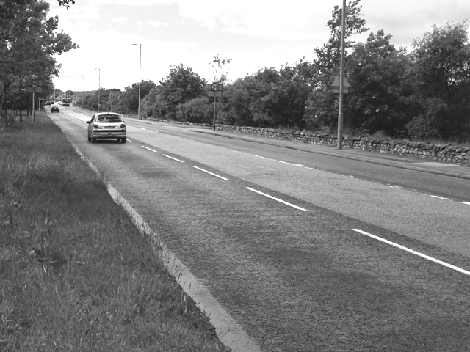
15 metres
first photograph
third photograph

(a) Find the time between the first and third photograph if each is taken
0·2 seconds apart.

(b) The pupils measure the distance the car travelled between the photographs and find that it travelled 15 metres. Calculate the average speed of the car.

19. Two teachers travel to work at the same school.

Teacher A drives to work at an average speed of 5 metres per second. His journey is 9000 metres long.

Teacher B takes the bus which travels at an average speed of 3 metres per second. Her journey is 6000 metres long.

Find which teacher gets to the school first.

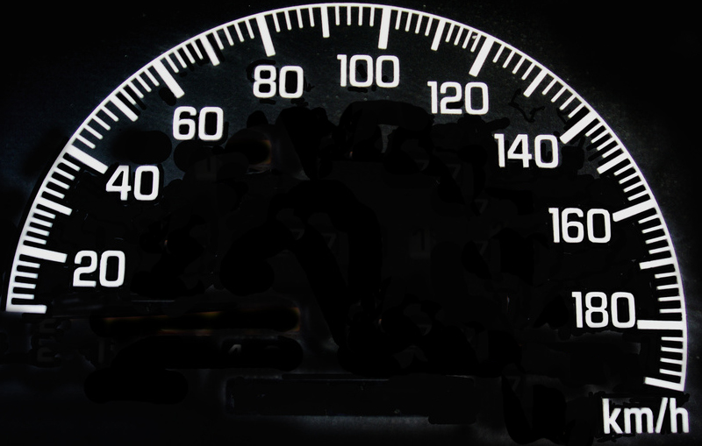
20. Tara and Stefina are travelling to school in a car. They both look at the speedometer.

Stefina says that the car is travelling at an instantaneous speed of
50 kilometres per hour.

Tara says that the car is travelling with an average speed of 50 kilometres per hour.

Which of the girls made the correct statement? Explain your answer.
21. A pupil wants to measure the speed his Scalextric car goes on a track.

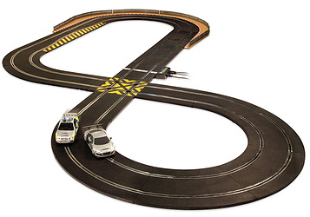
He has the following items to help him:
a stopwatch;
a ball of string;
a tape measure;
a marker pen.

(a) Describe how the pupil could find the distance the car would travel in
10 laps.

(b) Describe how the pupil could use this information to calculate the average speed of the car.

(c) The car travels 40 metres in 32 seconds. Calculate the speed of the car.

(d) The pupil now wants to find the cars instantaneous speed as it travels along the straight. Describe how he could do this and what additional apparatus he might need.

Acceleration
22. The apparatus used in question 3 can be modified to measure acceleration.
One way of achieving this is by replacing the single card with a double card as shown below.
vehicle
double card

(a) State the equation used to measure acceleration.

(b) Explain how the double card makes it possible to measure acceleration using a single light gate.

(c) Acceleration can still be found experimentally using a single card but with two light gates. Explain how this arrangement works.

23. Calculate the missing values in the table below.

Acceleration | Change in speed | Time taken for change
(a) | 20 metres per second | 5 seconds
(b) | 100 metres per second | 20 seconds
(c) | 60 metres per second | 20 seconds
0·5 metres per second per second | (d) | 50 seconds
2 metres per second per second | (e) | 10 seconds
2·5 metres per second per second | (f) | 8 seconds
5 metres per second per second | 55 metres per second | (g)
4 metres per second per second | 20 metres per second | (h)
8 metres per second per second | 64 metres per second | (i)

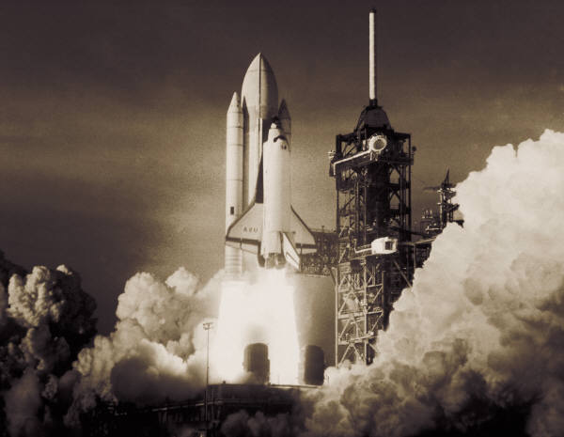
24. The space shuttle, starting from rest on the launch pad, could reach a speed of 1000 metres per second after 45 seconds. Calculate the acceleration of the shuttle.

25. A high speed lift in a high rise tower accelerates from rest at 3·5 metres per second per second. Calculate the final speed of the left if it accelerates at this rate for 4 seconds.

26. A cruise liner manoeuvres out of harbour at a speed of 1 metre per second. It then accelerates to a speed of 9 metres per second. Calculate the time this will take if the liner accelerates at 0·04 metres per second per second.

27. An object which is speeding up has a positive acceleration. What is happening to an object which has a negative acceleration?
28. (a) A high speed bullet train leaves a station and accelerates from rest to 60 metres per second in a time of 120 seconds. Calculate the acceleration of the train.

(b) The train is travelling at its top speed of 80 metres per second and brakes to slow down with an acceleration of ‒0·8 metres per second per second. Calculate the time it will take for the train to stop.

29. Calculate the acceleration shown in each of the following graphs.
(e)
(c)
(d)
(b)
speed in metres per second
time in seconds
(a)
0
20
10
0
0
0
0
time in seconds
time in seconds
time in seconds
time in seconds
10
50
5
8
speed in metres per second
speed in metres per second
speed in metres per second
speed in metres per second
20
4
2
16

30. The speed time graph below shown the motion of a car over 8 seconds.
4
2
6
10
8
12
0
1
2
3
speed in metres per second
time in seconds
4
5
6
7
8

(a) State the speed of the car after:
(i) 2 seconds;
(ii) 6 seconds.

(d) Calculate the acceleration of the car over the 8 seconds of its motion.

Forces, Motion and Energy

Newtons Laws of Motion ‒ Balanced and unbalanced forces
31. Sir Isaac Newton’s First Law of Motion states:
“An object at rest will remain at rest unless acted on by an unbalanced force. An object in motion continues in motion with the same speed and in the same direction unless acted upon by an unbalanced force.”
(a) Explain how this law applies to a snooker ball before it is hit by a snooker cue.

(b) Explain how this law applies to a snooker ball after it has been hit by a snooker cue.

32. A force is applied to a soft rubber ball. State three ways in which the ball may be affected.

33. State the effect of a force in the following situations.

(a) A cyclist applies the brakes on his cycle.

(b) A footballer kicks a football.

(c) You sit on a cushion on a chair.

(d) A goalkeeper catches a penalty shot during a football match.

34. Two pieces of elastic are attached to a ball and stretched so that they apply a force to the ball.

(a) State what happens when one piece of elastic is pulled and the other left slack.

(b) What will happen to the ball if both pieces of elastic are pulled with the same force?

(c) (i) What name is given to the forces in this situation?
(ii) What overall force would the ball experience in this situation?

35. State whether the footballs shown below remain stationary or will move.
If they move, in which direction will they move?

6 newtons
6 newtons
(a)
6 newtons
6 newtons
(b)

4 newtons
10 newtons
(c)
6 newtons
10 newtons
(d)
6 newtons

2 newtons
4 newtons
(f)
8 newtons
4 newtons
(e)
4 newtons

36. A car is stationary at traffic lights.

(a) What can be said about the forces acting on it?

(b) When the traffic lights change to green, the car moves away from the lights. What has changed about the forces acting on it?

(c) (i) After a short time the car is travelling at a constant speed. What can be said about the forces acting on it now?
(ii) There are forces of friction acting against the car. Describe two of these.
37. A dolphin is swimming through the water. It is propelled forwards by the force from its tail.

(a) What other forces act on the dolphin as it swims through the water?

(b) As the dolphin swims faster, the backward forces acting on it increase. What will happen when the forward and backward forces are equal?

38. Copy and complete the following sentences using the words below
less than the same as increases greater than
A car starts on a journey and accelerates along a straight, flat road. The driving force from its engine must be __________ the force of air resistance acting on it. As it speeds up the force from the air resistance __________ . The speed of the car will eventually become constant when the air resistance is __________ the engine force.

39. Sir Isaac Newton’s Second Law of Motion states:
“The acceleration of an object is dependent upon two variables – the net force acting upon the object and the mass of the object. The acceleration of an object depends directly upon the net force and inversely upon the mass of the object. The relationship between an object's mass m, its acceleration a, and the applied force F is:
F = m × a.
(a) Explain how this law predicts the acceleration of a bus and a small car if the same force was applied to each.


(b) Explain how this law predicts the acceleration of a car when the engine provides a small force and a large force.

40. (a) A car is being driven with no passengers. What effect will adding three passengers and a full boot of luggage have on the acceleration of the car?

(b) The same model of car comes with a more powerful engine which can provide a greater engine force.
How will the acceleration of this car compare with the acceleration of the car in part (a) assuming the mass of both cars is identical?
41. Calculate the missing values in the table below.

Force | Mass | Acceleration
(a) | 10 kilograms | 2 metres per second per second
(b) | 0·5 kilograms | 200 metres per second per second
50 newtons | 5 kilograms | (c)
10 newtons | 1 kilogram | (d)
20 newtons | (e) | 4 metres per second per second
30 newtons | (f) | 0·6 metres per second per second

42. A jogger with a mass of 50 kilograms accelerates at 0·5 metres per second per second. Calculate the unbalanced force required to produce this acceleration.

43. A car has a total mass of 1200 kilograms. Calculate the force required to accelerate the car at 2 metres per second per second.

44. Calculate the acceleration of a car that has a mass of 800 kilograms and is acted on by an unbalanced force of 2400 newtons.

45. A force of 180 newtons is applied by a cyclist to his bicycle to produce an acceleration of 3 metres per second per second. Calculate the combined mass of the cyclist and bicycle.

46. (a) A car travelling along a flat straight road slows down with an acceleration of ‒2 metres per second per second. What braking force must be applied if the car has a mass of 1000 kilograms?

(b) A road surface is often covered with special grit near dangerous road junctions.
(i) What effect will this have on the friction between the car tyres and the road surface?
(ii) How will the acceleration of the car be affected by the road surface assuming the same braking force is applied?

Extension questions
47. A television programme decides to compare the brakes on old and new models of the same car.

(a) An old mini is tested and can slow down from 16 metres per second to rest in a time of 4 seconds.
(i) Calculate the negative acceleration of the car.
(ii) The mini car a mass of 800 kilograms. Calculate the braking force applied to the car.

(b) A modern mini has far more efficient brakes. It can accelerate at ‒5 metres per second per second. Calculate the time it will take to come to a stop if it starts at 16 metres per second.

(c) Some roads have a special surface which consists of small pieces of grit. What effect has this on the negative acceleration of the car compared to a normal road? Explain your answer.

48. A computer and light gate are used to measure the speed of a trolley rolling down a flat ramp which has been placed at an angle.

(a) Explain how the apparatus shown below can be used to find the speed of the trolley as it goes down the ramp.
track
light gate
computer
trolley with card

(b) The card is 10 centimetres long. The computer records the time the card takes to pass through the light gate as 0·08 seconds. Calculate the speed of the trolley.

(c) Explain how the apparatus could be modified to allow it to measure the acceleration of the trolley.
49. A disc is placed on ‘air bed’ which consists of a metal plate with tiny holes through which air is pumped. This causes the disc to float on a cushion
of air. The disc has a mass of 0·5 kilograms.
disc
air holes
. . . . . . . . . . . . . . . . .
. . . . . . . . . . . . . . . . .
. . . . . . . . . . . . . . . . .
. . . . . . . . . . . . . . . . .
. . . . . . . . . . . . . . . . .

(a) The disc is given a push with a force of 1 newton. Calculate the acceleration of the disc.

(b) The ‘air bed’ is described as a frictionless surface. Explain what this means.

(c) A graph of the discs motion over the first half second is shown below.
0·1
0·2
0·4
0·3
0·5
0
0·2
0·4
0·6
0·8
speed in metres per second
time in seconds

(i) Describe the motion of the disc over this time.
(ii) Calculate how far the disc travelled during the first half second of its motion.
(iii) How long after the disc was first pushed was it released?

Weight and Gravity

50. Three pupils are discussing their Physics lesson that day.
Pupil A says “Weight is measured in kilograms and is the downwards pull on a body due to gravity.”
Pupil B says “Weight is measured in newtons and is the downwards pull on a body due to gravity.”
Pupil C says Mass is measured in kilograms and is the downwards pull on a body due to gravity.”

State which pupil made the correct statement and explain what is wrong with the others.
51. State the value of gravitational field strength on Earth.

52. State an equation that can be used to convert the mass of a body into its weight.

53. Complete the table below to convert between mass and weight for an object on Earth.

Mass | Weight
1 kilogram | (a)
0·5 kilograms | (b)
4 kilograms | (c)
(d) | 9·8 newtons
(e) | 49 newtons
(f) | 30 newtons

54. A pupil says that her weight is 50 kilograms.

(a) What is wrong about her statement?

(b) Calculate the value of her weight on Earth.

55. A lift is designed to carry a maximum load of 10 people, each with a mass of 80 kilograms. The lift has a mass of 500 kilograms. Calculate the total weight of the lift when full.
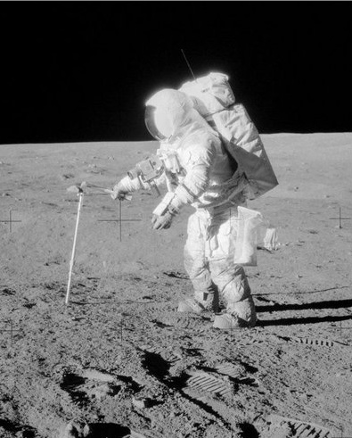
56. An astronaut has a hammer with a mass of 0·8 kilograms on the moon

(a) Calculate the hammer’s weight on Earth where the value of g is 9·8 newtons per kilogram.

(b) Calculate the hammer’s weight on the moon where the value of g is 1·6 newtons per kilogram.

57. A satellite orbits the earth at a height of 2000 kilometres where the value of gravitational field strength is 5·7 newtons per kilogram. Calculate the weight of the satellite if it has a mass of 900 kilograms.

Extension questions
58. The table below shows the gravitational field strength on a number of planets in our solar system. Use these values to answer the questions which follow.
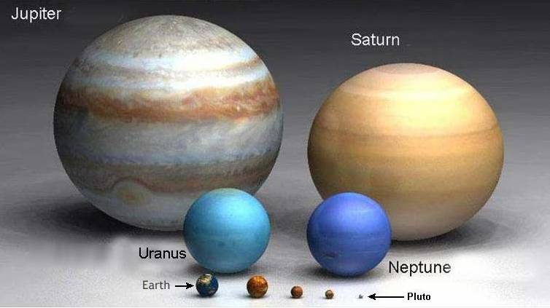

Planet | Gravitational field strength  (newtons per kilogram)
Mercury | 3·7
Venus | 8·9
Earth | 9·8
Mars | 3·7
Jupiter | 26
Saturn | 11·2
Uranus | 9·0
Neptune | 11·3

(a) A vehicle exploring the surface of mars has a mass of 174 kilograms. Calculate its weight on the Martian surface.

(b) What would be the weight of:
(i) a 60 kilogram person on Earth;
(ii) a 60 kilogram person on Jupiter?

(c) An object has a weight of 63 newtons on the surface of Uranus. Calculate its mass.

(d) Calculate the weight of a 5 kilogram object on the surface of Neptune.
Space exploration
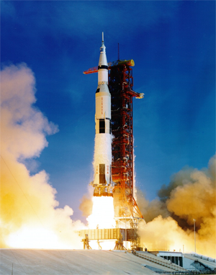59. Read the passage which follows and then answer the questions on the risks and benefits of space exploration.

For thousands of years, men and women have studied the stars and looked at what we call ‘space’. Only recently, in the last 60 years, have we had the means to actually go into space, send probes to distant planets and use ever more powerful telescopes. The exploration of space has brought great benefit along with costs and risks.

Benefits
Communication – modern communication uses satellites. Would you be without your mobile phone or Sky television.
Satellite navigation – this is not only used in cars but a whole range of industries including shipping, mining and aviation. The oil industry uses it to accurately position drilling rigs.
Jobs – there are thousands of people employed directly by the space industry but there are probably millions who are employed in spin off technology such as satellite communication including mobile phones and television.
Spin off technologies – Many applications that are developed for the space industry have been adopted widely and are now part of everyday life such as bar codes, miniaturised electronics, scratch resistant glasses, industrial materials, cordless power tools, water purification systems – even non-stick coatings for frying pans!
Mapping – satellites are able to accurately map the surface of the earth which aids important industries such as mining and can improve land use.
Weather monitoring –predicting weather patterns and anticipating dangerous hurricanes and tropical storms is now made more accurate and easier through using satellite imaging.
Satisfying our curiosity – finding out more about the universe and our place in it has become possible through the advances in space exploration. In the past 50 years we have sent men to the moon and probes to distant planets.

Risks and Costs
Pollution of space with debris from satellites and spacecraft. There is a risk that some debris may fall to Earth and reach the Earth’s surface. The risk of being hit is infinitely small though
Danger to life – several astronauts have lost their lives in both the Apollo moon missions and shuttle missions.
Cost – the budget for space exploration is high. Could that money be better spent elsewhere?

Answer these questions on the passage on the previous page.

(a) How long ago did space exploration begin?

(b) How are modern communication systems dependent on space?

(c) Are more people employed in the space industry directly or in jobs which depend upon space ‘spin-offs’?

(d) How do modern maps of the earth depend upon the exploration of space?

(e) The furthest man has travelled so far into space is to the moon.
(i) Find out some facts about the Apollo 11 mission⎯the first mission to the moon.
(ii) It is hoped to send a manned mission to the planet Mars. Investigate some of the difficulties of such a mission.
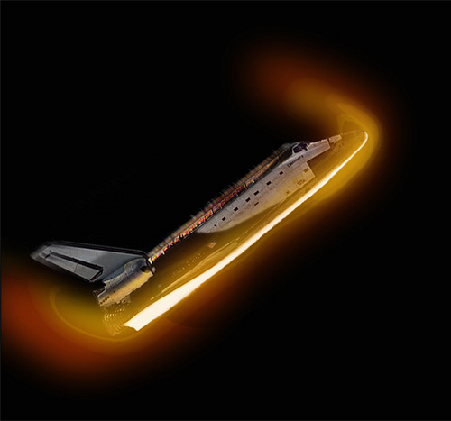
60. When the shuttle enters the atmosphere it does so at an angle. This helps to slow it down but generates a lot of heat.

(a) Why is so much heat generated when the shuttle enters the Earth’s atmosphere?

(b) How is the shuttle protected from the intense heat?

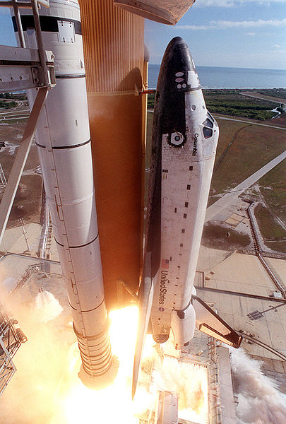
61. The space shuttle Columbia was destroyed when it broke up re-entering the Earth’s atmosphere on the return from its mission. A piece of foam is believed to have hit the tiles on the edge of one of the shuttle’s wings. Explain why this may have led to the disaster.

Satellites
62. A satellite is in orbit around the Earth.

(a) The satellite orbits the Earth once every 24 hours. What name is given to the time for one complete orbit?

(b) What will happen to the time for one complete orbit of the satellite if:
(i) the height of the orbit is increased;
(ii) the height of the orbit is decreased?

(c) (i) What name is given to a satellite which always remains above the same point on the Earths surface?
(ii) State one use for a satellite of this type.

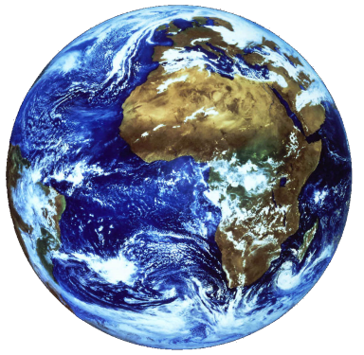
63. The image opposite is taken by a geostationary weather satellite.

(a) (i) Explain what is meant by a geostationary satellite.
(ii) Explain why a geostationary satellite is especially useful for taking images of an area of the earth over a period of time.

(b) Scientists also use polar orbiting satellites.
(ii) How does the orbit height of a polar orbiting satellite compare to that of a geostationary satellite?
(ii) How would the image produced from a polar orbiting satellite differ from that shown above?

64. A satellite receiver consists of a large curved dish with an antenna placed in front of it.
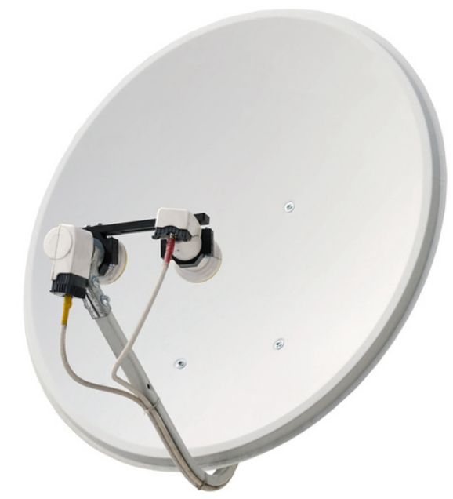
curved dish
antenna
(a) State the function of the antenna.

(b) State the function of the curved dish.

(c) State one way in which the strength of the received signal could be made stronger.

(d) Copy and complete the diagram below to show how the satellite dish acts on the incoming signal.
incoming signal
curved dish
antenna

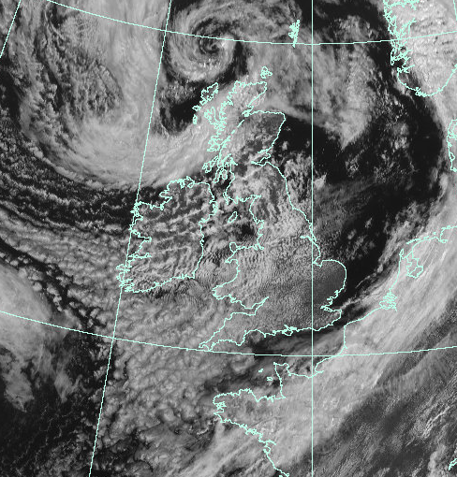
EXTENSION QUESTIONS
65. Weather satellites are in orbit around the Earth. Pictures of the weather systems around the globe can be sent back to allow more accurate weather predictions to be made.

(a) Explain what is meant by the weather satellite being in orbit around the Earth.

(b) A satellite transmits an image of the same part of the Earth all the time. State whether this is a geostationary or orbiting satellite.

(c) A satellite is relocated to a higher orbit. How does this affect the time for the satellite to make one orbit of the Earth?

Cosmology

The Universe
66. Copy the following terms down then match them against their correct definitions.
Term | Definition
(a) Solar system - | a body revolving around a planet.
(b) Moon - | a body revolving around a star.
(c) Planet - | the star at the centre of our solar system.
(d) Sun - | a grouping of solar systems.
(e) Galaxy - | a ball of burning gas at the centre of a solar system.
(f) Universe - | a star and its associated planets.
(g) Star - | a planet orbiting a star outside our solar system.
(h) exo-planet | all the matter that we know of.

67. Astronomers us the term a ‘light year’. Explain what is meant by the term a ‘light year’.

68. (a) How many seconds are there in one year?

(b) If light travels at 300 000 000 metres per second, how far will it travel in one year?

69. How long does it take light to travel from the Sun to the Earth?

70. The nearest star to our solar system is Alpha Centauri. How many light years away is it?.
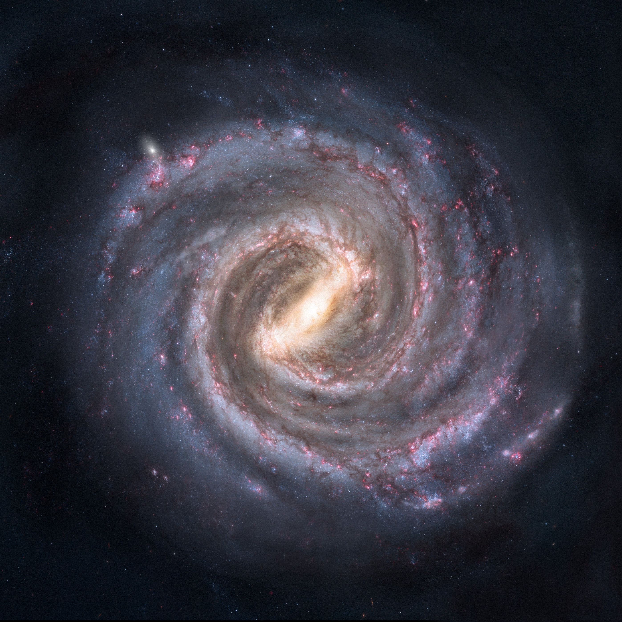
The Milky Way
you are here
71. Our solar system is in the galaxy called the Milky Way. How wide is the Milky Way in light years?

EXTENSION QUESTIONS
72. Read the passage below on exoplanets then answer the questions which follow.

An exoplanet, or extrasolar planet, is a planet outside our Solar System. More than a thousand such planets have been discovered. There are at least 100 billion planets in the Milky Way, with at least one planet on average per star. Around 1 in 5 Sun-like stars have an "Earth-sized" planet which might be able to support life so the nearest would be expected to be within 12 light-years distance from Earth. Astronomers have estimated that there could be as many as 40 billion Earth-sized planets orbiting in the habitable zones of Sun-like stars and red dwarfs within the Milky Way.

Most of the known exoplanets are giant planets—estimated to be the size of Jupiter or Neptune—because the larger and more massive planets are more easily detected. The discovery of exoplanets leads to the next question—could they support life. In order to support life, conditions on the planet’s surface must be right.

Orbit around the star
Some planets do not have a circular orbit around their star like the Earths. This means that the temperature on the planet’s surface can vary between extremes which make it uninhabitable.

Distance of orbit from the Sun
If a planet orbits very close to the Sun it will be too hot to allow life. If its orbit is too far away from the planet it will be too cold for life to survive.

Planet size
Factors such as the size, mass and density of a planet affect its gravitational field strength. If a planet has a high value (Earth’s is 9·8 Newtons per kilogram) any living organism would need very strong bones to support it—assuming it was large enough to need bones. The gravitational field strength also affects the ability of a planet to hang onto its atmosphere. If it is too low the atmosphere will disappear into space.

Presence of water
Life as we know it requires water so it would have to be present at temperatures which allow it to be in liquid form.

Presence of an atmosphere
Life as we know it requires oxygen in an atmosphere. This has to be at a certain concentration to allow life to develop, too much or too little is a bad thing. The atmosphere also protects life on the planet’s surface from harmful radiation from the star.

(a) What is an exo-planet?

(b) How many light years away from Earth is is thought the nearest planet would be that is able to support life?
72 continued
(c) Why would it be difficult for a planet to support life if it’s orbit took it too close to the star?

(d) A planet has a very low gravitational field strength. Why might this make it inhospitable to life?

(e) Name two things which have to be present on a planet for life to develop on it?

73. Read the passage below on a journey through space then answer the questions which follow.

The fastest speed that anything can travel, is at 300 000 000 metres per second. With our current technology, the fastest spaceships only travel at 11 000 metres per second. The Apollo Moon missions took about 3 days to travel from the Earth to the Moon as they only travelled at their maximum speed for a short time. Whilst light will take eight and a half minutes to reach the Earth from the Sun, a spaceship travelling from the Earth to the Sun would have to travel a distance of 150 000 000 000 metres which would take much, much longer. Not only would the journey take a long time, the spaceship would be exposed to many dangers. The level of ionising radiation would be very high, there would be a risk of being struck by tiny meteorites and there would be extremes of temperature—minus 180 °C in the shade and 115 °C in sunlight—and that is just near the Earth!

The Earth is part of our solar system which orbits the star in the middle—the Sun. The Sun is just one of many stars which are found in the galaxy of which we are part. The galaxy is called the Milky Way and contains 100 000 million other stars. The Milky Way consists of a spiral of stars and is about 1000 000 000 000 000 000 000 metres wide.

The Milky Way is not the only galaxy there is. It is estimated there are hundreds of billions of galaxies. That means there are vast number of stars, some of which will have orbiting planets and some of these may also contain life. The universe itself is probably about 93 billion light years but that’s only for what we can observe. Scientists have been able to calculate that the universe is about 13 billion years old and it is constantly expanding. No one knows what lies beyond the edge of the universe.

(a) What travels at a speed of 300 000 000 metres per second?

(b) If an Apollo space ship could travel at its maximum speed all the time, calculate how long it would take to reach the moon if it was
363 000 000 m away.

(c) Calculate the time it would take a spaceship travelling at 11 000 metres per second to travel from the Earth to the Sun.

72 continued

(d) What dangers would a spaceship be exposed to as it left the Earth?

(e) In which Galaxy is the Earth found?

(f) (i) What is meant by the term ‘a light year’?
(ii) How wide is the Milky Way?

(g) How wide is the observable universe?

