Waves and Radiation

**2018**

Physics Department

The Nicolson Institute

6/1/2018



Wave characteristics, parameters and behaviours

Types of wave

**I can: Compare longitudinal and transverse waves**

**Discuss what sound is and how it travels**

There are two different types of waves you will meet in this course, **transverse** waves and **longitudinal** waves

In transverse waves the particles oscillate (vibrate) at right angles to the motion of the wave

[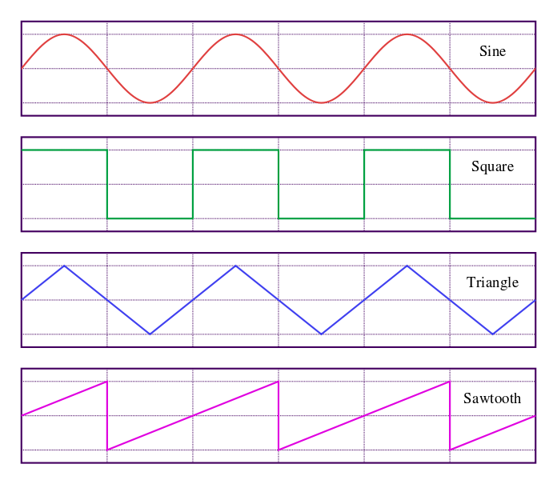](http://upload.wikimedia.org/wikipedia/commons/7/77/Waveforms.svg)

direction of particles’ motion

direction of the wave motion

[1]

In longitudinal waves the particles oscillate in the same direction as the motion of the wave

direction of wave’s motion

direction of particles’ motion

Examples of transverse waves include light waves, radio waves, microwaves.

Sound is an example of a longitudinal wave

Properties of waves

**I can:**

**Define wavelength, frequency and amplitude of a wave**



λ

trough

crest

amplitude

amplitude

λ

λ

*Waves are used to transfer energy. The particles oscillate around a fixed position but the energy travels along the wave.*

Several important features of a wave are shown in the diagram. These are explained in the following table

|  |  |  |  |  |
| --- | --- | --- | --- | --- |
| Wave property | Symbol | Definition | Unit | Unit symbol |
| crest |  | highest point of a wave |  |  |
| trough |  | lowest point of a wave |  |  |
| frequency | f | number of waves produced in one second | hertz | Hz |
| wavelength | λ | horizontal distance between successive crests or troughs | metre | m |
| amplitude | A | half the vertical distance between crest and trough | metre | m |
| *wave speed* | *v* | *distance travelled per unit time* | *metres per second* | *m/s* |

Distance, speed and time

**I can:**

**Use the appropriate relationship between distance, speed and time for waves.**

One of the most important equations you will meet in Physics concerns the relationship between **distance, speed and time**. This means that the speed of an object (or wave) is a measure of how much distance is covered in a certain time.

Another way of looking at this is that the distance travelled depends on how fast you travel and for how long. We represent this as shown below

$$distance=speed ×time$$

where the distance travelled is in metres (m)

the average speed is in metres per second (m/s)

and the time is in seconds (s)

**Example**

A wave travels 90 m in 30 s. Calculate the speed of the wave

$$distance=speed x time \\ 90=speed×30 \\ \frac{90}{30}=speed \\ 3m/s=speed$$

Wave speed, frequency and wavelength

**I can:**

**Use the appropriate relationship between wave speed, frequency and wavelength.**

By multiplying the frequency and wavelength we find that this is equal to the speed of the wave. We therefore say that:

$$wave speed=frequency ×wavelength$$

**Example:**

A wave has a wavelength of 0.5 m and a frequency of 4 Hz. What is its speed?

$$wave speed=frequency x wavelength \\ wave speed=4 ×0.5 \\ wave speed=2 m/s$$

Sound

**I can :**

**Use different methods to measure the speed of sound in air.**

Speed of sound in air

We can use two methods to measure the speed of sound in air.

**Method 1**

cymbals

d

stopclock

The distance between the observer (with the stopclock) and the person with the cymbals in measured with the use of a trundle wheel.

The cymbals are clashed together.

The observer starts the stopclock when he sees that the cymbals have been clashed and stops it when the sound is heard.

The equation $distance=speed x time$ is used to calculate the speed of sound.

This is not a particularly accurate method as it relies on human reaction time.

**Method 2**

electronic timer

microphone

d

mallet and block

The distance is measured with a metre stick.

The mallet is struck against the block.

As the sound reaches the first microphone the timer is started, and when it reaches the second microphone the timer is stopped.

The equation $distance=speed x time$ is used to calculate the speed.

This is a much more accurate method.

The exact value for the speed of sound in air can vary, however it is around **340 m/s**.

Amplitude and frequency

**I can:**

**Analyse sound waveforms including change amplitude and frequency.**

We can analyse waveforms by using a device called an **oscilloscope**.

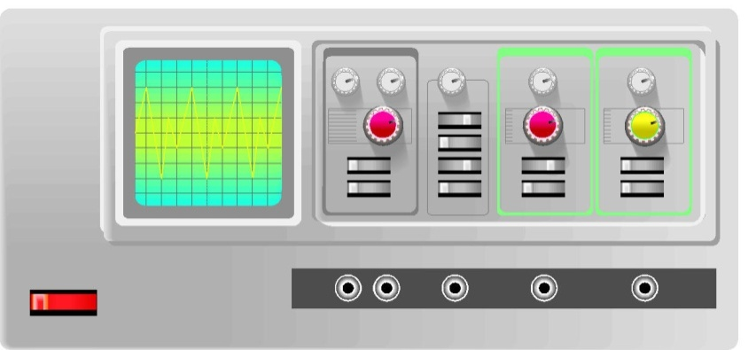[2]

The oscilloscope allows us to view waves and see what effect changing certain properties has.

original wave

smaller amplitude larger amplitude

lower frequency higher frequency

If we were to think of these in terms of sound, waves with small amplitudes would be quiet and those with a large amplitude would be loud.

Waves with a low frequency would be low pitched and waves with a high frequency would be high pitched.

Decibel scale and noise pollution

**I can:**

**Measure Sound levels in the decibel scale.**

**Discuss the risks to human hearing from noise pollution and the methods used to protect hearing.**

Noise levels are measured in **decibels** (dB). These can be measured using a sound level meter. Regular exposure to sounds above 85-90dB can cause damage to hearing. Some typical noise levels are given below

|  |  |
| --- | --- |
| Situation | Decibels |
| Threshold of human hearing | 0 |
| Leaves rustling in the wind | 20 |
| Whisper, rustling paper | 30 |
| Quiet residential area at night | 40 |
| Inside average home | 50 |
| Normal conversation at 1m distance | 60 |
| Phone ringing, busy street | 70 |
| Alarm clock at 0.5 m distance | 80 |
| **Threshold of hearing damage** | 85 |
| Truck heard from pavement, busy factory | 90 |
| Hair dryer | 100 |
| Lawn mower at a distance of 1m | 110 |
| Rock concert 1m from loudspeaker, vuvuzela horn at a distance of 1m | 120 |
| Jet engine at a distance of 50m | 130 |
| **Threshold of pain** | 120 - 140 |
| Stun grenade | 180 |
| Theoretical limit for sound travelling through the Earth’s atmosphere | 194 |

We can protect against damage to hearing by loud noises by wearing ear plugs or ear protectors.

Sonar and ultrasound

**I can:**

**Describe Applications of sound**

Humans can hear sounds with frequencies between 20Hz and 20000Hz. Sounds with a frequency above 20000Hz are called **ultrasound**.

Ultrasound can be used to examine a foetus in the womb. A picture is built up by timing how long it takes to receive an echo from an ultrasound pulse. Ultrasound can also be used to break up kidney stones without the need for invasive surgery.

Boats and submarines use **sonar** to detect shoals of fish, the sea bed or other submarines. Pulses of sound are sent out and then the echo is detected. This is similar to how bats and dolphins use echolocation.

Sound reproduction and noise cancellation

**I can:**

**Show noise cancellation by experiment and research its application**

Sound is an **analogue** signal. This means that it varies continuously over a range of values.

Most recording technology nowadays uses **digital** technology. Digital signals can be one of two values with nothing in between. Analogue to digital converters are used to process the sound signal so that it can be transmitted easier, then a digital to analogue device allows the sound to be reproduced faithfully at the other end.

If two waves travelling in opposite directions were to meet, the result would be that they cancel each other out. The same would happen any time a crest of one wave meets a trough of another.

This effect is called **interference of waves**. We can make use of this effect in noise cancelling technology.

+

=

Electromagnetic spectrum

**I can:**

**State applications and hazards associated with electromagnetic radiations.**

**State approaches to minimising risks associated with electromagnetic radiations**

*There are a number of waves which travel at the speed of light. They are all part of the* ***electromagnetic spectrum****. These waves are all transverse waves and travel at 300000000 m/s (3* x *108m/s) in a vacuum.*

Some information on each part of the spectrum is given below

|  |  |  |  |  |
| --- | --- | --- | --- | --- |
| Type of e-m radiation | Typical source | Application | Detector | Possible hazard |
| Radio & TV | Electrical antennae | Telecommunications | Aerial | Potential increased cancer risk |
| Microwaves | Cosmic sources, magnetron | Cooking, telecommunications | Diode probe | Heating of body tissues |
| Infra-red | Heat-emitting objects | Thermograms | Phototransistor, blackened thermometer | Heating of body tissues |
| Visible light | Stars | Vision | Eye, photographic film | Intense light can damage the retina |
| Ultraviolet | Sunlight | Treating skin conditions | Fluorescent paint | Skin cancer |
| X-rays | X-ray tube, cosmic sources | Medical imaging | Photographic plates | Destroys cells which can lead to cancer |
| Gamma rays | Nuclear decay | Treating tumours | Geiger–Müller tube and counter | Destroys cells which can lead to cancer |

Nuclear radiation

**I can:**

**State natural and artificial sources of nuclear radiation.**

**Describe medical and industrial applications of nuclear radiation.**

**List the pros and cons of generating electricity using nuclear fuel.**

**Describe the risks due to nuclear radiation and other environmental hazards and the management of this risk.**

Nuclear radiation comes from inside an atom.

Neutron – neutral (no) charge

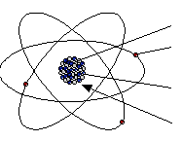

Electron – negatively charged

Proton – positively charged

Nucleus – contains protons and neutrons.



An alpha particle is a Helium nucleus. It is positively charged. Compared to beta radiation it is large.



A beta particle is an electron. It is negatively charged. Electrons are very small and light.



Gamma radiation is an electromagnetic wave. It has high frequency and high energy. It travels at 3 x 108m/s.

Background Radiation

Background radiation is radiation from our surroundings. It is normally at a very low level.

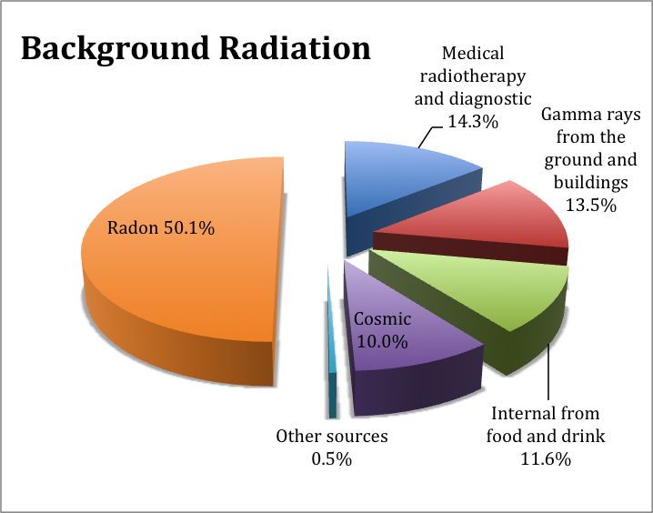**Natural sources of radiation**

Natural sources of radiation are – radon gas from rocks and soil (particularly granite), gamma rays from round, carbon and potassium in body and cosmic rays from outer space.  
  
**Artificial sources of radiation**

Human made sources of radiation are – medical applications such as x-rays and radionuclides, fallout from weapons testing; nuclear waste from power stations.

**Medical applications**

X-rays, scans and cancer treatment are all sources of radioactivity. These are kept to a minimum to protect your health.

**Industrial application**

Radiation can be used to test welds without destroying them. Some jobs expose workers to a higher dose of radiation than normal – these include miners and aircrew as well as nuclear power plant workers.

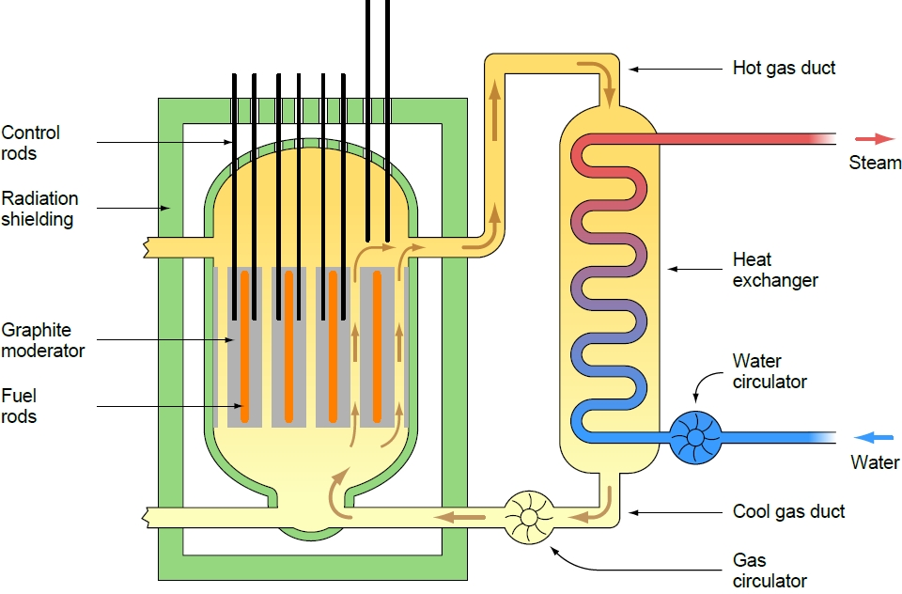Nuclear Power Stations

The heat released by the nuclear reaction is used to produce steam in the heat exchanger.

The steam is used to turn a turbine, which then turns a generator, producing electrical energy.

The UK still has several operational power stations.

**For nuclear fuel**

Nuclear power stations produce a large amount of energy for a small amount of fuel.

There are no carbon dioxide or sulphur dioxide emissions from a nuclear power station.

**Against nuclear fuel**

Nuclear waste must be stored securely for a very long time.

Many people have a negative view of nuclear fuel.

**Biological effects of radiation**

Radiation can kill or damage cells. If the DNA of a cell is altered it can grow into a tumour.

**Environmental hazards of radiation**

Living things – plants and animals as well as humans, are affected by radiation.

Very high doses can be fatal. Lower doses can cause sickness and mutations.

**Management of risk**

Health and Safety regulations dictate the amount of radiation the public can be exposed to on an annual basis.

Limits also exist for people who work in the nuclear industries or similar situations. These are higher than the limits for the general public.

Workers wear radiation monitoring badges.

Environmental agencies are responsible for monitoring any possible radiation leaks and will place warning signs in areas where there are potential hazards to health.

[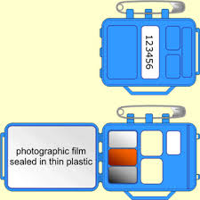](http://www.google.co.uk/imgres?q=radiation+monitoring+badge&um=1&safe=active&sa=N&rls=com.microsoft:en-gb:IE-SearchBox&rlz=1I7ADSA_enGB408&hl=en&biw=1005&bih=560&tbm=isch&tbnid=eNrZyqnZNXQ8vM:&imgrefurl=http://www.frankswebspace.org.uk/ScienceAndMaths/physics/physicsGCSE/detecting.htm&docid=TVdqQokZwDpvNM&imgurl=http://www.frankswebspace.org.uk/ScienceAndMaths/physics/physicsGCSE/bytesize%20images/detecting1.gif&w=340&h=337&ei=wjaKUYeIEYaZ0QWG0YDgDg&zoom=1&iact=hc&vpx=315&vpy=66&dur=5156&hovh=224&hovw=225&tx=167&ty=167&page=1&tbnh=142&tbnw=144&start=0&ndsp=17&ved=1t:429,r:7,s:0,i:106)

1. http://upload.wikimedia.org/wikipedia/commons/7/77/Waveforms.svg
2. © Glowgraphics taken from Images for schools