The mains supply
The wiring in a house connects all appliances together in parallel. This is so that each has the mains supply of 230 volts across it and also so that they can all be used independently. For credit level, you should know some more about house wiring.

House wiring
- The consumer unit contains the main switch and the fuses for all of the fixed circuits, such as the power ring circuit and the lighting circuit.
- The power sockets in a house are connected by means of a ring circuit. In a ring circuit the live, neutral and earth wires form a loop of cable going from the consumer unit to all of the sockets in turn and then back to the consumer unit.
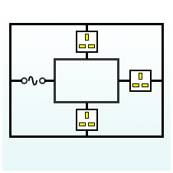
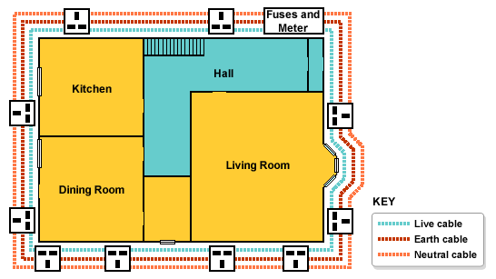
There are several advantages of using a ring circuit:
- the cables can be made thinner because there are two paths for the current
- each part of the cable carries less current
- a ring circuit is more convenient since sockets can be placed anywhere on the ring

Differences between lighting circuit and power ring circuit
There are differences between the lighting circuit and the power ring circuit
Lighting circuit  supplies fixed lights  uses 5 A fuse  thinner cable  parallel circuit | Power ring circuit  supplies power sockets  uses 30 A fuse  thicker cable  loop parallel circuit

