WAVE PARAMETERS AND BEHAVIOURS

1. **Energy can be transmitted as waves.**
2. **State the difference between a transverse and longitudinal wave and give examples of each.**

**In a transverse wave the particles move at 90 degrees to the direction of the flow of energy.**

**In a longitudinal wave the particles move along the line of the direction of travel of energy.**

|  |  |
| --- | --- |
| Transverse Waves | Longitudinal waves |
| 1. These waves travel in the form of crests and troughs. 2. The particles of the medium vibrate at right angles to the direction of propagation of waves 3. These waves can travel only in solids and on the surface of liquids which have rigidity. 4. There is no pressure variation in the medium through which they propagate.  For example, all e-m waves, water waves | 1. These waves travel in the form of compressions and rarefaction. 2. The particles of the medium vibrate in the direction of propagation of waves 3. These waves can travel in solids, liquids and gases. 4. The pressure and density is maximum at compressions and minimum at rarefactions.   http://astro.uchicago.edu/cara/outreach/se/ysi/1999/longitudinalwave.jpgFor example sound waves and some waves produced by earthquakes |

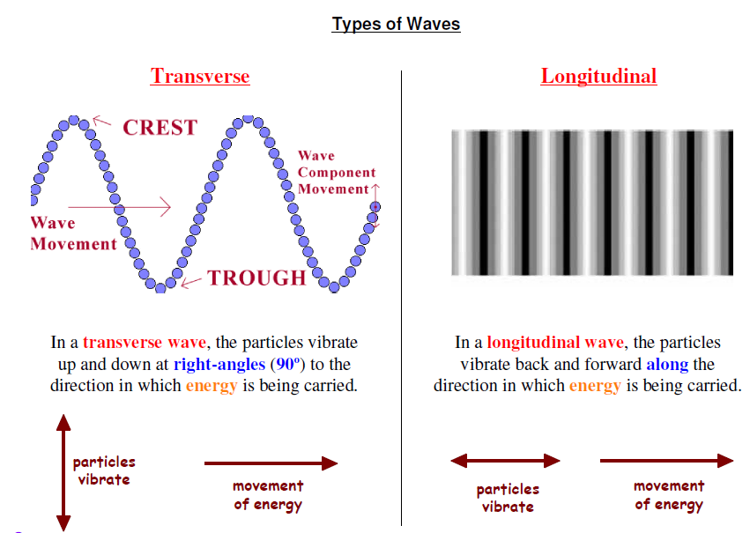

**Use the following terms correctly in context: wave, frequency, wavelength, speed, amplitude, period.**

**wave**, a way of transferring energy.

**frequency,** (f) number of waves produced or passing a point per second. (Hertz or Hz) 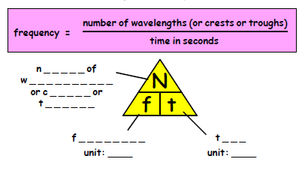

**wavelength, (λ)** the distance between two successive points on a wave. (metre or m)

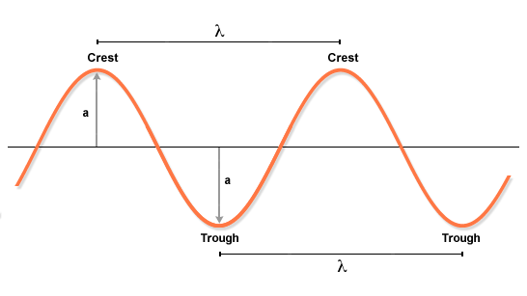

**amplitude, (a)** maximum disturbance of the particles in a wave. (or distance from middle to top of wave) (m)

**period. (T)** Time for one wave to pass a point or time for one wave to be produced. (s)

**speed, (v)** rate of covering a distance. Number of metres travelled per second.

(ms-1) The Speed of the waves is represented by the formula

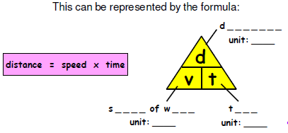

A water wave travels 25 metres in 3.4 s what is the speed of the water wave?

d=25m, t=3.4s

$$v=\frac{25}{3.4}=7.4ms^{-1}$$

1. A tsunami sea wave takes 6 seconds to travel up a beach with a speed of 15 metres per second. What distance does the wave travel up the beach?
2. When Sajidha threw a stone into a pond, circular waves travelled 7.5 metres across the water in 2.5 seconds. Calculate the speed of these water waves.
3. Sea waves approach a cliff at 4 metres per second. What time will the waves take to travel 20 metres?
4. Sid the surfer rides the crest of a sea wave travelling at 6 metres per second for 8 seconds. Calculate how far the wave carries Sid in this time.
5. A drop of water from a leaking tap causes waves on the surface of Brenda's bath water. If these waves travel 0.4 metres in 1.6 seconds, at what speed are they travelling?
6. As the tide goes out, sea waves travel 50 metres with a speed of 2.5 metres per second. How long do the waves take to travel this distance?

## It is also possible to calculate the speed of a wave if we know the wavelength and frequency of the wave.

**Speed = frequency x wavelength**

**v = f x λ**

Example: A water wave has a wavelength of 50cm. Twenty waves pass a point in 10 seconds.

f = 20 waves in 10s = 20/10 waves in 1s = 2Hz

λ = 50cm = 0.5 m

v = f x λ = 2 x 0.5 = 1ms-1

Calculate the speed of the wave.

v = ?

1. Calculate the speed of water waves which have a frequency of 2 hertz and a wavelength of 5 metres.
2. Calculate the frequency of water waves in a harbour if they travel at 3 metres per second and have a wavelength of 4 metres.
3. Calculate the wavelength of water waves on a pond which travel at 0.75 metres per second and have a frequency of 1.5 hertz.
4. Every second, 2 waves are produced on Alan's bath water by water dripping from a tap. If these waves have a wavelength of 0.05 metres, calculate their speed.
5. The wind causes waves to travel across a puddle at 2.4 metres per second. If the waves have a wavelength of 0.6 metres, determine their frequency.
6. A wave generator in a swimming pool produces 2.5 waves every second. The waves travel across the pool at 1.2 metres per second. Determine their wavelength.
7. Calculate the speed of sound waves in air which have a frequency of 500 hertz and a wavelength of 0.34 metres.
8. Calculate the frequency of sound waves in air which travel at 340 metres per second and have a wavelength of 1.7 metres.
9. Calculate the wavelength of sound waves in air if they travel at 340 metres per second and have a frequency of 6 800 hertz.
10. A submarine sends a pulse of sound through the sea. Determine the speed of the sound pulse if it has a frequency of 7 500 hertz and a wavelength of 0.2 metres.
11. Sound travels through steel at 5 200 metres per second. In the steel, sound waves have a wavelength of 2 metres. Calculate their frequency.
12. Ultrasound (frequency 21 000 hertz) travels through human muscle at 1 600 metres

per second. Calculate the wavelength of ultrasound in the muscle.

The question is asked WHY is  the same as .

Think of it like this:



What happens when we multiply these two quantities together?



1 a) Which of these waves is carrying more energy? b) Explain your answer.

2. a) The wave below is travelling to the right, what happens to the amplitude?



b) What must be happening to the energy of the waves

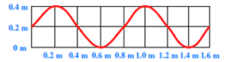3. State the values for the amplitude and wavelength of this wave.

1. The wave was produced in one second, state the value of the frequency of the wave?
2. State the period of the wave.

4. Determine the frequency and the period of the waves in the following situations

a) 5 waves are produced every second

b) 10 water waves pass the end of a pier in 2 seconds

c) 12 circular waves spread out across a pond every 20 seconds

5. a) For this wave state the value of the i) amplitude ii) frequency

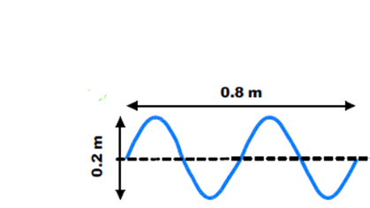

b) This wave was produced in 2 seconds, state i) the frequency ii) the period of the wave.

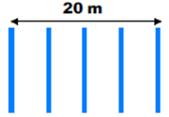

6. Determine the wavelength of these water waves.

These 5 wave crests were produced in 25 seconds. Determine the frequency of the waves.

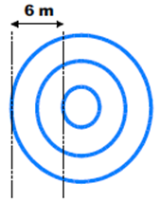7. What is the wavelength of these circular waves?

b) These waves were produced in 0.5 seconds. What is the frequency of the waves?

# Diffraction

Waves pass through a gap in more or less a straight line. The waves do spread out at the edges.

<http://www.acoustics.salford.ac.uk/feschools/waves/diffract3.htm>

# BEHIND THE HILL!

Signals from some radio transmitters travel in almost straight lines. These signals will not be easily received in a glen between the hills or behind a multi-storey building.

Other radio signals are able to bend round or over obstacles and can be picked up in these places. This bending is called DIFFRACTION

TV waves usually have a shorter wavelength than radio waves. This is why the people in a house behind a hill cannot get good TV reception but the radio reception is good.

LONG WAVES DIFFRACT MORE THAN SHORT WAVES (eg RADIO)

## SHORT WAVES do NOT DIFFRACT as well (eg TV)

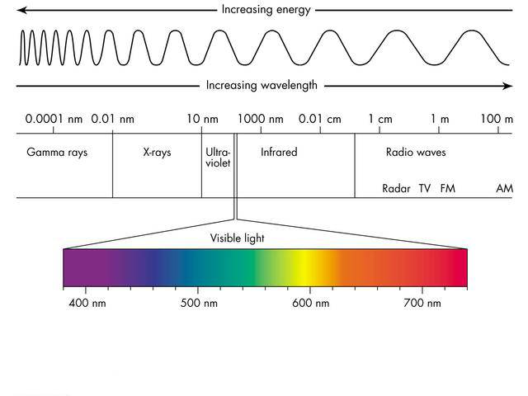The Electromagnetic Spectrum

Some information on each part of the spectrum is given below

|  |  |  |  |  |
| --- | --- | --- | --- | --- |
| Type of e-m radiation | Typical source | Application | Detector | Possible hazard |
| Radio & TV | Electrical antennae | Telecommunications | Aerial | Potential increased cancer risk |
| Microwaves | Cosmic sources, magnetron | Cooking, telecommunications | Diode probe | Heating of body tissues |
| Infra-red | Heat-emitting objects | Thermograms | Phototransistor, blackened thermometer | Heating of body tissues |
| Visible light | Stars | Vision | Eye, photographic film | Intense light can damage the retina |
| Ultraviolet | Sunlight | Treating skin conditions | Fluorescent paint | Skin cancer |
| X-rays | X-ray tube, cosmic sources | Medical imaging | Photographic plates | Destroys cells which can lead to cancer |
| Gamma rays | Nuclear decay | Treating tumours | Geiger–Müller tube and counter | Destroys cells which can lead to cancer |