Waves

Wave terminology
wavelength, λ (lambda)
amplitude

Amplitude: the distance from the middle of the wave to the top (or the bottom)
Wave speed: the speed at which the wave travels
Wavelength: the length of one cycle of the wave
Frequency: the number of waves per second. Frequency is measured in hertz (Hz).
1 kilohertz (1 kHz) = 1000 Hz.
$$Frequency (Hz)= \frac{no of waves}{time (s)}$$

$$F= \frac{n}{t}$$
Waves always transfer energy. The larger the amplitude, the more energy a wave carries.

  - Measuring wave speed
To measure the speed of a wave, you need to measure the distance it travels and the time it takes to travel that distance.
To find the speed, divide the distance by the time:
$$v=\frac{d}{t}$$
If the distance is in metres and the time in seconds, the speed will be in metres per second (m/s)

  - Speed, frequency and wavelength
For water waves travelling along a piece of guttering, the greater the frequency of the wave the shorter the distance between crests. This is true for all waves:
Wave speed (m/s) = frequency (Hz) x wavelength (m)
$$v=f × \text{λ}$$

  - Types of waves
The waves we have looked at so far have been transverse waves. For transverse waves, the vibration that produces the wave is perpendicular to the direction of travel of the wave. Water waves and waves in the electromagnetic spectrum are examples of transverse waves.

Sound waves are an example of a longitudinal wave. For these waves, the vibration that produces the wave is parallel to the direction of travel of the wave.
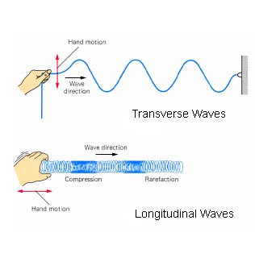
  - Longitudinal waves
Longitudinal waves consist of regions where particles are squashed closer together (compressions) and areas where they are pulled further apart (rarefactions) as the wave travels. Like transverse waves, the frequency of these waves is the same as the frequency of the source that produces them. The wavelength of a longitudinal wave is the distance between two adjacent centres of compression or rarefaction as on this diagram of a sound wave:
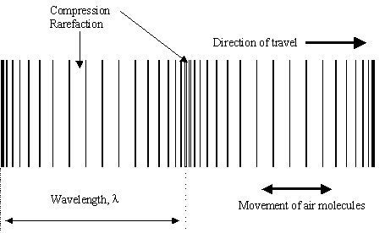

All sound waves are longitudinal waves, as are some types of waves produced by earthquakes (P-waves).

  - Diffraction
When waves encounter an obstacle, they bend round that obstacle into its shadow. This process is called diffraction. How much waves diffract depends on the wavelength of the wave and the size of the gap they pass through.
The longer the wavelength the more diffraction takes place.
The smaller the size of the gap in relation to the wavelength, the more diffraction takes place.

  - Radio and television communication
Radio and television signals both use waves from the electromagnetic spectrum. The wavelength of the waves used for radio is longer than the waves used for television, and the difference is big enough to make a difference to reception in hilly areas.
As radio waves have a longer wavelength they diffract more and so most houses can receive radio signals. The shorter wavelengths used for television signals will diffract less, and this has an effect on the signal received by houses beside large hills or other obstacles.

Sound
Sound is a wave which is produced by vibrations. A sound wave can be picked up using a microphone, and the electrical signal can be analysed using an oscilloscope.
If the frequency of the sound is increased this means that more waves are produced each second. The pitch of the note gets higher and more waves will be shown on the oscilloscope screen.
If the volume of the sound is increased, the amplitude of the signal on the screen increases as the sound has more energy.
Same frequency, louder
Original signal

Lower frequency, same volume

  - Voice recognition software
The computer uses a microphone to pick up the sound and change it to an electrical signal. The software then analyses this signal, looking at the frequency and volume of each word, and works out what word has been said. This then appears on the screen.
Different peoples’ voices will have different frequencies present in them, and so software could be developed to identify the person speaking.

  - Enhancing sound
Once sound has been recorded, software can be used to alter it or to enhance it. Some parts of the track can be amplified more than others to make them sound louder (or amplified less to make them sound quieter), and the frequency of some notes can be altered. Technology can be used to make everyone sound like they can sing in tune!

  - Measuring the speed of sound in air
Pupil A holds a pair of cymbals and crashes them together. Pupil B starts their stopwatch when they see the crash and stop them when they hear the sound it produces. The experiment is repeated several times, and all the times are used to calculate the average time. The distance between the two pupils is measured.
The speed of sound in air is found by dividing the distance by the average time.
For example:
Times measured (s): 0.33, 0.34, 0.40, 0.39, 0.68, 0.68, 0.68, 1.32, 0.56, 0.72, 0.32, 0.59, 0.37, 0.36, 0.34, 0.48, 0.54, 0.47, 0.49, 0.70, 0.70, 0.72, 0.58, 0.56, 0.48, 1.25, 0.50, 0.35, 0.75, 0.56, and 0.47
Average time = 0.57s
Distance between sound and observers = 160 m
Speed of sound in air = ^{d}/_{t} = ¹⁶⁰/_{0.57} = 281m/s
This value is lower than expected, but if the two highlighted readings are ignored this gives a value of 327m/s for the speed of sound in air. This is much closer to the expected value.

The speed of sound in liquids and solids can be found by using microphones to start and stop the timer, and using this time and the distance between the microphones to calculate the speed.

Sound travels fastest through solids and most slowly through gases. It cannot travel through a vacuum at all.

  - Measuring sound levels
Sound is measured in decibels (dB). Sound levels measured in the school were:

Area | Sound level (dB)
Science department
Store
Dining hall
Corridor
Library
Beside school bell

Typical sound levels in other areas are:
Area | Sound level (dB)
Quiet country lane | 20
Quiet conversation | 40
Normal conversation | 60
Alarm clock DANGER LEVEL | 80
Food blender at 0.5m | 100
Jet aircraft at 175 m | 120
Threshold of pain | 140

Exposing ears to loud noise always causes permanent damage to hearing. The louder the noise and the longer the exposure, the greater the damage is caused to the ears, but any sound louder than 80 dB causes damage.

  - Protection of hearing
In order to protect hearing, people who are exposed to loud noises should wear ear protectors. These absorb energy from the sound wave, and so reduce the damage to the ears.

  - Hearing aids
These have a microphone to pick up sound and change it into an electrical signal, an amplifier to make the signal larger and a loudspeaker to change the larger signal back into a louder sound. Modern digital hearing aids can amplify certain frequencies more to take account of an individual’s hearing loss.

  - Noise cancelling headphones
Noise cancelling headphones are used in noisy environments. The headphones contain a microphone which records the background noise and an electronic device which produces a signal which is the exact opposite of this. When these two are played together they cancel out and produce silence. This allows other signals (eg music or someone’s voice) to be heard clearly.

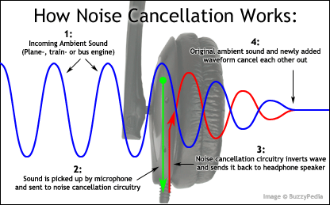

Noise cancelling headphones can be used to listen to music in noisy environments without having to turn the volume up to dangerous levels. They can also be used to allow people to talk to each other when there is a lot of background noise, for example in a helicopter.

  - Range of human hearing
The normal range of human hearing is from 20 Hz to 20 kHz for a young person. As we get older the highest frequency we can hear decreases gradually, so older people are less sensitive to very high pitched sound than younger people.

  - Ultrasound
Sound which has a frequency too high for humans to hear is called ultrasound. Ultrasound (also called sonar) is used at sea to measure the distance to the sea bed, and to locate shoals of fish. In medicine ultrasound is used to scan structures inside the body, and can give a picture of a baby inside the womb, provide information on the available space inside blood vessels and check the direction of blood flow through the heart.

Light

  - Refraction
Refraction happens when waves pass from one medium to another. If the waves change speed they will often change direction.
The angle between the incident ray and the normal is called the angle of incidence.
The angle between the refracted ray and the normal is called the angle of refraction.
The normal is the line perpendicular to the boundary at the point where the wave hits the boundary.
Angle of refraction
Angle of incidence
Normal

When the wave slows down, it bends towards the normal. When it speeds up it bends away from the normal. When light slows down its wavelength gets shorter and its frequency stays the same.

  - Lenses
Concave lenses are thinner at the middle than at the edges. Concave lenses make rays of light diverge.

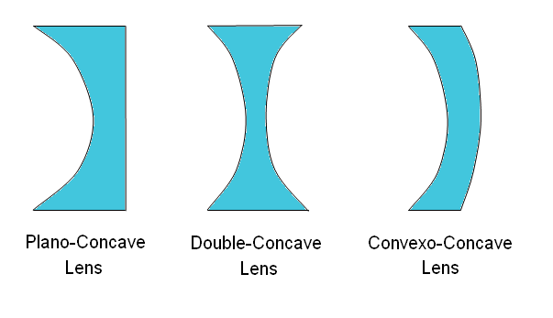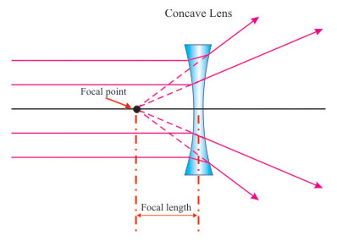

Convex lenses are thicker in the middle than at the edges.
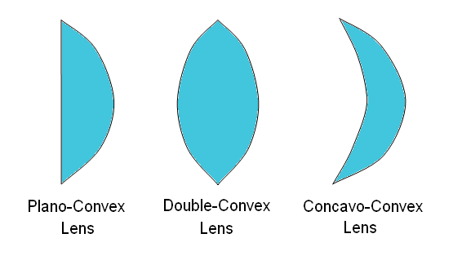
Convex lenses make the rays converge. The thicker the lens the more refraction it causes.
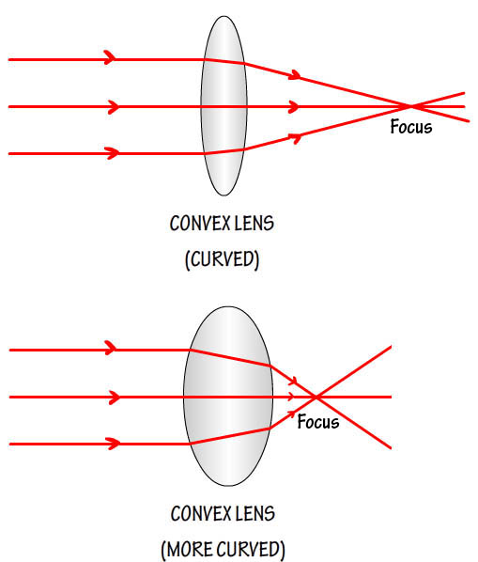

  - Real and apparent depth
Water always turns out to be deeper than it looks, and glass is always thicker than it looks. This is due to refraction.
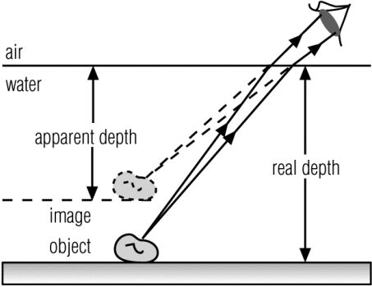
The light ray changes direction at the surface. The brain assumes that it has travelled in a straight line and so has come from a point directly above the true position.

  - The eye
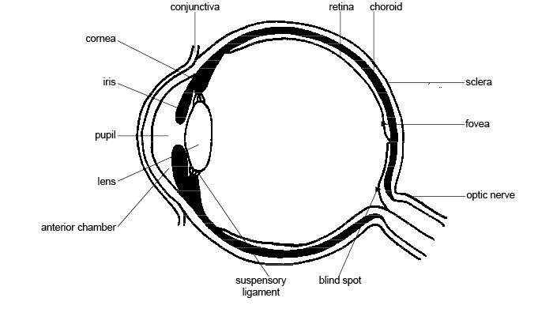
Light enters the eye through a clear window called the cornea, and passes through the pupil (the hole in the middle of the coloured iris). It then passes through the lens before coming to a focus on the retina at the back of the eye. The retina consists of light sensitive cells, and the signals from these cells are sent to the brain along the optic nerve. The fovea is a small area which has a higher density of light sensitive cells, and this is the area of detailed vision. The point where the optic nerve leaves the eye has no light sensitive cells, and so this is called the blind spot. The lens is held in place by the suspensory ligaments which attach it to a ring of muscle. When the muscle contracts the lens bulges more and so causes more refraction. This allows the eye to focus on both close and distant objects.

  - Accommodation
The ability of the eye to focus on close and distant objects is called accommodation.
When looking at a distant object, less refraction is needed to make the rays focus on the retina. The ciliary muscle is relaxed and the lens is thin.

When looking at a close object, more refraction is needed if the image is still to be formed on the retina. The ciliary muscle contracts and the lens bulges.
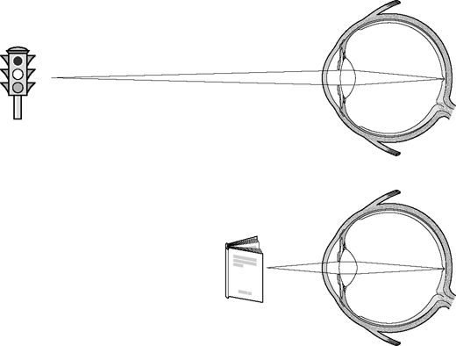

  - Long and short sight and correction
Someone with long sight can see distant objects clearly, but close objects are blurred. The lens cannot get thick enough to cause enough refraction to focus the rays on the retina.
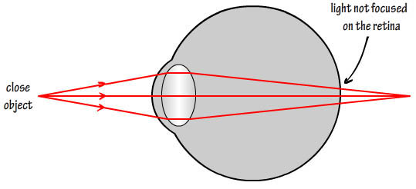
A convex lens is used to make the rays converge before they enter the eye and this makes the image of a close object clearer.

  - Short sight and correction
A person with short sight can only see close objects clearly. Distant objects are blurred.

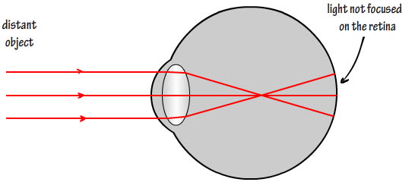
A concave lens is used to make the rays diverge before they reach the eye so that they can focus on the retina.

  - Total Internal Reflection
When light hits the internal surface of a block of glass (or other similar material) at too large an angle, the light cannot pass through the surface but is completely reflected inside the block. This is called Total Internal Reflection. The angle at which total internal reflection starts to happen is called the critical angle.

  - Measuring the critical angle

A ray of light is shone into a semi-circular block as shown. The angle of incidence on the straight side is gradually increased until the refracted ray passes along the edge of the block. At this point, the angle of incidence is equal to the critical angle.

If the angle of incidence is greater than the critical angle the ray is totally reflected inside the block.
If the angle of incidence is less than the critical angle most of the light passes through the straight side of the block although there is usually a weak reflected ray.

  - Optical fibres
Optical fibres are long, thin strands of very pure glass. Light passes along the fibres by total internal reflection.
Optical fibres are used for telecommunications. They are cheaper, lighter and more secure than copper wires, and can have a greater bandwidth which means they can pack more information into the signal. They are more easily broken and more difficult to join together than wires, but their main disadvantage is that the signal travels more slowly than it would through a copper wire (light only travels through the fibre at 2 x 10⁸ m/s but electrical signals travel along copper wires at almost 3 x 10⁸ m/s).
Optical fibres are used in medicine to look inside the body through small incisions. An endoscope uses one bundle of optical fibres to carry light inside the patient. This light reflects off the inside of the body and can be passed through a lens and picked up by another bundle of fibres and carried back outside the body where it can be viewed by the doctor. Other devices use optical fibres to carry light inside the patient but the reflected light is picked up by a tiny camera. This picture can then be displayed on a monitor.

Electromagnetic spectrum

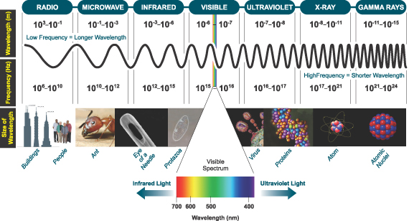
All the waves in this spectrum are the same type of wave, and all of them travel at 3 x 10⁸ m/s in air. The spectrum is divided up into different wavebands which have different frequencies and different properties. We can only sense those in the visible light section, but other parts of the spectrum have other uses and cause other dangers.

Uses and hazards of electromagnetic radiation

  - Radio waves
These are used to convey information over a wide area without the need for wires. A transmitter sends out a signal which is picked up by a receiver. They are also used for Wi-fi networks and to communicate with satellites. Radios are used by emergency services to allow them to communicate in areas where other means of communication are not possible. Some toys are also controlled remotely by radio signals.
Radio waves are not known to be dangerous, but there is a possibility that frequent and long term exposure can cause damage to the DNA in cells, and long exposure to certain frequencies could lead to brain damage. Avoiding prolonged exposure will avoid this.

  - TV waves
Used for both terrestrial and satellite broadcasting of television signals. These signals are heavily used by the advertising industry to promote products and services. Exposure to TV waves over a long period of time could be dangerous if radiation dose is large, and watching too much TV can affect children’s development and affect their physical health if it leads to them being less active.
Minimising exposure to TV waves and reducing time spent watching TV will minimise the risks to health.

  - Microwaves
Used for microwave ovens and for radar, airport scanners and mobile phone signals. The signals can be used to transmit information. In microwave ovens, the microwaves make the molecules of water vibrate, and the heat produced cooks the food. Military use it for guidance systems for missiles, and scientists pick up microwaves from stars to try to answer questions about the universe.
Overexposure to microwaves can cause microwave sickness, which has symptoms which include nausea, vision problems, headaches and dizziness. Concentrated beams can cause severe burns. The best way to minimise these risks is to avoid exposure to high doses of microwaves radiation.

  - Infra-red
All hot objects emit infra-red radiation, so infra-red is associated with heat. It is used by the military for night vision instruments which allow them to see better under low light conditions, and infra-red cameras can be used in searches for missing people, especially in the early stages of the search. Infra-red cameras can also be used to take thermograms of houses to see where the houses are losing most heat. Astronomers also observe the infra-red radiation given out by objects in the sky in order to gain more information about the universe.
Sources of infra-red radiation need to be used with caution as the radiation can cause severe burns, and over-heated objects could explode.
  - Ultraviolet
The food industry uses ultraviolet lamps to disinfect certain types of products and their containers. It is also used in manufacturing integrated circuits. Ultraviolet is also used to detect forged backnotes, forensic scientists use ultraviolet light to look for evidence at a crime scene and caterers use ultraviolet lights to attract any insects which enter the kitchen so that they do not contaminate food.
Exposure to ultraviolet can harm skin, causing sunburn which gives a higher chance of skin cancer developing. Large doses of ultraviolet also damage the retina of the eye which can lead to problems with vision.
  - X-rays
Used for medicine to detect kidney stones, broken bones, tumours, foreign bodies (eg bullets or swallowed coins) and other abnormalities. Dentists use them to find cavities and impacted teeth which need treatment. Archaeologists use them to investigate ancient objects. Industrial uses are to detect cracks in pipes and to check luggage in airports. Chemists use them to analyse the arrangement of atoms in crystals.
Over-exposure to X-rays can damage the DNA in cells which can cause cancer, can burn the skin and can reduce the blood supply to cells. Exposure to X-rays is particularly dangerous for the developing foetus as it could cause birth defects.

  - Gamma rays
Gamma rays cause damage to cells, and rapidly developing cells are most easily damaged. This means that a large dose of gamma rays can be used to treat cancer (radiotherapy), but exposure to gamma rays causes particular damage to cells in the stomach lining (causing nausea), hair follicles (leading to hair loss) and a growing foetus. Large doses of gamma rays are used to sterilise medical equipment. The food industry uses gamma rays to irradiate food to kill bacteria, yeast and insects, which prolongs the shelf-life of the food. Gamma radiation can also be used in industry to detect leaks in pipes.
Gamma radiation is highly dangerous for all living things, as it causes damage to cells which can lead to cancer. Thick concrete (over 3m) or lead (several centimetres) are needed to absorb it.

Detection of non-visible electromagnetic radiation

Since this radiation cannot be seen, other detectors must be used for non-visible radiation.
Part of spectrum | How it is detected
Radio and TV | Tuned circuits in radio and TV receivers
Microwaves | Tuned circuits in detector
Infra-red | phototransistor
Ultraviolet | Pigments in skin
X-rays | Photographic films
Gamma radiation | Photographic films, Geiger counter

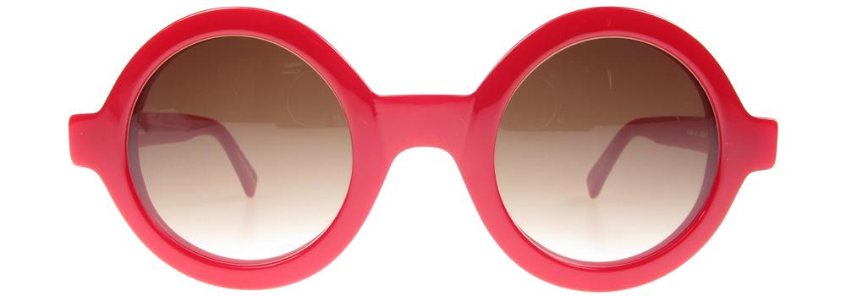
WARNING: Cheap sunglasses may cause permanent damage to your eyes!
Sunlight contains infra-red, visible and ultraviolet radiation. Any of these can damage eyes, so the normal response to bright sunlight is for the pupil to get smaller or the eyes to close, protecting the retina from damage, but it is the visible light which triggers this response.
Some sunglasses only absorb the visible light from the sunlight. This means that the pupil of the eye stays large, letting all the infra-red and ultraviolet enter the eye. This can cause permanent damage.
Make sure your sunglasses absorb ultraviolet as well as visible light!

And finally…
  - Calculation questions

ALWAYS SET OUT CALCULATIONS IN FULL

1. Read through the whole question, taking note of the important information.
2. Write down the important information with its symbol and the units in which it is given.
3. Write down the symbol of what you are asked to calculate, and put a question mark beside it.
4. Choose the correct equation and write it down.
5. Put the numbers into the equation, changing the units where necessary.
6. Calculate the answer.
7. Write in the units of the answer.
8. Check that your answer makes sense.

