Waves

From maths and the speed topic you should know that

**Speed = Distance ÷ Time or v=d/t**

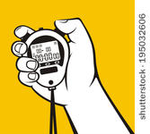This is the same for waves. If we take one peak of a wave and time how long it takes to travel a certain distance we can find the speed of the wave. Try this for the WAVES on the ANIMATIONS



1. Adjust the markers so that X and Y are200 mm apart.
2. Time how long it takes for one wave to pass between the two markers.
3. Record this time in your jotter
4. Repeat two more times and take an average of the time it takes to move 200mm
5. Using the equation v=d/t find the speed of the waves.

Now we are going to show that another formula can be used to find the speed to the waves.

1. Pause the wave and use the ruler to measure the wavelength of each wave.
2. Measure more than one wave to check the wavelength.

Now we are going to find the frequency of the wave. Frequency is the number of waves per second. But to time the number of waves per second is too quick

1. Time to find out how long it takes for 10 waves.
2. **10 waves = X seconds** so **10/X= no. of waves per second**, which is the frequency. Find the frequency (number of waves per second).
3. Now take the wavelength of the waves and multiply this by the frequency.
4. Compare this to the wave speed found using v=d/t (they ought to be the same).
5. Repeat for the other two waves.
6. Repeat for the other two waves.

 

**Period T, is the time for one wave Period is measured in seconds**

**Frequency is the number of waves produced per second or passing a point per second. Frequency is measured in Hertz (Hz)**

Think of it like this:



What happens when we multiply these two quantities together?



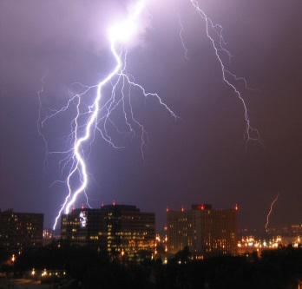We hear thunder after we see lightning because the speed of sound in air is almost a million times slower than the speed of light in air. The thunder and lightning are created at the same time but the light reaches us first.

Sound travels with a speed of around 340 m/s whereas light travels at 300 000 000 (300 million) metres per second in air.

Sound travels at different speed through different materials. It travels fastest through solids because the particles are closer together.

Calculations involving the speed of sound can be carried out using the equation:

d

v

t

$$v=\frac{d}{t}$$

Where: v is speed, measured in metres per second (m/s)

d is distance, measured in metres (m)

t is time, measured in seconds (s)

During a storm, lightning is seen in the distance and the thunder is heard 5 seconds later. How far away was the lightning strike?

d = ?

v = 340 m/s

t = 5 s

d = v t

d = 340 x 5

d =1700 m

# Speed of Sound Questions

1. Find the missing values in the following table:

|  |  |  |  |
| --- | --- | --- | --- |
|  | *Speed* (m/s) | *Distance* (m) | *Time* (s) |
| (*a*) |  | 15 000 | 5 |
| (*b*) |  | 38 | 0·02 |
| (*c*) | 1 500 |  | 0·25 |
| (*d*) | 5 200 |  | 0·01 |
| (*e*) | 340 | 17 |  |
| (*f*) | 330 | 3 465 |  |

2. The speed of sound in tissue is 1500 metres per second. How far would sound travel in tissue in a time of 0·0002 seconds?

3. Sound in jelly can travel a distance of 0·435 metres in a time of 0·000 3 seconds. What is the speed of sound in jelly?

4. How long would it take for sound to travel 0·435 m through air if the speed of sound in air is 340 m/s?

5. The speed of sound in muscle is 1 600 m/s. How far would sound travel in muscle in a time of 0·0005 seconds?

6. Calculate the speed of sound in bone given that it takes 0·00005 s for sound to travel 0·15 m through bone.

7. A boy is standing at a distance of 100 m from a large building. He shouts loudly and hears an echo.

|  |  |
| --- | --- |
| 100 m |  |

How far did the sound travel between leaving the boy and returning to him as an echo?

If the speed of sound in air is 340 m/s, how long did it take for the sound to cover this distance?

An ultrasound pulse is transmitted into an expectant mother’s womb and reflects from the baby. The pulse echo is detected 0·8 milliseconds after being transmitted. The speed of sound through the body tissue and fluid is 1500 m/s.

(*a*) How far does the pulse travel?

(*b*) How far from the transmitter is the baby?

Another pulse is reflected from the foot of the baby. If this reflected pulse is detected 0·15 milliseconds after being transmitted, how far from the transmitter is the baby’s foot?



(1 millisecond = 0.001 seconds = 1 x 10-3 seconds)

7·5 cm

9. During an ultrasound scan, a baby’s forehead is situated 7·5 cm from the transmitter. The ultrasound pulse travelling at 1 500 m/s is reflected from the baby’s forehead.

What is the total distance travelled by the pulse?

What time elapses between the transmission of the pulse and the detection of the pulse echo?

10. An ultrasound pulse is transmitted into the womb of an expectant mother and the pulse echo is detected after a time of 0·38 milliseconds. The pulse was reflected by one of the baby’s knees situated 28·5 cm from the transmitter.

Show that the speed of sound in the womb is 1 500 m/s.

## 

# Speed, Frequency and Wavelength Questions

Speed, frequency and wavelength are linked by the equation:

v

f

λ

1. Find the missing values in the following table:

|  |  |  |  |
| --- | --- | --- | --- |
|  | ***Speed* (m/s)** | ***Frequency* (Hz)** | ***Wavelength* (m)** |
| **(*a*)** |  | **7 000 000** | **0·000 5** |
| **(*b*)** |  | **80 000** | **0·02** |
| **(*c*)** | **1 360** | **6 800 000** |  |
| **(*d*)** | **330** | **660** |  |
| **(*e*)** | **1 500** |  | **0·002 5** |
| **(*f*)** | **5 200** |  | **1·3** |

|  |
| --- |
| *Helpful Hint*  1 kHz = 1 000 Hz = 1 x 103 Hz  1 MHz = 1 000 000 Hz = 1 x 106 Hz |

*Helpful Hint*

Remember: for waves you can also use the equation:

2. Calculate the wavelength of sound with frequency 1 000 Hz which is passing through carbon dioxide gas. (Speed of sound in carbon dioxide = 270 m/s.)

3. What is the speed of ultrasound in Glycerol given that a 40 kHz ultrasound pulse has a wavelength of 4·75 cm in Glycerol?

4. An 8 MHz ultrasound pulse is transmitted into water. It has a wavelength of 0.000187 m in water. Calculate its speed.

5. A buzzer emitting sound of frequency 12 kHz is switched on. What is the wavelength of the sound waves in air where the speed of sound is 340 m/s?

6. An ultrasound pulse of frequency 7.0 MHz is transmitted through 8 cm of muscle. The wavelength of the ultrasound in muscle is 2·29 x 10-4 m.

Calculate the speed of sound in muscle.

Calculate the time taken for the ultrasound to pass through the muscle.

7. Sound waves of frequency 4 kHz travel along a 2·6 m length of aluminium in a time of 0·5 milliseconds.

(*a*) What is the speed of sound in aluminium?

(*b*) Calculate the wavelength of this sound in aluminium.

8. An ultrasound pulse, of wavelength 3·75 x 10-4 m, is transmitted into the womb of an expectant mother. It is reflected by the head of her baby and the reflected pulse is detected 0·2 ms after transmission. The baby’s head is positioned 15 cm from the transmitter / detector.

(*a*) Show that the speed of ultrasound is 1 500 m/s inside the woman.

(*b*) What frequency of ultrasound was used?

Lesson 2 – Speed, Frequency and Wavelength

Learning Intention: At the end of this lesson, I will be able to carry out calculations involving speed, frequency and wavelength of sound waves.

Properties of Sound Waves

We can use an oscilloscope to help us see sound waves.

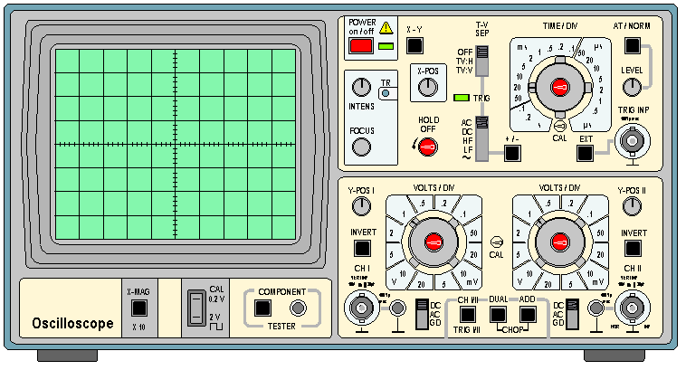

A sound wave looks like this:

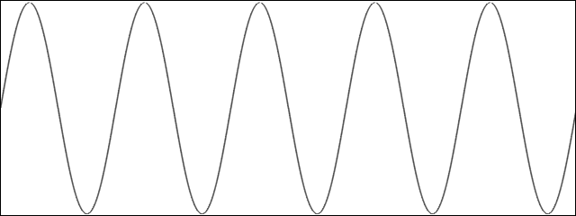

The amplitude of a wave is the distance from the axis to the crest of a wave. Amplitude is measured in metres (m).

The frequency of a sound wave is the number of waves that are produced every second. The closer together (or more bunched up) the waves are, the higher the frequency is. Frequency has the symbol, f, and is measured in hertz (Hz).

Wavelength is the distance from the crest of one wave to the crest of the next. Wavelength has the symbol, λ (lambda), and is measured in metres (m).

The speed of a wave is the distance that a wave travels in a certain time. Speed has the symbol, v, and is measured in metres per second (m/s).

Speed, frequency and wavelength are linked by the equation:

v

f

λ

$$v=fλ$$

What is the frequency of a sound wave travelling through air with a wavelength of 10cm?

f = ?

v = 340 m/s

λ = 10 cm = 0.1 m

= 5 s

$$f=\frac{v}{λ}$$

$$f=\frac{340}{0.1}$$

= **3400 Hz**