

**Physics**

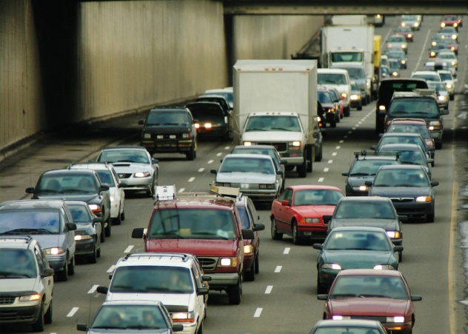

Dynamics and Space

1.1 Dynamics

Name_______________ Class ____

**SCN 4-07a**

I can use appropriate methods to measure, calculate and display graphically the speed of an object, and show how these methods can be used in a selected application.

**SCN 4-20a**

I have researched new developments in science and can explain how their current or future applications might impact on modern life.

**SCN 4-20b**

Having selected scientific themes of topical interest, I can critically analyse the issues, and use relevant information to develop an informed argument.

**Content National 4**

**Speed and acceleration**

* Calculations involving the relationship between speed, distance, and time.
* Determination of average and instantaneous speed.
* Interpretation of speed-time graphs to describe motion including calculation of distance (for objects which are speeding up, slowing down, stationary and moving with constant speed.)Motion in one direction only.
* Use of relationship of acceleration, change in speed and time.

**Content National 5**

**Velocity and displacement — Vectors and scalars**

* Vector and scalar quantities: force, speed, velocity, distance, displacement, acceleration, mass, time and energy.
* Calculation of the resultant of two vector quantities in one dimension or at right angles.
* Determination of displacement and/or distance using scale diagram or calculation.
* Use of appropriate relationships to calculate velocity in one dimension

**Velocity–time graphs**

* Velocity–time graphs for objects from recorded or experimental data.
* Interpretation of velocity–time graph to describe the motion of an object.
* Displacement from a velocity–time graph.

**Acceleration**

* Acceleration of a vehicle between two points using appropriate relationships with initial and final velocity and time of change.
* Acceleration from a velocity–time graph.

At National 4 level, by the end of this section you should be able to:

❑ 1. Carry out calculations using the relationship between speed, distance and time.

❑ 2. Determine average speed

* Describe an experimental method for measuring an average speed

❑ 3. Determine instantaneous speed

* Describe an experimental method for measuring an instantaneous speed.

❑ 4. Interpret speed – time graphs

* Describe motion of objects;

- speeding up

- slowing down

- travelling at constant speed

- when stationary

* Draw speed – time graphs representing the above motions
* Calculate distance travelled from a speed – time graph.

Speed = Distance v = speed (m/s)

Time d = distance (m)

t = time (s)

$v= \frac{d}{t}$

**Example 2**

What is the speed of a car which travels 6 kilometres in 4 minutes?

v = d = 6000=25 m/s

t 240

**Example 1**

What is the speed of a car that travels 2880m in 60 seconds?

v = d = 2880 = 48m/s

t 6

**Example 4**

How far does a car travelling at 25m/s travel in 30 minutes?

d = v x t

= 25 x 30 x 60

= 45,000m

**Example 3**

How long does it take to travel 7125m at 75m/s?

t = d= 7125 = 95s

v 75

Average speed is the **total** distance divided by the **total** time.

speed = distance $\overline{\text{v }}=\frac{d}{t}$ $\overline{\text{v}}$ = average speed (m/s)

time d = distance (m)

t = time (s)

# Average Speed using Light Gates

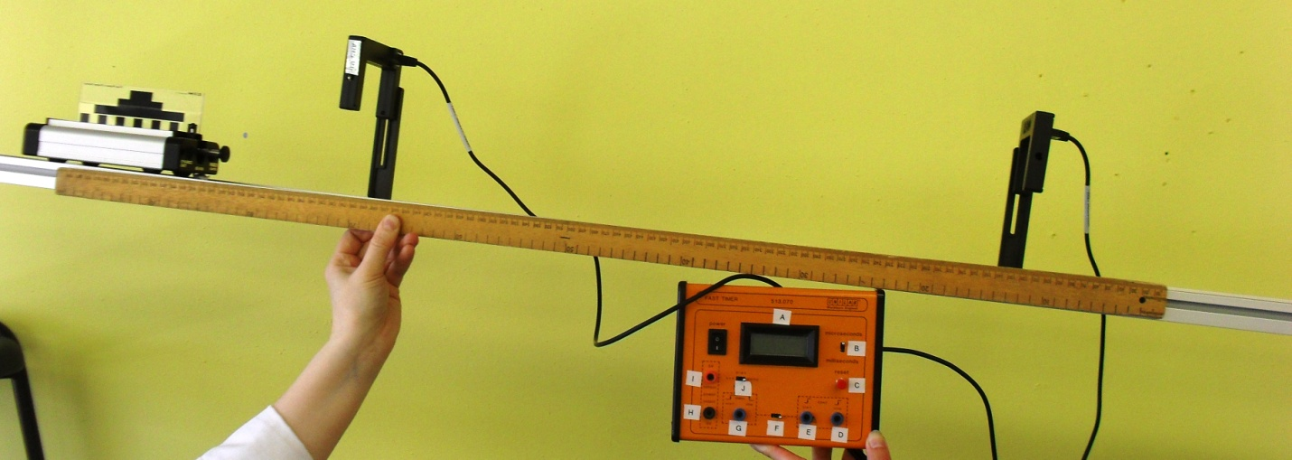

Label light gates, trolley, mask, ruler/metre stick, timer and ramp

Timer starts when the mask on the trolley cuts the first light gate and stops when it cuts the second light gate.

Measure the distance between the light gates using the metre stick.

Speed of trolley = distance between light gates

Time on timer

Could be used to measure the speed of a car passing between lamp-posts or past a fence.

*Remember to stress that light gates on their own are no use – the*

Instantaneous speed is the speed calculated using a **short** distance or **short** time interval.

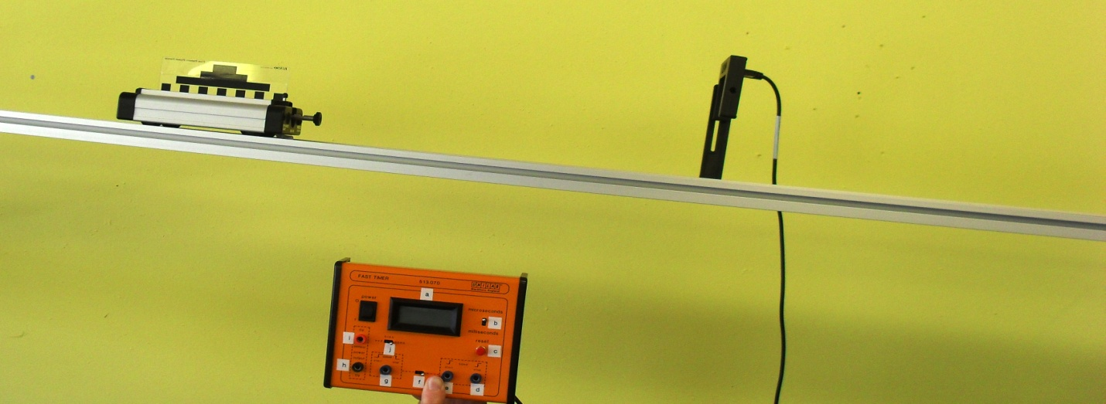

Label light gate, timer, trolley, mask, runway, ramp – diagram should also have a ruler in it.

The trolley runs down the slope. When the mask passes through the light gate the timer records the time the light beam is interrupted for.

The length of the mask is measured using a ruler.

Instantaneous speed = length of mask

Time on timer

Speed time graphs can help to describe the motion of an object.

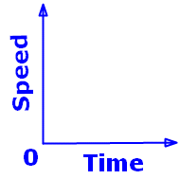  

Constant speed increasing speed decreasing speed

Time is always shown on the x-axis.

###### DISTANCE = AREA UNDER A SPEED TIME GRAPH

**Example 5** Distance = area under graph

= 5 x 10

= 50m

0

time (s)

Speed

(m/s)

5

10

**Example 6** Distance = area under graph

= ½ x 5 x 10

= 25m

0

time (s)

Speed

( m/s)

5

10

6

10

5

Speed

(m/s)

time (s)

0

**Example 7** Distance = area under graph

= Area 1 + Area 2

= [ ½ x 5 x 6] + [ 4 x 5]

= 15 + 20

= 35m

###### Example 8

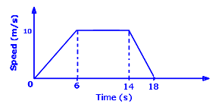

Calculate the total distance travelled.

Distance travelled = area under speed time graph

= [1/2 x 10 x 6] + [8 x 10] + [1/2 x 4 x 10]

= 30 + 80 + 20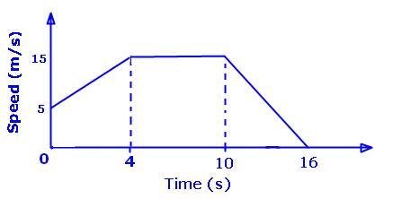

= 130m

Calculate

1. The distance travelled
2. The average speed
3. Distance travelled = area under speed time graph

= [4 x 5] + [1/2 x 4 x 10] + [6 x 15] + [1/2 x 6 x 15]

= 20 + 20 + 90 + 45

= 175m

1. Average speed = distance/time

= 175 /16

= 10.9 m/s

### At National 5 level, by the end of this section you should be able to:

Velocity and displacement

🔾 1. Define and classify the vector and scalar quantities; force, speed, velocity, distance, displacement, acceleration, mass, time and energy.

🔾 2. Calculate the resultant of two vector quantities in one dimension or at right angles

- using scale drawings

- using calculations

🔾 3. Determine displacement and/or distance

- using scale drawings

- using calculations

🔾 4. Use of the appropriate relationship to calculate velocity in one dimension.

Velocity – time graphs

🔾 5. Draw velocity – time graphs for objects using recorded or experimental data.

🔾 6. Describe the motion of an object from a velocity – time graph.

🔾 7. Calculate the displacement of an object from a velocity – time graph.

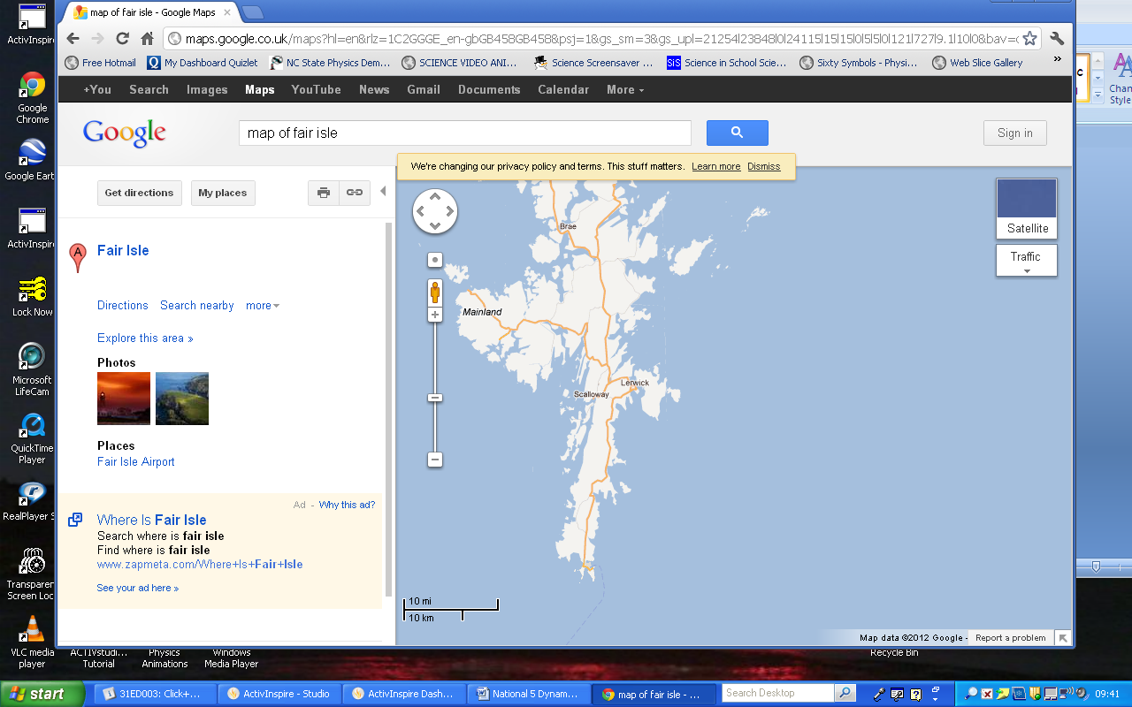

Distance just tells you how far away you are from a certain point

Lerwick -> Scalloway = 6538m

Scalloway -> Lerwick = 6538m.

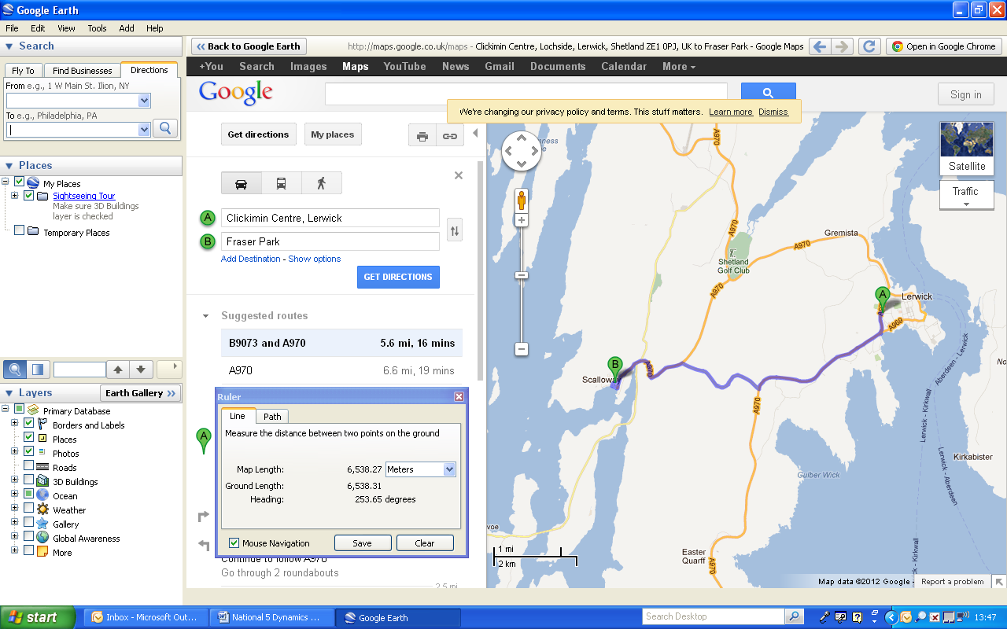

Displacement tells you how far away you are at a certain angle.

Lerwick -> Scalloway = 6538m at 254⁰

Scalloway -> Lerwick = 6538m at 084⁰



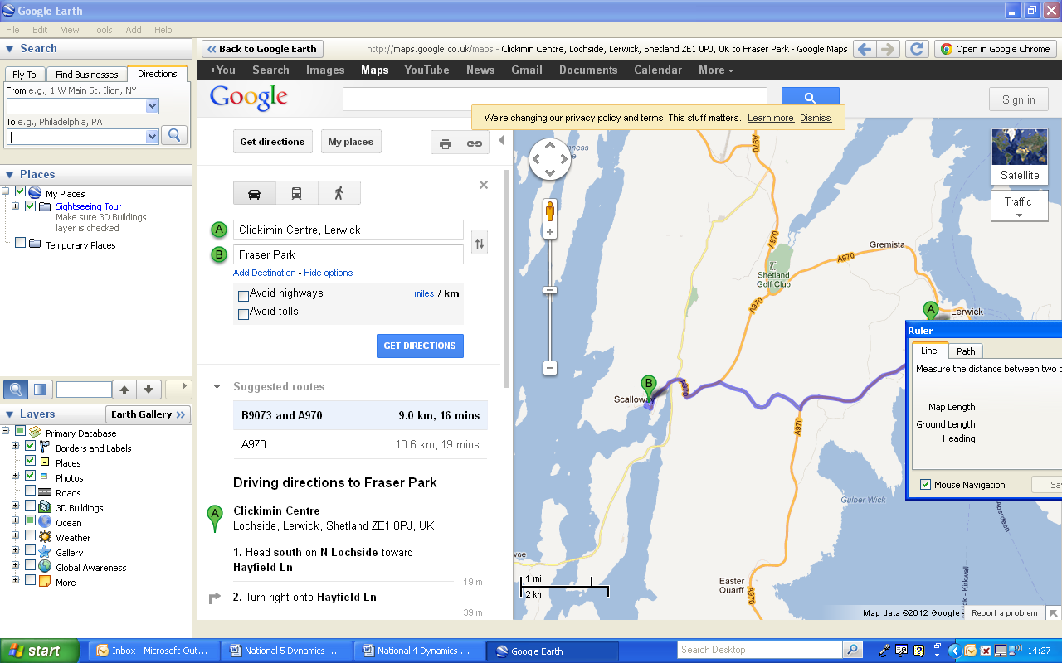

Distance is a scalar quantity because it only has a magnitude (size).

Displacement is a vector quantity because it has magnitude **and** direction.

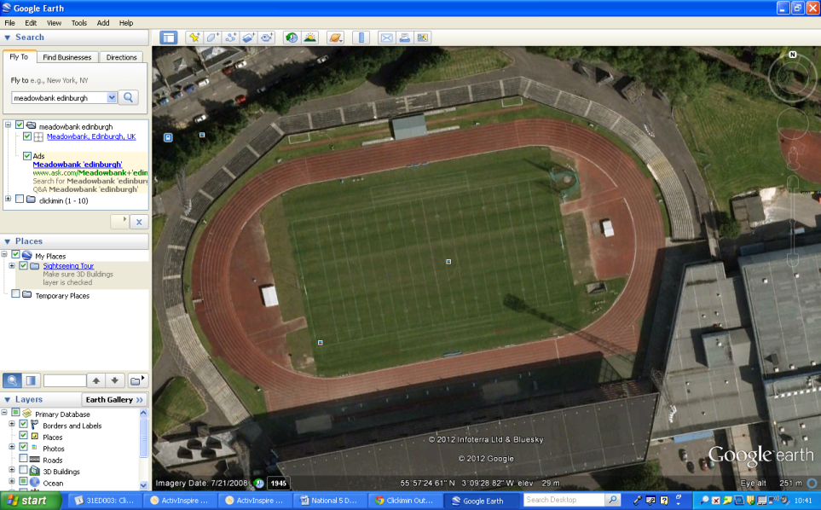

One complete lap of a running track has a distance of 400m.

Your displacement is 0 because you have ended up where you started.

Direction can be given in two ways – using a compass to give headings or using three figure bearings.

If you use a compass heading it is important to remember that a heading has an exact size, so you can’t use a rough heading.

.

N (000)

NW (315)

NE (045)

E (090)

S (180)

SE (135)

SW (225)

W (270)

[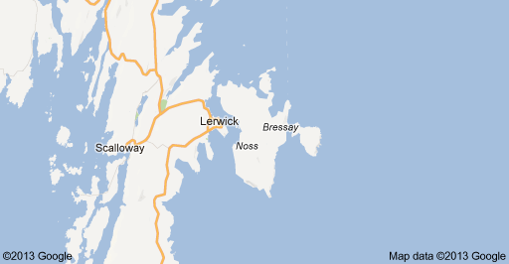](http://maps.google.co.uk/maps?rls=com.microsoft:en-gb:IE-SearchBox&oe=UTF-8&rlz=1I7ADSA_enGB408&safe=active&redir_esc=&q=google+map+bressay&um=1&ie=UTF-8&hq=&hnear=0x489e8a454fc560f1:0x6444d9e0f6c84262,Bressay&gl=uk&sa=X&ei=fBdDUaGkM_DZ0QWQpYGgDA&ved=0CDAQ8gEwAA)

The coastguard receive a Mayday call from a vessel which describes its position as being 15km on a bearing of 230⁰ from Lerwick. The Hrossey is 2km South of Lerwick. Should she head towards the vessel in distress? If not, why not?

No. The vessel in distress is on the other side of the Mainland. The Hrossey would need to go round Sumburgh Head first – a very long journey. Better to send the Coastguard helicopter and possibly the Aith lifeboat!

**Definition**

A **vector** quantity has magnitude and direction.

e.g. displacement

A **scalar** quantity has magnitude only.

e.g. distance

|  |  |
| --- | --- |
| **Scalar** | **Vector** |
| Speed | Velocity |
| Distance | Displacement |
| Time | Force |
| Energy | Acceleration |
| Mass |  |

**Example 10**

A dog walks 2m E followed by 0.5m E. What is it’s displacement? (Scale = 2cm = 1m)

2.5 m East

**Example 11**

A cat walks 2m W followed by 0.5m E. What is its displacement? (Scale = 2cm = 1m)





1.5m West

**Example 12**

(Scale 1 cm = 1m)

A person walks 4m East followed by 3m South. What is their displacement from the starting point?

Use scale drawing – 5m at an angle of 127⁰

**Example 13**

A person walks 12m East followed by 5m North. What is their displacement from the starting point?

12m at 067⁰

(Scale 1cm = 1m)

Velocity measured in metres per second at heading (m/s)

velocity = displacement displacement measured in metres at heading (m)

time time measured in seconds (s)

Velocity is a vector quantity because we use displacement to calculate it. It needs **both** magnitude (size) and direction to describe it.

**Example 15**

A car travels 8m E along a road, then has to reverse 3m to let the ambulance past. This takes 10s.

What was the velocity?

Scale 1cm =2m

velocity = displacement

time

= 5/10

= 0.5 m/s due East.

**Example 14**

A car travels 10m due S, stops at traffic lights then carries on for another 10m. This takes 5s.

What was the velocity?

Scale 1cm = 10m

velocity = displacement

time

= 20/5

= 4 m/s due South.

**Example 16**

A cyclist completes a 400m circuit of a track in a velodrome in 50s. What is their velocity? (Think very carefully!!)

velocity = displacement = 0 = 0m/s

time 50

**Example 19**

A car travels 400m S then 400m W.

This takes 20s. What is its velocity?

Scale 1cm = 100m



velocity = displacement

time

= 566/20

= 2.8m/s at 225⁰.(SW)

**Example 18**

A car travels 40m E, followed by

30m N. This takes 10s. What is its velocity?

Scale 1cm = 10m



velocity = displacement

time

= 50/10

= 5 m/s at 037⁰.

**Example 17**

A plane flies South at 100m/s, but the wind blows at 30m/s East. What is the plane’s velocity?

Scale 1cm = 10m/s

velocity = displacement

time

= 104/1

= 104 m/s at 199⁰

Increasing velocity

Constant acceleration

0

t s

0

t

v

0

t

v

(m/s)

Constant velocity

(m/s)

(s)

(s)

v

Decreasing velocity.

This would be like a ball being thrown into the air.

The ball leaves my hand at A.

At B the ball has reached its highest point.

At C the ball has dropped down again – note the velocity is increasing but the direction has changed.

A

(m/s)

B

(s)

t

0

C

Increasing velocity.

This would be like a ball being dropped onto the floor.

The ball leaves my hand at 0.

At A the ball has reached the floor.

Between A and B the ball squashes and unsquashes.

At B the ball starts to travel upwards again, slowing down as it travels.

This is an ideal version.

B

v

(m/s)

C

A

(s)

L

v

0

t

A

B

C

E

G

I

K

D

F

H

J

(m/s)

(s)

This is more like an actual bouncing ball.

0A – the ball leaves your hand and falls to the floor.

AB – the ball compresses

BC – the ball goes back to its original shape

CD – the ball rises, but it has lost energy so it doesn’t rise to the same height

DE – the ball falls again and the cycle repeats.

Each time the ball loses energy, so the bounces lose height.

Which direction have we chosen as positive this time?

**Displacement** = Area under a **velocity-time** graph

(in the same way that Distance = Area under a speed-time graph)

**Example 20**

Displacement = area under graph

= ½ x 20 x 6

= 60m

v (m/s)

0

t (s)

6

20

**Example 21**

Displacement = area under graph

= [½ x 10 x 8] + [½ x -10 x 8]

= 40 + (-40)

= 0m

v (m/s)

0

t (s)

16

8

-10

10

### At National 4 level, by the end of this section you should be able to:

❑ 1. Calculate acceleration using the relationship between change in speed and time of change.

### Additionally, at National 5 level

🔾 2. Calculate the acceleration between two points using the relationship between initial and final velocity and time of change.

🔾 3. Calculate acceleration from a velocity – time graph.

time

Acceleration = change in velocity a = acceleration in metres per second squared(m/s2)

Δv = change in velocity (m/s)

t = time (s)

0 15 time (s)

80

20

v (m/s)

**Example 23**

0 5 time (s)

20

v (m/s)

**Example 22**

a = Δv = 20 = 4 m/s2  a = Δv = 80-20 = 4 m/s2

t 5 t 5

This means the velocity

increases by 4 m/s

every second.

.**Example 24**



The **acceleration** is**-2m/s2**.

When an object slows down we call this **negative** acceleration

a = Δv = -10= -2m/s2

t 5

10

5

**Example 25**

a = Δv = -15= -3m/s2

t 5

7

22

v

t

0

5

To make it easier the two velocities are named.

u = initial velocity (22m/s)

v = final velocity (5m/s)

This gives us a new equation a = v-u

t

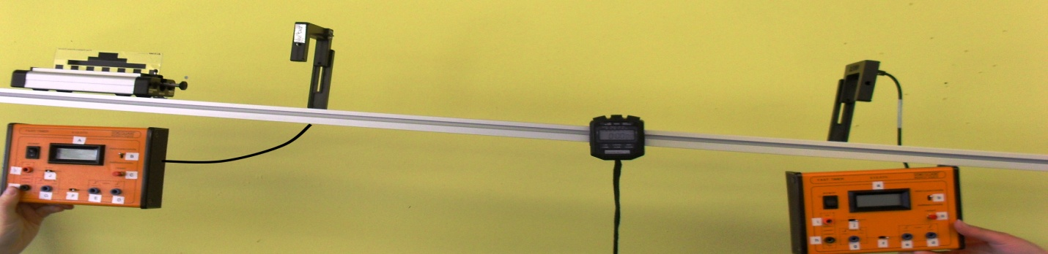

*Label – runway, trolley, mask, light gate 1+ timer, light gate 2 + timer, stopwatch*

The trolley runs down the slope. When the mask cuts the first light gate the time is recorded on the timer. We can calculate the initial speed using

speed = length of mask. The final speed is calculated in the same way using the

Time on timer second light gate. The time between light gates is

recorded on the stopwatch.

These values can be used to calculate acceleration using a = v –u

t

v = final velocity

u = initial velocity

a = acceleration

t = time

a = v-u

t

**Example 26**

A car accelerates from 20m/s to 80m/s in 12 seconds. Calculate the acceleration.

a = v-u = 80 – 20 = 60 =5m/s2

t 12 12

**Example 27**

An object travelling at 80m/s suddenly comes to a stop in 2 seconds Calculate the deceleration.

a = v-u = 0 – 80 = -80 = -40m/s2

t 2 2

**Example 28**

A trolley starts at rest and speeds up at 4m/s2 for 6 seconds.

Calculate the final speed.

a = v-u ⇒ 4 = v – 0 ⇒ v = 4 x 6 = 24m/s

t 6

**Example 29**

A car travelling at 5m/s accelerates at 3m/s2 for 4s. What is its final speed?

a = v-u ⇒ 3 = v – 5 ⇒ 3x 4 = v - 5 ⇒v = 12 + 5 = 17m/s

t 4

# Acceleration due to Gravity

When an object is dropped it falls towards the centre of the Earth.

As it falls it’s velocity increases – this is called the acceleration due to gravity, usually given the symbol ‘g’.

On Earth g = 10m/s2.

**Example 30**

A stone is dropped off the edge of a cliff. It takes 6 seconds to hit the ground. What speed does it hit the ground at?

a = v-u ⇒ 10 = v – 0 ⇒ v = 6 x 10 = 60m/s

t 6