

**Physics**



Dynamics and Space

1.2 Forces

Name_______________ Class ____

**SCN 4-07b**

By making accurate measurements of speed and acceleration, I can relate the motion of an object to the forces acting on it and apply this knowledge to transport safety.

**SCN 4-16a**

I have carried out research into novel materials and can begin to explain the scientific basis of their properties and discuss the possible impacts they may have on society.

**SCN 4-20a**

I have researched new developments in science and can explain how their current or future applications might impact on modern life.

**SCN 4-20b**

Having selected scientific themes of topical interest, I can critically analyse the issues, and use relevant information to develop an informed argument.

**Content National 4**

**Relationship between forces, motion and energy**

* The use of Newton’s first law and balanced forces to explain constant speed, making reference to frictional forces.
* The use of Newton’s second law to explain the movement of objects in situations involving constant acceleration.
* Calculations using the relationship between force, mass and acceleration in situations where only one force is acting.
* Calculations using the relationship between weight, mass and gravitational field strength within our solar system.
* Risks and benefits associated with space exploration including challenges of re-entry to a planet’s atmosphere.
* The use of thermal protection systems to protect spacecraft on re-entry.

**Content National 5**

**Newton’s laws**

* Applications of Newton’s laws and balanced forces to explain constant velocity, making reference to frictional forces.
* Calculations involving the relationship between unbalanced force, mass and acceleration for situations where more than one force is acting.
* Calculations involving the relationship between work done, unbalanced force and distance/displacement.
* Calculations involving the relationship between weight, mass and gravitational field strength during interplanetary rocket flight.
* Newton’s second law and its application to space travel, including rocket launch and landing.
* Newton’s third law and its application to explain motion resulting from a ‘reaction’ force.
* Use of Newton’s laws to explain free-fall and terminal velocity

**Projectile motion**

* Explanation of projectile motion.
* Calculations of projectile motion from a horizontal launch using appropriate relationships and graphs.
* Explanation of satellite orbits in terms of projectile motion.

**At National 4 level, by the end of this section you should be able to:**

Relationship between forces, motion and energy

❑ 1. Use Newton’s first law and balanced forces to explain constant speed, making references to frictional forces.

❑ 2. Use Newton’s second law to explain the movement of objects in situations involving constant acceleration.

* Make and use accurate measurements of speed and acceleration to relate the motion of an object to the forces acting on it and apply this knowledge to transport safety.

❑ 3. Carry out calculations involving the relationship between force, mass and acceleration in situations where only one force is acting.

❑ 4. Carry out calculations involving the relationship between weight, mass and gravitational field strength within our solar system.

❑ 5. List the risks and benefits associated with space exploration and challenges of re-entry to a planet’s atmosphere.

❑ 6. Describe the use of thermal protection systems to protect spacecraft on re-entry.

**Additionally, at National 5 level:**

Newton’s Laws

🔾 7. Apply Newton’s laws and balanced forces to explain constant velocities, making references to frictional forces.

🔾 8. Carry out calculations involving the relationship between unbalanced force, mass and acceleration in situations where more than one force is acting.

🔾 9. Carry out calculations involving the relationship between work done, unbalanced force and distance/displacement.

🔾 10. Carry out calculations involving the relationship between weight, mass and gravitational field strength during interplanetary rocket flight.

🔾 11. Apply Newton’s second law to space travel, including rocket launch and landing.

🔾 12. Apply Newton’s third law to explain motion resulting from a ‘reaction’ force.

🔾 13. Use Newton’s third law to explain free-fall and terminal velocity.

.

Forces can do three things to an object.

Change the –

1.

2.

3.

# Measuring Force

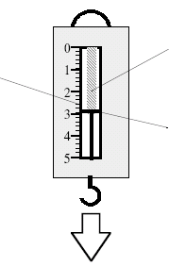





# Balanced Forces on the Move



# C:\Documents and Settings\nancyhunter\Local Settings\Temporary Internet Files\Content.IE5\CR28S5NJ\MC900320932[1].wmfC:\Documents and Settings\nancyhunter\Local Settings\Temporary Internet Files\Content.IE5\ETDZV2HM\MC900318354[1].wmfC:\Documents and Settings\nancyhunter\Local Settings\Temporary Internet Files\Content.IE5\NR5E1W91\MC900383858[1].wmfC:\Documents and Settings\nancyhunter\Local Settings\Temporary Internet Files\Content.IE5\ETDZV2HM\MC900326676[1].wmf

# Seatbelts

# Friction

Definition –

INCREASING FRICTION DECREASING FRICTION

**Example 1**

Calculate the unbalanced force needed

to accelerate a bike of mass 60kg at a

rate of 4m/s2.

**Example 2**

Calculate the acceleration caused by a force of 300N acting on a 25kg mass.

**Example 4**

A boy pushes his sister downhill on her sledge with a force of 150N. The combined mass of the girl and sledge is 40kg. What is her acceleration?

**Example 3**

An object accelerates at 15m/s2 when a force of 900N is applied. What was its mass?

C:\Documents and Settings\nancyhunter\Local Settings\Temporary Internet Files\Content.IE5\EOETE3UC\MC900056961[1].wmf

In a tug-o-war the two sides each exert a force.

**Example 5**

A dog out for a walk sees a cat and tries to chase after it. It exerts a force of 75N forwards on the lead. If the child holding the lead can exert a force of 65N backwards – what will happen?

**Example 8**

A boat engine is able to apply a force of 6000N. The boat has a mass of 500kg and accelerates at a rate of 10m/s2.

1. Calculate the size of the frictional force acting on the boat.
2. What will happen to this force if the barnacles grow on the hull over the summer

**Example 7**

A car has an engine force of 5000N. Each of the four tyres has a frictional force of 50N with the road.

If the mass of the car is 1200kg, what is the acceleration?

**Example 6**

A motorbike of mass 800kg has an

engine force of 12,000N.

The frictional force is 2000N.

What is the acceleration of the bike?

**Example 9**

A boat tows a barge with a force of 800N South. The tide exerts a force of 600N East. What is the effect of these forces on the barge?

Gravity is



Gravititational Field Strength

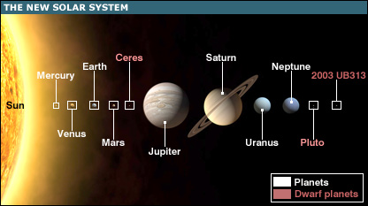

**Example 11**

What is the mass of an object which has a weight of 7200N on Earth.

**Example 10**

What is the weight of a person with a mass of 65kg (on Earth)

**Example 12**

Find the weight and mass of a 75kg spaceman on

1. Moon
2. Mars

|  |  |
| --- | --- |
| **Planet/Moon** | **‘g’ (N/kg)** |
| Mercury | 4 |
| Venus | 9 |
| Earth | 10 |
| Mars | 4 |
| Jupiter | 25 |
| Saturn | 10 |
| Uranus | 10 |
| Neptune | 12 |
| Moon | 1.6 |

**Example 16**

How far can a football team tow a truck using a force of 1500N if their available energy is 22,500J ?

**Example 15**

A winch uses 750J of energy pulling a car 6m out of a ditch. What force is exerted on the car?

**Example 14**

A battery powered model car has a motor which exerts a force of 1.5N over a distance of 25m.

How much work does the motor do?

**Example 13**

A cyclist exerts a force of 200N when riding a bike a distance of 60m.

How much work has she done?

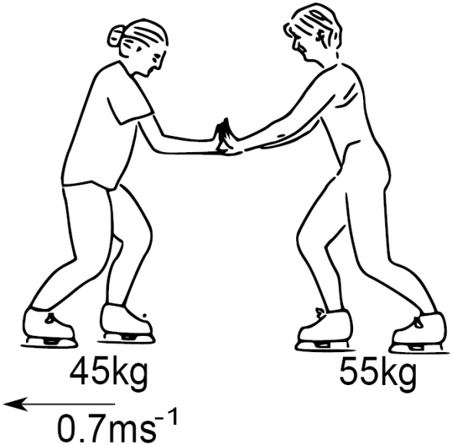

C:\Documents and Settings\nancyhunter\Local Settings\Temporary Internet Files\Content.IE5\8NCHQ1SJ\MC900332876[1].WMF

*[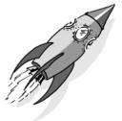](http://www.picsearch.com/imageDetail.cgi?id=ZWtBfg6bLGGzJitDWnDf-XUMAl9l9UX8wI6xVrv1NMo&width=1259&start=91&q=Rocket)*

Example 17

After lift off a spacecraft of mass 6000kg applies its thruster rockets with a combined thrust of 480000N. What is the acceleration of the rocket?

*[](http://www.picsearch.com/imageDetail.cgi?id=ZWtBfg6bLGGzJitDWnDf-XUMAl9l9UX8wI6xVrv1NMo&width=1259&start=91&q=Rocket)*

Example 18

Explain why a rocket motor does not need to be kept on all the time while the rocket is moving far away from any planets.

What would happen to a rocket in space if the rocket motor was fired?

**At National 5 level, by the end of this section you should be able to:**

Projectile motion

🔾 1. Explain projectile motion.

🔾 2. Calculate projectile motion from a horizontal launch using appropriate relationships and graphs.

🔾 3. Explain satellite orbits in terms of projectile motion.

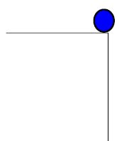



Example 19



A helicopter flying at 40m/s releases an aid package. It takes 3s to hit the ground.

Calculate:

1. The horizontal speed when the package hits the ground
2. The horizontal distance travelled
3. The initial vertical speed
4. The final vertical speed when it hits the ground.
5. The height of the helicopter when it released the package.