**Science** **Department**

National 5 Physics

Open Ended Questions Booklet

# **Strategy for Solving Open-Ended Questions.**

Experience has shown that students generally find solving open-ended questions more difficult than the more familiar type of problem requiring a quantitative solution.

The problem-definition phase of the problem solving is the part likely to cause most difficulty and will therefore require to be practised by the student.

The following suggested strategy may prove useful to students attempting open-ended questions.

The student should be encouraged to

1. read the question - taking care not to skim read.
2. reread the question.
3. try to understand/define the problem situation and what is asked.
4. visualise the situation.
5. draw a diagram and include any relevant information such as speeds, velocities, forces, vector directions etc.
6. determine and write down
   1. relevant physics principles e.g. conservation of momentum
   2. note area/topic of physics involved in problem e.g. internal resistance of supplies
   3. relationship relevant to variables in the problem.
7. use knowledge of familiar quantities such as body mass, body height, length of running track to create estimated values as required.
8. with the information noted previously solve the problem or do what can be done.

reread the response to see if it makes sense and answers the question.

# Examples

1. LEDs and filament lamps are examples of output devices.

Use your knowledge of physics to explain why LEDs are replacing filament lamps.

1. A box is dropped off from the top of a tall building.

Use your knowledge of physics to comment on what the final velocity of the box would depend on.

1. There are many parts of space that are detected by different types of telescope.

Use your knowledge of physics to describe one telescope that is used in astronomy.

1. A ball rolls off from a table as shown.

ball

table

ball’s trajectory

floor

Use your knowledge of physics to comment on what the ball’s horizontal distance from the edge of the table would and would not depend on.

1. Read this small article taken from a science magazine.

**SPACE TOURISTS ARE GO**

Customers paying $250,000 each are expected to take their seats on Virgin Galactic’s SpaceShipTwo for the trip of a lifetime into sub-orbital space, including six minutes of weightlessness.

Use your knowledge of physics to comment on the above paragraph.

1. A velocity-time graph of skydiver 1 is shown below.

time (s)

0

velocity (ms-1)

40

70

5

A velocity-time graph of skydiver 2 is shown below

time (s)

0

velocity (ms-1)

50

90

2

Use your knowledge of physics to explain how the second skydiver’s velocity-time graph during descent compares with that of the first skydiver.

, starting from his own house. He finishes the 26∙1 mile run but is only 1 mile from his

1. A trolley is at rest on a slope. It is pushed up the slope then released. The velocity–time graph shows the resultant motion of the trolley.



Use your knowledge of physics to comment on the shape of the graph.

1. A class of S4 students launched water-rockets from the playground in their school. The rockets accelerate upwards, but it is noted that the acceleration of the rockets is not constant.

Using your knowledge of physics, comment on why the acceleration of the rockets is not constant.

1. The acceleration of a trolley running down a slope can be measured in two ways.

2– double mask and single light gate connected to a computer set to calculate acceleration

1 – single mask and two light gates connected to a computer set to calculate acceleration

mask

light gate

mask

light gate

The light gates and masks are used to calculate two different velocities of the trolley. These velocities are then used to calculate the acceleration of the trolley.

Using your knowledge of physics, comment on the reliability of the two methods used to calculate the acceleration of the trolley down the slope.

1. This astronaut aboard the International Space Station lets go off a grape of small mass and a melon of large mass

Use your knowledge of physics to **explain** what happens when he lets go of the fruit

1. Two ice hockey players are standing on the ice in their ice hockey skates, and then one pushes the other away.

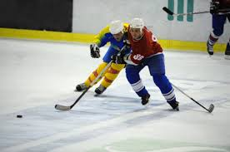

Using your knowledge of physics, comment on the motion of the ice hockey players afterwards.

1. Two people are discussing satellite motion one person says:

**“Satellites stay in motion because there is no gravity”**

Using your knowledge of Physics comment on that response.

1. An astronaut on the international space station was quoted as saying:

**“I sometimes feel like a human cannon ball.”**

Using your knowledge of physics, explain why he may or may not be acting like a cannon ball in space.

1. Recently, one of the first space probes launched by NASA in 1977 has now left our Solar System.

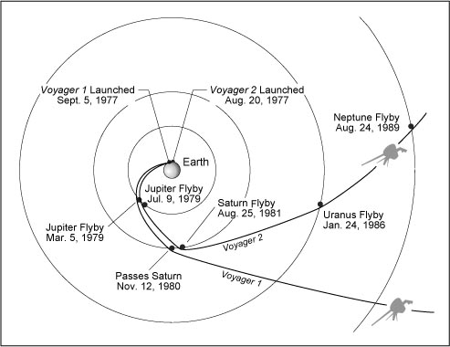

EITHER: Using your knowledge of physics, explain how this space probe was able to reach the outer planets.

OR: Using your knowledge of physics, explain how NASA might **know** that the probe has now left our Solar System.

OR: Using your knowledge of physics, comment on what happens next for this space probe.

1. Using your knowledge of physics explain how satellites are used in society.
2. Telescopes come in all shapes and sizes. Using your knowledge of the electromagnetic spectrum, expand on this statement.
3. Using your knowledge of physics discuss and describe the everyday application of electric charge.
4. Using your knowledge of physics discuss why you think mains electricity is ac rather than dc.
5. What do you think is the most useful ac. or dc.? Support your answer
6. Using your knowledge of physics discuss why you think a charged rod bends a flow of water
7. A student sets up the following circuit to measure the voltage across and the current through a lamp. The student’s results are recorded on the graph shown.

voltage (V)

0

current (A)

Using your knowledge of physics, comment on the shape of the graph the student has produced.

1. A pupil states that a resistor slows down the flow of charge in a circuit. Using your knowledge of physics comment on this statement.
2. A pupil discussing a circuit design mentioned using a bigger resistor. Comment on the word bigger in this context.
3. A pupil says when using ammeters and voltmeters, ammeters are easier to use as they can be placed anywhere in a circuit but care must be taken with the location of voltmeters. Comment on this observation using your knowledge of physics.
4. Using your knowledge of physics explain Ohm’s Law.
5. Using your knowledge of physics explain why a light bulb does not always obey Ohm’s Law.
6. Discuss why Ohm’s Law is not appropriate for a thermistor.
7. Using your knowledge of physics explain the difference between power and energy.

1. Using your knowledge of physics discuss the difference between power and voltage.
2. A flooring technician was puzzled that slate tiles always feel colder than wooden floors but they are both at the same temperature when measured by a thermometer. Comment on this observation.
3. Using your knowledge of physics, design an experiment to demonstrate the difference between temperature and heat.
4. Using your knowledge of physics estimate the pressure exerted on the floor when you stand on two feet, including all assumptions made.
5. Using your knowledge of physics estimate the pressure exerted on the floor by an object of your choice, including all assumptions made.
6. The following wave pattern was created in a physics lab.

Wave direction

Using your knowledge of physics, describe the properties of the wave along the trace and discuss how this wave pattern can be changed.

1. When a girl uses her phone in different parts of the house she notices that she gets different signal strengths.

Using your knowledge of physics, explain the difference in reception quality.

1. A newspaper article quotes a mobile provider as saying, ‘The new 4G transmits a faster signal’. A competitor has come into the debate pointing out that these high frequency signals may not be picked behind buildings.

Using your knowledge of physics, comment on the accuracy of these news reports.

1. Take one part of the electromagnetic spectrum and describe its practical application in society.
2. Different parts of the electromagnetic spectrum have different uses. Using your knowledge of physics, state which part of the spectrum is the most useful and back up your opinion.
3. A physics student sees the colours of the rainbow on his inside wall. Use your knowledge of physics to explain this event.
4. 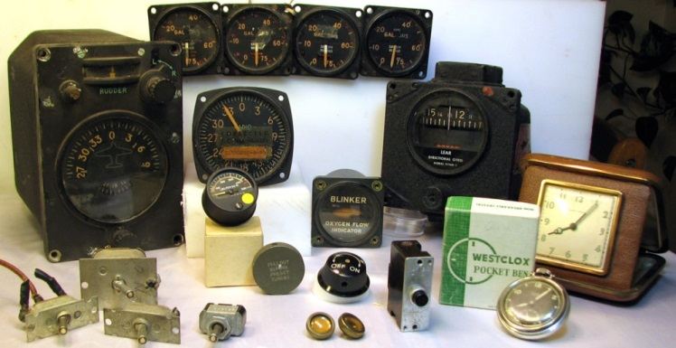Radioactive particles have been discovered on Dalgety Bay beach in Fife. The particles discovered have been traced back to the radium paint that was used on the instrument dials used in World War II aircraft which were dumped in the River Forth in the 1940’s after the aircraft were decommissioned.

Using your knowledge of physics, explain how scientists were able to detect these particles.