H

Higher Assignment
Guide Sheet B: Determining g

Instructions:
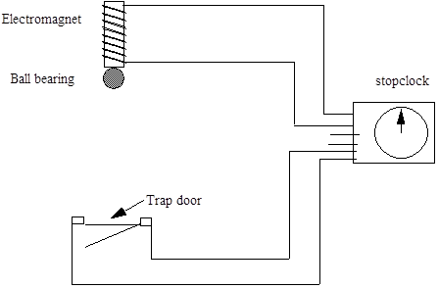

- Set up the apparatus as shown in the diagram. You may need to adjust the distance of fall and the point at which the ball strikes the flap.
- Arrange the timer so that it starts when the electromagnet is switched off and stops when the hinged flap opens.
- Check that the flap does open when the ball strikes it. You may need to make the distance of fall larger, or move the flap so that the ball strikes it further from the hinge.
- Measure the distance h from the bottom of the ball to the hinged flap. Be careful to avoid parallax error in this measurement.
- Change the starting height and repeat the procedure.
- Present your results.

