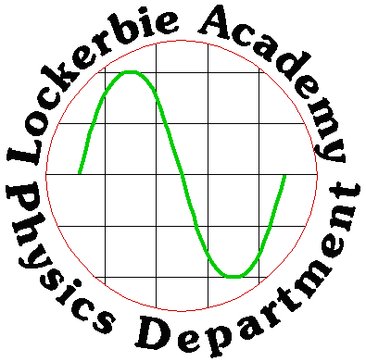

Nat 4 Physics

Electricity & Energy

Nat 4 PHYSICS COURSE
Generating & Distributing
Electricity

J. A. Hargreaves

June 2014

TASK (Deadline October Holidays)- NB part of this work could form your AVU, O1, 2.2 & 2.3

In groups build a model of the Electrical Generation and Transport System from generating electricity to use in houses.

TASK | WHO | Assess

To complete this you will need to learn about each part:
- Generating Electricity
- Research different forms of energy – sound, light, movement (kinetic), stored (potential), chemical, nuclear, elastic, gravitation | T+G
- Research and make notes on different ways of generating electricity for homes and industry for example: | P | AVU
- Nuclear, | G
- Thermal (coal, oil, gas) | G
- hydroelectric | G
- wind, | G
- wave | G
- tidal | G
- pumped storage | G
Also
- microgeneration, | G
- Decide from your research which method of generation you will use for your model (only one eg per class, so you will need to discuss with your teacher as well as your classmates and group) | G+T
- Research energy supply using the website http://www.gridwatch.templar.co.uk/ and demand projections from current data. | P | AVU
- Debate the pros and cons of generating electricity using nuclear fuel. | T + G | AVU
- Debate the risk of generating electricity due to nuclear radiation and other environmental hazards caused by Nuclear Radiation. Find out how the risks are reduced. (Could you show initiative and ask for someone from Chapelcross to speak to us) | T + P | AVU
Homework Research about one nuclear power station accidents, http://en.wikipedia.org/wiki/List_of_nuclear_power_accidents_by_country | P | AVU
- Three Mile Island | P
- Windscale Fire, | P
- Chernobyl, | P
- Fukushima Daiichi nuclear disaster | P
- Carry out investigations into generation of electricity, for example, dynamo, magnet through coil of wire, etc. | T + P | O1 AVU
- Compare input and output power for power stations using different energy sources. http://www.gridwatch.templar.co.uk/ SG Energy Books, textbooks, websites | P | AVU
- Research or investigate the factors affecting the electrical output from a range of sources (solar cells, etc.) | T+P | O1  AVU
- Research the effect of wind speed on wind turbines | P | O1  AVU
- Research microgeneration (eg home-based wind or hydro) | P
- Relationship between electricity and magnetism. | T
- Practical applications of magnets and electromagnets. | T+P | 2.2/2.3  AVU
- Drawing of magnetic fields from permanent magnets using iron filings etc. | T+P
- Magnetic fields of different shapes of electromagnets (solenoid, horseshoe). | T+P
- Examine a range of applications using permanent and electromagnets and justify why each type of magnet is used. | P | O1 2.2/2.3  AVU
- Transporting Electricity
- How electricity is transported to homes via the National Grid, covering transformers, power losses, cables, you will need a knowledge of Current (I) Voltage (V) Power (P) and Energy (E) | T+P
- Research generation and transmission losses. | T
- Discuss the implications of distribution methods — overhead cables versus underground cables. | P
- Model power lines. | T+P
- Using Electricity in the Home
- How electricity is used in your house. Voltage of the mains, frequency, cost of electricity, fuses, wiring etc | T+P
- Hairdryer wiring/car heater blowers, etc. for different heat settings | T+P
- Investigate power rating plates. | P
Possible Assessment
Prepare a plan for a Scottish island to be self-sufficient in electricity from natural resources
Also to cover
Range of applications — relays, bells, loudspeakers, fire door retainers, fail-safe brakes on lifts, Maglev trains, etc.

KEY

T = Teacher required to help

P = Pupil working on their own

G = Groupwork

O1 = outcome 1, a practical experiment and write up

2.2/2.3 A written piece of work covering some application of Physics related to a key area and its effect on Society

AVU= the Value Added Unit that forms a unit for your course award.

You will need to make notes of the work as we go along and think CAREFULLY about your model. Do not rush in to producing this until you have knowledge of each section. PLAN how big it will be, what bits need to be included. Would you be able to get some working parts? If you require special equipment you will need to give us plenty of warning and there will not be much money to provide this.

