Sound revision questions
- How can we measure the speed of sound in air?
- Ten pupils are standing on Calton Hill, looking at Edinburgh Castle. They measure the time difference between seeing the smoke from the one o’clock gun and hearing the bang.
Their measured times were 3.8 s, 4.2 s, 4.0 s, 3.8 s, 4.4 s, 3.8 s, 4.0 s, 4.2 s, 3.6 s and 4.2 s.
- Calculate the average time for the group. (1)
- (b) Calculate the distance from the Castle to Calton Hill, if the speed of sound is 340 ms⁻¹

- What is the speed of sound in air?
- What is the danger level (in decibels) of human hearing?
- Copy and complete the table
Situation | Decibels
Threshold of human hearing | 0
Leaves rustling in the wind
Whisper, rustling paper | 30
Quiet residential area at night | 40
Inside average home
Normal conversation at 1m distance | 60
Phone ringing, busy street | 70
Alarm clock at 0.5 m distance | 80
Threshold of hearing damage
Truck heard from pavement, busy factory | 90
Hair dryer | 100
Lawn mower at a distance of 1m
Rock concert 1m from loudspeaker, vuvuzela horn at a distance of 1m | 120
Jet engine at a distance of 50m | 130
 | 120 - 140
Stun grenade | 180
Theoretical limit for sound travelling through the Earth’s atmosphere | 194
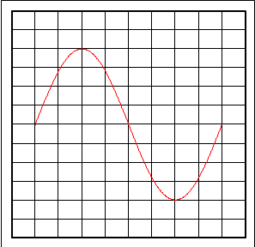
- Look at this diagram of a sound signal pattern displayed on an oscilloscope. Describe in words what would happen to its frequency and amplitude in each of the following situations:

(a) The volume of the sound is increased. (1)
(b) The pitch is increased, but the volume is the s
(c) The pitch is decreased and the volume is decreased.

- How can we protect our hearing?
- What are some uses of sonar?
- What are some uses of ultrasound?

