Wave characteristics revision questions

- Explain, using diagrams, the difference between a transverse and a longitudinal wave (2)

- Give an example of:
a) a transverse wave
and b) a longitudinal wave. (1)
- Draw a copy of this wave in your jotter and label: wavelength, peak, trough, amplitude

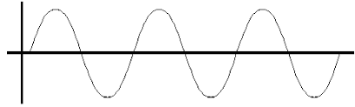
- The questions below refer to this diagram.
12 m
2 m

(a) From the diagram calculate the wavelength of the waves shown. (1)
(b) What is the amplitude of these waves?
- A wave travels 90 m in 30 s. Calculate the speed of the wave.
- A wave has a wavelength of 0.5 m and a frequency of 4 Hz. What is its speed?

- What is frequency?
- What are the units for frequency?
- 12 waves pass a point in 3 seconds. What is the frequency of the wave?

