N4 Waves and Radiation Homework

**2018**

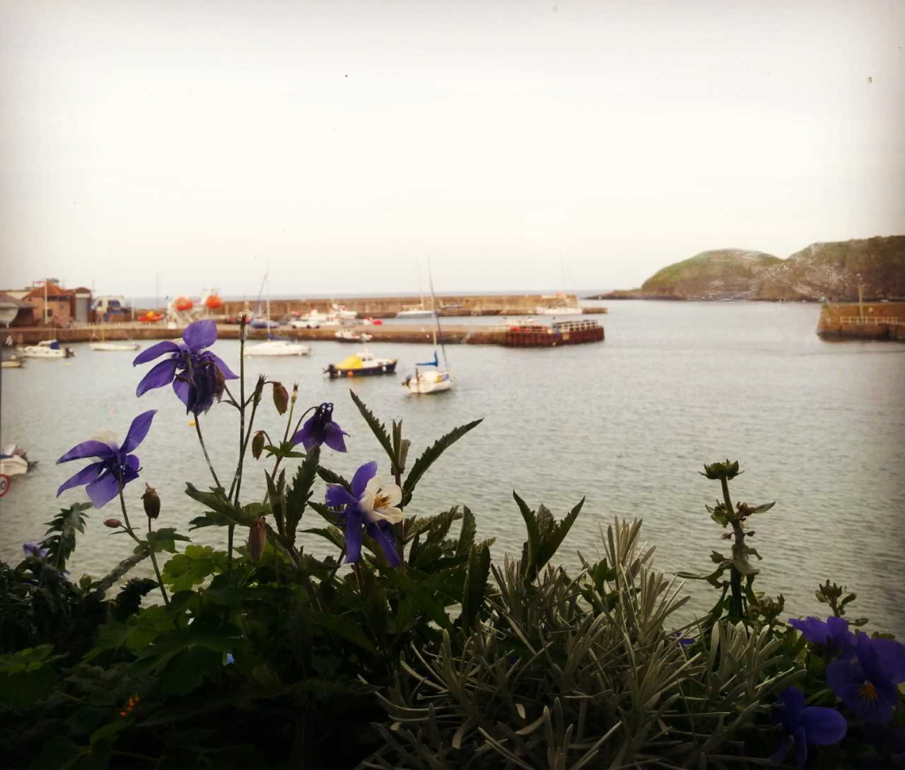

# Wave characteristics

1. What do waves transfer from place to place?

2. Waves can be divided into two groups – what are they called?

1.

2.

What is the difference between the two groups of waves?

Name one example from each group of waves.

3. What is meant by the term “frequency?

Complete the box

|  |  |  |  |
| --- | --- | --- | --- |
| Quantity | Symbol | Unit | Symbol |
| Frequency |  |  |  |

4. What is meant by the’amplitude’ of a wave?

|  |  |  |  |
| --- | --- | --- | --- |
| Quantity | Symbol | Unit | Symbol |
| amplitude |  |  |  |

Complete the box

5. What is meant by the “wavelength” of a wave?

Complete the box

|  |  |  |  |
| --- | --- | --- | --- |
| Quantity | Symbol | Unit | Symbol |
| wavelength |  |  |  |

6. Write down the equation that links speed, distance and time.

÷

x

Complete the table

|  |  |  |  |
| --- | --- | --- | --- |
| Quantity | Symbol | Unit | Symbol |
| Speed |  |  |  |
|  |  |  | m |
|  | t |  |  |

A wave travels 25 m in 10 s. Calculate its speed.

A wave travels at 12 m/s for 3 s. How far did it travel?

A wave travelling at 8 m/s covers a distance of 64 m. How long did it take?

7. Write down the equation that links frequency, velocity and wavelength

x

÷

Complete the table

|  |  |  |  |
| --- | --- | --- | --- |
| Quantity | Symbol | Unit | Symbol |
|  |  | metres per second |  |
|  | λ |  |  |
|  |  |  | Hz |

8. A wave has a frequency of 12 Hz and a wavelength of 4 m. Calculate its speed

9. A wave travelling at a speed of 36 m/s has a wavelength of 9m. Calculate its frequency

10. A wave travelling at 21 m/s has a frequency of 3Hz. Calculate its wavelength

# Sound

1. How is the pitch of a note related to the frequency of a note?

How is the volume of a note related to the amplitude of a note?

This is note A. Compare each wave below with this wave and decide how (or if) their pitches and volumes are different.

This note is h _ _ _ _ _ than the Note A because the number of waves ha i _ _ _ _ _ _ _ _. It has the s _ _ _ v _ _ _ _ _ as Note A because the a _ _ _ _ _ _ _ _ of the note has not changed

This note has the s _ _ _ p _ _ _ _ as Note A because the number of waves has not increased. It has a l _ _ _ _ _ volume than Note A because the a _ _ _ _ _ _ _ _ of this note is bigger.

This note has the s _ _ _ p _ _ _ _ as Note A because the n _ _ _ _ _ of waves has not changed. It is q _ _ _ _ _ _ than Note A because the a _ _ _ _ _ _ _ _ of this wave is s _ _ _ _ _ _ .

This note is h _ _ _ _ _ than Note A because the number of waves has i _ _ _ _ _ _ _ _. It is a l _ _ _ _ _ than Note A because the a _ _ _ _ _ _ _ _ of this note is l _ _ _ _ _.

2. A musician plays a note at a frequency of 250 Hz.

What would be the frequency of the note that is one octave higher?

What would be the frequency of the note one octave lower?

3. Describe an experiment to measure the speed of sound in air.

4. What is meant by the term “Ultrasound”?

How is Ultrasound used in medicine?

How is Ultrasound used in industry?

5. What is SONAR?

How does SONAR work?

6. A survey boat is using sonar to measure the depth of a loch. It sends out a signal which travels at 1500 m/s in water. The signal returns to the boat after 0.2 s.

How long did it take the sound to reach the bottom of the loch?

Calculate the depth of the loch.

7. What device is used to measure sound levels?

Complete this table

|  |  |  |
| --- | --- | --- |
| Quantity | Unit | Symbol |
| Sound level |  |  |

Complete this table

|  |  |
| --- | --- |
| Situation | Estimated noise level. (dB) |
| Quiet room |  |
| Quiet conversation |  |
| Teacher talking to class |  |
| Teacher shouting |  |

8. How does prolonged exposure to high sounds levels affect human hearing?

What can people do to reduce the prolonged effects of high sound levels?

9. What is meant by the term “noise pollution”?

Name three examples of noise pollution.

1.

2.

3.

Name 3 ways in which noise pollution can be reduced.

1.

2.

3.

10. How does the tightness of a string on a stringed instrument affect its frequency?

How does the length of a string on a stringed instrument affect its frequency?

11. Why does a recording of your voice not sound the same as your voice when you are talking?

12. What is Auto-Tune and who uses it?

13. How do noise cancelling headphones work?

# Electromagnetic Spectrum

1. At what speed do all electromagnetic waves travel at (in a vacuum)?

2. Complete the diagram below

|  |  |  |  |  |  |  |  |  |  |
| --- | --- | --- | --- | --- | --- | --- | --- | --- | --- |
| Longest Wavelength | | | | | | Smallest Wavelength | | | |
| http://www.ilibrarian.net/science/electromagnetic_spectrum.jpg | | | | | | | | | |
| Lowest Frequency | | | | Highest Frequency | | | | | |
|  |  |  | Infra  Red | |  | |  | X-Rays |  |

3. Write down the equation that links speed, distance and time.

÷

x

Complete the table

|  |  |  |  |
| --- | --- | --- | --- |
| Quantity | Symbol | Unit | Symbol |
| Speed |  |  |  |
|  |  |  | m |
|  | t |  |  |

4. How do you change km into metres?

How do you change minutes into seconds.?

5. A microwave wave from a transmitter takes 0.0003 s to reach the nearest receiver. Calculate the distance between the transmitter and the receiver.

X-rays can travel 1 500 000 000 m in 0.5 s. Calculate their speed.

Mars is about 225 million km away from Earth. How long will it take a radio signal to travel from Mars to the Earth.

6. Write down the equation that links frequency, velocity and wavelength

÷

x

Complete the table

|  |  |  |  |
| --- | --- | --- | --- |
| Quantity | Symbol | Unit | Symbol |
|  |  | metres per second |  |
|  | λ |  |  |
|  |  |  | Hz |

How many Hertz are in one kiloHertz?

How many Hertz are in one Mega Hertz?

7. Beat 106 broadcasts radio waves with a frequency of 106 MHz. Calculate the wavelength of its signal.

BBC Radio Scotland broadcasts with a wavelength of 810 m. Calculate the frequency of its signal.

8. Complete the table below.

|  |  |  |  |
| --- | --- | --- | --- |
| EM Radiation | Detector | Uses | Safety concerns or precautions |
| Radio waves |  |  |  |
| TV waves |  |  |  |
| Microwaves |  |  |  |
| Infra red rays |  |  |  |
| Visible light |  |  |  |
| Ultra Violet rays |  |  |  |
| X-rays |  |  |  |
| Gamma Rays |  |  |  |

## 

## Nuclear Radiations

1. Complete the table given below.

|  |  |  |  |
| --- | --- | --- | --- |
| http://cache.lexico.com/dictionary/graphics/ahd4/jpg/A4atom.jpg | Particle | Mass in atomic units | Charge carried |
| P _ _ _ _ _ | 1 | P _ _ _ _ _ _ _ |
| N _ _ _ _ _ _ | 1 | N _ _ _ |
| E _ _ _ _ _ _ _ | 1 / 1835 | N _ _ _ _ _ _ _ |

What is the centre of the atom called?

Which particles are found within the nucleus?

What is the overall charge of the nucleus?

Which particles orbit around the nucleus?

2. What is meant by the term “ionisation”?

3. Complete the table below

|  |  |  |  |  |
| --- | --- | --- | --- | --- |
|  | What is it made from? | How far can it travel in air? | What can absorb it? | What is its level of ionisation? |
| Alpha particle |  |  |  |  |
| Beta particle |  |  |  |  |
| Gamma ray |  |  |  |  |

4. Which device is used to measure ionising radiation?

5. What is meant by the term “background radiation”?

Name 2 examples of natural background radiation.

Name 2 examples of man-made background radiation.

6. How does time affect the strength of a radioactive source?

7. Name 2 examples of where nuclear radiation can be used in **medicine**.

1.

2.

Name 2 examples of where nuclear radiation can be used in **industry**.

1.

2.

8. What is the energy change that takes place in a nuclear reactor?

Name 2 advantages of using nuclear fuel to generate electricity

Name 2 disadvantages of using nuclear fuel to generate electricity.

Do you think that nuclear fuel should be used in power stations? – you must give at least 2 reasons for your choice.

9. Name 2 safety precautions that are needed when handling a radioactive source.

Name 2 risks that are associated with handling and storing nuclear waste.