2018
N4 Physics Questions
Lockerbie Academy
1/6/2018
Waves and Radiation

Electromagnetism

Magnetic fields

1. Magnetic fields are invisible. Describe a way in which they can be made visible.

2. Magnetic fields are found around permanent magnets. Sketch the magnetic fields that would be found around the permanent magnets shown below.

(a)
N
S
N
S
N
S
N
S
S
N

(b)

(c)

3. A wire is wrapped around an iron nail and connected to a cell as shown below.
coil of wire
nail
cell
switch

(a) What name is given to the device above?

(b) What will be found surrounding the nail and wire when the switch is closed?

(c) Sketch the nail and show the magnetic field surrounding it.

(d) State two ways in which the magnetic field could be made stronger.
4. State whether there is a force of attraction or repulsion if two magnets are placed end to end:
(i) with two north poles together;
(ii) two south poles together;
(iii) a north and a south pole together.

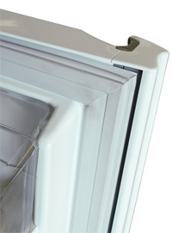
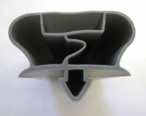
5. The rubber door seal on a refrigerator has a flexible magnetic strip within it as shown below.
cross section of seal
fridge door
rubber seal
flexible magnet

(a) Why must the fridge body be made of steel?

(b) Describe how the presence of the magnet ensures a tight seal on the door.

6. A relay is operated by a small current passing through the relay coil. This causes the switch connections to close.
relay coil with iron core
coil connections
switch connections
switch contacts
iron pivot arm

(a) What happens to the relay coil when a current flows through it?

(b) Explain how this causes any device connected to the switch connections to be turned on.
7. A wire is placed between two magnets whose poles are on the faces of the magnets. A wire connected to a switch and a cell is placed between the poles of the magnets.
north pole
south pole
switch
cell

(a) The switch is closed. What will now be found around the wire?

(b) What will now happen to the wire whilst it is between the poles of the magnets?

8. Look at the cross section through a loudspeaker shown below.
coil of wire
permanent magnet
flexible cone of paper or plastic attached to coil of wire
electrical connections to coil of wire

Explain how the loudspeaker operates when a voltage is applied to the connections at the end of the coil of wire.

9. Look at the diagram of the transformer below which converts 230 volts a.c. to 12 volts a.c. Name the parts labelled A, B and C.
A
B
C
240 volts a.c
12 volts a.c.

10. Copy and complete the paragraph on transformers using the words given below.
secondary voltage step-down magnetic
primary step-up alternating direct core
Transformers consist of two coils of wire wound around an iron __________ . The input coil is called the __________coil and the out put coil is called the __________ coil. Transformers can convert the input __________ to either a higher or lower value. Transformers which increase the voltage are called __________ transformers and ones which decrease the voltage are called __________ transformers.
Transformers will only work with an __________ current such as a mains supply and will not work with a __________ current supply. This is because there has to be a changing __________ field around the coils.

Extension Questions
11. A pupil wants to build a small electromagnet that would be able to pick up paper clips.

(a) State what pieces of equipment the pupil would need and how the electromagnet would be constructed.

(b) Describe how the strength of the electromagnet could be altered.

12. An electric doorbell contains a coil of wire wrapped around an iron core.
bell
steel
clapper
spring
contact
point
iron core
door bell switch
power supply
coil of wire

(a) When the door bell switch is closed, a current flows through the coil of wire.
(i) Describe the effect this has on the iron core.
(ii) Explain why this makes the steel clapper strike the bell

(b) When the steel clapper moves its contact with the contact point is broken. What effect has this on the circuit?

Practical electrical and electronic circuits

Electrical circuits
13. State which of the following circuits are series circuits and which are parallel circuits.
(b)
(a)

(d)
(c)

(f)
(e)

14. Copy and complete the paragraph on electrical meters using the words given below.
voltage resistance ammeters ohms
energy amperes volts electrons series

A number of instruments are used to make measurements in electrical circuits. __________ measure the flow of charge or __________ in a circuit and measure the current in __________. An ammeter is always placed in __________with the component it measures the current through.
Voltmeters are used to measure the __________or potential difference between two points in a circuit. The voltage is a measure of the __________given to the electrons to push through the circuit. Voltage is measured in __________.
Ohmmeters measure the __________ of a component in __________. They cannot make measurements when the component is being used in a circuit and it is normally removed from the circuit first.

15. Identify the symbols of the electrical components shown below.

–
+
(c)
(b)
(a)
(i)
(j)
(h)
V
(e)
A
(f)
Ω

–
+
(d)

(g)

16. (a) What instrument is used to measure current?

(b) What is the unit of current?

17. (a) What instrument is used to measure voltage?

(b) What is the unit of voltage?

18. (a) What instrument is used to measure resistance?

(b) What is the unit of resistance?

19. (a) A circuit is shown below. State the components that would be required to wire up this circuit.

(b) Redraw the circuit with a voltmeter and ammeter correctly positioned to measure the voltage across the lamp and the current through the lamp.

V

A

Voltage, Current and Resistance

Series circuits
20. Look at the series circuits below. For each one, state the value of the current on the ammeters labelled A1, A2, A3, and A4,
(a)
(b)
A2
A1
A4
A3
2 A
3 A

21. Look at the series circuits below. For each one, state the value of the voltage on the voltmeters labelled V1 and V2.
6 V
V1
2 V
(a)
(b)
V2
2 V
2 V

22. Look at the series circuit below. State the value of the voltage and current on the meters V1 and A1.
12 V
8 V
V1
A1

2 A

23. State three factors which will affect the resistance of a length of wire.

24. State an equation that links voltage, current and resistance.

25. Calculate the missing values in the table below.

Voltage | Current | Resistance
(a) | 0·5 amperes | 20 ohms
(b) | 4 amperes | 57·5 ohms
230 volts | 1·0 amperes | (c)
12 volts | 0·02 amperes | (d)
230 volts | (e) | 500 ohms
12 volts | (f) | 60 Ω

26. A circuit is constructed using a power supply with a variable voltage output. It is connected to a fixed value of resistance. What will happen to the current in the circuit as the voltage is increased?

27. An electric kettle is connected to mains electricity at 230 volts. A current of 5 amperes flows to the kettle when it is switched on. Calculate the resistance of the kettle element.

28. A 40 ohm resistor is connected to a 1·5 volt supply. Calculate the current passing through the resistor.

29. An electric iron has a resistance of 57·5 ohms. Calculate the voltage across it when a current of 4 amperes flows.

30. A voltage of 2·2 volts is applied across a resistor in an electronic circuit. Calculate the current through the resistor.
2 A
12 V
resistor, R
31. Calculate the value of the resistor, R, in the circuit opposite.

32. A filament type electric light bulb has a resistance of 920 ohms when operating at normal brightness.
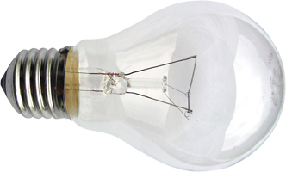

(a) Calculate the current through the light bulb when it is connected to a
230 volts mains supply.

(b) Before it was switched on, the light bulb has a resistance of only 57·5 ohms.
(i) Suggest a reason for this difference in resistance.
(ii) Calculate the current through the light bulb when it is first switched on.

Extension Questions
R
0–12 volt variable power supply
33. A pupil sets up the circuit shown opposite. An ammeter and voltmeter are to be added to the circuit to make measurements so that the resistance of the resistor can be calculated.

(a) Redraw the circuit with the ammeter and voltmeter correctly positioned to make the readings.

(b) Readings are taken from the ammeter and voltmeter as the power supply voltage is altered and a graph produced from the measurements.
4
2
6
10
8
12
0
0⋅5
1⋅0
1⋅5
voltmeter reading
in volts
ammeter reading in amperes
2⋅0
2⋅5
3⋅0
3⋅5
4⋅0

(i) What is the reading on the ammeter when the voltage across the resistor is 4 volts?
33 continued
(ii) Taking readings from the graph, calculate the resistance of the resistor in the circuit.

(c) An ohmmeter can be used to measure the resistance of a component. Draw the symbol for an ohmmeter.

34. A pupil investigates the relationship between current and resistance in a circuit containing a resistor as shown below. A variable resistor in series with the resistor R, is used to change the current flowing in the circuit.
cell
variable resistor
resistor R

(a) What can be said about the value of the current flowing through the variable resistor and the resistor R?

(b) Redraw the circuit and show, using the correct symbols, a correctly placed ammeter to measure the current through R and a correctly placed voltmeter to measure the voltage across R.

(c) A graph is produced from the results obtained from the experiment. Use these results to calculate the resistance of resistor R.
4
2
6
10
8
12
0
0⋅1
0⋅2
0⋅3
voltmeter reading
in volts
ammeter reading in amperes
0⋅4
0⋅5
0⋅6
0⋅7
0⋅8

(d) The value of the variable resistor is now increased. What effect will this change have on the reading on the ammeter?

Electronic Circuits

Electronic components
35. Electronic circuits consist of an input, a process and an output. In the table below are listed a number of devices and a range of inputs and output devices. Copy out the table and place these in the appropriate columns.
INPUTS
mouse motion sensor microphone satellite dish
smoke tv receiver keypad
OUTPUTS
siren liquid crystal display monitor buzzer screen
loudspeaker television

Device | Input | Output
computer
television
burglar alarm
calculator
karaoke player
satellite TV system
smoke alarm

36. The names of different electronic components are listed below.
motor thermistor switch light dependent resistor
light emitting diode lamp microphone loudspeaker

Match these up with the correct symbol from those shown.
(e)
(d)
(b)
(a)
(g)
(h)
M
(f)
(c)

37. By referring to question 35, draw up a table to show which components are input devices and which are output devices.

38. By referring to question 35, answer the following questions.

(a) Which component changes its resistance as its temperature changes?

(b) Which component will emit light when a current flows through it – but in one direction only?

(c) Which component will convert sound energy into electrical energy?

(d) Which component will convert electrical energy into sound energy?

(e) Which component changes its resistance as the light falling on it changes?

(f) Which component will convert electrical energy into kinetic energy?

39. A pupil designs a circuit which will automatically switch on and off an outside light. Suggest a suitable input device for this application.

40. A greenhouse uses an electronic circuit to open and close an electrically operated window so that the temperature inside the greenhouse is controlled.

(a) Name a suitable input device for the circuit.

(b) What output device could be used to open and close the window?

41. An alarm system in a house requires an indicator to show that it is on.

(a) Give two reasons why a light emitting diode would be a good choice for this.

(b) Draw the symbol for a light emitting diode.

(c) If any part of the alarm circuit is tampered or interfered with, a buzzer sounds. Why is this a good choice of output for this function?

42. A circuit switches on and off a fan to cool a room.

(a) What would be a suitable input device for this?

(b) What would be a suitable output device?

43. A car has headlights which switch on when it gets dark.

(a) Name a suitable input device for the circuit which controls this.

(b) Describe what change takes place in your input device as light levels fall.
Logic gates
44. Logic gates are used in electronic circuits. Look at the symbols below and name each gate represented.

(c)
(b)
(a)

45. In logic circuits, a signal can be described as HIGH or LOW.

(a) A signal can also be described as logic 1. Is this a HIGH or LOW signal?

(b) A voltmeter measures the output voltage from a logic circuit as 5 volts. Is this a HIGH or LOW signal?

46. The truth tables for a NOT gate, an AND gate and an OR gate are shown below. Copy and complete each of the tables.

(a) NOT gate
INPUTOUTPUT01
(b) AND gate
INPUT AINPUT BOUTPUT00011011

(c) OR gate
INPUT AINPUT BOUTPUT00011011

47. A logic gate with two inputs only gives a HIGH output when both inputs are HIGH. What type of gate is this?

48. A circuit is used to switch on the light in a hallway. It will switch on the light automatically whenever it is dark or if a switch is pressed. The circuit is shown below.

light sensor
switch

X
hall light

(a) What electronic component could be used as sensor to tell if it is dark
or light?

(b) The light sensor gives a HIGH output when it is dark and the switch gives a HIGH output when pressed. What logic gate could be placed at X?


49. A gardener has orchids in a greenhouse which must be protected from frost at night.

light sensor

X
heater
temperature sensor

(a) What electronic component could be used as sensor to measure the temperature?

(b) The light sensor gives a HIGH output when it is dark and the temperature sensor gives a HIGH output when temperatures drop to near freezing. What logic gate could be placed at X so that the heater is turned on when it is dark and cold?

(c) The temperature sensor is faulty and the new sensor gives a HIGH output when it is hot. Redraw the circuit showing and additions or modifications which could be made so that the circuit works as it did before.

Extension Questions
50. Logic gates are often supplied in small plastic packages with pins to connect to the outside circuitry. The diagram below shows a 14 pin ‘chip’ which contains 4 logic gates in a single package.
1
3
2
4
5
6
7
14
12
13
11
10
9
8

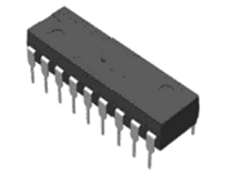

(a) Name the gates contained in this package.

(b) Copy and complete the truth table for this gate.
INPUT A | INPUT B | OUTPUT
0 | 0
0 | 1
1 | 0
1 | 1

(c) Two of the gates are connected together as shown below. The input signals to pins 1 and 2 are both a 1.
input signal
1
input signal
0
input signal
1
pin 3
pin 6

(i) Is an input of a 1 equivalent to a HIGH or LOW signal?
(ii) State if the output will be HIGH (1) or LOW (0) at the following pins:
A. pin 3;
B. pin 6.
51. (a) Name the logic gates shown below.

(i) (ii)

(b) An electrical engineer uses a probe to test whether the signal at a point in a circuit is HIGH or LOW.

The probe touches the output from an INVERTER or NOT gate. The input to the gate is a HIGH signal. Will the probe indicate a HIGH or LOW signal?

(c) Wine bottles are filled automatically. An electronic circuit checks that the filling mechanism only operates when the wine bottle is present and that it is filled to the correct level. The output from the light sensor changes from HIGH to LOW when the liquid reaches the neck of the bottle. The pressure sensor gives a LOW signal when the bottle is present on the pad.
pressure sensor
light sensor
light
filler
mechanism

X

(i) What type of logic gate is the gate labelled X?
(ii) Why will no wine be released from the filler mechanism if no bottle is present? Explain your answer.

Electrical Power

Energy consumption
52. Listed in the table below are some common appliances found in a house. Using the types of energy given, complete the table to show the energy changes which take place in the appliance. (Note: some appliances may have more than one output energy.

Types of energy
sound heat electrical kinetic potential
chemical light nuclear

Device | Input energy | Output energy
television
washing machine
electric cooker
radio
sewing machine
kettle
food mixer

53. Looking at the appliances in the table in question 52, which ones would use the most amount of energy? Give a reason for your answer.

54. (a) A number of electrical appliances are listed below. Sort these into order with the appliance having the highest power rating first and the lowest power rating last.

table lamp electric kettle electric cooker television

(b) Which of the appliances is likely to have a power rating of:
(i) 8000 watts
(ii) 40 watts
(iii) 200 watts
(iv) 1500 watts

Calculating power
55. State an equation that links power, energy and time.

56. Calculate the missing values in the table below.

Power | Energy | Time
(a) | 100 joules | 10 seconds
(b) | 2000 joules | 2 seconds
40 watts | 4000 joules | (c)
2000 watts | 120 000 joules | (d)
10 watts | (e) | 100 seconds
1200 watts | (f) | 300 seconds

57. Calculate the power of an appliance which consumes 200 joules of energy in 100 seconds.
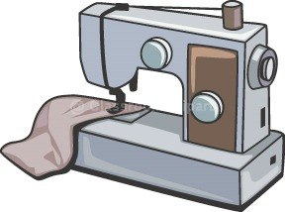
58. A sewing machine has a power rating of 100 watts. Calculate the time it will operate for on 3000 joules of energy.

59. A steam iron consumes 32 000 joules of energy in 40 seconds. Calculate the power of the iron.

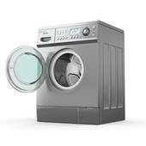
60. A washing machine has an average power of 600 watts over its wash cycle.

(a) How many joules of energy are used during a wash cycle lasting 30 minutes?

(b) At times, the power rating of the washing machine is much higher than the average of 600 watts. Suggest a reason for this.
Energy waste and efficiency

61. A leaflet explains ways in which a householder can save energy and reduce their energy bills.

(a) Look at the suggestions listed below and for each one, describe how it will be able to reduce the energy being used.
A. Turn out the lights when not in the room.
B. Don't overfill your kettle.
C. Only use a dishwasher when full.
D. Insulate your walls and loft.
E. Don’t leave appliances on standby.
F. Reduce the use of labour saving electrical gadgets.
G. Choose energy efficient appliances.
H. Fit double glazing.
I. Fit insulation around the hot water storage tank.
J. Have showers instead of baths.
K. Switch energy supplier.
L. Turn down room thermostats.

(b) Which of the advice above is likely to save most money?

62. Thermal images can be used to show the heat being lost through different parts of a house. Light areas of the image are hotter and dark areas colder. In the image below, the block of flats on the right of the picture is newly built. The flats on the left behind the trees was built in the 1970s.
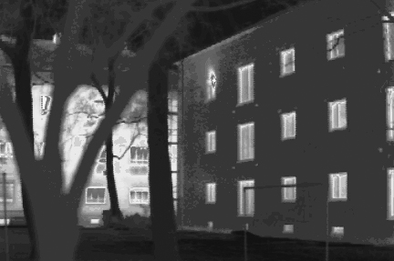
Photograph by Passivhaus Institut

(a) Which area(s) of the modern block is loosing most heat?

(b) Which block, the new or the older, is loosing most heat? Suggest a reason for your answer.
63. The diagram below shows the typical energy losses from a house.
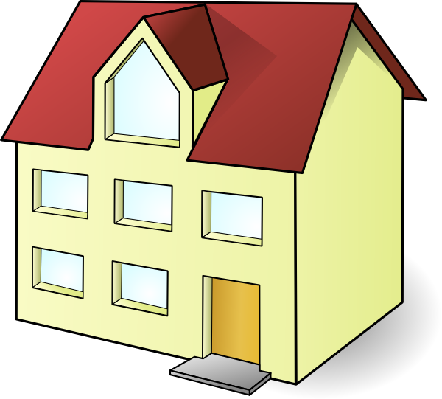
draughts 26%
walls 33%
roof 26%
windows 26%
floors 8%
doors 3%

(a) Where is most energy lost from the house?

(b) The householder spends £1500 each year on heating the house. Listed below are some of the energy saving measures that could be installed and their cost. Suggest which you would be most likely to choose if you were the householder and give reasons for your choice.
Measure cost
Fit draught excluders £120
Insulate roof £300
Lay carpets in downstairs rooms £1200
Replace doors £1500
Fit double glazed windows £8000
Insulate walls with cavity foam £5500

64. State an equation that links percentage efficiency, energy in and energy out.

65. Calculate the missing values in the table below.

% Efficiency | Energy in | Energy out
(a) | 50 joules | 40 joules
(b) | 2000 joules | 1500 joules
50 % | 4000 joules | (c)
80 % | 100 000 joules | (d)
30 % | (e) | 1800 joules
90 % | (f) | 10 000 joules

66. Calculate the percentage efficiency of an appliance which consumes 8000 joules of energy with an energy output of 6000 joules.

67. An electric drill is 40% efficient. The energy input to it is 40 000 joules. Calculate the useful energy out.

68. State an equation that links percentage efficiency, power in and power out.

69. Calculate the missing values in the table below.

% Efficiency | Power in | Power out
(a) | 500 watts | 400 watts
(b) | 18 000 watts | 12 000 watts
80 % | 300 watts | (c)
50 % | 2000 watts | (d)
10 % | (e) | 500 watts
80 % | (f) | 10 000 watts

70. Calculate the percentage efficiency of an appliance which is rated at 40 watts with a useful power output of 5 watts.

71. A food mixer is 60% efficient. Its power input is 400 watts. Calculate the useful power out.

Extension Questions
72. An electric kettle consumes 2000 joules each second.

(a) The water in the kettle absorbs 1800 joules of energy. How much energy is wasted?

(b) Where might the energy not used to heat the water go to?

(c) Calculate the percentage efficiency of the kettle.

73. The electric motor of a lift uses 100 000 joules of energy to raise the lift and its passengers. At the end they have gained 15 000 joules of potential energy.

(a) Where has all the ‘lost’ energy gone?

(b) Calculate the percentage efficiency of the lift.
74. A food blender uses 10 000 joules of energy when switched on for 5 seconds.
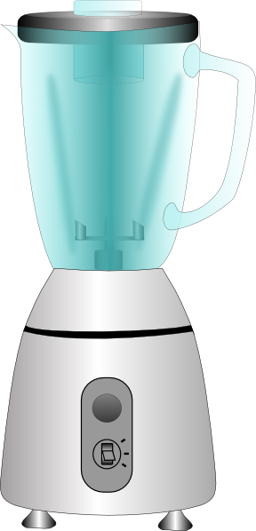
(a) Calculate the power of the blender.

(b) The useful power output of the blender is 200 watts. Calculate its percentage efficiency.

75. A machine in a factory has a power rating of 50 kilowatts. The useful energy transferred by the machine in 30 seconds is 300 kilojoules

(a) Calculate the power output of the machine in kilowatts.

(b) Calculate how percentage efficient the machine is.

Generation of Electricity
76. Most of the energy we use at the moment comes from fossil fuels.

(a) Name three fossil fuels.

(b) Explain why fossil fuels are given their name.

(c) Fossil fuels are often described as ‘finite’. What does this mean?

77. Energy sources can be split into two types, renewable and non-renewable. Explain the difference between these two types.

78. Look at the table below. A range of energy sources are listed. Copy the table and complete it by putting a tick in the appropriate column. The first has been done for you.

Energy Source | Renewable | Non-renewable
(a) Oil |  | ✓
(b) Wave power
(c) Solar power
(d) Coal
(e) Geothermal
(f) Gas
(g) Hydroelectric
(h) Wind power

79. For each of the energy sources listed in question 77 above, state an advantage and a disadvantage of using this energy source.

80. Copy and complete the paragraph on power stations using the words given below.
hydro-electric oil gas uranium ethanol
An example of a biofuel is __________. __________ and __________ are both fossil fuels. When there is a sudden surge in electricity demand a __________ power station can generate electricity in a short space of time. Nuclear power stations use __________ as a fuel.
81. Each person in Scotland uses energy at a rate of 6000 watts.

(a) Calculate the total power consumption for the whole country if Scotland has a population of 5 million.

(b) How many power stations would be required in Scotland if each power station produces an output of 2000 mega watts.

82. A wind turbine produces 2 mega watts of power.

(a) How many wind turbines would be required for Aberdeen if it has a total power demand of 1200 mega watts?

(b) Give two reasons why generating all Aberdeen’s electricity by wind turbines would not be a good idea.

83. A pupil places a length of wire between the north and south pole of two magnets. A voltmeter is placed in the wire. The pupil then moves the wire up and down between the poles of the magnets.
magnets
V
wire

(a) What will be observed on the voltmeter as the wire is moved up and down?

(b) The pupil now stops moving the wire. What will be seen on the voltmeter now?
84. A pupil uses a bar magnet to generate a voltage across a coil of wire.
N
S
bar magnet
coil of wire
V

(a) Explain what the pupil must do to generate the voltage.

(b) State three things that could be done to generate a larger voltage.

85. Electricity is generated in a power station by burning a fuel to create steam. The diagram below shows the parts of a typical power station.
BOILER
fossil fuel burned - water turned into steam
TURBINE
steam at pressure causes turbine blades to rotate
GENERATOR
turbine turns generator which produces electricity

(a) Name three fossil fuels which could be used as the fuel for this power station.

(b) Name the energy change which takes place in the boiler.

(c) Name the energy change which takes place in the generator.

(d) State one advantage and one disadvantage of using fossil fuels as a source of energy in a power station.

(e) Nuclear power stations are very similar to the power station outlined above.
(i) What do they use as their source of heat energy?
(ii) Nuclear power stations have elaborate safety systems built into their design. Why are these necessary?
86. A typical hydro electric power station consists of water stored behind a dam. At the base of the dam there will be a generating station.
dam
generating
station
(a) In what form is the energy stored in the water?

(b) Name the energy change which takes place when water flows to the generating station.

(c) Name the energy change which takes place in the generating station.

(d) State one advantage and one disadvantage of using hydro electric energy.

87. Copy and complete the paragraph on the transmission of electricity using the words given below.
decreased smaller connect step-up energy
The National Grid is a network of cables which __________ power stations and our homes. Power stations generate electricity which is then transmitted across the country. Power stations are connected to the grid by __________ transformers which increases the voltage of the supply. This means that the electricity is transmitted with a __________ current. As a result, the __________losses in the transmission cables are far less. Before the electricity is supplied to homes, the voltage is __________ by a step-down transformer.

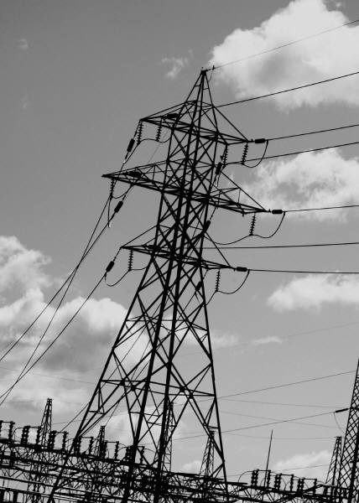
88. Read the passage below about the National Grid then answer the questions which follow.

The national grid uses overhead cables strung between pylons to transmit electricity across the country. Many people would rather have the cables buried underground in places of natural beauty. They say they spoil the natural beauty of the countryside. In addition, electric currents produce magnetic fields which may affect people.
If the cables were buried underground it would be much more expensive and if any faults developed they would be difficult to locate and repair. Crossing roads and rivers would be difficult.

(a) Why would the National Grid not want to bury their cables underground?

(b) What might affect people if they are close to high voltage power lines?

(c) Do you think consumers would be willing to pay more for their electricity if the National Grid buried cables in areas of natural beauty?
Extension Questions
89. The block diagram below shows the typical layout of a power station which uses fossil fuels as a source of energy.
boiler
turbine
generator
National Grid

(a) Name three fossil fuels which may be used in this power station.

(b) State the energy change which takes place in the boiler.

(c) In which part of the power station is kinetic energy changed into electrical energy?

(d) What happens to the electricity generated before it enters the National Grid?

(e) Some power stations use nuclear energy to produce the steam in the boiler.
(i) State one advantage of nuclear energy as a source of energy.
(ii) State one disadvantage of nuclear energy as a source of energy.

90. A cyclist fits a dynamo onto his bicycle like the one shown below.
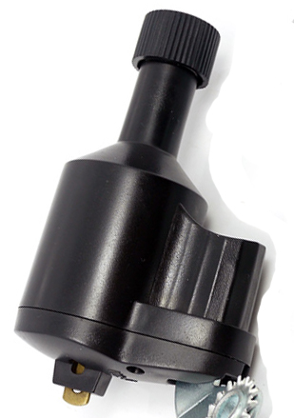
rotating wheel presses against bicycle tyre
dynamo body contains rotating magnet within coils of wire.

(a) State the energy change which takes place in the dynamo.

(b) Describe the principal that is used to generate electricity in the dynamo.

(c) State two ways in which the dynamo could be made to produce a higher voltage output.

Gas Laws and the Kinetic Model

Kinetic model
91. Which of the following statements about a gas is/are true or false.
A. A gas has a fixed shape and a fixed volume.
B. A gas has a fixed shape but not a fixed volume
C. A gas has a fixed volume but not a fixed shape.
D. A gas has neither a fixed shape or volume.
E. The particles in a gas can increase and decrease in size.
F. The particles in a gas can increase and decrease in speed.

92. The diagram opposite shows how gas particles in a container. (particles greatly enlarged)

(a) What will happen when the particles collide with the walls of the container?

(b) The temperature of the gas is raised. How does this affect the movement of the gas particles?

(c) (i) What happens to the pressure inside the container if the gas is heated?
(ii) Explain why any changes in the pressure take place.

93. A metal canister of gas is cooled. State the effect has this on the pressure inside the container and explain your answer.
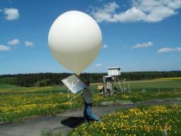
94. A weather balloon is made of a very stretch material and filled with helium gas.

(a) As the balloon rises, how will the pressure inside the balloon compare with the pressure outside.

(b) The air at higher altitudes is ‘thinner’. What will happen to the volume of the balloon as it rises.?

