EARTHING
For obvious reasons it is not possible to experiment on a real life situation to find out how the Earth wire works.
We will use a model to demonstrate the importance of correctly wiring plugs.
“Polly put the kettle on…..”
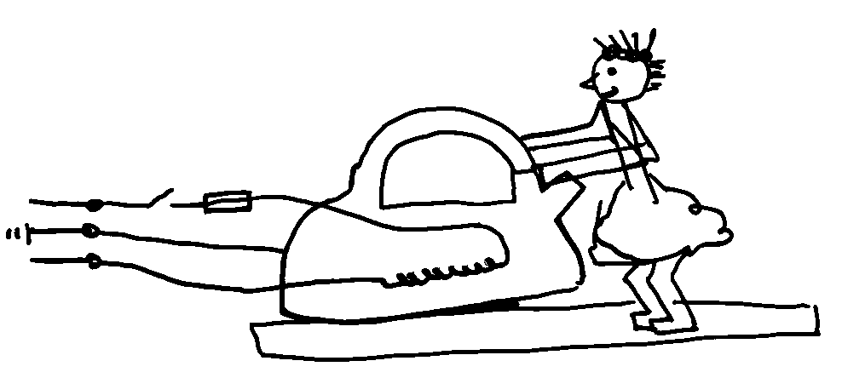
Fault | What happens
Short between live and the  kettle casing | No Earth | Polly is electrocuted when she switches on the kettle  FUSE DOES NOT MELT
 | Earth | As Polly switches on a large current flows through the casing to Earth. THE FUSE MELTS
Short between live and kettle  casing, but live and neutral  wires are reversed | No Earth | The fuse does not blow. Polly gets a very large shock, EVEN WHEN THE APPLIANCE IS SWITCHED OFF
 | Earth | This would cause a very large current which is not protected by the fuse. This could damage the supply cables. EXPENSIVE.

Fuses get hot even when working properly and so gradually deteriorate with age. Therefore, fuses can sometimes melt even when there is no fault in the appliance. So replace MELTED fuses once (or twice) before fault finding, (don’t say blown)

The Earth Wire

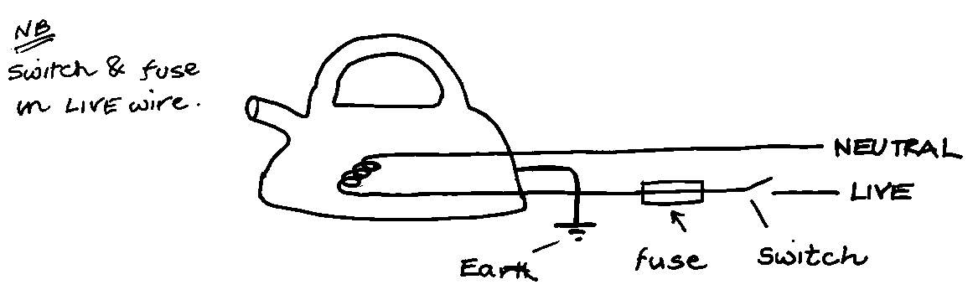
The electric current flows through the live wire, into the heating element and out through the neutral wire. The fuse and switch are placed in the live wire (see note below). The Earth wire is connected to the outside casing of the kettle. Normally, no current flows through the Earth wire, so what is it for?
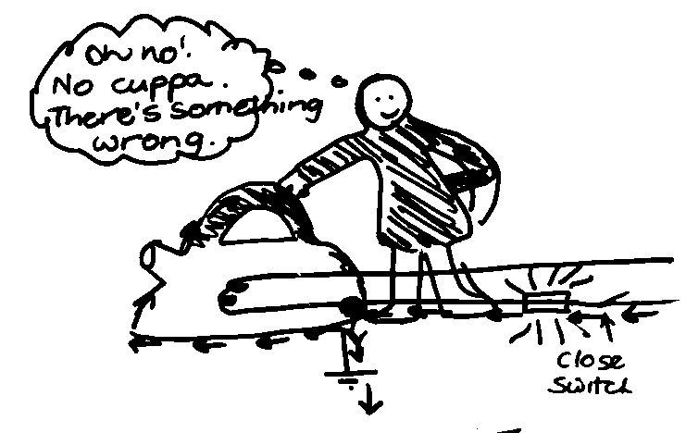
It is a safety device. If the kettle is wired correctly and a loose wire touches the casing, a large current flows along the live wire through the Earth wire. This large current causes the fuse to melt. The kettle won’t work but YOU are safe.

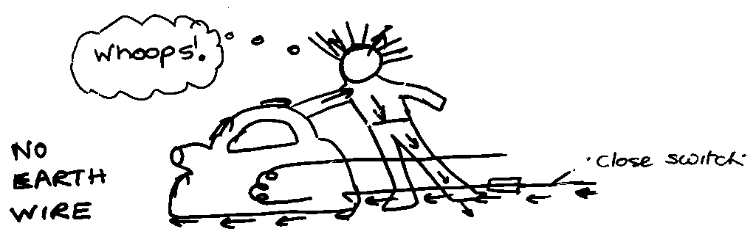

If there is a fault and a live wire touches the casing, then a person touches the casing, the electricity will go through the person and into the ground. The person could be killed.
Why did the person get an electric shock when the neutral and live wires were connected the wrong way round?

How the Earth wire works

Current flows through the live wire, through the appliance and back through the neutral wire. The Earth wire is connected to the casing of the appliance, so when the appliance is working normally no current flows through the Earth wire. IF A LOOSE LIVE WIRE TOUCHES THE CASING THE CASING WOULD BE RAISED TO A POTENTIAL OF 230 V, AND THIS DRIVES A VERY LARGE CURRENT THROUGH THE CASING AND THROUGH THE EARTH WIRE. THIS LARGE CURRENT MELTS THE FUSE AND MAKES THE APPLIANCE SAFE.

If there were no Earth wire, the metal casing would be raised to 230V if a loose live wire touched it. If you then touched the casing a large current would flow through YOU to Earth. This would be enough to kill you.

Appliances marked are double insulated and have no earth wire. They are called double insulated because they have two layers of functional insulation between any external surface and any conductor which is at a high voltage and could cause shocks.

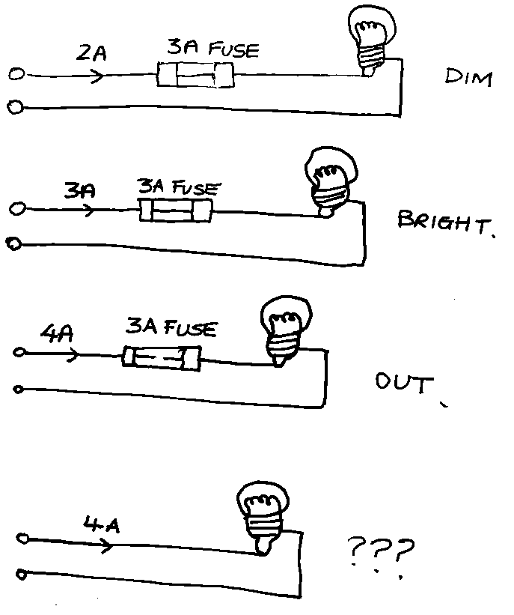
The correct fuse

To change a fuse in a plug:

- Take the plug out of the socket;
- Take the top off the plug (using a screwdriver);
- Lift out the fuse (carefully);
- Put in a new fuse OF THE CORRECT VALUE.

There are lots of fuses that you can buy for plugs: 1A, 2A, 3A, 5A, 10A and 13A. At home the only 2 fuses that you need are 3A and 13A.
How do you choose the correct value of fuse?
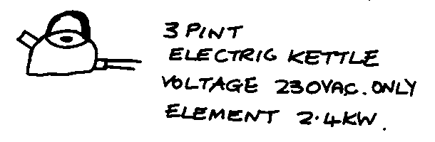
All appliances have plates showing their power rating and voltage. This information can be used to calculate the current that flows in the appliance when it is in use. You can then work out which fuse to use.
To find the current the kettle uses you do this sum:
Current (A) = Power (W) Voltage (V)
For appliances up to 720 W use a 3A fuse.
For appliances 720W- 3000W use a 13A fuse.
Some low powered appliances might need a higher rated fuse as they have high switch on currents.

Where do these figures come from?

$$P=IV$$
P = 3 × 240
P=720W

$$P=IV$$
P = 13 × 240
P=3120W

But hang on – isn’t the voltage output from the mains 230V?
Well prior to 1995 the UK generated voltages of 240V ± 10V
From 1995 the UK generates voltages of 230V ± 20V

So it is still basically the same but with a greater margin of difference.
Whenever you are asked a question involving mains voltage use the number 230V
When asked about a fuse, use 240 V

I didn’t make it up, so don’t blame me. It is what ROSPA recommend!

ADDITIONAL INFORMATION FOR THE EARTH WIRE

Explain the purpose of the Earth wire

If there is a fault and the casing becomes live there is a low resistance path from the live to earth. A large current flows to earth. This causes the fuse to MELT which disconnects the live wire, making the appliance safe (or isolating the appliance)

Why must switches and fuses be in the live wire?

The live wire is the dangerous wire because it is at high voltage with respect to the earth. When the fuse blows or an appliance is switched off it is important that the live wire is disconnected so the appliance is safe.

What is the purpose of the fuse?

The fuse protects the flex from overheating.

