National 4/5
Physics
Waves and Radiations
Summary Notes

Wave characteristics, parameters and behaviours
Types of wave
There are two different types of waves you will meet in this course, transverse waves and longitudinal waves
In transverse waves the particles oscillate (vibrate) at right angles to the motion of the wave
direction of particles’ motion
direction of the wave motion

In longitudinal waves the particles oscillate in the same direction as the motion of the wave
direction of wave’s motion
direction of particles’ motion

Examples of transverse waves include light waves, radio waves, microwaves.
Sound is an example of a longitudinal wave
Properties of waves
λ
trough
crest
amplitude
amplitude
λ
λ
Waves are used to transfer energy. The particles oscillate around a fixed position but the energy travels along the wave.
Several important features of a wave are shown in the diagram. These are explained in the following table
Wave property | Symbol | Definition | Unit | Unit symbol
crest |  | highest point of a wave
trough |  | lowest point of a wave
frequency | f | number of waves produced in one second | hertz | Hz
wavelength | λ | horizontal distance between successive crests or troughs | metre | m
amplitude | A | half the vertical distance between crest and trough | metre | m
wave speed | v | distance travelled per unit time | metres per second | m/s

Distance, speed and time
One of the most important equations you will meet in Physics concerns the relationship between distance, speed and time. This means that the speed of an object (or wave) is a measure of how much distance is covered in a certain time.
Another way of looking at this is that the distance travelled depends on how fast you travel and for how long. We represent this as shown below
$$distance=speed ×time \\ d= \overline{v}t$$
where d is the distance travelled in metres (m)
$\overline{v}$ is the average speed in metres per second (m/s)
and t is the time in seconds (s)
Example A wave travels 90 m in 30 s. Calculate the speed of the wave
$$d=\overline{v}t \\ 90=\overline{v}×30 \\ \frac{90}{30}=\overline{v} \\ 3m/s=\overline{v}$$

Wave speed, frequency and wavelength
By multiplying the frequency and wavelength we find that this is equal to the speed of the wave. We therefore say that:
$$wave speed=frequency ×wavelength \\ v=fλ$$
Example: A wave has a wavelength of 0.5 m and a frequency of 4 Hz. What is its speed?
$$v=fλ \\ v=4 ×0.5 \\ v=2 m/s$$
Diffraction
Waves are able to bend around obstacles. This bending of waves around corners is called diffraction.
Long wavelength waves diffract more than short wavelength waves.
Long wavelength Short wavelength

Sound
Speed of sound in air
We can use two methods to measure the speed of sound in air.
Method 1.
cymbals
flag
d
stopclock

Large cymbals are clashed a long distance from the observer. The observer starts the stopclock when he sees the signal that the cymbals have been clashed and stops it when the sound is heard. Using the distance travelled d (measured by a trundle wheel), the time on the stopclock t the equation d=vt is used to calculate the speed of sound. This is not a particularly accurate method as it relies on human reaction time.
Method 2.
electronic timer
microphone
d
mallet and block

The distance d is measured with a metre stick. The mallet is struck against the block. As the sound reaches the first microphone the timer is started, when it reaches the second microphone the timer is stopped. The equation $d= vt$ is used to calculate the speed again. This is a much more accurate method.
The exact value for the speed of sound in air can vary, however it is around 340 m/s.

Amplitude and frequency
We can analyse waveforms by using a device called an oscilloscope.
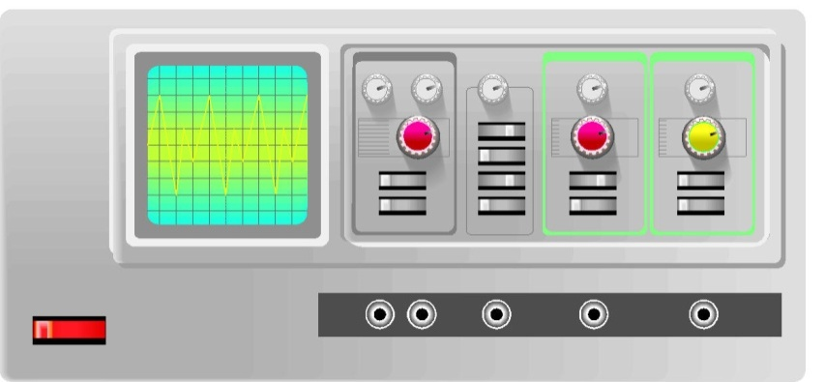
The oscilloscope allows us to view waves and see what effect changing certain properties has.

original wave

smaller amplitude larger amplitude

lower frequency higher frequency
If we were to think of these in terms of sound, waves with a small amplitude would be quiet and those with a large amplitude would be loud. Waves with a low frequency would be low pitched and waves with a high frequency would be high pitched.

Decibel scale and noise pollution
Noise levels are measured in decibels (dB). These can be measured using a sound level meter. Regular exposure to sounds above 85-90dB can cause damage to hearing. Some typical noise levels are given below
Situation | Decibels
Threshold of human hearing | 0
Leaves rustling in the wind | 20
Whisper, rustling paper | 30
Quiet residential area at night | 40
Inside average home | 50
Normal conversation at 1m distance | 60
Phone ringing, busy street | 70
Alarm clock at 0.5 m distance | 80
Threshold of hearing damage | 85
Truck heard from pavement, busy factory | 90
Hair dryer | 100
Lawn mower at a distance of 1m | 110
Rock concert 1m from loudspeaker, vuvuzela horn at a distance of 1m | 120
Jet engine at a distance of 50m | 130
Threshold of pain | 120 - 140
Stun grenade | 180
Theoretical limit for sound travelling through the Earth’s atmosphere | 194

We can protect against damage to hearing by loud noises by wearing ear plugs or ear protectors.
Sonar and ultrasound
Humans can hear sounds with frequencies between 20Hz and 20000Hz. Sounds with a frequency above 20000Hz are called ultrasound.
Ultrasound can be used to examine a foetus in the womb. A picture is built up by timing how long it takes to receive an echo from an ultrasound pulse. Ultrasound can also be used to break up kidney stones without the need for invasive surgery.
Boats and submarines use sonar to detect shoals of fish, the sea bed or other submarines. Pulses of sound are sent out and then the echo is detected. This is similar to how bats and dolphins use echolocation.

Sound reproduction and noise cancellation
Sound is an analogue signal. This means that it varies continuously over a range of values. Most recording technology nowadays uses digital technology. Digital signals can be one of two values with nothing in between. Analogue to digital converters are used to process the sound signal so that it can be transmitted easier, then a digital to analogue device allows the sound to be reproduced faithfully at the other end.
If two waves travelling in opposite directions were to meet, the result would be that they cancel each other out. The same would happen any time a crest of one wave meets a trough of another.
This effect is called interference of waves. We can make use of this effect in noise cancelling technology.
+
=

Electromagnetic spectrum and light
The electromagnetic spectrum
There are a number of waves which travel at the speed of light. They are all part of the electromagnetic spectrum. These waves are all transverse waves and travel at 3000000000 m/s (3 x 10⁸m/s) in a vacuum.
The different parts of the electromagnetic spectrum differ in wavelength and frequency
Gamma rays
X-rays
increasing frequency
increasing wavelength
Ultraviolet
Visible light
Infrared
Microwaves
Radio and TV
The different parts of the electromagnetic spectrum can also be distinguished by their energy. Higher frequency electromagnetic radiation has a greater amount of energy than lower frequency electromagnetic radiation.
Some information on each part of the spectrum is given below
Type of e-m radiation | Typical source | Application | Detector | Possible hazard
Radio & TV | Electrical antennae | Telecommunications | Aerial | Potential increased cancer risk
Microwaves | Cosmic sources, magnetron | Cooking, telecommunications | Diode probe | Heating of body tissues
Infra-red | Heat-emitting objects | Thermograms | Phototransistor, blackened thermometer | Heating of body tissues
Visible light | Stars | Vision | Eye, photographic film | Intense light can damage the retina
Ultraviolet | Sunlight | Treating skin conditions | Fluorescent paint | Skin cancer
X-rays | X-ray tube, cosmic sources | Medical imaging | Photographic plates | Destroys cells which can lead to cancer
Gamma rays | Nuclear decay | Treating tumours | Geiger–Müller tube and counter | Destroys cells which can lead to cancer

Light
At the boundary between different types of materials, the speed of the light wave changes. This results in a change in wavelength, and can often cause the direction of a wave to change.
The change in light speed when going from one medium into another is known as refraction.
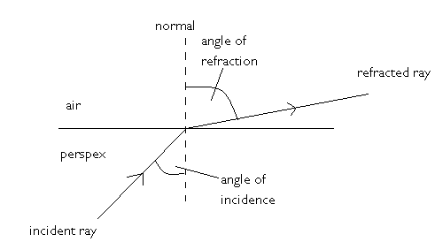
This effect is used in lenses.
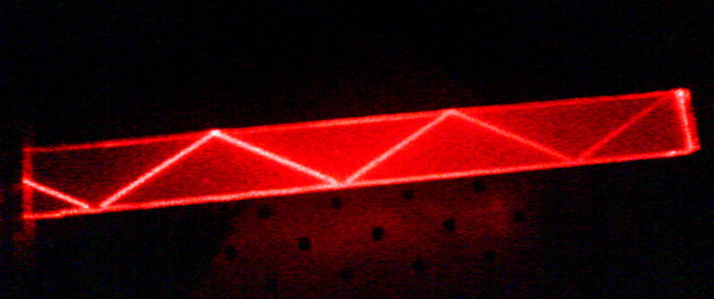
Above a certain angle of incidence, refraction no longer occurs, and instead the wave is reflected back into the first medium. This is known as total internal reflection. The angle of incidence that causes an angle of refraction of 90° is called the critical angle.

Total internal reflection is used in optical fibres. Optical fibres can be used for communication or in medical applications to allow doctors to see into the body. One bundle of fibres carries light into the body whilst another carries the light back out of the body. This is known as an endoscope.

Nuclear radiation

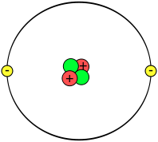
nucleus
neutron
proton
electron

Nuclear radiation is so called because it originates in the nucleus of an atom. The above diagram (not to scale) shows the structure of an atom. Nuclear radiation can come from natural sources such as cosmic rays and naturally occurring radioactive materials such as uranium. It can also come from artificial sources such as man-made radioisotopes such as plutonium.
Nuclear radiation can be used in medicine to sterilise instruments by killing germs and bacteria. It can also be used to kill the cells which make up a cancerous tumour. Nuclear radiation can also be used to examine the body through using radioactive materials in something called a tracer. This is a substance that is injected into the body and detected to analyse its progress through the body.
We will look at three different types of nuclear radiation:
alpha α
beta β
gamma γ
type of radiation | nature | absorbed by
alpha | two protons and two neutrons (helium nucleus) | sheet of paper, few centimetres of air
beta | fast-moving electron | few cm of aluminium
gamma | electromagnetic wave | few m of lead

The process by which nuclear radiation damages cells is known as ionization. This is where electrons are stripped from their atoms. Alpha radiation is far more ionising than beta or gamma radiation
Nuclear radiation is always present in our environment. This is known as background radiation. This can come from natural sources e.g. radon gas, cosmic rays or from man-made sources e.g. nuclear fallout from weapons testing, accidents at nuclear power stations.
The amount of energy received by a substance per unit mass is known as the absorbed dose. This can be calculated by using the equation $D =\frac{E}{m}$
where D is the absorbed dose in grays (Gy)
E is the energy in joules (J)
and m is the mass in kilograms (kg)
This does not tell the whole story of how a person would be affected by nuclear radiation. It does not take into account the type of radiation encountered.
The equivalent dose allows us to take the type of radiation into account. It is calculated by using the equation $H =Dw_{R}$
where H is the equivalent dose in sieverts (Sv)
D is the absorbed dose in grays (Gy)
and w_{R} is the radiation weighting factor.
Alpha radiation has a radiation weighting factor of 20, whereas beta and gamma radiation both have a radiation weighting factor of 1.
The activity or a radioactive source is a measure of how many nuclei decay every second. It is calculated by $A =\frac{N}{t}$
where A is the activity in becquerels (Bq)
N is the number of nuclei that decay
and t is the time in seconds (s)
The activity of a source decreases over time. Whilst the decay of an individual atom is completely random and unpredictable, the time taken for half the atoms in a sample of a particular material to decay can be predicted as it will always be the same. This is known as the half-life.
Different materials have different half lifes:
hydrogen-7 1 x 10⁻²² s californium-254 60.5 days
carbon-15 2.5 s plutonium-238 87.7 years
nobelium-259 58 minutes uranium-238 4.5 billion years
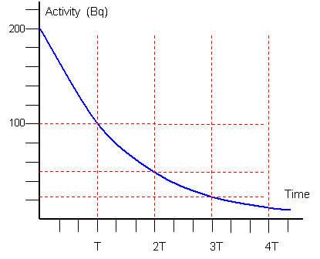
This can be represented on a graph of activity against time as shown. The half life is the time taken for the activity of a sample to drop by half. From the graph it can be seen that the time taken to drop from 200 Bq to 100 Bq is the same amount of time taken to drop from 100 Bq to 50Bq.

Nuclear radiation can be used to generate energy. There are two ways in which nuclear radiation can be used to generate energy.
1. Fission
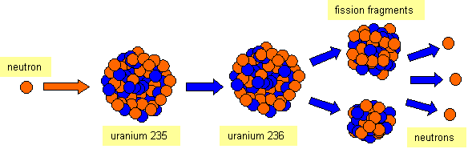
If a neutron is fired at a uranium 235 nucleus, it becomes unstable and separates into two smaller nuclei and releases some more neutrons. The mass of these nuclei and neutrons is slightly less than the mass of the original nucleus and neutron. Using the equation E= mc²we can calculate the energy released in each fission reaction. If the neutrons that are released are captured by other uranium 235 nuclei, the process can be repeated. This is known as a chain reaction.
In nuclear power stations, the energy released is used to heat water to produce steam to turn a turbine. This drives a generator which produces electricity.

2. Fusion
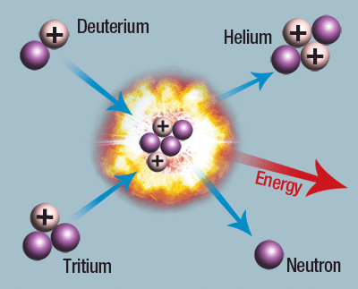
Fusion is a process where two smaller nuclei are combined to create a larger nucleus. Again, the total mass of the products of this reaction is less than the total mass before the reaction, allowing us to calculate the energy released by using the equation E = mc². It is thought that fusion would allow us to generate far more energy than fission at much lower risk, however we are currently unable to do this economically. Fusion is the process in which stars convert fuel to light and heat.
Note: It is important that you do not misspell fusion or fission!
Using nuclear radiation to produce electricity reduces the amount of carbon dioxide released into the atmosphere. Carbon dioxide is a greenhouse gas which helps contribute to global warming. However, nuclear reactors produce radioactive waste which needs to be stored for thousands of years before it is safe.

http://upload.wikimedia.org/wikipedia/commons/7/77/Waveforms.svg
http://www.schoolphysics.co.uk/age14-16/glance/Waves/Diffraction_/index.html?PHPSESSID=43cdadeaf8c0a5aeacf88cced9468bab
© Glowgraphics taken from Images for schools
Sai2020 taken from http://en.wikipedia.org/wiki/File:TIR_in_PMMA.jpg
Svdmolen/Jeanot http://commons.wikimedia.org/w/index.php?title=File:Atom.svg&page=1
http://www.schoolphysics.co.uk/age14-16/glance/Nuclear%20physics/Half_life/index.html
http://commons.wikimedia.org/wiki/File:Nuclear_fusion.gif?uselang=en-gb

