

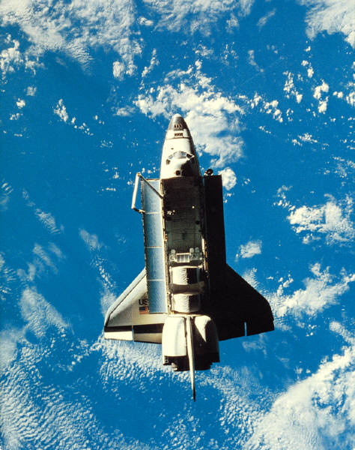**C:\Users\Stephen\AppData\Local\Microsoft\Windows\Temporary Internet Files\Content.IE5\Y7JRKGOJ\MC900413302[1].wmf**

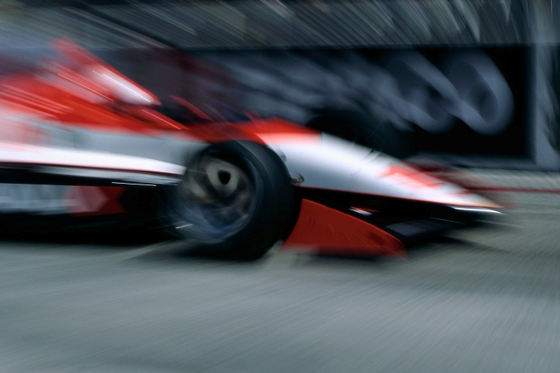

**National 5 Physics**

**Dynamics and Space**

**Problem Booklet**



**Contents**

|  |  |
| --- | --- |
| **Topic** | **Page** |
| Velocity & Displacement | 4 - 6 |
| Acceleration | 7 - 8 |
| Velocity-Time Graphs | 9 - 11 |
| Weight | 12 - 13 |
| Newton’s Laws | 14 - 19 |
| Work Done | 20 - 21 |
| Projectile Motion | 22 - 25 |
| Specific Heat Capacity | 26 - 27 |
| Specific Latent Heat | 28 - 30 |
| Space Exploration | 31 - 32 |
| Cosmology | 33 - 36 |

**Velocity and Displacement**

**Useful Equation:**

v

=

t

d

v

d

t

where: v is the average speed of an object (m/s)

d is distance travelled by an object (m)

t is the time taken by an object to travel a distance (s)

1. What is the difference between a scalar and a vector quantity?
2. Put these quantities in to a table that shows whether they are vector or scalar:

*force, speed, velocity, distance, displacement, acceleration, mass, time, energy.*

1. Copy and complete this table.

|  |  |  |  |
| --- | --- | --- | --- |
|  | ***Distance* / m** | ***Time* / s** | ***Speed* / m/s** |
| **(a)** | 100 | 10 |  |
| **(b)** | 30 | 2.5 |  |
| **(c)** | 510 |  | 17 |
| **(d)** | 72 |  | 1.5 |
| **(e)** |  | 30 | 12 |
| **(f)** |  | 0.3 | 25 |

1. C:\Users\Stephen\AppData\Local\Microsoft\Windows\Temporary Internet Files\Content.IE5\80M20XLK\MM900354669[1].gifA person walks 25 metres west along a street before turning back and walking 15 metres east. The journey takes 50 seconds. What is the:
2. Total distance travelled by the person?
3. Displacement of the person?
4. Average speed of the person?
5. Average velocity of the person?
6. An Olympic runner runs one complete lap around an athletics track in a race. The total length of the track is 400 metres and it takes 45 seconds for the runner to complete the race. Calculate the:
7. Displacement of the runner at the end of the race.
8. Average speed of the runner during the race.
9. Average velocity of the runner during the race.
10. An orienteer starts at point A, walks 300 metres north then 400 metres east until point B is reached in a total time of 900 seconds, as shown.

**A**

**B**

300 m

400 m

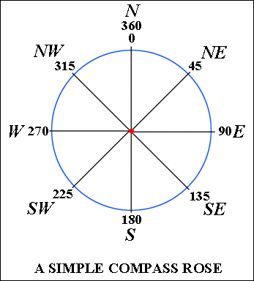

1. What is the total distance walked by the orienteer?
2. What is the displacement of point B relative to point A?
3. What is the average speed of the orienteer?
4. What is the average velocity of the orienteer?
5. A car drives 15 kilometres east for 12 minutes then changes direction and drives 18 kilometres south for 18 minutes.
6. What is the average speed of the car, in metres per second?
7. What is the average speed of the car, in kilometres per hour?
8. What is the average velocity of the car, in metres per second?

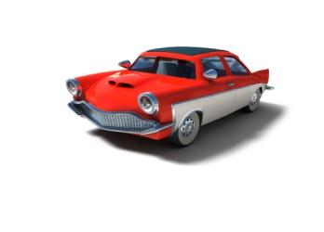

1. On a journey, a lorry is driven 120 kilometres west, 20 kilometres north then 30 kilometres east. This journey takes 2 hours to complete.
2. What is the average speed of the lorry, in km/h?
3. What is the average velocity of the lorry, in km/h?

C:\Users\Stephen\AppData\Local\Microsoft\Windows\Temporary Internet Files\Content.IE5\208GXVS7\MC900326650[1].wmf

1. A car makes a journey from Castle Douglas to Stranraer along the A75 in 1 hour and 15 minutes. Use the map below to calculate the:
2. Average speed of the car during the journey.
3. Average velocity of the car during the journey.

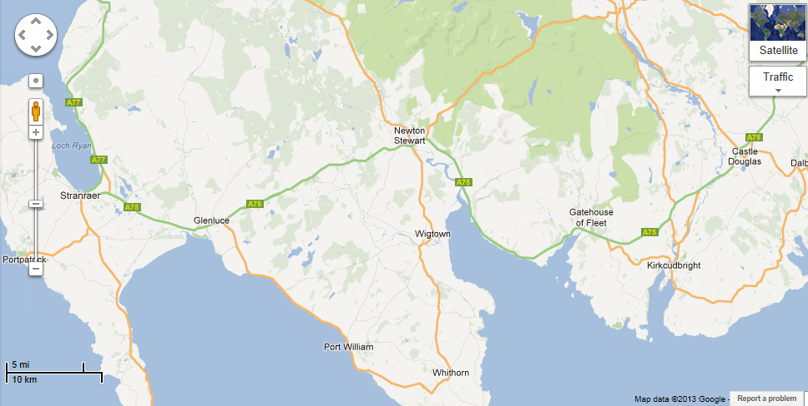

**Acceleration**

**Useful Equation:**

a

v –u

t

a

=

t

v - u

where: a is the acceleration of an object (m/s2)

v is the final velocity of an object (m/s)

u is the initial velocity of an object (m/s)

t is the time that an object accelerates for (s)

1. Copy and complete this table .

|  |  |  |  |
| --- | --- | --- | --- |
|  | ***Acceleration* / m/s2** | ***Change in Speed* / m/s** | ***Time /* s** |
| **(a)** |  | 12 | 6 |
| **(b)** |  | 16.5 | 5.5 |
| **(c)** | 0.5 |  | 18 |
| **(d)** | 1.2 |  | 30 |
| **(e)** | 0.125 | 0.50 |  |
| **(f)** | 2.70 | 11.34 |  |

1. What is the magnitude of the acceleration of a dog that starts from rest and reaches a speed of 4.0 metres per second in 2.0 seconds?
2. What is the size of the acceleration of a car that speeds up from 3 metres per second to 15 m/s in 7.5 seconds?
3. 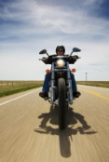A motorbike accelerates at a rate of 0.8 m/s2. How long will it take for the motorbike to increase in speed by 18 m/s?
4. What is the final speed of a sprinter who starts at rest and accelerates at 2.2 m/s2 for 4.5 seconds?

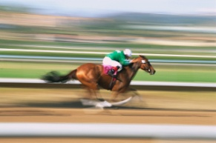

1. What was the initial speed of a horse that reaches a speed of 12.3 m/s after accelerating at a rate of 3.8 m/s2 for 2.5 seconds?
2. A car is travelling at 9.0 m/s when a cat runs out on to the road. The driver applies the brakes and comes to a stop 0.6 seconds later. What is the magnitude of the deceleration of the car during this time?
3. An aeroplane accelerates from 360 km/h to 396 km/h in 1 minute and 40 seconds. What is the size of the acceleration of the aeroplane in m/s2?
4. In an experiment, the acceleration of a ball is found by dropping it through two light gates connected to a timer. The change in speed of the ball and the time taken for the ball to pass between both light gates are measured. The spacing between the light gates are altered and the experiment is repeated. The results of this entire experiment are shown:

|  |  |
| --- | --- |
| ***Time /* s** | ***http://undsci.berkeley.edu/images/us101/falling_ball.jpgSpeed* / m/s** |
| 0.14 | 1.4 |
| 0.29 | 2.9 |
| 0.36 | 3.8 |
| 0.44 | 4.2 |
| 0.58 | 5.9 |
| 0.61 | 6.2 |

Draw a line graph of these results, and use the gradient of the graph to find the acceleration of the falling ball.

**Velocity-Time Graphs**

1. For each of these velocity-time graphs, describe the motion of the vehicle.

0

v

t

**(b)**

0

v

t

**(a)**

0

v

t

**(d)**

0

v

t

**(c)**

1. Plot a velocity-time graph from each of these sets of data.

|  |  |
| --- | --- |
| ***Time / s*** | ***Speed / m/s*** |
| 0 | 10 |
| 0.5 | 8.75 |
| 1 | 7.5 |
| 1.5 | 6.25 |
| 2 | 5.0 |
| 2.5 | 3.75 |

1. **(b)**

|  |  |
| --- | --- |
| ***Time / s*** | ***Speed / m/s*** |
| 0 | 0 |
| 1 | 1.5 |
| 2 | 3.0 |
| 3 | 4.5 |
| 4 | 6.0 |
| 5 | 7.5 |

1. Calculate the size of the acceleration of the vehicles represented by these velocity-time graphs.

**(b)**

0

v / m/s

t / s

**(a)**

3.0

12

6.8

v / m/s

0.85

0

t / s

0

0.3

v / m/s

t / s

**(c)**

0.5

1.8

0

4

v / m/s

t / s

**(d)**

4

16

1. Calculate the magnitude of the displacement of the vehicles represented by these velocity-time graphs.

0

v / m/s

t / s

**(a)**

7.0

16

0

v / m/s

t / s

**(b)**

2.8

4.5

7

v / m/s

t / s

**(c)**

18

3

0

4

v / m/s

t / s

**(d)**

8.5

16

0

6.0

3.0

1. A ball is bounced off a surface. The velocity-time graph of the ball is shown.

0

v / m/s

t / s

**A**

**B**

**C**

**D**

**E**

1. Describe the motion of the ball at each point indicated on the graph.
2. Explain why the ‘spikes’ on the velocity graph are getting smaller as time increases.
3. Sketch the *speed*-time graph of the ball during this time.

**Weight**

**Useful Equation:**

m

W

g

W = m g

where: W is the weight of on an object (N)

m is the mass of an object (kg)

g is the gravitational field strength (N/kg)

1. What is the difference between weight and mass?
2. Copy and complete this table:

|  |  |  |  |
| --- | --- | --- | --- |
|  | ***Weight* / N** | ***Mass* / kg** | ***Gravitational Field Strength (N/kg)*** |
| **(a)** |  | 3 | 10 |
| **(b)** |  | 0.25 | 9 |
| **(c)** | 300 |  | 10 |
| **(d)** | 210 |  | 7 |
| **(e)** | 520 | 65 |  |
| **(f)** | 3640 | 140 |  |

1. What is the weight of these objects on the surface of the Earth?
2. A 3 kg cat.
3. A 100 g apple.
4. A 65 kg pupil.
5. A 1200 kg car.
6. What happens to the weight of a space shuttle as it gets further away from the surface of the Earth? Give *two* reasons for your answer.
7. The mass of an astronaut is found to be 85 kg on Earth. What is the mass of the astronaut on the moon?

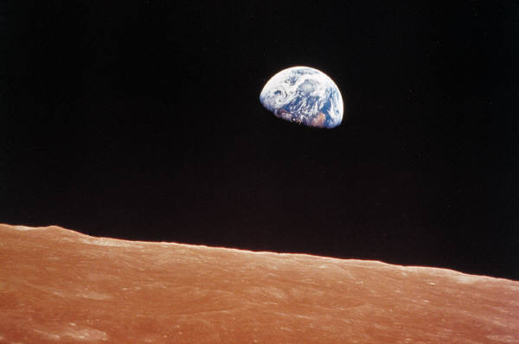

1. What is the weight of a 93 kg astronaut in the following places in the solar system:
2. C:\Users\Stephen\AppData\Local\Microsoft\Windows\Temporary Internet Files\Content.IE5\RE6RYTXF\MC900150142[1].wmfThe surface of Mars.
3. The surface of Jupiter.
4. The surface of Mercury.
5. Drifting in space on an ‘EVA’ – a space walk.
6. What is the mass of an astronaut who has a weight of 675 N on the surface of Venus?
7. An astronaut of mass 82.0 kg is standing on the surface of a planet in our solar system and measures his weight to be 902 N. Which planet is the astronaut standing on?
8. In a set of experiments being carried out on a far away planet, an alien measures the mass and weight of different objects. The results are shown.

|  |  |
| --- | --- |
| ***Mass /* kg** | ***Weight* / N** |
| 0.3 | 3.9 |
| 0.5 | 6.5 |
| 0.7 | 9.1 |
| 1.4 | 18.2 |
| 1.8 | 23.4 |
| 2.1 | 27.3 |

Draw a line graph of these results and use the gradient of the graph to calculate the gravitational field strength of the far away planet.

**Newton’s Laws**

**Useful Equation:**

Fun = m a

m

Fun

a

where: Fun is the unbalanced force acting on an object (N)

m is the mass of an object (kg)

a is the acceleration of an object (m/s2)

1. State the unbalanced force acting on each of these objects. Remember to include magnitude and direction.

2.5 N

8 N

**(b)**

5 N

7 N

**(a)**

8 N

13 N

**(d)**

15 N

8 N

12 N

**(c)**

1. Copy and complete this sentence:

When the forces acting on an object are balanced, the object will move with a constant ________________________. In other words, the object will have zero _____________________________.

1. Each of these vehicles is travelling at a constant speed. Calculate the value of the missing force in each of the situations.

135 N

?

**(b)**

?

120 N

**(a)**

C:\Program Files\Microsoft Office\MEDIA\CAGCAT10\j0212957.wmf

C:\Users\Stephen\AppData\Local\Microsoft\Windows\Temporary Internet Files\Content.IE5\PWI08MPO\MC900320948[1].wmf

C:\Users\Stephen\AppData\Local\Microsoft\Windows\Temporary Internet Files\Content.IE5\CJ7AZKB2\MC900333100[1].wmfC:\Users\Stephen\AppData\Local\Microsoft\Windows\Temporary Internet Files\Content.IE5\PWI08MPO\MC900296356[1].wmf

?

450 N

**(d)**

275 N

?

1.5 kN

**(c)**

1. 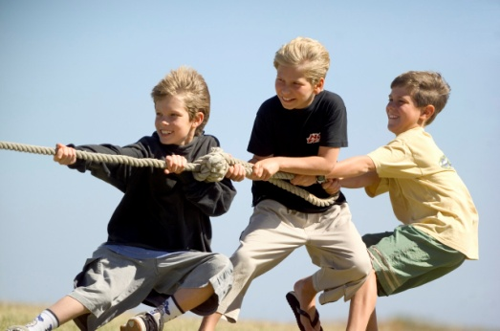In a tug of war competition, two teams of eight people are competing against each other. The teams start at rest, then each team exerts a total of 5.6 kN of force on the rope.
2. Describe and explain the motion of the teams.
3. What is the average force exerted by each person taking part?
4. One person leaves the competition. Assuming that the opposing team still pulls with a force of 5.6 kN, what is the average force per person required to keep to stop the other team from winning?
5. What is friction?
6. Give two examples of situations where it is a good idea to increase friction.
7. Give two examples of situations where it is a good idea to decrease friction.
8. Copy and complete this sentence:

When the forces acting on an object are unbalanced, the _________________________

_______________________________________________________________________.

1. Copy and complete this table.

|  |  |  |  |
| --- | --- | --- | --- |
|  | ***Unbalanced Force* / N** | ***Mass* / kg** | ***Acceleration* / m/s2** |
| **(a)** |  | 15 | 1.5 |
| **(b)** |  | 0.8 | 0.25 |
| **(c)** | 0.6 |  | 1.5 |
| **(d)** | 2.0 |  | 0.05 |
| **(e)** | 15 | 10 |  |
| **(f)** | 350 | 140 |  |

1. Calculate the acceleration of these objects.

40 kg

200 N

400 N

**(a)**

5 kg

45 N

35 N

**(b)**

135 kg

1.6 kN

350 N

**(d)**

0.5 kg

2.4 N

2.5 N

**(c)**

1. What is the unbalanced force acting on a 1200 kg car accelerating at 1.2 m/s2?

C:\Program Files\Microsoft Office\MEDIA\CAGCAT10\j0216858.wmf

1. C:\Users\Stephen\AppData\Local\Microsoft\Windows\Temporary Internet Files\Content.IE5\RE6RYTXF\MC900157387[1].wmfDescribe and explain, using Newton’s Laws, how the following safety features of a car could save your life:
2. Seat belts.
3. Air bags.
4. Bumpers.
5. A sky diver jumps out of an aeroplane. The graph shows the vertical speed of the sky diver for the first 60 seconds of the jump.

0

v / m/s

t / s

15

53

30

45

60

**A**

**B**

**C**

**D**

2

1. What are the two vertical forces acting on the sky diver during the jump?
2. What is meant by the term ‘terminal velocity’?
3. What is the terminal velocity of the sky diver in this example?
4. Explain, in terms of vertical forces, the motion of the sky diver at each of the points indicated on the graph.



1. Explain the results of these experiments:
2. When released from the same height on Earth, a hammer will hit the ground before a feather.
3. When released from the same height on the moon, a hammer and feather will hit the ground at the same time.
4. A space shuttle has a mass of 2.4 x 105 kg. What is the engine force required at launch to make the shuttle accelerate upwards at a rate of 18 m/s2?

C:\Users\Stephen\AppData\Local\Microsoft\Windows\Temporary Internet Files\Content.IE5\RE6RYTXF\MC900212247[1].wmf

1. In an experiment, a trolley is connected to hanging masses and placed on to an air track as shown.

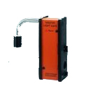

Trolley

Micro Computer

Air Track

Light Gate

Hanging Masses

The acceleration of the trolley is measured. The value of the hanging masses is then changed thus altering the force pulling the trolley. The results of the experiment are shown.

|  |  |
| --- | --- |
| ***Force /* N** | ***Acceleration* / N** |
| 0 | 0.0 |
| 0.1 | 0.5 |
| 0.2 | 1.0 |
| 0.3 | 1.5 |
| 0.4 | 2.0 |
| 0.5 | 2.5 |

Draw a line graph of these results, and use the gradient of the straight line to calculate the mass of the trolley.

1. Copy and complete these sentences:

If object A applies a force on to object B, then object B applies an ___________ but _________________ force back on to object A.

Every action has an _____________ but ___________________ reaction.

1. Identify the Newton pairs being represented in these examples:

**(b)**

**(a)**

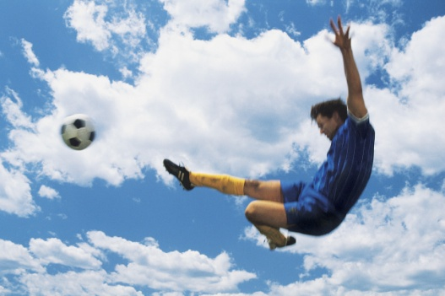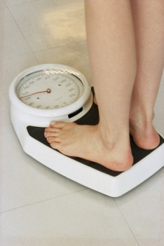

**(c)**

1. Explain, using Newton’s Third Law, how a space shuttle is able to take off from the surface of the Earth.

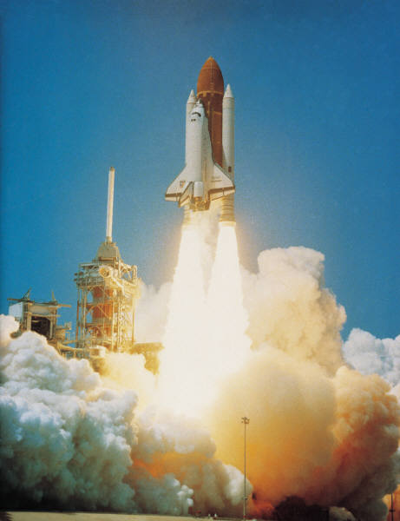

**Work Done**

**Useful Equation:**

F

Ew

d

Ew = F d

where: Ew is the work done on an object (J)

F is the force acting on an object (N)

d is the distance or displacement of an object (m)

1. What is meant by the term ‘work done’?
2. Copy and complete this table:

|  |  |  |  |
| --- | --- | --- | --- |
|  | ***Work Done* / J** | ***Force* / N** | ***Distance* / m** |
| **(a)** |  | 100 | 30 |
| **(b)** |  | 25 | 6.2 |
| **(c)** | 300 000 |  | 150 |
| **(d)** | 40 |  | 2 |
| **(e)** | 1250 | 125 |  |
| **(f)** | 144 000 | 3200 |  |

1. What is the work done by a shopper pushing a shopping trolley with an average force of 480 N over a distance of 35 metres?

C:\Users\Stephen\AppData\Local\Microsoft\Windows\Temporary Internet Files\Content.IE5\80M20XLK\MC900354041[1].wmf

1. What is the average force applied by a mother pushing a pram for a distance of 500 metres if her total work is 150 000 J?
2. What is the distance that a boy pushes his bike if he does 240 000 J of work and applies a constant force of 6000 N?
3. What is the work done by a truck if it drives 20 km with an average engine force of 1.5 kN?

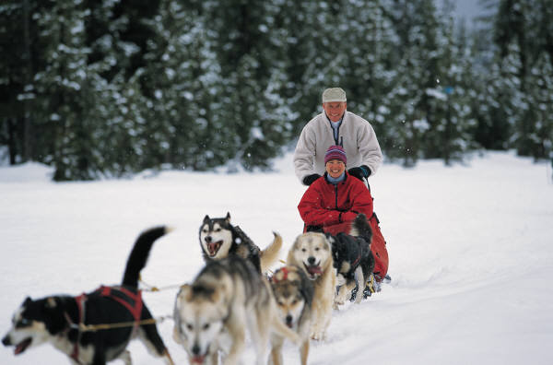

1. A group of 6 snow dogs pull a sledge with an average force of 600 N each. What is the distance that the sledge has been pulled when the total work done by all of the dogs is 90 MJ?
2. 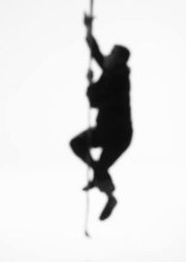The Formula 1 Australian Grand Prix is a race where the winning car drives 308 km. The work done by a car that completes the full race is 2.43 x 109 J. What is the average engine force of the car?
3. In a P.E. lesson, a pupil of mass 58 kg climbs 12 metres up a rope. What is the work done by the pupil during this climb?
4. In an experiment, a pupil measures the distance travelled and the work done by a battery powered toy car (using E = P t). The results are shown:

|  |  |
| --- | --- |
| ***Distance /* m** | ***Work Done* / J** |
| 0.0 | 0.00 |
| 2.5 | 11.25 |
| 5.0 | 18.00 |
| 7.5 | 33.75 |
| 10.0 | 45.00 |
| 12.5 | 56.25 |

Draw a line graph of these results and use the gradient of the straight line to find the average force of the motor of the toy car.



**Projectile Motion**

**Useful Equations:**

v H

=

t

s

v H

s

t

where: vH is the horizontal velocity of an object (m/s)

s is the horizontal displacement of an object (m)

t is time taken (s)

a

v –u

t

v v = u + at

where: a is the vertical acceleration of an object (m/s2)

vv is the final vertical velocity of an object (m/s)

u is the initial vertical velocity of an object (m/s)

t is the time that an object accelerates for (s)

1. Describe what is meant by ‘projectile motion’.
2. A rock is dropped from the top of a cliff. It lands in the sea 2.7 seconds after being dropped. What is the vertical velocity of the rock when it reaches the sea?

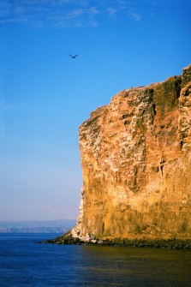

1. These graphs show how *vertical* velocity of an object changes with time. In each case, calculate the vertical displacement of the object.

0

v v / m/s

t / s

**(a)**

1.4

14

0

v v / m/s

t / s

**(b)**

3.8

11

1. These graphs show how *horizontal* velocity of an object changes with time. In each case, calculate the horizontal displacement of the object.

0

v H / m/s

t / s

**(b)**

0.4

5.6

0

v H / m/s

t / s

**(a)**

8.0

3.2

1. A monkey is relaxing in a tree when it sees a hunter climb a nearby tree and take aim with a bow and arrow. The hunter is aiming directly at the head of the monkey.

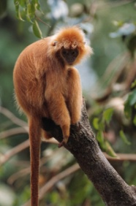

The monkey is smart though. It decides to jump out of the tree at the exact moment the arrow is released from the hunter’s bow.

Assume that the hunter has perfect aim, the monkey has zero reaction time and that air resistance is negligible.

Explain whether the monkey will avoid being struck by the arrow.

1. A cowboy uses a gun to fire a bullet horizontally. He drops his gun at *exactly* the same time as the bullet leaves. Which will hit the ground first – the bullet, the gun or will they land at the same time? Explain your answer.

The effects of air resistance should be ignored.

1. A high speed camera is used to analyse the motion of a ball falling with projectile motion. The ball is thrown from a height of 20 metres and photographed every 0.5 seconds as shown.

20

0

*Horizontal Distance* / m

15

16

12

8

4

0

3

6

9

12

*Vertical Distance from floor* / m



1. How long does it take for the ball to hit the floor?
2. What is the horizontal velocity of the ball?
3. C:\Users\Stephen\AppData\Local\Microsoft\Windows\Temporary Internet Files\Content.IE5\CJ7AZKB2\MC900191813[1].wmfA golfer hits a golf ball from the top of a hill with a horizontal velocity of 35 m/s. The ball takes 3.0 seconds to hit the ground.
4. What is the horizontal displacement of the ball when it lands?
5. What is the vertical velocity of the ball when it hits the ground?

35 m/s

C:\Users\Stephen\AppData\Local\Microsoft\Windows\Temporary Internet Files\Content.IE5\32QT04MX\MP900398861[1].jpg

1. A plane is travelling at a constant horizontal velocity of 75 m/s when a box is dropped out of it. The box lands on the ground after a time of 15.5 seconds.
2. What is the horizontal distance travelled by the box during the drop to the ground?
3. What is the horizontal displacement of the box, relative to the plane when it hits the ground?
4. What is the vertical velocity of the box when it hits the ground?
5. In reality, the vertical velocity of the box is around 55 m/s when it hits the ground. Explain the difference between this value and your answer to (c).

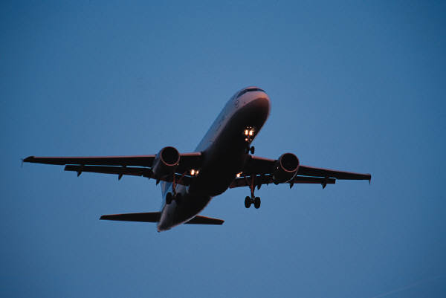

1. Using Newton’s Thought Experiment, explain how satellites stay in orbit around a planet.

**Specific Heat Capacity**

**Useful Equation:**

c

Eh

m

ΔT

Eh = c m ΔT

where: Eh is the heat energy absorbed by a material (J)

c is the specific heat capacity of a material (J / kg °C)

m is the mass of a material (kg)

ΔT is the change in temperature of a material (°C)

1. What is meant by the following statement:

“The specific heat capacity of water is 4180 J / kg °C.”

1. Copy and complete this table:

|  |  |  |  |  |
| --- | --- | --- | --- | --- |
|  | ***Heat Energy* / J** | ***Specific Heat Capacity / J* / kg °C** | ***Mass* / kg** | ***Change in Temperature* / °C** |
| **(a)** |  | 2350 | 2.0 | 10 |
| **(b)** |  | 902 | 5.0 | 25 |
| **(c)** | 36 900 |  | 4.5 | 2 |
| **(d)** | 6885 |  | 0.75 | 34 |
| **(e)** | 10 080 | 2100 |  | 12 |
| **(f)** | 105 600 | 480 |  | 40 |
| **(g)** | 2400 | 128 | 2.5 |  |
| **(h)** | 27 690 | 2130 | 3.25 |  |

1. C:\Users\Stephen\AppData\Local\Microsoft\Windows\Temporary Internet Files\Content.IE5\9K5OLWWR\MC900196458[1].wmfWhat is the heat energy required to heat 3.0 kg of water from 20 °C to 80°C?
2. A 2.4 kg lump of brass is heated up by a Bunsen burner. When 9120 J of heat energy has been absorbed, the temperature of the brass increases by 10 °C. What is the specific heat capacity of the brass?

C:\Users\Stephen\AppData\Local\Microsoft\Windows\Temporary Internet Files\Content.IE5\PWI08MPO\MC900389388[1].wmf

1. A pane of glass has a mass of 800 g. What is the temperature change of the glass if it is heated by 1000 J of heat energy?

1. A block of lead is heated from 24 °C to 28°C by a heat source that gives off 6144 J of heat energy. What is the mass of the lead block?
2. In an experiment, a 2 kg block of copper is warmed with a 70 W electrical immersion heater. The temperature of the copper is measured every minute using a thermometer. The heat energy used is calculated by finding the power of the heater and using E = P t. The results are shown.

Thermometer

Heater

Copper

|  |  |
| --- | --- |
| ***Heat Energy /* J** | ***Change In Temperature* / °C** |
| 0 | 0 |
| 4 200 | 3.4 |
| 8 400 | 6.8 |
| 12 600 | 10.2 |
| 16 800 | 13.6 |
| 21 000 | 17.0 |

1. Using *this data*, draw a line graph and use the gradient of the straight line to find the specific heat capacity of copper.
2. Is this experimental value for the specific heat capacity of copper larger, smaller or the same as the actual value? Explain any difference.

**Specific Latent Heat**

**Useful Equation:**

m

Eh

l

Eh = m l

where: Eh is the heat energy absorbed or given out by an object (J)

m is the mass of a material (kg)

l is the specific latent heat of fusion or vaporisation (J/kg)

1. What is the meaning of the following terms:
2. Specific Latent Heat of Vaporisation?
3. Specific Latent Heat of Fusion?
4. Copy and complete this flow diagram to show the name given to each change of state.

Solid

Liquid

Gas

**(a)**

**(b)**

**(c)**

**(d)**

Heat gained by substance

Heat lost by substance

1. Stearic acid is a solid at room temperature. 100 g of stearic acid is heated in a water bath until it reaches a temperature of 85 °C. A graph of how the temperature changes with time is shown.

0

Temperature/ °C

*Time* / mins

5

10

20

70

15

**A**

**B**

85

Describe and explain what happens to the stearic acid between points A and B.

1. Copy and complete this table:

|  |  |  |  |
| --- | --- | --- | --- |
|  | ***Heat Energy* / J** | ***Mass* / kg** | ***Specific Latent Heat of Fusion* / J/kg** |
| **(a)** |  | 1.5 | 0.99 x 105 |
| **(b)** |  | 0.6 | 3.95 x 105 |
| **(c)** | 144 000 |  | 1.80 x 105 |
| **(d)** | 266 500 |  | 2.05 x 105 |
| **(e)** | 60 000 | 2.4 |  |
| **(f)** | 48 060 | 0.18 |  |

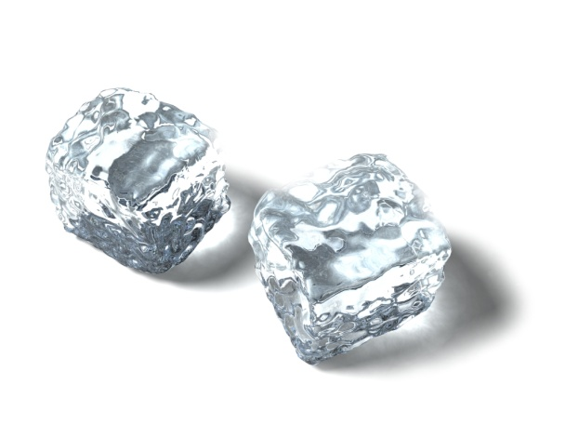

1. How much heat energy is required to:
2. Turn 400 g of ice in to 400 g of water?
3. Turn 400 g of water in to 400 g of steam?
4. C:\Users\Stephen\AppData\Local\Microsoft\Windows\Temporary Internet Files\Content.IE5\9K5OLWWR\MC900351496[1].wmfHow much heat energy is given out by:
5. 400 g of steam turning in to 400 g of water?
6. 400g of water turning in to 400 g of ice?
7. What is the mass of alcohol if 1.008 MJ of energy is required to change all of the alcohol from a liquid to a gas?
8. A 50 g substance is a gas at room temperature. It is cooled to a very low temperature and it becomes 50 g of liquid. If the substance releases 18 850 J of heat energy as it changes state:
9. What is the specific latent heat of vaporisation of the substance?
10. What is the name of the substance?

C:\Users\Stephen\AppData\Local\Microsoft\Windows\Temporary Internet Files\Content.IE5\32QT04MX\MC900030279[1].wmf

1. In a laboratory, 150 g of water is found to have a temperature of 20 °C. It is heated to a temperature of 100 °C and it is all converted in to steam. How much heat energy is required to do heat 150 g of water at 20 °C in to 150 g of steam at 100 °C?
2. During an experiment, a 1.5 kW kettle is filled with 400 g of water and switched on. After 30 seconds, the heat energy given to the water is calculated (using E = P t), the mass of the water is measured with digital scales and the mass loss of the water is worked out. The results of the experiments are shown.

|  |  |
| --- | --- |
| ***Heat Energy /* J** | ***Mass Loss of Water* / g** |
| 0 | 0 |
| 750 | 0.14 |
| 1500 | 0.27 |
| 2250 | 0.41 |
| 3000 | 0.55 |
| 3750 | 0.68 |

1. Using *this data*, draw a line graph and use the gradient of the straight line to find the specific latent heat of vaporisation of water.
2. Is this experimental value for the specific latent heat of vaporisation of water larger, smaller or the same as the actual value? Explain any difference.

**Space Exploration**

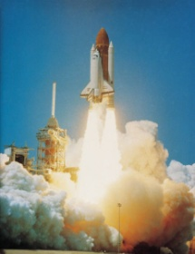

1. A space shuttle is about to be launched from the surface of the Earth. It has a mass of 7.9 x 104 kg.
2. What is the weight of the space shuttle at launch?
3. Describe and explain what happens to the weight of the space shuttle as it gets further away from the surface of the Earth.
4. A space rocket has a mass of 9.0 x 104 kg. What engine thrust is required to make the rocket accelerate at 25 m/s2 at take off?

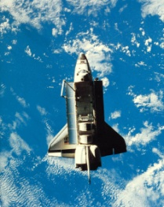

1. A spacecraft of mass 9000 kg is to re-enter Earth’s atmosphere. Just before re-entry it has a speed of 7500 m/s. At a point during re-entry, the speed of the spacecraft drops to 700 m/s. What is the heat energy gained by the spacecraft up to this point in re-entry?
2. A pupil in a physics class makes the following statement:

“The material used to protect space shuttles during re-entry needs to have a low specific heat capacity”.

Do you agree or disagree with this statement? Give a reason for your opinion.

1. A 50 kg piece of space junk orbits the Earth with a speed of 1200 m/s. It re-enters the Earth’s atmosphere and its speed drops to 400 m/s. The specific heat capacity of the piece of space junk is 850 J/kg °C. What is the temperature change of the space junk during re-entry?

C:\Users\Stephen\AppData\Local\Microsoft\Windows\Temporary Internet Files\Content.IE5\CJ7AZKB2\MC900083187[1].wmf

1. A NASA scientist has to choose a suitable material to construct heat tiles on the outside of a space shuttle. The possible materials are shown.

|  |  |  |  |
| --- | --- | --- | --- |
| ***Material*** | ***Density (g /cm3)*** | ***Specific Heat Capacity* (J/kg °C)** | ***Melting Point* (°C)** |
| Aluminium | 2.700 | 897 | 660 |
| Copper | 8.960 | 385 | 1085 |
| Iron | 7.874 | 450 | 1538 |
| Silica | 2.448 | 703 | 1725 |
| Titanium | 4.506 | 523 | 1668 |

Which material is best suited to protect a space shuttle during re-entry to the Earth’s atmosphere? Give reasons for your answer.

1. Voyager 2 is a spacecraft that was launched on August 20th 1977. It took many photographs of Jupiter, Saturn, Uranus and Neptune in the 1980s and is still in contact with the Earth despite now being over 1.50 x 1013 metres away. Why is it useful to have explored these planets using spacecraft, such as Voyager 2, and telescopes?

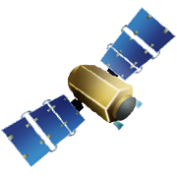

1. Satellites which orbit the Earth are of great use to society. Give some examples of everyday use of satellites.
2. The Hubble Space Telescope orbits the Earth and is used to look at far away stars and galaxies. Why does the Hubble Space Telescope get clearer images of space than telescopes on the surface of the Earth?
3. As a result of space exploration, many ‘spin-off’ technologies have been developed that have gone on to be of great use on Earth.

Choose an area from the list and write a short description of how space exploration has benefitted it:

C:\Users\Stephen\AppData\Local\Microsoft\Windows\Temporary Internet Files\Content.IE5\PWI08MPO\MC900057033[1].wmfC:\Program Files\Microsoft Office\MEDIA\CAGCAT10\j0233312.wmf

*Environment & Agriculture*

*Home*

*Industry*

*Medicine*

*Transport*

**Cosmology**

1. How far is a light year, in metres?
2. Copy and complete this table.

|  |  |  |  |
| --- | --- | --- | --- |
|  | ***Celestial Body*** | ***Average distance from the Sun (m)*** | ***Time taken for light from the sun to travel to body*** |
| **(a)** | Earth |  | 8 minutes |
| **(b)** | Neptune | 4.503 x 1012 |  |
| **(c)** | Proxima Centauri |  | 4.3 years |
| **(d)** | Betelgeuse | 6.079 x 1018 |  |
| **(e)** |  |  | 434 years |

1. On average, Jupiter is around 7.78 x 1011 metres from the Sun. How long does it take for light from the Sun to reach Jupiter?

C:\Users\Stephen\AppData\Local\Microsoft\Windows\Temporary Internet Files\Content.IE5\32QT04MX\MC900083191[1].wmf

1. By using detailed analysis of the stars and galaxies that surround us, astronomers have made some theories about the observable universe, all of which have been backed up by experimental evidence.
2. Why are there parts of the universe that can’t be observed from Earth?
3. Explain the ‘Big Bang’ theory regarding the origin of the universe.
4. How old is the universe believed to be? Explain how astronomers came to this estimate.
5. Copy and complete this sequence to show the electromagnetic spectrum in order of increasing wavelength.

**(a)**

**X Rays**

**(b)**

**Visible**

**(c)**

**Micro waves**

**(d)**

1. Why is it useful to study electromagnetic radiation from stars and galaxies which have wavelengths outside of the visible spectrum?

1. Why are radio telescopes often found in large groups called ‘arrays’?

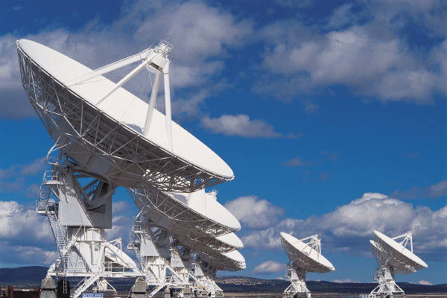

1. COBE (Cosmic Background Explorer) is a satellite that detects infrared and microwave ‘background’ radiation in space. Why is COBE collecting this data?

C:\Users\Stephen\AppData\Local\Microsoft\Windows\Temporary Internet Files\Content.IE5\RE6RYTXF\MC900371088[1].wmf

1. SETI (Search for Extra-Terrestrial Intelligence) is a group of organisations that study electromagnetic radiation, in particular radio waves, from space. Why are the SETI organisations analysing this data?
2. A beam of white light is shone through a Perspex prism as represented in the diagram.

White light

Copy and complete the diagram to show what happens to the light as it passes through the prism.

1. The emission spectra of some elements are shown below.

**Hydrogen**



**Helium**

File:Helium Emission Spectrum.svg

**Lithium**



**Neon**



**Carbon**



**Sodium**



**Beryllium**



Which elements are present in stars that produce these emission spectra?

**(a)**



**(b)**



**(c)**

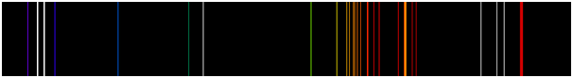

**(d)**



**(e)**

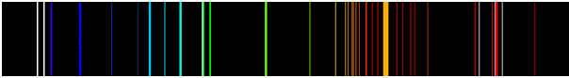

**Answers**

**Velocity & Displacement (p4 – 6)**

1. *Scalar* quantities have a magnitude only.

*Vector* quantities have a magnitude and direction.

1. *Scalars*: Speed, Distance, Mass, Time, Energy.

*Vectors*: Force, Velocity, Displacement, Acceleration

1. **(a)** 10m/s
2. 12 m/s
3. 30 s
4. 48 s
5. 360 m
6. 7.5 m
7. **(a)** 40 m
8. 10m west
9. 0.8 m/s
10. 0.2 m/s west
11. **(a)** 0 m
12. 8.89 m/s
13. 0 m/s
14. **(a)** 700 m
15. 500 m (053°)
16. 0.78 m/s
17. 0.56 m/s (053°)
18. **(a)** 18.3 m/s
19. 66 km/h
20. 13.0 m/s (140°)
21. **(a)** 85.0 km/h
22. 46.1 km/h (283°)
23. **(a)** 19.8 m/s
24. 15.4 m/s (260°)

**Acceleration (p7 – 8)**

1. **(a)** 2 m/s2
2. 3 m/s2
3. 9 m/s
4. 36 m/s
5. 4 s
6. 4.2 s
7. 2 m/s2
8. 1.6 m/s2
9. 22.5 s
10. 9.9 m/s
11. 2.8 m/s
12. -15 m/s2
13. 0.1 m/s2
14. 10 m/s2

**Velocity-Time Graphs (p9 – 11)**

1. **(a)** Uniform acceleration
2. Uniform deceleration
3. Constant speed / zero acceleration
4. Accelerates uniformly from rest. Stays at a constant speed. Decelerates uniformly until it has stopped.

0

v / m/s

t / s

**(a)**

5

7.5

0

v / m/s

t / s

**(b)**

2.5

10

3.75

1. **(a)** 4 m/s2
2. 8 m/s2
3. 3 m/s2
4. -3 m/s2
5. **(a)** 56 m
6. 12.6 m
7. 43.5 m
8. 118 m
9. **(a)** A – ball is accelerating

down towards ground.

B – ball is bouncing on ground.

C – ball is decelerating upwards.

D – ball reaches highest point.

E – ball is accelerating down towards ground.

1. The ball is losing energy

0

v / m/s

t / s

**Weight (p12 – 13)**

1. *Mass* is a measure of how much of an object is there. It is measured in kg.

*Weight* is a downward force caused by gravity.

It is measured in N.

1. **(a)** 30 N
2. 2.25 N
3. 30 kg
4. 30 kg
5. 8 N/kg
6. 26 N/kg
7. **(a)** 30 N
8. 1 N
9. 650 N
10. 12 000 N
11. The weight of the space shuttle *decreases*.

This is because:

* There is less mass due to fuel being used up.
* The shuttle is getting further away from the surface of the Earth.

1. 85 kg
2. **(a)** 372 N
3. 2418 N
4. 372 N
5. 0 N
6. 75 kg
7. Saturn
8. 13 N/kg

**Newton’s Laws (p14 – 19)**

1. **(a)** 2 N to the right
2. 5.5 N to the right
3. 4 N to the left
4. 10 N to the left
5. Speed, acceleration.
6. **(a)** 120 N
7. 135 N
8. 1.5 kN
9. 175 N
10. **(a)** Teams remain at rest.
11. 700 N
12. 800 N
13. Friction is a force that opposes motion.
14. Tread on vehicle tyres, grips on shoes.
15. Streamlined shape of vehicles, lubrication in engines.
16. The object will accelerate in the direction of the unbalanced force.
17. **(a)** 22.5 N
18. 0.2 N
19. 0.4 kg
20. 40 kg
21. 1.5 m/s2
22. 1.5 m/s2
23. **(a)** 5 m/s2 to the right
24. 2 m/s2 to the left
25. 0.2 m/s2 to the right
26. 10 m/s2 to the left
27. 1440 N
28. *Seat belts* create an unbalanced force when a car brakes allowing a person to slow down with the car.

*Air bags* and *bumpers* increase the time taken to slow down during a collision, reducing the force acting on a person.

1. **(a)** Weight & air resistance
2. Terminal velocity is the speed at which a falling object stops accelerating.
3. 53 m/s
4. A – Weight > Air resistance, so sky diver is accelerating.

B – Weight = Air resistance, so sky diver has constant speed.

C – Weight < Air resistance, so sky diver is decelerating.

D – Weight = Air resistance, so sky diver has constant speed.

1. **(a)** A hammer is more

streamlined than a

feather.

1. There is no air resistance on the moon
2. 1. 92 x 106 N
3. 0.2 kg
4. Equal, opposite, equal, opposite.
5. **(a)** Hammer imparts a

force on nail. Nail

imparts a force back on

to hammer.

1. Foot imparts a force on ball. Ball imparts a force back on foot.
2. Person pushes down on scales. Scales push back up on person.
3. Shuttle pushes gases down. Gases push shuttle up.

**Work Done (p20 – 21)**

1. Work done is the energy transferred to an object.
2. **(a)** 3000 J
3. 155 J
4. 2000 N
5. 20 N
6. 10 m
7. 45 m
8. 16 800 J
9. 300 N
10. 40 m
11. 3 x 107 J
12. 25 km
13. 7890 N
14. 6960 J
15. 4.5 N

**Projectile Motion (p22 – 25)**

1. A projectile has vertical and horizontal motion at the same time.
2. 27 m/s
3. **(a)** 9.8 m
4. 41.8 m
5. **(a)** 25.6 m
6. 2.24 m
7. Monkey gets struck by arrow. It falls at the same rate as the arrow.
8. Gun and bullet hit the ground at the same time. They fall at the same rate.
9. **(a)** 2 s
10. 6 m/s
11. **(a)** 105 m
12. 30 m/s
13. **(a)** 1162.5 m
14. 0 m
15. 155 m/s
16. Air resistance will slow the box.
17. A projectile with a high enough horizontal velocity will fall with the curvature of the Earth, staying in orbit.

**Specific Heat Capacity**

**(p26 – 27)**

1. 4180 J of heat energy is needed to change the temperature of 1 kg of water by 1 °C.
2. **(a)** 47 000 J
3. 112 750 J
4. 4100 J / kg °C
5. 270 J / kg °C
6. 0.4 kg
7. 5.5 kg
8. 7.5 °C
9. 4 °C
10. 752 400 J
11. 380 J / kg °C
12. 2.5 °C
13. 12 kg
14. **(a)** 618 J / kg °C
15. The experimental value is larger. This is because not all heat energy is absorbed by the copper block.

**Specific Latent Heat (p28 - 30)**

1. **(a)** The energy required to

change 1 kg of a liquid

in to a gas OR the

energy given out by 1

kg of a gas turning in

to a liquid.

1. The energy required to change 1 kg of a solid in to a liquid OR the energy given out by 1 kg of a liquid turning in to a solid.
2. **(a)** Melting
3. Evaporating
4. Freezing
5. Condensing
6. The stearic acid is changing state from solid to liquid.
7. **(a)** 148 500 J
8. 237 000 J
9. 0.8 kg
10. 1.3 kg
11. 0.25 x 105 J/kg
12. 2.67 x 105 J/kg
13. **(a)** 133 600 J
14. 904 000 J
15. **(a)** 904 000 J
16. 133 600 J
17. 0.9 kg
18. **(a)** 3.77 x 105 J/kg
19. Carbon Dioxide
20. 389 160 J
21. **(a)** 5.35 x 106 J/kg
22. The experimental value is larger. This is because some of the heat energy is being used to change the temperature of the water, rather than change its state.

**Space Exploration (p31 – 32)**

1. **(a)** 7.9 x 105 N
2. The weight of the space shuttle *decreases*.

This is because:

* There is less mass due to fuel being used up.
* The shuttle is getting further away from the surface of the Earth.

1. 1.35 x 106 N
2. 2.51 x 1011 J
3. *Disagree*. High specific heat capacity is required to stop the surface of the tiles increasing in temperature by too much.
4. 753 °C
5. *Silica*. It has a low density, a high specific heat capacity and a high melting point.
6. Astronomers get a more detailed image of a planet than can be seen with the naked eye. Helps give a better idea of how the solar system was created.
7. Telephones, television, GPS, etc.
8. The Earth’s atmosphere can’t distort an image seen by the Hubble space telescope.
9. *Environment & Agriculture*: Water purification, solar energy.

*Home*: Memory foam, cordless vacuum cleaners.

*Industry*: Lubricants, food safety.

*Medicine*: Infrared ear thermometers, artificial limbs.

*Transport*: Anti-icing systems, improved tyres.

**Cosmology (p33 – 36)**

1. 9.46 x 1015 m
2. **(a)** 1.44 x 1011 m
3. 4.17 hours
4. 4.07 x 1016 m
5. 642.5 years
6. 4.106 x 1018 m, Polaris / North Star / Ursa Minor
7. 43.2 minutes
8. **(a)** Light from these

objects haven’t

reached Earth yet.

1. The Big Bang theory describes an event at which the universe started to expand and grow. It is still expanding to this day.

White light

R

V

1. 13.8 billion years. This figure came from studies of cosmic background radiation, and analysing the speed and positions of stars and galaxies.
2. **(a)** Gamma rays
3. Ultraviolet radiation
4. Infrared radiation
5. Radio waves
6. Visible light from far away objects can’t always pass through some regions of space. However, other members of the electromagnetic spectrum can. Therefore, astronomers can get more detailed images of far away object. Also, the temperature of stars can be more accurately estimated.
7. Radio telescopes are often found in arrays to pick up more radio waves, and get more detailed images of stars or galaxies.
8. COBE collects infrared radiation and microwaves to look for proof of the Big Bang theory.
9. SETI are searching for artificial electromagnetic waves that could prove the existence of extraterrestrial life.
10. **(a)** Hydrogen & Helium
11. Helium & Neon
12. Lithium & Neon
13. Helium & Sodium
14. Carbon, Beryllium & Neon