

**Physics**

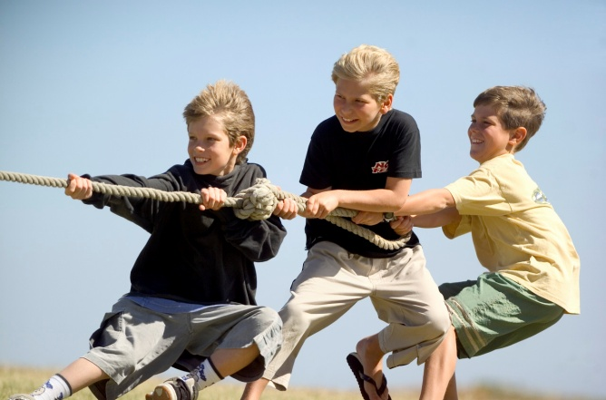

Dynamics and Space

1.2 Forces

Name_______________ Class ____

**SCN 4-07b**

By making accurate measurements of speed and acceleration, I can relate the motion of an object to the forces acting on it and apply this knowledge to transport safety.

**SCN 4-16a**

I have carried out research into novel materials and can begin to explain the scientific basis of their properties and discuss the possible impacts they may have on society.

**SCN 4-20a**

I have researched new developments in science and can explain how their current or future applications might impact on modern life.

**SCN 4-20b**

Having selected scientific themes of topical interest, I can critically analyse the issues, and use relevant information to develop an informed argument.

**Content National 4**

**Relationship between forces, motion and energy**

* The use of Newton’s first law and balanced forces to explain constant speed, making reference to frictional forces.
* The use of Newton’s second law to explain the movement of objects in situations involving constant acceleration.
* Calculations using the relationship between force, mass and acceleration in situations where only one force is acting.
* Calculations using the relationship between weight, mass and gravitational field strength within our solar system.
* Risks and benefits associated with space exploration including challenges of re-entry to a planet’s atmosphere.
* The use of thermal protection systems to protect spacecraft on re-entry.

**Content National 5**

**Newton’s laws**

* Applications of Newton’s laws and balanced forces to explain constant velocity, making reference to frictional forces.
* Calculations involving the relationship between unbalanced force, mass and acceleration for situations where more than one force is acting.
* Calculations involving the relationship between work done, unbalanced force and distance/displacement.
* Calculations involving the relationship between weight, mass and gravitational field strength during interplanetary rocket flight.
* Newton’s second law and its application to space travel, including rocket launch and landing.
* Newton’s third law and its application to explain motion resulting from a ‘reaction’ force.
* Use of Newton’s laws to explain free-fall and terminal velocity

**Projectile motion**

* Explanation of projectile motion.
* Calculations of projectile motion from a horizontal launch using appropriate relationships and graphs.
* Explanation of satellite orbits in terms of projectile motion.

**At National 4 level, by the end of this section you should be able to:**

Relationship between forces, motion and energy

❑ 1. Use Newton’s first law and balanced forces to explain constant speed, making references to frictional forces.

❑ 2. Use Newton’s second law to explain the movement of objects in situations involving constant acceleration.

* Make and use accurate measurements of speed and acceleration to relate the motion of an object to the forces acting on it and apply this knowledge to transport safety.

❑ 3. Carry out calculations involving the relationship between force, mass and acceleration in situations where only one force is acting.

❑ 4. Carry out calculations involving the relationship between weight, mass and gravitational field strength within our solar system.

❑ 5. List the risks and benefits associated with space exploration and challenges of re-entry to a planet’s atmosphere.

❑ 6. Describe the use of thermal protection systems to protect spacecraft on re-entry.

**Additionally, at National 5 level:**

Newton’s Laws

🔾 7. Apply Newton’s laws and balanced forces to explain constant velocities, making references to frictional forces.

🔾 8. Carry out calculations involving the relationship between unbalanced force, mass and acceleration in situations where more than one force is acting.

🔾 9. Carry out calculations involving the relationship between work done, unbalanced force and distance/displacement.

🔾 10. Carry out calculations involving the relationship between weight, mass and gravitational field strength during interplanetary rocket flight.

🔾 11. Apply Newton’s second law to space travel, including rocket launch and landing.

🔾 12. Apply Newton’s third law to explain motion resulting from a ‘reaction’ force.

🔾 13. Use Newton’s third law to explain free-fall and terminal velocity.

.

Forces can do three things to an object.

Change the –

1. . Shape

2. Speed

3. Direction

# Measuring Force

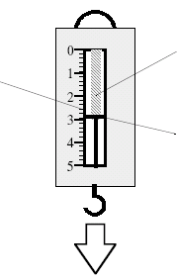

Spring

Scale

When a force is applied the spring is stretched. The pointer moves down the scale and tells you how much force has been applied.

Force is measured in Newtons (N).

Pointer

FORCE

Equal forces in opposite directions

In both cases the trolley will not move.





# Balanced Forces on the Move



Trolley will move with constant speed in a straight line (this is the same as constant velocity).

50N

50N

Lift

Force of ground on tyres

# C:\Documents and Settings\nancyhunter\Local Settings\Temporary Internet Files\Content.IE5\CR28S5NJ\MC900320932[1].wmfC:\Documents and Settings\nancyhunter\Local Settings\Temporary Internet Files\Content.IE5\ETDZV2HM\MC900318354[1].wmfC:\Documents and Settings\nancyhunter\Local Settings\Temporary Internet Files\Content.IE5\NR5E1W91\MC900383858[1].wmfC:\Documents and Settings\nancyhunter\Local Settings\Temporary Internet Files\Content.IE5\ETDZV2HM\MC900326676[1].wmf

Friction

or Drag

Friction

or Drag

Air Resistance

or Drag

Engine Force

Engine Force

Engine Force

Buoyancy force or

Upthrust

Buoyancy force or

Upthrust

Weight

Weight

Weight

Weight

An object at rest will remain at rest or will remain at constant speed in a straight line unless acted on by an unbalanced force.

# Seatbelts

When a car stops suddenly you will continue to move forwards at the original speed of the car until something stops you.

If you wear your seat belt it will provide a force in the opposite direction to stop you – preventing more serious injuries.

# Friction

Definition – Friction is a force which opposes motion.

INCREASING FRICTION DECREASING FRICTION

Smooth surfaces

Streamlining

Decrease surface area –

Use rollers

Use ball bearings

Use lubrication – oil or graphite

Brakes – increased roughness

* Increased surface area
* Increase force

Car tyres – tread

Shoes – rubber grips

The acceleration of an object varies directly with the unbalanced force and inversely with its mass.

F = ma F = force (N)

a = acceleration (m/s2)

m = mass (kg)

**Example 1**

Calculate the unbalanced force needed

to accelerate a bike of mass 60kg at a

rate of 4m/s2.

F = ma = 4 x 60 = 240N

**Example 2**

Calculate the acceleration caused by a force of 300N acting on a 25kg mass.

F = ma ⇒ 300 = 2.5 a

⇒ a = 300/2.5 = 12m/s2

**Example 4**

A boy pushes his sister downhill on her sledge with a force of 150N. The combined mass of the girl and sledge is 40kg. What is her acceleration?

F = ma ⇒ 150 = a x 40

⇒ m = 150/40 = 3.75m/s2

**Example 3**

An object accelerates at 15m/s2 when a force of 900N is applied. What was its mass?

F = ma ⇒ 900 = m x 15

⇒ m = 900/15 = 600kg

Force is a vector quantity. Any force has both magnitude (size) and direction.

Like any other vector quantity you can add two force vectors together.

C:\Documents and Settings\nancyhunter\Local Settings\Temporary Internet Files\Content.IE5\EOETE3UC\MC900056961[1].wmf

In a tug-o-war the two sides each exert a force.

If the forces are balanced then neither side moves. Resultant = 0

2000N

2000N

If one side is stronger and exerts a greater force than the other there is an unbalanced force – leading to an acceleration in that direction.

Resultant = 500N to the right

2000N

1500N

**Example 5**

A dog out for a walk sees a cat and tries to chase after it. It exerts a force of 75N forwards on the lead. If the child holding the lead can exert a force of 65N backwards – what will happen?

The child will be pulled forwards because there is an unbalanced force of 10N acting forwards.

**Example 8**

A boat engine is able to apply a force of 6000N. The boat has a mass of 500kg and accelerates at a rate of 10m/s2.

1. Calculate the size of the frictional force acting on the boat.
2. What will happen to this force if the barnacles grow on the hull over the summer
3. F = ma ⇒ F = 500 x 10 ⇒ F = 5000N.

Actual force applied = 6000N

Frictional force = 6000 – 5000 = 1000N

1. When barnacles grow on the hull the surface will become rougher, increasing the frictional force. The boat will be unable to accelerate at the same rate and will use more fuel.

**Example 7**

A car has an engine force of 5000N. Each of the four tyres has a frictional force of 50N with the road.

If the mass of the car is 1200kg, what is the acceleration?

Fun = 5000 – (4 x 50) = 5000- 200 = 4800N

F = ma ⇒ 4800 = 1200 a ⇒ a = 4m/s2

**Example 6**

A motorbike of mass 800kg has an

engine force of 12,000N.

The frictional force is 2000N.

What is the acceleration of the bike?

Fun = 12,000 – 2000 = 10,000N

F = ma ⇒ 10,000 = 800 a ⇒ a = 12.5 m/s2

**Example 9**

A boat tows a barge with a force of 800N South. The tide exerts a force of 600N East. What is the effect of these forces on the barge?

Use a scale drawing. Scale 1cm = 100N

Resultant force = 1000N at 143⁰

Gravity is a force of attraction that exists between objects because of their masses.

We are aware of gravity on Earth because it has a very large mass compared to a person.



**Gravititational Field Strength**

Gravitational Field Strength = force per unit mass

Force of gravity = pull of Earth on an object = gravitational force on an object

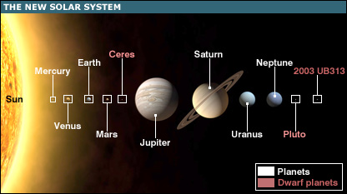

Different planets have different gravitational field strengths because they have different masses.

Weight is a downwards force due to gravity.

W = mg W = weight (N)

m = mass (kg)

g = acceleration due to gravity (m/s2) or gravitational field strength (N/kg)

**Example 11**

What is the mass of an object which has a weight of 7200N on Earth.

W = mg ⇒ 7200 = 10m ⇒ m = 720kg

**Example 10**

What is the weight of a person with a mass of 65kg (on Earth)

W = mg = 65 x 10 = 650N

Your weight can change depending upon where you are – even on Earth.

The mass of an object stays the same – regardless of where you are.

If you go to a different planet you have a different weight because the weight of an object depends on the acceleration due to gravity.

**Example 12**

Find the weight and mass of a 75kg spaceman on

1. Moon
2. Mars
3. Mass = 75kg W= mg = 75 x 1.6 = 120N
4. Mass = 75kg W = mg = 75 x 4 = 300N

|  |  |
| --- | --- |
| **Planet/Moon** | **‘g’ (N/kg)** |
| Mercury | 4 |
| Venus | 9 |
| Earth | 10 |
| Mars | 4 |
| Jupiter | 25 |
| Saturn | 10 |
| Uranus | 10 |
| Neptune | 12 |
| Moon | 1.6 |

**Example 16**

How far can a football team tow a truck using a force of 1500N if their available energy is 22,500J ?

Ew = Fd ⇒22,500 = 1500 x d

⇒ d = 15m

**Example 15**

A winch uses 750J of energy pulling a car 6m out of a ditch. What force is exerted on the car?

Ew = Fd ⇒750 = F x 6 ⇒ F = 125N

**Example 14**

A battery powered model car has a motor which exerts a force of 1.5N over a distance of 25m.

How much work does the motor do?

Ew = Fd = 1.5x 25 = 37.5J

**Example 13**

A cyclist exerts a force of 200N when riding a bike a distance of 60m.

How much work has she done?

Ew = Fd = 200 x 60 = 12,000J

When you exert a force on an object for a certain distance you use energy. This is called ‘Work Done’.

Ew = Fd W = Work done (Joules – J)

F = Force (N)

d = distance (m)

For every action force there is an equal and opposite reaction force.

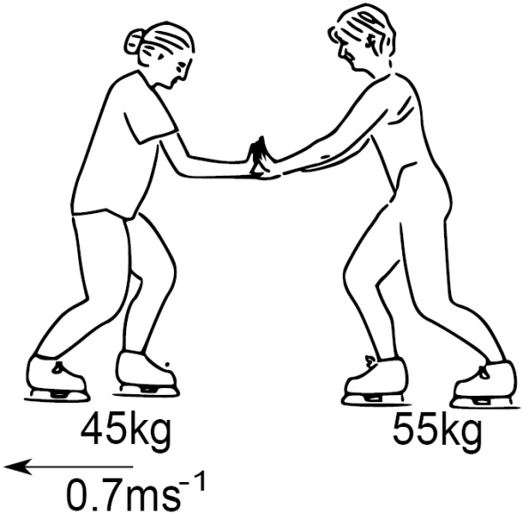

Lift force pushes up on the air.

The air pushes down on the balloon.

Skater A pushes on Skater B

Skater B pushes back on Skater A

Swimmer pushes back on the water.

The water pushes forward on the swimmer

C:\Documents and Settings\nancyhunter\Local Settings\Temporary Internet Files\Content.IE5\8NCHQ1SJ\MC900332876[1].WMF

The walker pushes backwards on the ground.

The ground pushes the walkers foot forwards

Fun = Engine Force – [Weight + Frictional forces]

As long as Fun > zero the rocket will take off and accelerate.

Use **F = ma** to calculate the acceleration.

As the rocket rises the acceleration increases because

* Mass decreases as fuel is used up
* Weight decreases as gravitational field strength decreases (with height)
* Frictional forces decrease since ‘air is thinner’

*[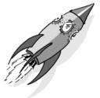](http://www.picsearch.com/imageDetail.cgi?id=ZWtBfg6bLGGzJitDWnDf-XUMAl9l9UX8wI6xVrv1NMo&width=1259&start=91&q=Rocket)*

Example 17

After lift off a spacecraft of mass 6000kg applies its thruster rockets with a combined thrust of 480000N. What is the acceleration of the rocket?

W = mg = 6000 x 10 = 60,000N

Unbalanced force = 480,000 – 60,000 = 420,000N

F = ma => a = 420,000/6000 = 70 m/s2

A high speed stream of hot gases, produced by burning fuel, is pushed backwards – with a large force.

A force of the same size pushes the rocket forwards.

ACTION = Rocket pushes hot gases backwards

REACTION = Hot gases push the rocket forwards

*[](http://www.picsearch.com/imageDetail.cgi?id=ZWtBfg6bLGGzJitDWnDf-XUMAl9l9UX8wI6xVrv1NMo&width=1259&start=91&q=Rocket)*

Example 18

Explain why a rocket motor does not need to be kept on all the time while the rocket is moving far away from any planets.

There is no wind or air resistance since space is a vacuum and there is no gravitational pull from any planet. Since there are no forces acting on the rocket, it will continue to move in a straight line at a steady speed.

This is an example of Newton’s First Law.

What would happen to a rocket in space if the rocket motor was fired?

There would be an unbalanced force acting on the rocket and so it would accelerate - either change its speed or change its direction.

**At National 5 level, by the end of this section you should be able to:**

Projectile motion

🔾 1. Explain projectile motion.

🔾 2. Calculate projectile motion from a horizontal launch using appropriate relationships and graphs.

🔾 3. Explain satellite orbits in terms of projectile motion.

The ball follows a curved path called a parabola.

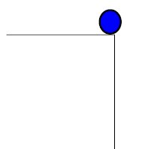



0

t

v

Horizontal Velocity Vertical Velocity

There are no unbalanced forces in the horizontal direction, so the horizontal velocity is constant

In the vertical direction the force due to gravity acts on the object, causing it to accelerate when moving downwards and decelerate when moving upwards.

Example 19



A helicopter flying at 40m/s releases an aid package. It takes 3s to hit the ground.

Calculate:

1. The horizontal speed when the package hits the ground
2. The horizontal distance travelled
3. The initial vertical speed
4. The final vertical speed when it hits the ground.
5. The height of the helicopter when it released the package.
6. Horizontal velocity = 40m/s
7. d = vt = 40 x 3 = 120m
8. 0m/s
9. v= u + at = 0 + (3 x 10) = 30m/s
10. Either draw a graph and use distance = area under graph

Or/

Average speed = (30+ 0) /2 = 15 m/s

Distance = average speed x time = 15 x 3 = 45 m/s