

**Physics**

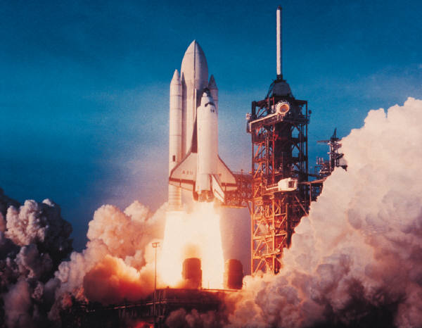

Dynamics and Space

1.3 Space

Name_______________ Class ____

**SCN 4-06a**

By researching developments used to observe or explore space, I can illustrate how our knowledge of the universe has evolved over time.

**SCN 4-16a**

I have carried out research into novel materials and can begin to explain the scientific basis of their properties and discuss the possible impacts they may have on society.

**SCN 4-20a**

I have researched new developments in science and can explain how their current or future applications might impact on modern life.

**SCN 4-20b**

Having selected scientific themes of topical interest, I can critically analyse the issues, and use relevant information to develop an informed argument.

**Content National 4**

**Satellites**

* The range of heights and functions of satellites in orbit around the earth, including geostationary and natural satellites.
* The dependence of period of orbit on height.
* The use of parabolic reflectors to send and receive signals.
* Use of the relationship between distance, speed and time applied to satellite communication.
* Range of applications of satellite including telecommunications; weather monitoring; the use of satellites in environmental monitoring.
* The use of satellites in developing our understanding of the global impact of mankind’s actions.

**Cosmology**

* Description of planet, moon, star, solar systems, exo-planet, galaxy and universe.
* Scale of the solar system and universe measured in light years.
* Space exploration and its impact on our understanding of the universe and planet Earth.
* Conditions required for an exo-planet to sustain life.

**Space exploration**

* Evidence to support current understanding of the universe from telescopes and space exploration.
* Impact of space exploration on our understanding of planet Earth, including use of satellites.
* The potential benefits of space exploration including associated technologies and the impact on everyday life.
* Risks and benefits associated with space exploration, including challenges of re-entry to a planet’s atmosphere.

**Cosmology**

* Use of the term ‘light year’ and conversion between light years and metres.
* Observable universe — description, origin and age of universe.
* The use of different parts of the electromagnetic spectrum in obtaining information about astronomical objects.
* Identification of continuous and line spectra.
* Use of spectral data for known elements, to identify the elements present in stars.

.

### At National 4 level, by the end of this section you should be able to:

Cosmology

❑ 1. List the risks and benefits associated with space exploration and challenges of re-entry to a planet’s atmosphere.

❑ 2. Describe the use of thermal protection systems to protect spacecraft on re-entry.

❑ 3. Provide descriptions of the following; planet, moon, star, solar systems, exo-planet, galaxy and universe.

❑ 4. State the scale of the solar system and universe measured in light years.

❑ 5. Describe the impact of space exploration on our understanding of the universe and planet Earth.

* Research developments used to observe or explore space and illustrate how our knowledge of the universe has evolved over time.

❑ 6. Describe the conditions required for an exoplanet to sustain life.

**Additionally, at National 5 level:**

🔾 7. Describe the term ‘light year’ and use the conversion between light years and meters.

🔾 8. Provide a description of the observable universe and know the origin and age of the universe.

🔾 9. Describe the use of different parts of the electromagnetic spectrum in obtaining information about astronomical objects.

🔾 10. Identify continuous and line spectra.

🔾 11. Identify elements present in stars from the use of spectral data for known elements.

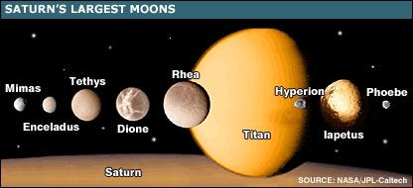

# Stars – what are they?

s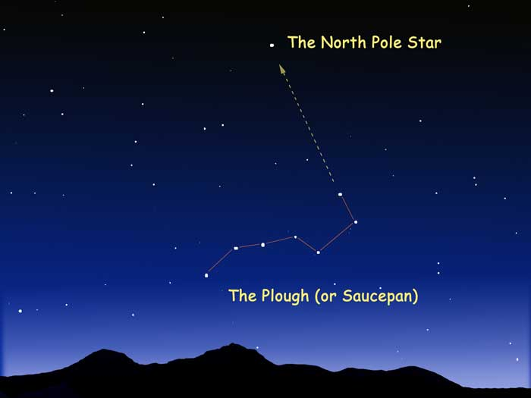

# http://solarsystem.nasa.gov/planets/images/splash-planets.jpg

# Light year Equivalent in Metres

Calculate the distance in metres, that light travels in one year.

The speed of light in vacuum is 300 000 000m/s..

# Distances in Space

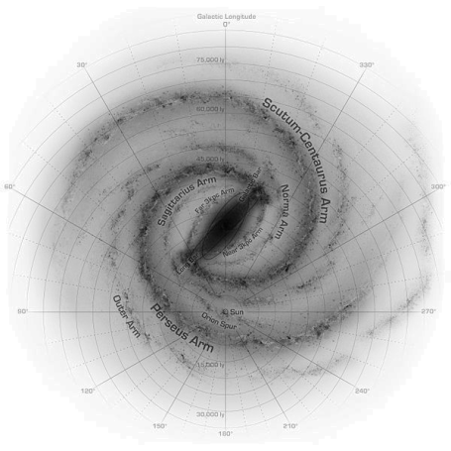

# Exoplanets and Life Beyond Our Solar System

# The Age of the Universe

Cosmologists estimate the age of the universe to be around 14 billion years, since the “Big Bang”.

# How do we Explore Space?

There are 3 main ways to explore space:

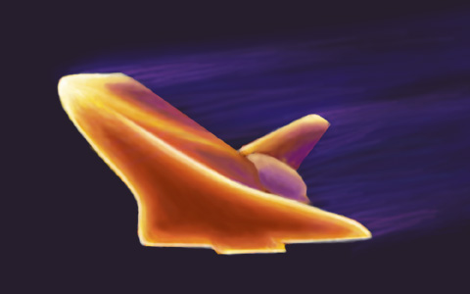**Re-entry to atmosphere**

Satellites

❑ 1. Describe the range of heights and functions of satellites in orbit around the earth, including geostationary and natural satellites.

❑ 2. Describe the dependence of period of orbit on height.

❑ 3. Describe the use of parabolic reflectors to send and receive signals.

❑ 4. Carry out calculations involving the relationship between distance, speed and time applied to satellite communication.

❑ 5. Describe the range of applications of satellites including telecommunications; weather monitoring; the use of satellites in environmental monitoring.

❑ 6. Describe the use of satellites in developing our understanding of the global impact of mankind’s actions.



C:\Documents and Settings\nancyhunter\Local Settings\Temporary Internet Files\Content.IE5\X63YNML8\MC900331618[1].WMF

Newton’s Thought Experiment

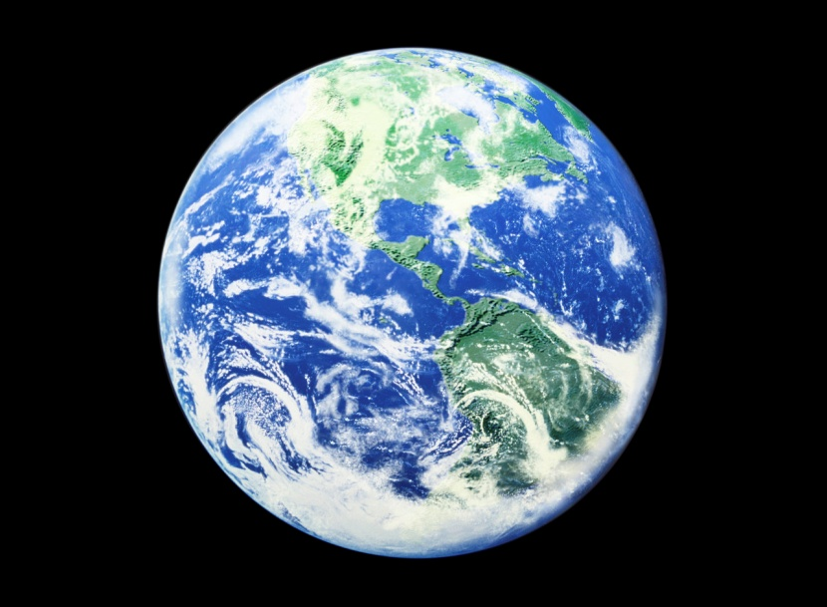

**

# Uses of Satellites

# Geostationary Satellite

# Satellite Transmitter



# Satellite Receiver



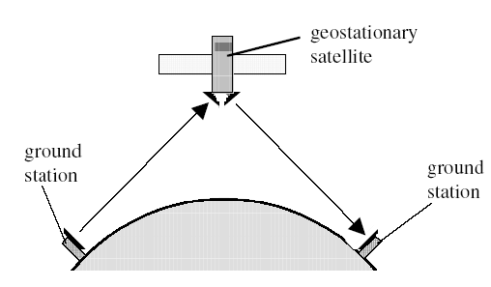

**Example 51**

A satellite is at a height of 150km. If the signal travels at 300,000,000m/s, how long will it take for the signal to travel from one ground station to the other?

**Example 50**

In addition to the speed of the signals, what other quantity must be known to calculate distance?

B

A

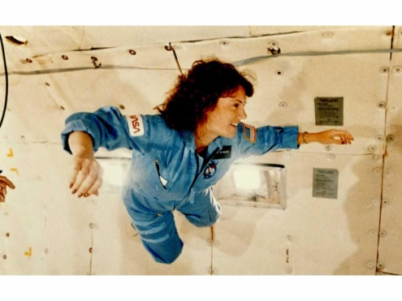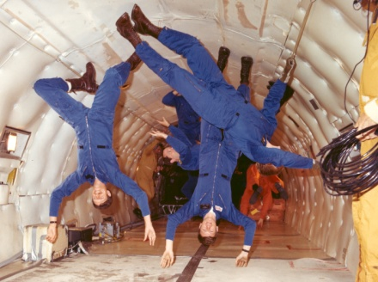

**Example 52**

On Earth an astronaut has a weight of 550N. What is her weight in the Space Station?

**Example 53**

On Earth an astronaut has a weight of 550N. What is her mass in the Space Station?

Space Exploration

🔾 1. List evidence that supports our current understanding of the universe from telescopes and space exploration.

🔾 2. Describe the impact of space exploration on our understanding of planet Earth, including the use of satellites.

🔾 3. Describe the potential benefits of space exploration including associated technologies and the impact on everyday life.

🔾 4. Describe the risks and benefits associated with space exploration, including challenges of re-entry to a planet’s atmosphere.

# Re-entry to atmosphere

/kg⁰)

C:\Documents and Settings\nancyhunter\Local Settings\Temporary Internet Files\Content.IE5\8NCHQ1SJ\MC900389086[1].WMF

# C:\Documents and Settings\nancyhunter\Local Settings\Temporary Internet Files\Content.IE5\ETDZV2HM\MC900250398[1].WMF

**

When white light is passed through a prism it forms a spectral pattern

**R –**

**O -**

**Y -**

**G -**

**B –**

**I -**

**V -**

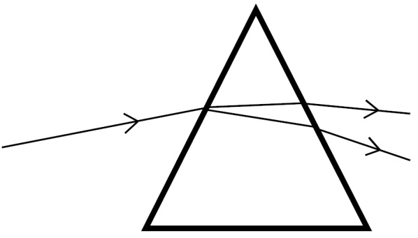

White light

# Telescopes

Objective Lens -

Eyepiece Lens –

Light tight tube –

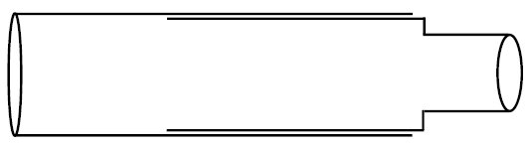

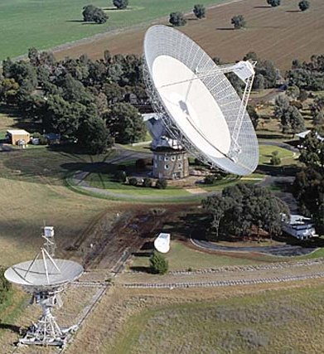

Parkes Observatory, NSW, Australia

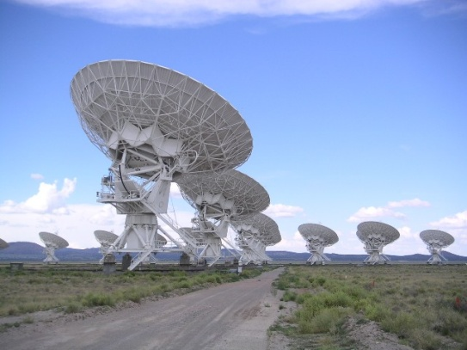

Very Large Array, New Mexico, USA

****Radiations from Space**

**Example 54**

Some spectral lines of radiation from a distant star are shown below. 

The spectral lines of a number of elements are also shown. Use the spectral lines of the elements shown to identify which of these elements are present in the distant star.