

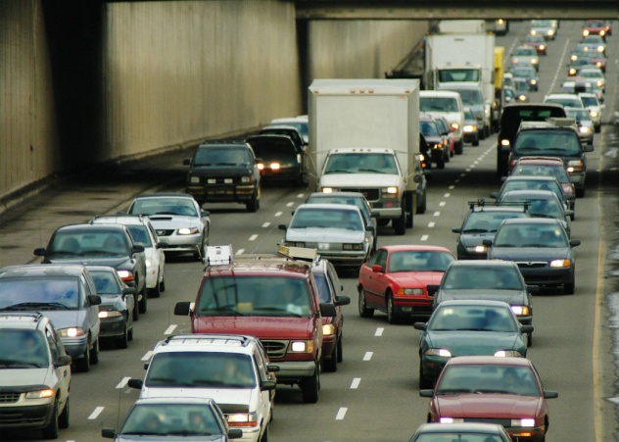

**Physics**

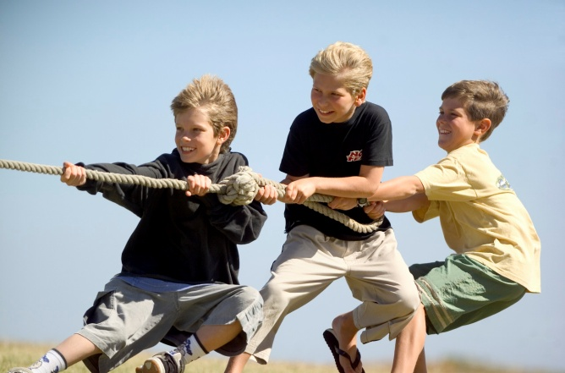

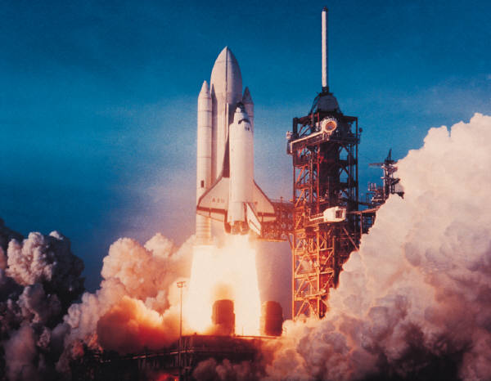Dynamics and Space

Name_______________ Class ____

**SCN 4-06a**

By researching developments used to observe or explore space, I can illustrate how our knowledge of the universe has evolved over time.

**SCN 4-07a**

I can use appropriate methods to measure, calculate and display graphically the speed of an object, and show how these methods can be used in a selected application.

**SCN 4-07b**

By making accurate measurements of speed and acceleration, I can relate the motion of an object to the forces acting on it and apply this knowledge to transport safety.

**SCN 4-16a**

I have carried out research into novel materials and can begin to explain the scientific basis of their properties and discuss the possible impacts they may have on society.

**SCN 4-20a**

I have researched new developments in science and can explain how their current or future applications might impact on modern life.

**SCN 4-20b**

Having selected scientific themes of topical interest, I can critically analyse the issues, and use relevant information to develop an informed argument.

**Speed and acceleration**

* Calculations involving the relationship between speed, distance, and time.
* Determination of average and instantaneous speed.
* Interpretation of speed-time graphs to describe motion including calculation of distance (for objects which are speeding up, slowing down, stationary and moving with constant speed.)Motion in one direction only.
* Use of relationship of acceleration, change in speed and time.

**Relationship between forces, motion and energy**

* The use of Newton’s first law and balanced forces to explain constant speed, making reference to frictional forces.
* The use of Newton’s second law to explain the movement of objects in situations involving constant acceleration.
* Calculations using the relationship between force, mass and acceleration in situations where only one force is acting.
* Calculations using the relationship between weight, mass and gravitational field strength within our solar system.
* Risks and benefits associated with space exploration including challenges of re-entry to a planet’s atmosphere.
* The use of thermal protection systems to protect spacecraft on re-entry.

**Satellites**

* The range of heights and functions of satellites in orbit around the earth, including geostationary and natural satellites.
* The dependence of period of orbit on height.
* The use of parabolic reflectors to send and receive signals.
* Use of the relationship between distance, speed and time applied to satellite communication.
* Range of applications of satellite including telecommunications; weather monitoring; the use of satellites in environmental monitoring.
* The use of satellites in developing our understanding of the global impact of mankind’s actions.

**Cosmology**

* Description of planet, moon, star, solar systems, exo-planet, galaxy and universe.
* Scale of the solar system and universe measured in light years.
* Space exploration and its impact on our understanding of the universe and planet Earth.
* Conditions required for an exo-planet to sustain life.

**Velocity and displacement — Vectors and scalars**

* Vector and scalar quantities: force, speed, velocity, distance, displacement, acceleration, mass, time and energy.
* Calculation of the resultant of two vector quantities in one dimension or at right angles.
* Determination of displacement and/or distance using scale diagram or calculation.
* Use of appropriate relationships to calculate velocity in one dimension

**Velocity–time graphs**

* Velocity–time graphs for objects from recorded or experimental data.
* Interpretation of velocity–time graph to describe the motion of an object.
* Displacement from a velocity–time graph.

**Acceleration**

* Acceleration of a vehicle between two points using appropriate relationships with initial and final velocity and time of change.
* Acceleration from a velocity–time graph.

**Newton’s laws**

* Applications of Newton’s laws and balanced forces to explain constant velocity, making reference to frictional forces.
* Calculations involving the relationship between unbalanced force, mass and acceleration for situations where more than one force is acting.
* Calculations involving the relationship between work done, unbalanced force and distance/displacement.
* Calculations involving the relationship between weight, mass and gravitational field strength during interplanetary rocket flight.
* Newton’s second law and its application to space travel, including rocket launch and landing.
* Newton’s third law and its application to explain motion resulting from a ‘reaction’ force.
* Use of Newton’s laws to explain free-fall and terminal velocity

**Projectile motion**

* Explanation of projectile motion.
* Calculations of projectile motion from a horizontal launch using appropriate relationships and graphs.
* Explanation of satellite orbits in terms of projectile motion.

**Space exploration**

* Evidence to support current understanding of the universe from telescopes and space exploration.
* Impact of space exploration on our understanding of planet Earth, including use of satellites.
* The potential benefits of space exploration including associated technologies and the impact on everyday life.
* Risks and benefits associated with space exploration, including challenges of re-entry to a planet’s atmosphere.

**Cosmology**

* Use of the term ‘light year’ and conversion between light years and metres.
* Observable universe — description, origin and age of universe.
* The use of different parts of the electromagnetic spectrum in obtaining information about astronomical objects.
* Identification of continuous and line spectra.
* Use of spectral data for known elements, to identify the elements present in stars.

.

**Example 2**

What is the speed of a car which travels 6 kilometres in 4 minutes?

**Example 1**

What is the speed of a car that travels 2880m in 60 seconds?

**Example 4**

How far does a car travelling at 25m/s travel in 30 minutes?

**Example 3**

How long does it take to travel 7125m at 75m/s?

# Average Speed using Light Gates

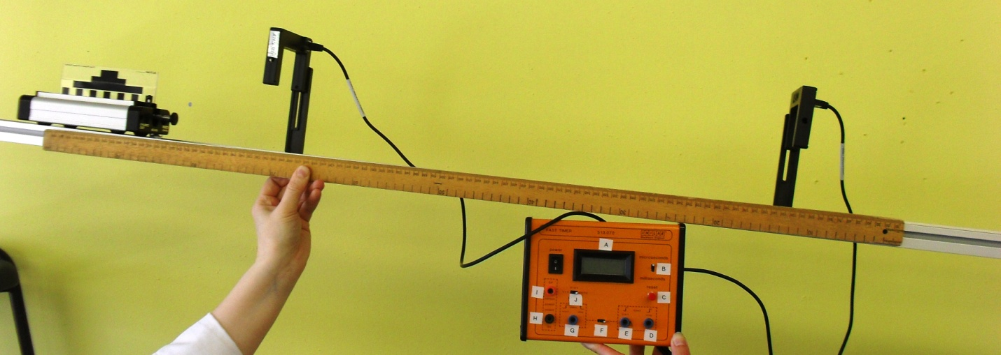

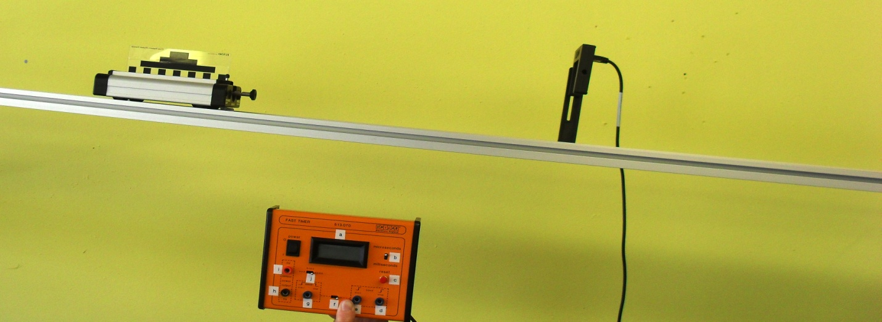

Speed time graphs can help to describe the motion of an object.

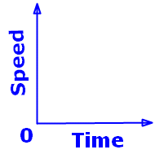  

###### DISTANCE = AREA UNDER A SPEED TIME GRAPH

**Example 5**

0

time (s)

Speed

(m/s)

5

10

**Example 6**

0

time (s)

Speed

( m/s)

5

10

6

10

5

Speed

(m/s)

time (s)

0

**Example 7**

###### Example 8

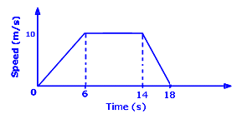

Calculate the total distance travelled.

###### Example 9

.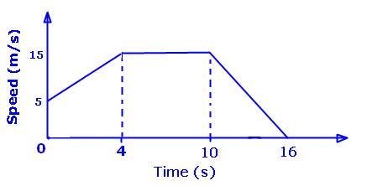

Calculate

1. The distance travelled
2. The average speed

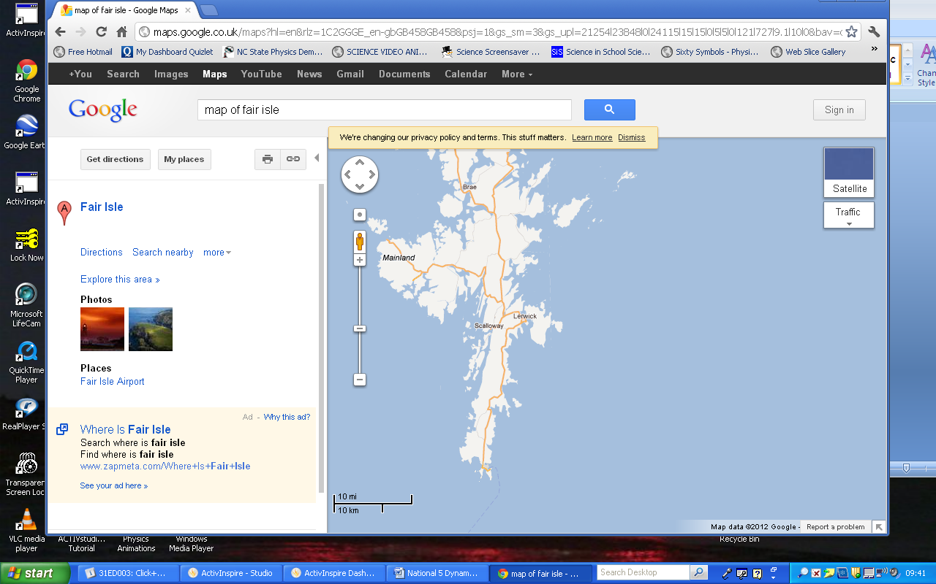

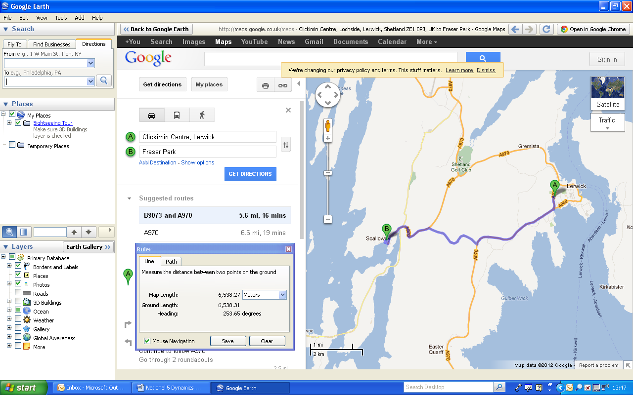



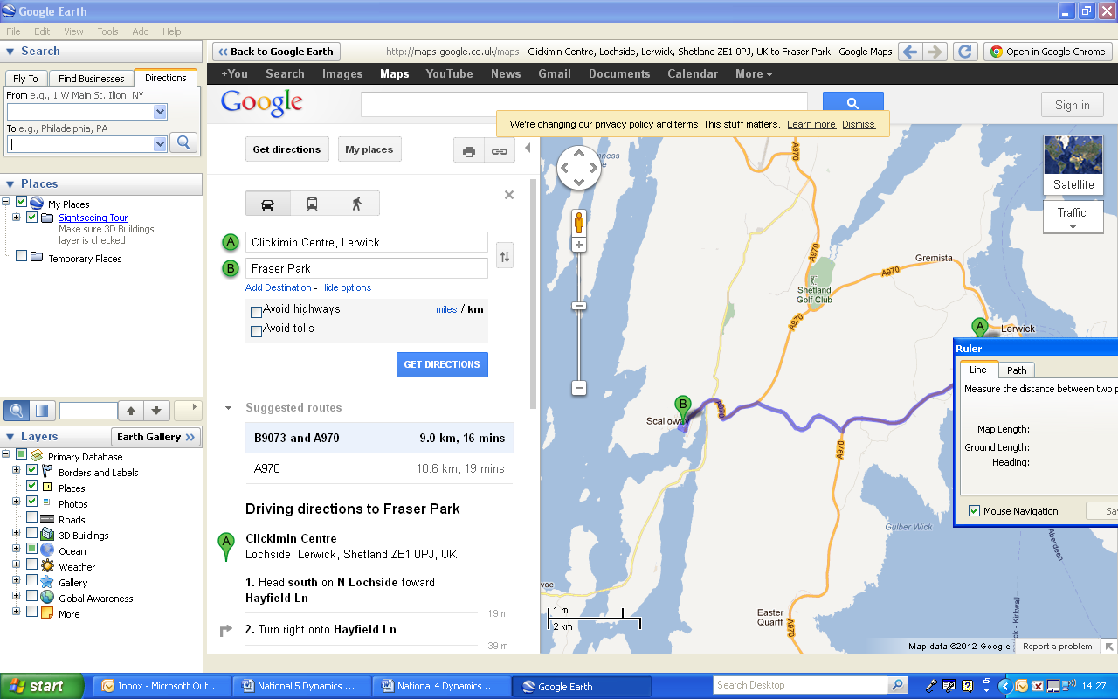

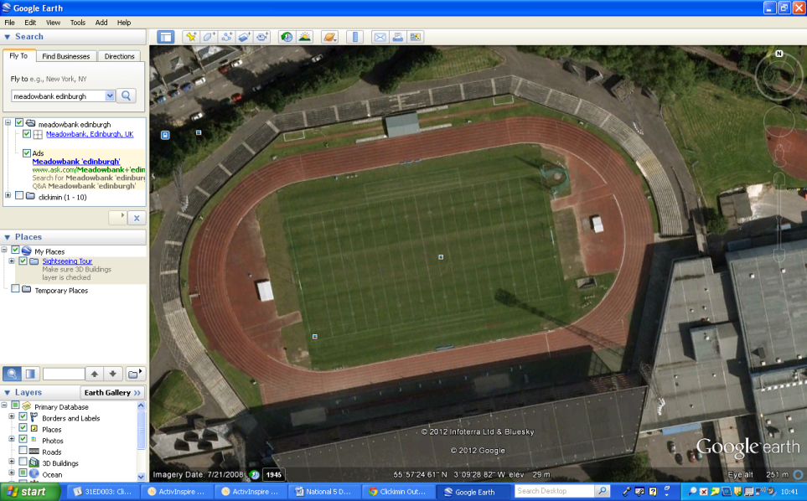

Direction can be given in two ways

1.

2.

N (000)

NW (315)

NE (045)

E (090)

S (180)

SE (135)

SW (225)

W (270)

**Definition**

A **scalar** quantity has

A **vector** quantity has

|  |  |
| --- | --- |
| **Scalar** | **Vector** |
|  |  |
|  |  |
|  |  |
|  |  |
|  |  |

**Example 10**

A dog walks 2m E followed by 0.5m E. What is it’s displacement? (Scale = 2cm = 1m)

**Example 11**

A cat walks 2m W followed by 0.5m E. What is its displacement? (Scale = 2cm = 1m)





**Example 12**

(Scale 1 cm = 1m)

A person walks 4m East followed by 3m South. What is their displacement from the starting point?

**Example 13**

A person walks 12m East followed by 5m North. What is their displacement from the starting point?

(Scale 1cm = 1m)

**Example 15**

A car travels 8m E along a road, then has to reverse 3m to let the ambulance past. This takes 10s.

What was the velocity?

Scale 1cm =2m

**Example 14**

A car travels 10m due S, stops at traffic lights then carries on for another 10m. This takes 5s.

What was the velocity?

Scale 1cm = 10m

**Example 16**

A cyclist completes a 400m circuit of a track in a velodrome in 50s. What is their velocity? (Think very carefully!!)

**Example 19**

A car travels 400m S then 400m W.

This takes 20s. What is its velocity?



**Example 18**

A car travels 30m E, followed by

40m N. This takes 10s. What is its velocity?



Scale 1cm = 10m

**Example 17**

A plane flies South at 100m/s, but the wind blows at 10m/s East. What is the plane’s velocity?

0

t s

0

t

v

0

t

v

(m/s)

(m/s)

(s)

(s)

v

(m/s)

(s)

t

0

v

(m/s)

(s)

L

v

0

t

A

B

C

E

G

I

K

D

F

H

J

(m/s)

(s)

**Example 20**

0

t

v

**Example 21**

0

t

v

**Example 23**

**Example 22**

v (m/s)

v (m/s)

0 5 time (s)

20

0 15 time (s)

80

20

.**Example 24**



The **acceleration** is

10

5

**Example 25**

7

22

v

t

0

5

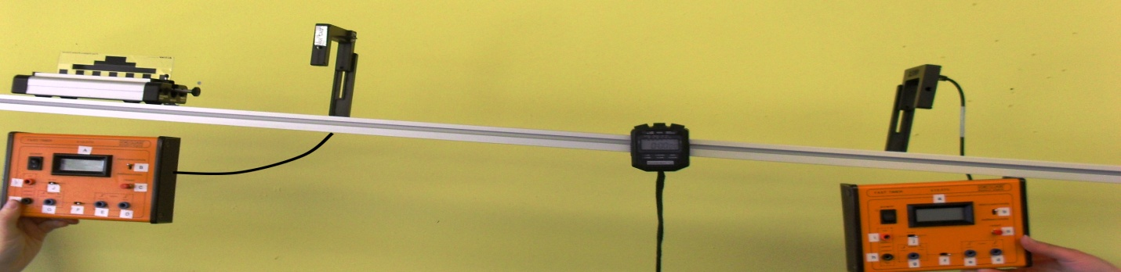

v = final speed

u = initial speed

a = acceleration

t = time

**Example 26**

A car accelerates from 20m/s to 80m/s in 12 seconds. Calculate the acceleration.

**Example 27**

An object travelling at 80m/s suddenly comes to a stop in 2 seconds Calculate the deceleration.

**Example 28**

A trolley starts at rest and speeds up at 4m/s2 for 6 seconds.

Calculate the final speed.

**Example 29**

A car travelling at 5m/s accelerates at 3m/s2 for 4s. What is its final speed?

# Acceleration due to Gravity

**Example 30**

A stone is dropped off the edge of a cliff. It takes 6 seconds to hit the ground. What speed does it hit the ground at?

Forces can do three things to an object.

Change the –

1.

2.

3.

# Measuring Force

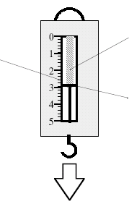





# Balanced Forces on the Move



C:\Documents and Settings\nancyhunter\Local Settings\Temporary Internet Files\Content.IE5\CR28S5NJ\MC900320932[1].wmf*C:\Documents and Settings\nancyhunter\Local Settings\Temporary Internet Files\Content.IE5\V8RVIWU3\MC900021419[1].wmf*

# C:\Documents and Settings\nancyhunter\Local Settings\Temporary Internet Files\Content.IE5\NR5E1W91\MC900383858[1].wmfC:\Documents and Settings\nancyhunter\Local Settings\Temporary Internet Files\Content.IE5\CR28S5NJ\MC900286889[1].wmf*C:\Documents and Settings\nancyhunter\Local Settings\Temporary Internet Files\Content.IE5\ETDZV2HM\MC900318354[1].wmf*C:\Documents and Settings\nancyhunter\Local Settings\Temporary Internet Files\Content.IE5\ETDZV2HM\MC900326676[1].wmf

# Seatbelts

# Friction

Definition –

INCREASING FRICTION DECREASING FRICTION

**Example 31**

Calculate the unbalanced force needed

to accelerate a bike of mass 60kg at a

rate of 4m/s2.

**Example 32**

Calculate the acceleration caused by a force of 300N acting on a 25kg mass.

**Example 34**

A boy pushes his sister downhill on her sledge with a force of 150N. The combined mass of the girl and sledge is 40kg. What is her acceleration?

**Example 33**

An object accelerates at 15m/s2 when a force of 900N is applied. What was its mass?

C:\Documents and Settings\nancyhunter\Local Settings\Temporary Internet Files\Content.IE5\EOETE3UC\MC900056961[1].wmf

In a tug-o-war the two sides each exert a force.

**Example 35**

A dog out for a walk sees a cat and tries to chase after it. It exerts a force of 75N forwards on the lead. If the child holding the lead can exert a force of 65N backwards – what will happen?

**Example 38**

A boat engine is able to apply a force of 6000N. The boat has a mass of 500kg and accelerates at a rate of 10m/s2.

1. Calculate the size of the frictional force acting on the boat.
2. What will happen to this force if the barnacles grow on the hull over the summer

**Example 37**

A car has an engine force of 5000N. Each of the four tyres has a frictional force of 50N with the road.

If the mass of the car is 1200kg, what is the acceleration?

**Example 36**

A motorbike of mass 800kg has an

engine force of 12,000N.

The frictional force is 2000N.

What is the acceleration of the bike?

**Example 39**

A boat tows a barge with a force of 800N South. The tide exerts a force of 600N East. What is the effect of these forces on the barge?

**Example 41**

What is the mass of an object which has a weight of 7200N on Earth.

**Example 40**

What is the weight of a person with a mass of 65kg (on Earth)

**Example 42**

Find the weight and mass of a 75kg spaceman on

1. Moon
2. Mars

|  |  |
| --- | --- |
| **Planet/Moon** | **‘g’ (N/kg)** |
| Mercury | 4 |
| Venus | 9 |
| Earth | 10 |
| Mars | 4 |
| Jupiter | 25 |
| Saturn | 10 |
| Uranus | 10 |
| Neptune | 12 |
| Moon | 1.6 |

**Example 46**

How far can a football team tow a truck using a force of 1500N if their available energy is 22,500J ?

**Example 45**

A winch uses 750J of energy pulling a car 6m out of a ditch. What force is exerted on the car?

**Example 44**

A battery powered model car has a motor which exerts a force of 1.5N over a distance of 25m.

How much work does the motor do?

**Example 43**

A cyclist exerts a force of 200N when riding a bike a distance of 60m.

How much work has she done?

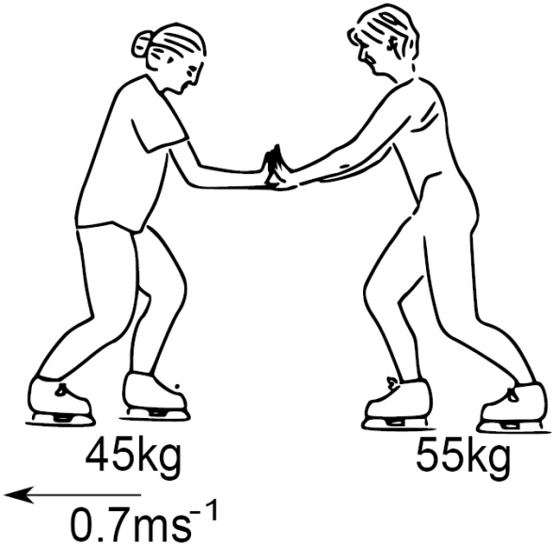

C:\Documents and Settings\nancyhunter\Local Settings\Temporary Internet Files\Content.IE5\8NCHQ1SJ\MC900332876[1].WMF

*[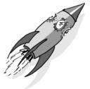](http://www.picsearch.com/imageDetail.cgi?id=ZWtBfg6bLGGzJitDWnDf-XUMAl9l9UX8wI6xVrv1NMo&width=1259&start=91&q=Rocket)*

Example 47

After lift off a spacecraft of mass 6000kg applies its thruster rockets with a combined thrust of 480000N. What is the acceleration of the rocket?

*[](http://www.picsearch.com/imageDetail.cgi?id=ZWtBfg6bLGGzJitDWnDf-XUMAl9l9UX8wI6xVrv1NMo&width=1259&start=91&q=Rocket)*

Example 48

# Stars – what are they?

# Our Solar System

# Light year Equivalent in Metres

Calculate the distance in metres, that light travels in one year.

The speed of light in vacuum is 300 000 000m/s..

# Distances in Space

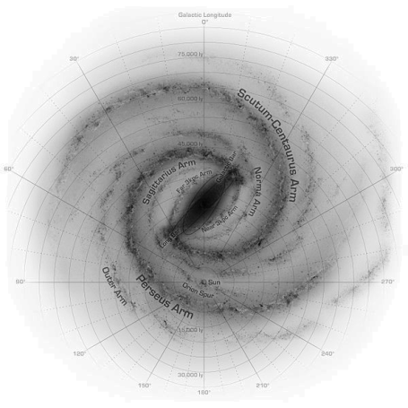

# Exoplanets and Life Beyond Our Solar System

# The Age of the Universe

Cosmologists estimate the age of the universe to be around 14 billion years, since the “Big Bang”.

# How do we Explore Space?

There are 3 main ways to explore space:

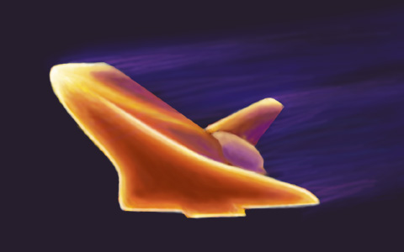**Re-entry to atmosphere**

Vertical Velocity

Horizontal Velocity

v

v

0

t

0

t

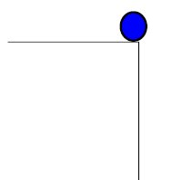

Example 49

A helicopter flying at 40m/s releases an aid package. It takes 3s to hit the ground.

Calculate:

1. The horizontal speed when the package hits the ground
2. The horizontal distance travelled
3. The initial vertical speed
4. The final vertical speed when it hits the ground.

**



C:\Documents and Settings\nancyhunter\Local Settings\Temporary Internet Files\Content.IE5\X63YNML8\MC900331618[1].WMF

Newton’s Thought Experiment

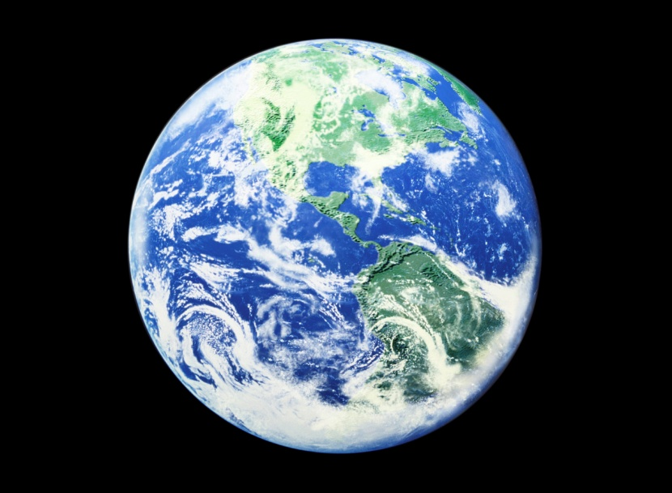

# Uses of Satellites

# Period of a Satellite

# Geostationary Satellite

# Satellite Receiver



# Intercontinental Communication using Satellites

B

A

# 

# Navigation System (GPS)

**Example 50**

In addition to the speed of the signals, what other quantity must be known to calculate distance?

**Example 51**

A satellite is at a height of 150km. If the signal travels at 300,000,000m/s, how long will it take for the signal to travel from one ground station to the other?

# 

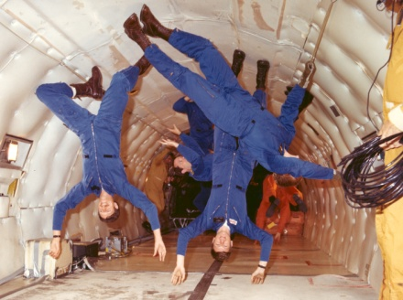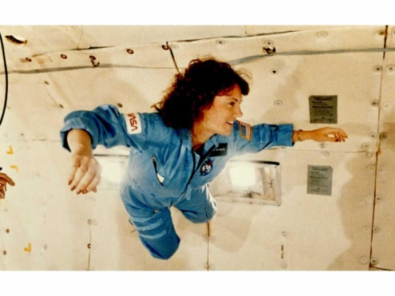

**Example 53**

On Earth an astronaut has a weight of 550N. What is her mass in the Space Station?

**Example 52**

On Earth an astronaut has a weight of 550N. What is her weight in the Space Station?

# Re-entry to atmosphere

/kg⁰)

C:\Documents and Settings\nancyhunter\Local Settings\Temporary Internet Files\Content.IE5\8NCHQ1SJ\MC900389086[1].WMF

# C:\Documents and Settings\nancyhunter\Local Settings\Temporary Internet Files\Content.IE5\ETDZV2HM\MC900250398[1].WMF

**

When white light is passed through a prism it forms a spectral pattern

White light

**R –**

**O -**

**Y -**

**G -**

**B –**

**I -**

**V -**

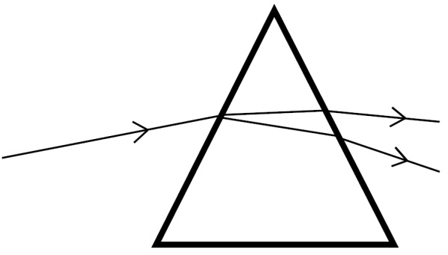

# Telescopes

Objective Lens -

Eyepiece Lens –

Light tight tube –

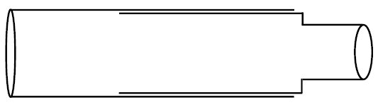

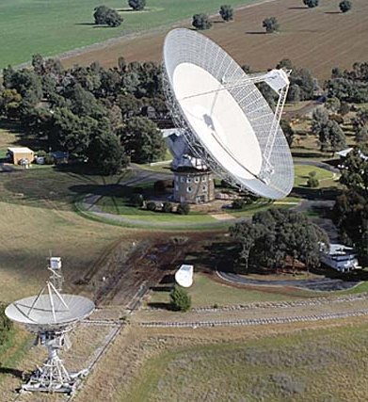

Parkes Observatory, NSW, Australia

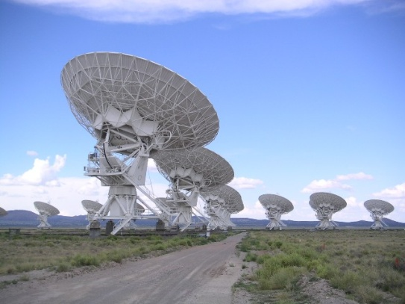

Very Large Array, New Mexico, USA

**

**Radiations from Space**

**Example 54**

Some spectral lines of radiation from a distant star are shown below. 

The spectral lines of a number of elements are also shown. Use the spectral lines of the elements shown to identify which of these elements are present in the distant star.