Mass & Weight

Mass is a measure of the amount of matter (stuff) in an object. It is measured in kilograms (kg)

|  |  |  |  |
| --- | --- | --- | --- |
| Quantity | Symbol | Unit | Unit Symbol |
| mass | m | Kilogram | kg |
| weight | W | Newtons | N |
| Gravitational field strength | g | Newtons per kilogram | N/kg |

|  |  |  |
| --- | --- | --- |
| Mass (g) | Predicted weight (N) | Weight (N) |
| 100 |  | 1 |
| 200 |  | 2 |
| 300 |  | 3 |
| 400 |  | 4 |
| 500 |  | 5 |
| 600 |  | 6 |
| 700 |  | 7 |
| 800 |  | 8 |
| 900 |  | 9 |
| 1000 (1kg) |  | 10 |

Weight is a force and it is the pull of gravity acting on an object. It is measured in Newtons.

Experiment

* Collect a 20N spring balance and a set of 100 g masses.
* Predict the weight (force of gravity) on 100 g.
* Record this in the table.
* Test your answer and record the measured weight.
* Repeat for other masses until you can discover a relationship.
* Replace the 20 N spring balance with a 50 N spring balance and place 5 kg on the end.
* Record carefully the value of the weight.

# Conclusion

From our experiment we have found out that the Earth pulls every 1kg with a force of ??N

# Formula : Weight =mass × ??

This value of ?? Newtons per kilogram is called the GRAVITATIONAL FIELD STRENGTH, g

**Weight =mass × gravitational field strength**

**W = m × g**

|  |  |  |
| --- | --- | --- |
| Object | Mass (kg) | Weight (N) |
| A bag of sugar | 1 | 10 |
| A bag of tatties | 5 |  |
| A loaf of bread | 0.5 |  |
| An apple |  | 1 |
| A small car |  | 8000 |
| A small pupil |  | 450 |
| ME |  |  |
| Bag of crisps | 23g |  |

Change 23g into kg =23 x 1/1000 = 0.023kg

Inertia is the tendency of an object to remain in a state of rest or uniform speed unless acted upon by an unbalanced force. That is, it is the resistance of an object to motion. Measurement of inertia is a way of measuring mass.

“g” is the gravitational field strength. It is measured in NEWTONS PER KILOGRAM. It is the WEIGHT PER UNIT MASS (force of gravity on every kilogram)

|  |  |  |  |
| --- | --- | --- | --- |
| Gravitational field strength | g | Newtons per kilogram | N/kg |

# My Weight on other planets

|  |  |  |  |
| --- | --- | --- | --- |
| Planet | g (N/kg) | m (kg) | W (N) =m x g |
| Mercury | 3.7 |  |  |
| Venus | 8.8 |  |  |
| Earth | 10.0 |  |  |
| (Moon) | 1.6 |  |  |
| Mars | 3.8 |  |  |
| Jupiter | 26.4 |  |  |
| Saturn | 11.5 |  |  |
| Uranus | 11.7 |  |  |
| Neptune | 11.8 |  |  |
| Pluto | 4.2 |  |  |

Calculate your own weight on each of the planets.

i) Find out the distance of each of the planets from the Sun.

ii) Present the above information on ‘g’ on a drawing of the Solar System.



# Forces and the Newton Balance

**Aim:** To use the newton balance to pull and lift various known masses.

**Apparatus:** Newton balance

Selection of masses of known size



**Instructions for experiment 1**

• Use the newton balance as in Diagram 1 to pull each mass across the top of your desk.

• Compare the force required to

a) start the mass moving

b) keep the mass moving slowly at a steady speed

c) keep the mass moving quickly at a steady speed.

Explain how the newton balance is used to measure force.

**Instructions for experiment 2**

• Use the newton balance as in Diagram 2 to lift each mass.

• Compare the force required to

a) support the mass so that it is not moving

b) move the mass upwards at a steady speed

c) move the mass downwards at a steady speed.

Record your results in a table, recording the mass in kilograms (kg).

Extend your table, calculate the ratio of weight to mass; ie.

State the name given to this ratio.

Gravity, mass and weight

|  |  |
| --- | --- |
| **Planet** | **g (N/kg)** |
| Mercury | 3.7 |
| Venus | 8.8 |
| Earth | 10 |
| Mars | 3.8 |
| Jupiter | 26.4 |
| Saturn | 11.5 |
| Uranus | 11.7 |
| Neptune | 11.8 |
| Pluto | 4.2 |

The data table on the right may be required for questions 1-8.

Assume the questions refer to the Earth unless otherwise stated

1. What is the weight of a 10 kg bag of potatoes?

2. What is the weight of a 250 g bag of sweets?

3. What is the mass of a 450 N girl?

4. What is the weight of a 10,000 kg spacecraft on

a) Earth b) Mars c) Venus?

5. What would a 60 kg man weigh on Jupiter?

6. Which planet’s gravity is closest to our own?

7. An astronaut who weighs 700 N on Earth goes to a planet where he weighs 266 N.

Calculate his mass and state which planet he was on.

8. What would an astronaut weigh on Earth, if his weight on Venus was 528 N?

Gravitational Field Strength with Height

The value of g changes with the distance from a planet. On Earth the radius of the Earth is approximately 6400 km or 4000 miles. So on average the value of g on the surface of the Earth is just under 9.8 N/kg. However, you can see from the graph that the value of g takes a very long distance to reduce.

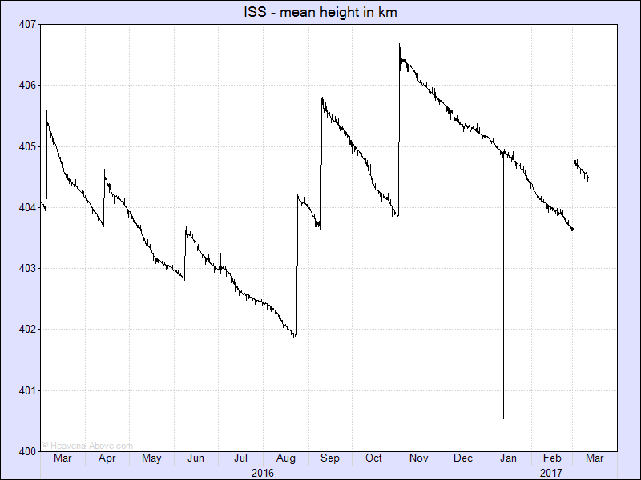

<http://heavens-above.com/IssHeight.aspx>

This plot shows the orbital height of the ISS over the last year. Clearly visible are the re-boosts which suddenly increase the height, and the gradual decay in between. The height is averaged over one orbit, and the gradual decrease is caused by atmospheric drag. As can be seen from the plot, the rate of descent is not constant and this variation is caused by changes in the density of the tenuous outer atmosphere due mainly to solar activity.

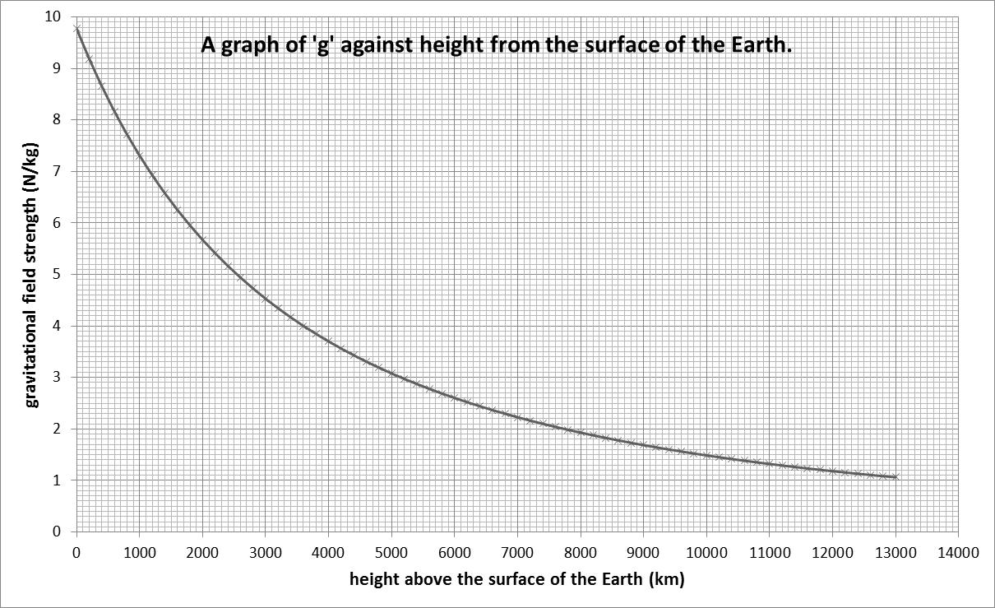

1. Plot your own graph of height against g using the data in the table below.

|  |  |
| --- | --- |
| Height in km | gravitational field stegnth (N/kg) |
| 0 | 9.8 |
| 200 | 9.2 |
| 400 | 8.7 |
| 600 | 8.2 |
| 800 | 7.7 |
| 1000 | 7.3 |
| 2000 | 5.7 |
| 2600 | 4.9 |
| 2800 | 4.7 |
| 3000 | 4.5 |
| 3800 | 3.8 |
| 4000 | 3.7 |
| 4800 | 3.2 |
| 5000 | 3.1 |
| 6000 | 2.6 |
| 7000 | 2.2 |
| 8000 | 1.9 |
| 9000 | 1.7 |
| 10000 | 1.5 |
| 11000 | 1.3 |
| 12000 | 1.2 |
| 13000 | 1.1 |

1. Choose your birthday or a significant day and find the approximate height of the ISS on this day. Record the day and the height.
2. Using the information in the graph of g against height, find the value of the gravitational field strength on the ISS when it is at your chosen height.
3. What would be the calculated value of your weight on the ISS?
4. Why would you be described as “weightless”

Test your current ideas about weightlessness:

Astronauts on the orbiting space station are weightless because...

A. There is no gravity in space and they do not weigh anything.

B. Space is a vacuum and there is no gravity in a vacuum.

C. Space is a vacuum and there is no air resistance in a vacuum.

D. The astronauts are far from Earth's surface at a location where gravitation has a minimal effect.

<http://www.physicsclassroom.com/class/circles/Lesson-4/Weightlessness-in-Orbit>

Find the answer at the website above, I think some of you might be surprised by the answer.

Weightlessness

The answer to the multiple choice question above was that none of the answers were correct, I promise the SQA won’t write a question like that!

When we say “weightless” what we generally mean is “in freefall”.

According to the formula:

|  |  |
| --- | --- |
| **W= mg** | Where W = weight  m = mass  g = gravitational field strength |

To be weightless you must travel to a region where there is no gravitational field. Even in space, where spacecraft travel, ‘g’ has a value greater than zero. An example of what actually happens is when a car goes over a bump in the road too fast and takes off. Both the car and the occupants fall back to the road at the same rate and so the occupants momentarily feel ‘weightless’ because they are not being supported by anything. Being in contact with the ground makes us aware of our weight. In a spacecraft the spacecraft and the occupants are falling to Earth at the same rate so they feel weightless even though there is gravitational force acting on them. The astronauts are actually in freefall.

Weightlessness is simply a sensation experienced by you when there are no external objects touching and exerting a push or pull upon you. Weightless sensations exist when all contact forces are removed. These sensations are common when you are momentarily in a state of free fall. When in free fall, the only force acting upon your body is the force of gravity - a non-contact force. Since the force of gravity cannot be felt without any other opposing forces, you would have no sensation of it. You would feel weightless when in a state of free fall.

# Scale Readings and Weight

Technically speaking, a scale does not measure your weight. While we use a scale to measure our weight, the scale reading is actually a measure of the upward force applied by the scale to balance the downward force of gravity, *weight*, acting upon an object. When an object is at rest or in motion at constant speed, these two forces are balanced. The upward force of the scale upon you equals your weight (the downward pull of gravity). And in this instance, the scale reading (that is a measure of the upward force) equals the weight of the person. However, if you stand on the scale and bounce up and down ***(not on my scales though!),*** the scale reading undergoes a rapid change. As you undergo this bouncing motion, your body is accelerating. During the acceleration periods, the upward force of the scale is changing. And as such, the scale reading is changing. Is your weight changing? Absolutely not! You weigh as much (or as little) as you always do. The scale reading is changing, but remember: the SCALE DOES NOT MEASURE YOUR WEIGHT. The scale is only measuring the external contact force that is being applied to your body.

# Weightlessness in orbit

Many students believe that orbiting astronauts are weightless because they do not experience a force of gravity. If a person believes that the absence of gravity is the cause of their weightlessness, then how would they explain why the astronauts are orbiting the Earth? The fact is that there must be a force of gravity in order for there to be an orbit.

Astronauts are weightless because there is no external contact force pushing or pulling upon their body. In each case, the force of gravity is the only force acting upon their body. Being an action-at-a-distance force, it cannot be felt and therefore would not provide any sensation of their weight. If there was no force of gravity on the astronauts, then they would not be orbiting in circular motion but would drift off into space at a constant speed in a straight line.

<http://www.physicsclassroom.com/class/circles/Lesson-4/Weightlessness-in-Orbit>

Friction

Friction is a **resistive** force, which opposes the relative motion of two surfaces in contact.

This means that it acts in the **opposite** direction to the relative movement of the two surfaces.

Friction acts between any two surfaces in contact. When one surface moves over another, the force of friction acts between the surfaces and the size of the force depends on the surfaces, e.g. a rough surface will give a lot of friction.

Friction is a very common force.

**Friction** between two solid surfaces depends on two factors:

* how **rough** the two surfaces are
* the size of the **force** between the two surfaces [how hard they are pressed together.]

Friction increases the rougher the two surfaces are and the bigger the force between them.

If there is no friction between surfaces then the surfaces can move easily over each other.

This can be achieved by placing a layer of a different material between the surfaces.

An example of this is air being used in an air puck.

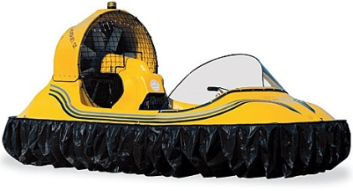 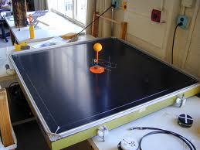

tsgphysics.mit.edu funcrate.com

Friction is a force which tries to stop things moving. Friction occurs between two solid surfaces. Friction can be good or a nuisance

| Friction good | Friction bad |
| --- | --- |
| braking | shooting (drag slows the bullet) |
| walking | sledging |
| space craft re-entry | skiing |
| running | ice skating |
| writing | snowboarding |
| sky-diving (drag) | putting on clothes (chaffing) |
| opening bottles | swimming |
| cutting things | wears down tyres |
| putting spin on an object | engines wear away |
| rock climbing | slide |
| steering wheel | F1 racing !!!! |
| striking matches | ceramic brakes!!! |
| cats using to drink | in space things don’t stop easily |
| slugs | boats |
| conveyor belts | rotating machinery slowed down and wears away |
| sports |  |
| sharpening knives |  |
| holding things |  |
| grip for tyres/shoes |  |

A teardrop is a very streamlined shape. Air can flow over it without producing turbulence (little winds!) To reduce fuel consumption cars and lorries are made as close to this shape as possible, but with wheels, doors, mirrors etc the shape is compromised.

The force of air resistance can also be called DRAG. Drag is a force like friction which opposes motion. Drag occurs when a solid moves through a liquid or gas.

|  |  |
| --- | --- |
| Increasing Friction | Decreasing Friction |
| less aerodynamic | lubrication eg oil, wax, grease, soap |
| greater surface area | streamlining |
| spoilers | more aerodynamic |
| increase mass | reduce mass |
| surface rough eg sand | rollers |
| gritting roads | layer of air |
| stickier surface | polystyrene beads |
| rougher tyres | smooth surface |
|  | ice |
|  | water on road |
|  | LORRIES BOARD |

**Title: Friction and Movement**

**Aim:** To investigate the force of friction between various surfaces.

**Apparatus:**

* Newton balance
* Block of wood
* Different surface materials
* A range of masses from 1 kg upwards.



**Instructions**

• Set up the apparatus as shown above using one of the surface materials.

• Using the newton balance, pull the block along the board at a steady speed.

• Record the reading on the balance in a table.

• Repeat the above for different surface materials.

• Repeat the above increasing the mass on top of the block.

**Results**

• List the surfaces in order of increasing friction with the wooden block.

• For each of the surfaces, plot a graph of the mass on block against the pulling force.

# Questions

Answer the following questions in your jotter.

9. Describe two methods of

a) increasing friction b) decreasing friction.

10. Where, in a bicycle, is friction deliberately

a) increased b) decreased?

EXOPLANETS

<https://www.spaceplace.nasa.gov/all-about-exoplanets/e>