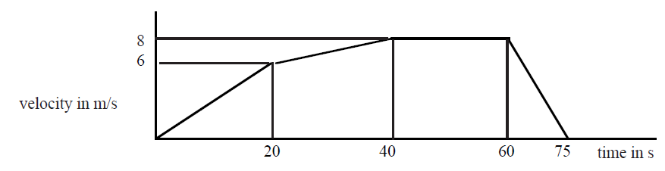

Displacement = area under a v-t graph

s = area 1 + area 2 + area 3 + area 4

$$\left(\frac{1}{2}bh\right)+\left(bh\right)+\left(bh\right)+\left(\frac{1}{2}bh\right)+\left(\frac{1}{2}bh\right)$$

$$\left(\frac{1}{2}×20×6\right)+\left(20×6\right)+\left(20×8\right)+\left(\frac{1}{2}×20×6\right)+\left(\frac{1}{2}×20×6\right)$$

Displacement = 420m

Speed/ ms-1

Time/s

10

20

30

40

50

8

6

4

2

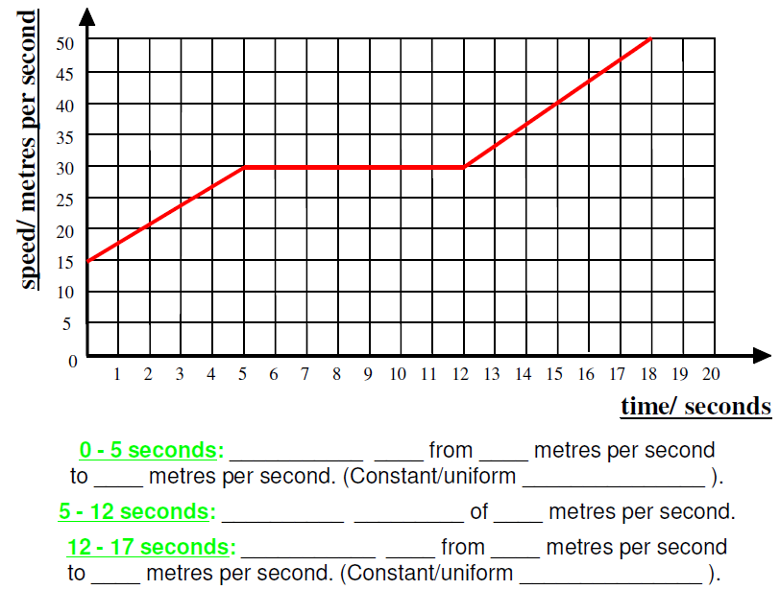

Displacement = area under a v-t graph

s = area 1 + area 2 + area 3 + area 4

$$\left(\frac{1}{2}bh\right)+\left(bh\right)+\left(bh\right)+\left(\frac{1}{2}bh\right)$$

$$\left(\frac{1}{2}×5×15\right)+\left(15×5\right)+\left(13×30\right)+\left(\frac{1}{2}×6×20\right)$$

Displacement = 560m

Displacement = area under a v-t graph

s = area 1 + area 2 + area 3

$$\left(\frac{1}{2}bh\right)+\left(bh\right)+\left(\frac{1}{2}bh\right)$$

$$\left(\frac{1}{2}×30×2\right)+\left(20×2\right)+\left(\frac{1}{2}×20×4\right)$$

Displacement = 110m

#### B

#### C

#### D

Speed/ m/s

Time/s

10

20

30

40

50

40

30

20

10

#### A

Displacement = area under a v-t graph

s = area 1 + area 2 + area 3

$$\left(\frac{1}{2}bh\right)+\left(bh\right)+\left(\frac{1}{2}bh\right)$$

$$\left(\frac{1}{2}×8×40\right)+\left(3×40\right)+\left(\frac{1}{2}×7×40\right)$$

Displacement = 420m

Displacement = area under a v-t graph

s = area 1 + area 2 + area 3

$$\left(\frac{1}{2}bh\right)+\left(bh\right)+\left(\frac{1}{2}bh\right)$$

$$\left(\frac{1}{2}×20×40\right)+\left(20×40\right)+\left(\frac{1}{2}×10×40\right)$$

Displacement = 1400m

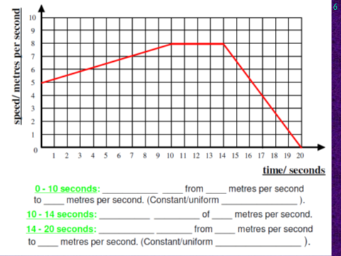

Displacement = area under a v-t graph

s = area 1 + area 2 + area 3 + area 4

$$\left(\frac{1}{2}bh\right)+\left(bh\right)+\left(bh\right)+\left(\frac{1}{2}bh\right)$$

$$\left(\frac{1}{2}×10×3\right)+\left(10×5\right)+\left(4×8\right)+\left(\frac{1}{2}×6×8\right)$$

Displacement = 121m