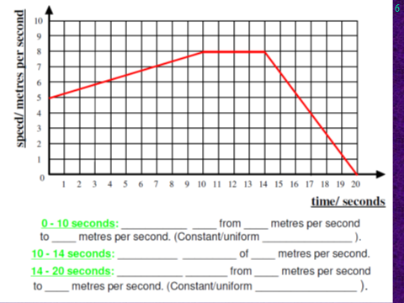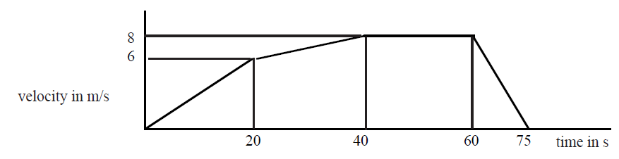

#### B

#### C

#### D

Speed/ m/s

Time/s

10

20

30

40

50

40

30

20

10

#### A

Speed/ ms-1

Time/s

10

20

30

40

50

8

6

4

2

