Velocity and Displacement

Vectors and Scalars
A scalar quantity is a quantity which is specified by magnitude or size alone.
A vector quantity is a quantity which is specified by magnitude or size but will also have a direction.

For example, speed is a scalar quantity which has magnitude only e.g a car can be travelling at 5 m s-1. Velocity is a vector quantity which has both magnitude and direction e.g. a car can be travelling at 5 m s-1 due north.

The table below shows a list of common vector and scalar quantities.

Scalar quantities | Vector Quantities
Speed | Velocity
Distance | Displacement
Temperature | Acceleration
Mass | Force
Energy | Weight
Time

Some scalar quantities have equivalent vector quantities. Velocity is the vector equivalent of speed i.e. a velocity has magnitude in a particular direction while speed has no associated direction.

Displacement is the vector equivalent of distance i.e. a displacement has direction whilst distance has not.

Adding Vectors
If vectors are in the same direction then they are simply added together.

For example, a woman walks 150 m to the right followed by another 50 m to the right. Her total displacement is 200 m to the right.

150 m
50 m

If vectors are in the opposite direction then they are subtracted, one from
the other.

For example, a woman walks 250 m to the right followed by 100 m to the left. Her total displacement is 150 m to the right.

250 m
100 m

Sometimes vectors will be at right angles to one another. In this case they have to be added using either trigonometry or by scale drawing. It does not matter which method you use, both are acceptable so use whichever method you find easiest.
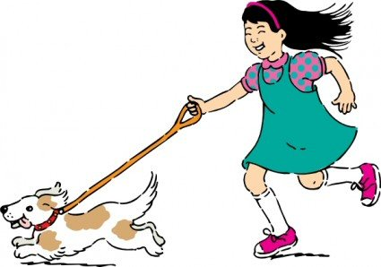
300 m
400 m
A vector is represented by an arrow with the arrowhead pointing in the direction of the vector. Here is an example. A girl takes her dog for a walk by walking 400 m north followed by 300 m west. The sum of these two displacements is called the resultant displacement

Finding the resultant of two forces using a scale drawing
Using the example above find the resultant displacement by scale drawing. Here are the steps in finding the answer.

1. Decide on a suitable scale and write this down at the start of the answer. If appropriate write down the direction you take as forwards, north etc.
north

Let 1 cm = 100 m

2. Draw an arrow to represent the first vector ensuring that it is the correct size and in the correct direction.
north
4 cm
Let 1 cm = 100 m

3. Draw a second arrow to represent the second vector starting at the head of the first vector. Vectors must always be added head to tail. Continue until all the vectors have been drawn.
3 cm
4 cm
north

Let 1 cm = 100 m

4. The resultant vector is now found by drawing it from the tail of the first vector to the head of the last vector. The resultant vector can be distinguished from other vectors by drawing a double arrow on it. The magnitude and direction of this vector is the required answer. These are found by measuring the line using a ruler and finding the angle with a protractor. In this example the girl’s resultant displacement is 500 m at an angle of 36·9° west of north.
36·9°
5 cm
north
3 cm
4 cm

Let 1 cm = 100 m

5. The resultant is 5 cm long which means the displacement is 500 m. When quoting the final answer always ensure you clearly state the magnitude and direction of the resultant.
Resultant displacement of the girl is 500 m at an angle of 36·9° to
the west of north.

It is also possible to quote the direction as a bearing. If North is regarded
as 000° and the bearing of the resultant displacement is 323°.
323°

Finding the Resultant using Trigonometry
When you are dealing with two vectors at right angles, the resultant can be found using Pythagoras’ theorem and one of the three trigonometric ratios (sine, cosine and tangent).

Consider the problem involving the girl and her dog described previously. Always sketch the situation first so that you know what the approximate answer will be.
300 m
400 m
north

The magnitude of the resultant of the two vectors is found by using Pythagoras’ theorem.
36·9°
500 m
north
300 m
400 m

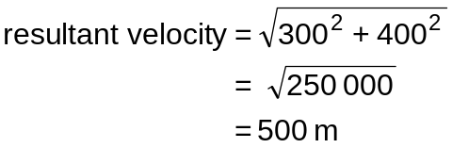

The direction is found using a trigonometric function i.e.

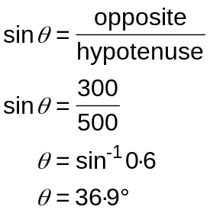 or 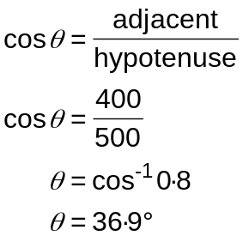 or 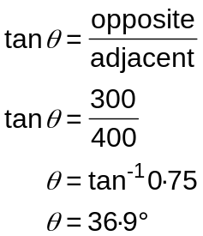

Displacement of the girl and dog is 500 m at an angle of 36·9° west of north.

The above methods can be applied to any two vectors you want to add, whether they are displacements, velocity or some other vector.

Speed-Time Graphs
Speed-time graphs can provide information about the motion of an object. The graphs below demonstrate the shape obtained for different types of motion.
At rest
speed
time
Constant speed
speed
time

speed

time
0
0

Uniform negative acceleration or slowing down
Uniform acceleration or speeding up

speed

time
0
0

A speed time graph can tell us how far an object has travelled. The distance travelled is equal to the area under the graph. The graph can be split into sections and the area of each calculated. The sum of these is equal to the distance travelled.
time in s
speed in m s-1
0
4
8
12
10
½ × b × h
½ × b × h
b × h

Total area = (½ × 4 × 10) + (4 × 10) + (½ × 4 × 10) = 80 m

Average and Instantaneous speeds
Speed is calculated by dividing the distance travelled by the time taken. Measured over a long distance or long time, the speed calculated is an average speed.

The average speed can be found using the formula:

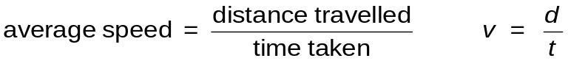

where v = final speed measured in metres per second (m s-1)
d = distance measured in metres (m)
t = time measured in seconds (s)

Worked example
A car travels from Aberdeen to Stonehaven, a distance of 24 km. Calculate the average speed of the car in m s–1 if it takes 15 minutes to complete the journey.
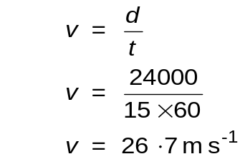

The instantaneous speed of a vehicle is measured over very short distances or time intervals. In a car, the speedometer indicates the instantaneous speed.

Electronic methods of measuring instantaneous speed can be used in the laboratory. This is done with an electronic timer or computer connected to light gates.

Using Light Gates to Measure Speed
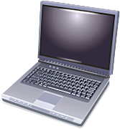
A light gate consists of a light source and a photocell. The photocell is connected to an electronic timing device or a computer. The timing device is triggered by the light beam falling on the photocell being blocked by a card or similar. The timing device records how long the beam is blocked for.
light gate
computer interface
vehicle
photocell
light
card of known length

The instantaneous speed can then be found using the formula:

instantaneous speed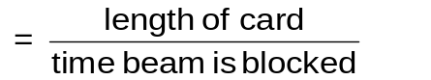

Acceleration
Acceleration is a measure of the rate at which something increases or decreases its speed. (something slowing down is said to have negative acceleration).
Definition:- acceleration is the change in velocity per unit time.
Acceleration can be calculated using the formula below.

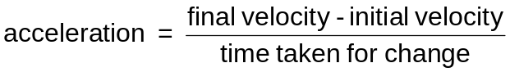 or 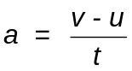

where a = acceleration measured in metres per second per second (m s-2)
v = final velocity measured in metres per second (m s-1)
u = initial velocity measured in metres per second (m s-1)
t = time measured in seconds (s)

Worked example
A cheetah can accelerate from rest to 24 m s–1 in 3 s. Calculate its acceleration.
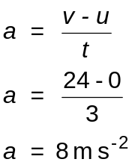

Using Light Gates to Measure Acceleration
Just as light gates can be used to measure speed, light gates can be used to measure acceleration also.

To calculate acceleration you need to know an initial velocity and a final velocity. This is achieved by using a double card. The same effect can also be achieved by using a single card and two light gates.

vehicle
double card

Measuring Acceleration from Speed-Time Graphs
Information can be obtained from a speed-time graph which allows acceleration to be calculated.

Worked example
A car accelerates from 20 m s-1 to 80 m s-1 in a time of 10 s as shown in the graph below. Calculate its acceleration between 0 s and 10 s.
speed in m s-1
60
40
20
80
100
0 1 2 3 4 5 6 7 8 9 10 11 12
time in s

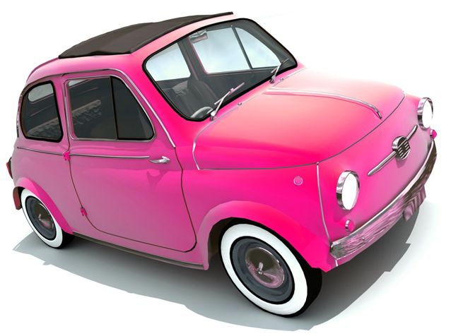
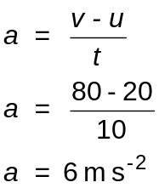

Newton’s Laws

Force is measured in newtons. When a force is applied to an object it can change its shape, its speed or its direction of travel.

When forces are applied to an object they can either be balanced or unbalanced.

In a situation where the forces are balanced there are either no forces acting on the object or the forces that are acting, cancel each other out. Remember that force is a vector quantity with both direction and magnitude.
equal and opposite forces are balanced


In a situation where the forces are unbalanced there will be a net or resultant force acting on the object.
unequal forces are unbalanced

Sir Isaac Newton summarised the effect of forces in his three Laws of Motion.

Newton’s First Law of Motion states:
“An object at rest will remain at rest unless acted on by an unbalanced force. An object in motion continues in motion with the same speed and in the same direction unless acted upon by an unbalanced force.”

In simple terms, this means that:

if the forces acting on a stationary object are all balanced the object remains at rest;

if the forces acting on a moving object are all balanced the object will continue to move at a steady speed in a straight line;

if the forces acting on an object are unbalanced the object will accelerate in the direction of the unbalanced force.

Worked example
Calculate the resultant force acting on the football and describe its motion as a result.

12 N
5 N
4 N

Total force to the right = 9 N. Total force to the left = 12 N.
Resultant force = 3 N to the left.

Newton’s Second Law of Motion states:
“The acceleration of an object is dependent upon two variables – the net force acting upon the object and the mass of the object. The acceleration of an object depends directly upon the net force and inversely upon the mass of the object. The relationship between an object's mass m, its acceleration a, and the applied force F is:
F = m × a.
If there are more than two forces acting on an object, it is important that it is the net unbalanced force that is used in the calculation. Using the equation below can help you to remember this.
Fun = m × a.
where Fun = unbalanced force measured in newtons (N)
m = mass measured in kilograms (kg)
a = acceleration measured in metres per second per second (m s-2)

In simple terms this means that if an object is acted on by an unbalanced force it will accelerate. The amount of acceleration increases as the force increases. However if you apply the same force to a larger mass the acceleration will be less.

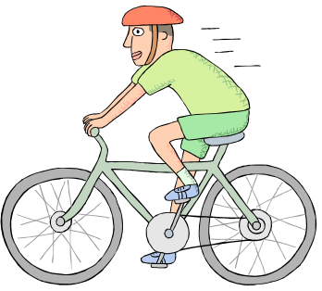
Worked example
A cyclist pedals to produce a forward force of 200 N.
The forces of friction acting on the cyclist are 60 N.

(a) Find the resultant force acting on the cyclist.

(b) Calculate the acceleration of the cyclist if he has a mass of 70 kg.

(a) Resultant force = 200 − 60 = 140 N.

(b)
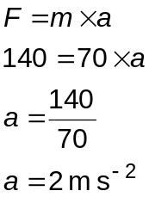

Work Done, Force and Distance

Work takes place when an object is moved by a force, the force transferring energy to the object.

If an archer pulls back the string on a bow and arrow, the work done on stretching the string and bow will be transferred to the arrow when it is fired.

The work done by a weightlifter in applying an unbalanced upward force to the weights is transferred into the potential energy they gain.

When work is done against friction the energy will be transferred into heat.

Work can be calculated using the formula below.

work = force × distance in direction of force Ew = F d

where Ew = work measured in joules (J)
F = force measured in newtons (N)
d = distance measured in metres (m)

Worked example
A wheelbarrow is pushed a distance of 20 m by applying a force of 50 N. Calculate the work transferred.

Work = force × distance
Ew = F d
Ew = 50 × 20
= 1000 J


Weight and Gravity
A gravitational field exists around the Earth as shown opposite. It acts on any mass to attract it towards the Earth.

The downwards force per kilogram is called the gravitational field strength and is 9·8 N kg-1 on Earth.

Note that mass is defined as the amount of matter in a body and is measured in kilograms.
Weight is the force with which the Earth’s gravity pulls an object downwards and, as it is a force, is measured in newtons.

Weight = mass × gravitational field strength or W = m g

where W = weight and is measured in newtons (N)
m = mass measured in kilograms (kg)
g = gravitational field strength and is 9·8 N kg-1 on Earth

Worked example
A pupil has a mass of 50 kg. Calculate her weight.
weight = mass × gravitational field strength
W = m g
W = 50 × 9·8
= 490 N

The value of gravitational field strength (g) varies from planet to planet. Whilst the mass of objects will not vary, their weight will, depending upon where the object is.
Definition:- Gravitational field strength is the force per unit mass.
The table below shows values of g for the moon and different planets.

Planet | Gravitational field strength  (N kg–1)
Moon | 1·6
Mercury | 3·7
Venus | 8·9
Earth | 9·8
Mars | 3·7
Jupiter | 26
Saturn | 11·2
Uranus | 9·0
Neptune | 11·3

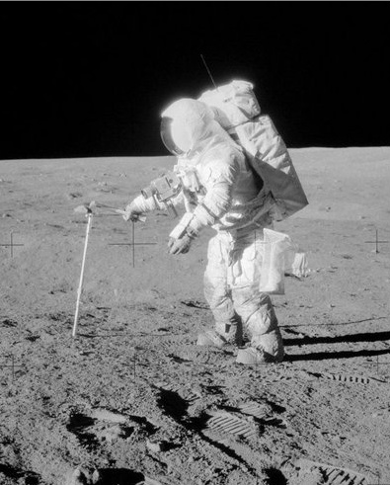
Worked example
A hammer has a mass of 1·2 kg.
Calculate the weight of the hammer on the moon.

W = m g
W = 1·2 × 1·6
= 1·92 N
Newton’s Laws and Space Flight

Sir Isaac Newton’s Third Law of Motion states:
“For every action force there is an equal and opposite reaction force.”

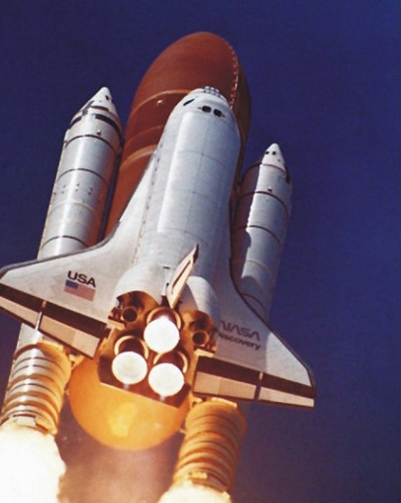
This statement means that forces always exist in pairs. There are many practical examples of this.
- If two ice skaters stand opposite each other and one pushes the other, they both move backwards.
- When a gun is fired there is a force pushing the bullet out of the muzzle but an equal and opposite force pushing the gun backwards (called the recoil).
- When the space shuttle rockets are fired the hot gases are forced out backwards. This causes an equal and opposite force propelling the shuttle forwards.

When a rocket is launched it will accelerate upwards due to the thrust from its engines. As it uses up fuel the rockets will continue to produce the same upwards thrust but the force is acting on a smaller and smaller mass. As a result, the acceleration of the rocket increases.

As it climbs upwards, the gravitational field strength decreases. This means that the weight of the shuttle which is a downwards force acting against its movement, gets less and less. At the same time the atmosphere, which produces air resistance acting against the shuttles movement, gets less and less. Both of these factors also contribute to a greater unbalanced upwards force and so greater acceleration.

Once the rocket has escaped from the pull of the Earth's gravity the rockets can be switched off and it will continue at the same speed as there are now no forces acting against its motion.

Free Fall and Terminal Velocity
When a skydiver jumps out of a plane they accelerate downwards due to the force of gravity. As their speed increases the force of friction due to air resistance gets greater and greater. Eventually the weight and friction reach a point where they are equal.
skydiver’s weight acting downwards
force of air resistance acting upwards

There are now no unbalanced forces acting on the skydiver so, by Newton’s Second Law, they continue downwards at a steady speed. They are said to have reached their terminal velocity.

Projectiles
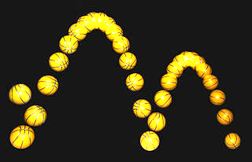
A projectile is an object which has a forwards speed at the same time as it is falling freely through the air.

Strobe photographs can be taken of projectiles where multiple images are made of a moving object a short time interval apart. The picture below shows a bouncing basketball. Notice that the horizontal distance the ball travels between each image remains constant whilst the vertical distance changes.
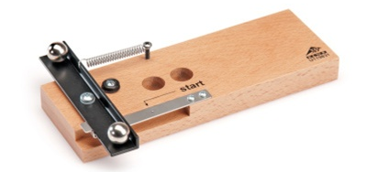

A popular experiment uses the apparatus shown opposite. It projects one ball bearing horizontally whilst dropping another vertically at the same time.

If air resistance is ignored, the ball bearing projected horizontally continues at a constant speed. Both ball bearings will be pulled downward with the same force of gravity so have the same downward acceleration. As a result they will reach the floor at the same instant. The diagrams below illustrate the trajectory or flight of each ball bearing. The images are taken equal time intervals apart.
Ball bearing dropped vertically
Ball bearing projected horizontally
The ball bearing accelerates downwards which increases the distance it travels during each time interval.
Like the ball bearing dropped vertically, the distance the ball bearing travels vertically during each time interval increases. However, in the horizontal direction it travels an equal distance each time interval.

When solving projectile problems, the horizontal motion has to be considered separately from the vertical motion. Use equations for constant speed for the horizontal motion and acceleration for the vertical motion.
Horizontal motion - 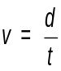
Vertical motion - or v = u + at
Worked example
A ball rolls off the top of a horizontal laboratory bench at 2 m s–1. It lands on the floor 1·2 s later.

(a) State the final horizontal speed of the ball just as it hits the ground.

(b) State the initial vertical speed of the ball.

(c) Calculate the final vertical speed of the ball if acceleration due to gravity is 9·8 m s–2.

(d) Calculate the horizontal distance the stone lands away from the table.

(a) 2 m s–1.

(b) 0 m s–1.

(c)
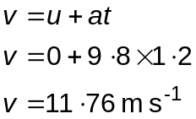

(d)
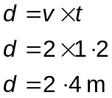

The horizontal and vertical motion of a projectile can also be represented on graphs as shown below.
horizontal motion
vertical motion
0
0
speed
in m s-1
speed
in m s-1
time in s
time in s

The horizontal distance and vertical distance travelled can be calculated from the area under the lines on the respective graphs.
Satellite motion
A satellite is like a projectile which is falling towards the Earth’s surface at the same rate as the Earth’s surface is curving away from the satellite. This means that the satellite never gets any closer to the Earth and so is said to be in orbit.

Think of a cannonball fired from the top of a very high mountain. At a certain horizontal velocity, A, it will fall towards the Earth’s surface. Increase the speed, as in B, and it will travel further. Increase the speed even more and it will never reach the Earth’s surface as in C, and will be in orbit around the Earth.
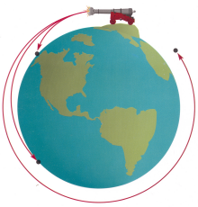
Copyright 1995, Mosby-Year Book, Inc, Astronomy:Journey to the Cosmic Frontier
A
B
C

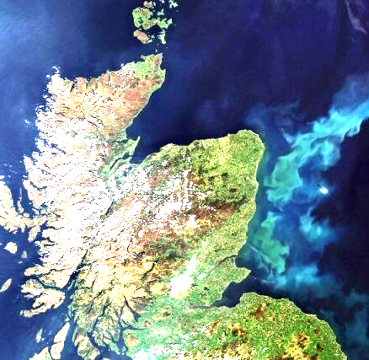
Satellites can be either orbiting or geostationary. Orbiting satellites orbit at a lower height above the Earth’s surface and can be used to map the ground, observe weather or be used for military purposes.

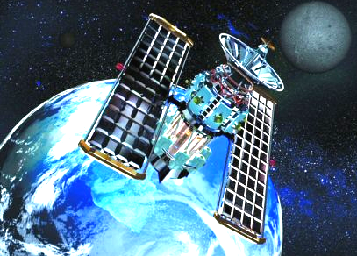

Geostationary satellites are in a higher orbit and orbit the Earth once every 24 hours. As a result, they always remain in the same position above the Earth’s surface. They are mostly used for telecommunications and weather observation.

Space exploration
The exploration of space and the technology involved has brought a lot of benefits. There is also a negative side to the exploration of space. You must decide if it is worth the risk.

Benefits
Communication – modern communication uses satellites and could not function as it does without them.

Satellite navigation – this is not only used in cars but a whole range of industries including shipping, mining and aviation. The oil industry uses it to accurately position drilling rigs.

Jobs – there are thousands of people employed directly by the space industry but there are probably millions who are employed in spin off technology such as satellite communication including mobile phones and television.
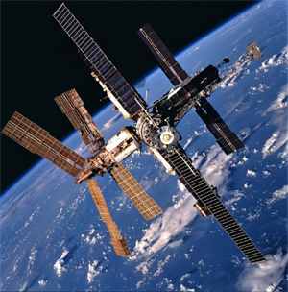
Spin-off technologies. Many applications that are developed for the space industry have been adopted widely and are now part of everyday life such as bar codes, miniaturised electronics, scratch resistant glasses, industrial materials, cordless power tools, water purification systems – even non-stick coatings for frying pans!

Mapping – satellites are able to accurately map the surface of the earth which aids important industries such as mining and can improve land use.

Weather monitoring – accurately predicting weather patterns and anticipating dangerous hurricanes and tropical storms is now made more accurate and easier through using satellite imaging.

Satisfying our curiosity – finding out more about the universe and our place in it has become possible through the advances in space exploration. In the past 50 years we have sent men to the Moon and probes to distant planets.

Risks and Costs
Pollution of space with debris from satellites and spacecraft. There is a risk that some debris may fall to Earth and reach the Earth’s surface. The risk of being hit is infinitely small though

Danger to life – several astronauts have lost their lives in both the Apollo Moon missions and shuttle missions.

Cost – the budget for space exploration is high could that money be better spent elsewhere.
Re-entry and Heat
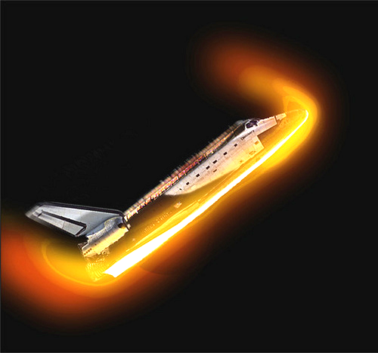
In space there is no atmosphere and hence no friction for spacecraft to contend with. However, when re-entering the Earth’s atmosphere at high speed, the spacecraft faces problems.

If the spacecraft hits the atmosphere at the wrong angle it can bounce back into space like a stone skipping off water.

The atmosphere also creates a great deal of friction creating a lot of heat. As the spacecraft loses kinetic energy this is converted into heat energy. The space shuttle is covered with heat resistant tiles which prevent damage to the shuttle.
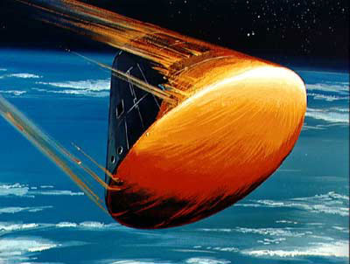
Older spacecraft such as the American Apollo missions and Russian Soyuz missions used a system called ablation to prevent damage to the re-entry modules like the one shown opposite.

The underside of the craft which experiences most friction is covered with a heat shield, a material which undergoes a process called ablation. This means that it removes excess heat by melting. The heat absorbed by the heat shield to melt it is called the latent heat of fusion.

Latent Heat
The graph below shows what happens to the temperature of a solid substance as heat energy is added to it.
temperature of substance
energy added to substance
melting point
substance is a solid
substance is a gas
substance is a liquid
boiling point

As energy is added to a substance its temperature rises. However, when it reaches its melting or boiling point the energy being added to it causes a change of state rather than a rise in temperature.
The latent heat of fusion is the energy added or removed from a kilogram of substance to change it from solid to liquid or liquid to solid;

The latent heat of vaporisation is the energy added or removed from a kilogram of substance to change it from liquid to gas or gas to liquid.

Note that there is never a change in temperature when the change of state takes place e.g. boiling water changes from water to steam at 100°C—both the steam and the water are at the same temperature. The energy added to the water goes into changing the substance’s state, not into raising its temperature.

The amount of energy required to change the state of a substance can be found using the equation below.

heat energy = mass changed × specific latent heat Eh = m l

Worked example
A material is being tested for use on the heat shield of a spacecraft. It has a mass of 0·5 kg. How much heat energy is required to change it from a solid to a liquid if its latent heat of vaporisation is 3·10 × 105 J kg-1

Eh = m l
Eh = 0·5 × 3·10 × 105 J kg-1
Eh = 155 000 or 155 kJ

Remember that you may be asked to carry out calculations involving the interchange of energy e.g. calculating the kinetic energy of an object in space using Ek = ½m v 2 and heat energy using Eh = c m ΔT or Eh = m l

The Dangers of Space
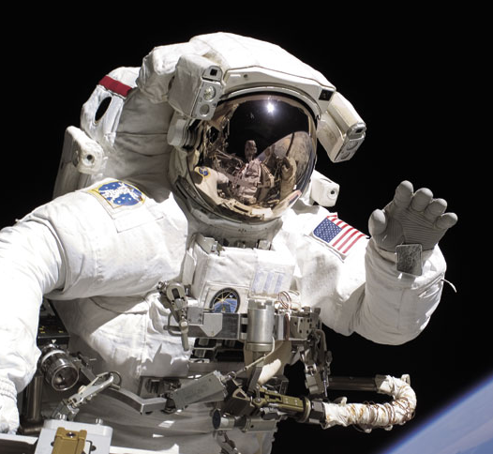
Outer space is a very unpleasant place to be. It is hard to get up there in the first place but once you are there, you have to be protected from all the dangers that surround you. This is largely accomplished through wearing a specially designed space suit.

Space is a vacuum so there is no oxygen there. As a result you would lose consciousness very quickly.
Worse will happen however, due to this lack of an atmosphere. As there is no air pressure acting on your body, dissolved gases in your body would come out of solution and your body fluids would start to boil. (fluids boil at lower temperatures at lower pressure). The boiling process also removes energy from the body which cools down very rapidly indeed.

Tissues in your body and critical organs such as the heart will swell up and expand due to the boiling fluids. Death would be very quick but agonisingly painful.

There would be extremes of temperature. Parts of your body in direct sunlight would experience very high temperatures whilst those in the shade would be extremely cold.

Your body would be bombarded by radiation and charged particles from the Sun. The Earth’s atmosphere filters most of the harmful radiation out before it reaches the Earth’s surface but there would be no protection in space.

If all of the above have not already killed you, there is a risk that you would be hit by tiny particles of dust or rock that are moving at very high speeds. You might even be hit by debris or ‘space junk’ from the many satellites and spacecraft that have been abandoned in space.

Cosmology

The Universe
On Earth, distances are measured in kilometres. In space, the distances involved are so large that they are measured in light years i.e. the distance that light will travel in 1 year.

Since light travels at 3 × 108 m s–1 and there are 3·15 × 107 (60 × 60 × 24 × 365) seconds in a year it means that in 1 year light travels 9·5 million million kilometres or 9·5 × 1015 m.

Some important distances in light years are:
The Sun to the Earth - 8·5 minutes
The Sun to the nearest star - 4·3 light years
The diameter of the Milky Way - 120 000 light years
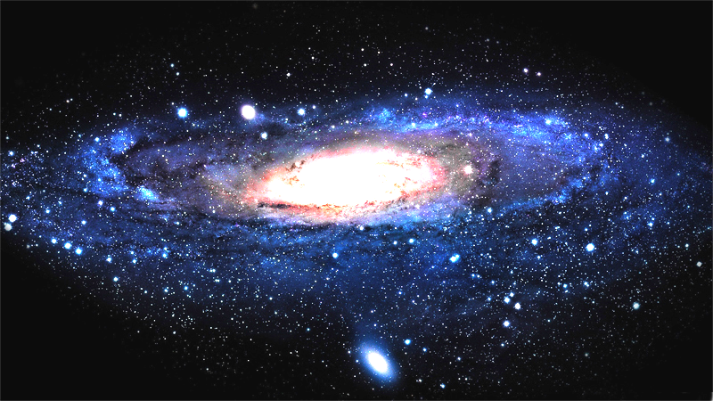

You should know a number of definitions and terms relating to space and the universe.
Planet - a body revolving around a star.
Moon - a body revolving around a planet.
Star - a ball of burning gas at the centre of a solar system.
Sun - the star at the centre of our solar system.
Solar system - a star and its associated planets.
Galaxy - a grouping of solar systems.
Universe - all the matter that we know of.

The Earth is part of our solar system which orbits the star in the middle—the Sun. The Sun is just one of many stars which are found in the galaxy of which we are part. The galaxy is called the Milky Way and contains 100 000 million other stars. The Milky Way consists of a spiral of stars and is about 1 × 1021 m wide.

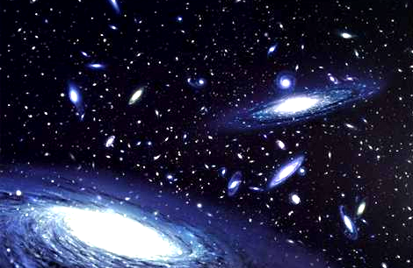
The Milky Way is not the only galaxy there is. It is estimated there are hundreds of billions of galaxies. That means there are a.vast number of stars, some of which will have orbiting planets and some of these may also contain life. The universe itself is probably about 93 billion light years wide but that’s only what we can observe. Scientists have been able to calculate that the universe is about 13 billion years old and it is constantly expanding. No one knows what lies beyond the edge of the universe.

Telescopes and waves
Electromagnetic waves arrive at the Earth from space. These waves belong to the electromagnetic spectrum and all travel at the speed of light (3 × 108 m s–1)
Radio waves have the lowest frequency with gamma radiation having the highest frequency.
radio
waves
microwaves
infra
red
visible light
ultraviolet radiation
X-rays
gamma radiation
TV
waves

Different detectors are used for different waves. These are listed below.
Radio waves - aerial and radio receiver.
Television -aerial and television receiver
Microwaves – aerial and microwave receiver.
Infrared – Photodiode, thermocouple or themistor.
Visible light - the eye or photographic film.
Ultraviolet - fluorescent material.
X-rays - photographic film.
Gamma radiation - Geiger counter, photographic film.

Different types of telescopes can be used to detect different waves. Radio telescopes like the one shown opposite are used to detect radio waves emitted by stars.

Optical telescopes are used to observe visible light from stars. An objective lens at the end of the telescope gathers light from an object in space to form a very small image. This is magnified using the eyepiece lens The larger the diameter of the objective lens, the more light can be captured and hence the brighter the image.

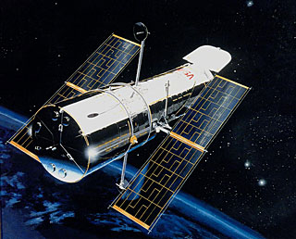
illustration by NASA/ESA

The Earth’s atmosphere and light from other sources limit the quality of image that can be seen using a telescope on Earth. The answer is to place it in space which was done with the Hubble telescope opposite

Using the Spectra
white light
prism
spectrum of colours
A prism will split white light into its component wavelengths or colours. This can also be achieved using a device called a diffraction grating.

If white light is shone through a grating it produces a continuous spectrum.
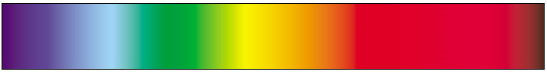

By shining light from a star through a grating a spectrum made up of a series of lines is observed called a line spectrum.

The line spectra depends upon the elements present in the star with every element having its own unique set of lines. Astronomers can identify the elements making up a star by analysing the light coming from it.

