Electrical charge carriers and electric fields

Electric charge
Electric charge is either positive or negative. Negative charge is made up of electrons and it is electrons which flow through a conductor when a current flows. In a conductor, there are electrons free to move. The more charge flows around the circuit the larger is the current.
conductor
+
−
flow of electrons
electrons

Like charges (positive and positive or negative and negative) repel one another. Unlike charges (positive and negative) attract one another. Electrons flow from the negative terminal to the positive terminal. The potential difference or voltage which causes the flow of electrons is usually provided by a battery, cell or power supply.
A
The current in a circuit is a measure of the rate of flow of charge through it. Ammeters are always placed in series or in line with a component. It does not matter if the ammeter is before or after the component⎯the current is the same.

The charge flowing in a circuit can be calculated using the formula below.

charge = current × time Q = I t

where Q = charge measured in coulombs (C)
I = current measured in amperes (A)
t = time measured in seconds (s)

Worked example
A charge of 20 C passes through a circuit in 5 seconds. Calculate the current in the circuit.
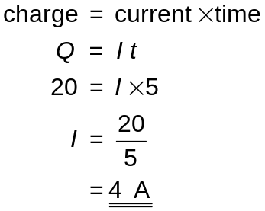

Current can be either direct current (d.c.) or alternating current (a.c.). A d.c. supply has one continuous, steady current flowing in one direction only. In an a.c. supply the current constantly changes its value and changes direction flowing first one way then the other. The oscilloscope traces below what would be seen if connected to each type.

An a.c. supply
A d.c. supply

A d.c. supply would be from a cell or battery. An a.c. supply would be from a mains socket. Mains electricity is at a voltage of 230 V and a frequency of 50 Hz.

Electric Fields
Around any charged object there is an electric field or area in which an electric charge will experience a force. Electric fields are invisible but can be made visible using simple techniques.
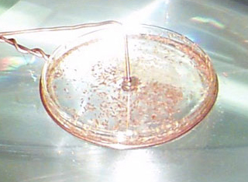

An electrode at a high voltage can be placed in a dish of oil. Sprinkling the oil surface with semolina powder or grass seeds will make the field lines visible. These line up along the electric field lines so making them visible.

The diagrams below show the shape of two electric fields. The spacing of the field lines indicates the strength of the field—where the lines are closer together the field is stronger.

+
+
+
+
+
–
–
–
–
–
Electric field between two parallel plates
+
Electric field around a positive charge

The field lines always point in the direction in which a positive charge would move.

Potential difference (voltage)
The energy for electrons to flow around a circuit comes from a voltage or potential difference provided by a power supply. Electrons will flow towards the positive connection of the power supply and away from the negative connection. The size of the potential difference or voltage is a measure of the energy given to the electrons.
V

Electrons loose energy as they flow through a component – it is changed into other forms such as heat or light. The energy lost by the charge (the voltage) is measured by connecting a voltmeter across either side of the component. The voltmeter in the circuit opposite will measure the voltage across the lamp.

Circuits and Ohm’s Law
Symbols are used to represent components in electrical circuits. Some of these are shown below.
–
+
battery
–
+
cell
linked wires
switch
variable
resistor
lamp
V
voltmeter
A
ammeter
resistor
ohmmeter
Ω
fuse
motor
M

The resistance of an electrical circuit can be investigated using a voltmeter and ammeter. They are connected as shown in the circuit below.
A
V

The voltage across the resistor and the current through it are measured for a range of voltages. The value of the resistor is the voltage divided by the current.

i.e.  will give a constant value equivalent to the resistance of the circuit.

Thus voltage, current and resistance are related in the following formula:

voltage = current × resistance V = I R

where V = voltage measured in volts (V)
I = current measured in amperes (A)
R = resistance measured in ohms (Ω)

Worked example
A 12 V supply is connected to lamp which draws a current of 0·5 A. Calculate the resistance of the lamp.
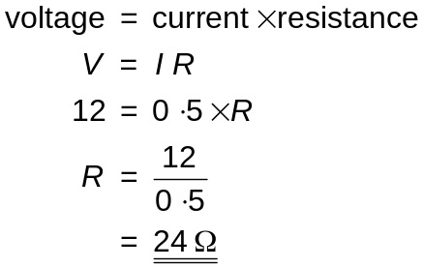

If a graph of voltage against current is plotted, it will be a straight line through the origin. This is because the current is directly proportional to the voltage for a fixed resistance. Doubling the voltage across a resistor will double the current flowing through it.
voltage
current
0
An ohmmeter can also be used to measure the resistance of a resistor directly but it must be disconnected from any circuit before this can be done.

The resistance of a length of wire will depend upon several factors. The size of the resistance will depend upon:
- what material the wire is made from;
- the length of the wire⎯the longer it is the more its resistance;
- its cross sectional area (thickness)⎯the thinner the wire the more its resistance;
- its temperature⎯the hotter the wire the higher its resistance.

Series and parallel circuits
Circuits can be series or parallel or a combination of the two.

In a series circuit there is only one path through the components and back to the cell or battery.

In a parallel circuit there are two or more paths around the circuit. There is at least one point in the circuit where there is a choice of paths.

Series Circuits
In the series circuit below the current is the same through all components. The readings on ammeters A1 and A2 will be the same.

The supply voltage, Vsupply, is split between the components in the circuit
thus Vsupply = V1, + V2 + V3.
V1
V2
V3
Vsupply
A1
A2

Parallel Circuits
In the parallel circuit below the voltage is the same across all components i.e. it will be the same as the supply voltage.

The current leaving the supply, Itotal, is split between the components in the circuit
thus Isupply = I1, + I2 + I3.
V
V
I
1
V
I
2
V
I
3
I
total
I
total
A
A
A
A
A

Resistors in Series and Parallel
Often two or more resistors are connected together in a circuit. This can either be in series or in parallel.

When adding resistors in series, the total resistance of the circuit increases―its as if the length of a piece of resistance wire was being made longer. When adding resistors in series use the formula:

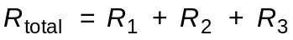
20 Ω
30 Ω
60 Ω

The three resistors in the circuit opposite will have a total resistance of 110 Ω

When adding resistors in parallel, the total resistance of the circuit always decreases―its as if a piece of resistance wire was being made thicker. The total resistance will always be less than the smallest resistance in the circuit.

When adding resistors in parallel use the formula:

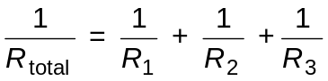
60 Ω
30 Ω
20 Ω

The three resistors in the circuit opposite will have a total resistance of 10 Ω

Here’s how it’s calculated.
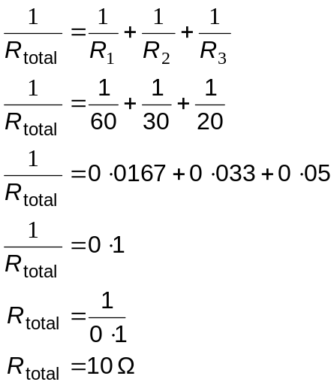

Voltage Dividers
Potential or voltage dividers are used to split a voltage. The voltage across any single resistor depends upon what proportion its resistance is of the total resistance of the circuit. Suppose we want to find the voltage across the two resistors in the circuit shown below.
0 V
+12 V
R2 = 20 Ω
R1 = 10 Ω
V1
V2

The 12 V supply voltage will divide in proportion between the 10 Ω and 20 Ω resistors. The voltage across each resistor can be calculated as follows.

Total resistance of circuit = 20 Ω + 10 Ω = 30 Ω.

so, 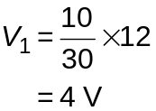 and 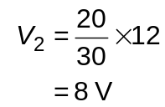
This can be put into a general formula 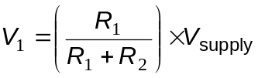

Electronic Circuits

Electronic components
Electronic circuits consist of an input, a process and an output e.g. a calculator has a keyboard as the input, a microprocessor carries out the process part and the liquid crystal display is the output.

Symbols are used to represent electronic components. Some of these are shown below.
motor
M
capacitor
thermistor
light dependent resistor (LDR)
diode
Light emitting diode (LED)
photovoltaic cell
+
‒
loudspeaker
relay
+
‒
+
‒
NPN transistor
base
collector
emitter
s—source
g—gate
d—drain
MOSFET transistor

Capacitor:- these store electric charge and are often used in time delay circuits. When uncharged the voltage across a capacitor will be 0 V rising to the same voltage as the supply when fully charged.

The circuit below can be used to charge a capacitor.

resistor
capacitor
supply voltage
0 V
switch
V

When the switch is closed the voltage across the capacitor will slowly increase. The time it takes for a capacitor to charge up depends upon the size of the capacitor and the size of the resistor. The larger they both are, the longer it takes for the capacitor to charge.

Thermistor:- a thermistor is a device which changes its resistance with temperature. Its resistance can decrease or increase with a rise in temperature but the commonest thermistors decrease their resistance as temperatures increase.

Light dependent resistors (LDR):- the resistance of an LDR alters as the light falling on it changes. Increasing the light level decreases the resistance.

Diode:- a diode only allows current to flow through it in one direction. The negative side of the diode must be connected to the negative of the power supply for it to conduct.

Light Emitting Diode (LED):- an LED converts electrical energy into light energy. It works from a low voltage using a small current. It will only operate in a circuit if connected the right way round i.e. its negative connection must be connected to the negative terminal of the power supply.
This LED will not light as it is connected to the cell the wrong way.
–
+
–
+
This LED will light, the negative side of the LED is connected to the negative terminal of the cell.

Photovoltaic cell:- This will convert light energy into electrical energy.

Motor:- an electric motor converts electrical energy into kinetic energy.

Loudspeaker:- a loudspeaker converts electrical energy into sound energy.

Transistor:- a transistor can be used as an electronic switch. All transistors have three connections and can either by NPN type or MOSFET type.
base
collector
emitter
s—source
g—gate
d—drain
MOSFET transistor
NPN transistor

+ 5 V
0 V
0·7 V or
more

How a transistor works
Consider an NPN transistor. By applying a voltage between the base and emitter the transistor can be made to conduct through the emitter and collector. The voltage required to switch on the transistor is 0·7 V or above. Potential divider circuits can often be used to achieve this in a variety of situations.

+ 5 V
0 V
lamp
LDR
variable resistor

In the circuit opposite, the resistance of the LDR increases as it gets dark. The voltage across the LDR increases and once it is above 0·7 V, the transistor will switch the lamp on. Altering the value of the variable resistor can alter the light level at which the transistor switches on.
In the circuit opposite, the resistance of the thermistor will decrease as it gets hotter. The voltage across it decreases and so the voltage across the variable resistor will increase. Once it is above 0·7 V, the transistor will switch the warning lamp on.

warning
lamp
+ 5 V
0 V
variable
resistor
thermistor

A MOSFET transistor works in the same way as an NPN transistor. The only difference is that the voltage required to switch the transistor on is 2 V and over and this is applied between the gate and source connections. When this happens the transistor will conduct through the source and drain.
+ 5 V
0 V
2·0 V or
more

Worked example
Which of the two transistors shown below will be switched on, so operating the motor.
+ 5 V
0 V
400 Ω
+ 5 V
0 V
Circuit A
100 Ω
400 Ω
100 Ω
Circuit B
M
M

In both circuits, there will be 1·0 V across the 100 Ω resistor and 4·0 V across the 400 Ω resistor. In circuit A, the NPN transistor will be switched on and so will apply a voltage to the motor which will operate. In circuit B, the MOSFET transistor is not turned on as 1·0 V is not large enough.

Relay:- a small voltage applied to the input of the relay will activate an electro-mechanical switch which can be used to control a larger current or voltage.
Electrical Power

Energy consumption
Appliances in the home convert electrical energy into other forms.
- A television converts electrical energy into light and sound energy.
- A washing machine converts electrical energy into kinetic energy and heat energy.

The rate at which appliances use energy is termed their power and is measured in watts. If an appliance has a power of 1 watt it uses 1 joule of energy every second.

Appliances with high power ratings usually produce a lot of heat. Toasters, electric irons, kettles etc. usually have power ratings of over 1000 watts.

Calculating power
The power of an appliance can be calculated using the formula below.

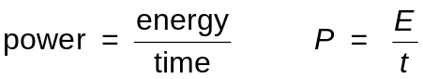

where P = power measured in watts
E = energy measured in joules
t = time measured in seconds

Worked example
An electric heater with an output power of 1 kW is switched on for 5 minutes. Calculate the energy output from the heater.

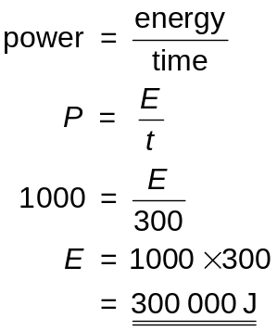

The power of an appliance can also be calculated using one of three formula involving the voltage, current and resistance of an appliance.

power = current × voltage P = I V

where P = power measured in watts (W)
I = current measured in amperes (A)
V = voltage measured in volts (V)

Voltage 230 V a.c. 50 Hz
Power 2·2 kW

Must not be used in bathrooms
Do not cover heater
This formula is especially useful when calculating the current drawn by an appliance so that the correct value of fuse can be chosen. A mains appliance will always have a rating plate attached which gives information about the voltage and power of the appliance.

Worked example
Calculate the current drawn by a 805 W electric toaster connected to 230 V mains electricity.

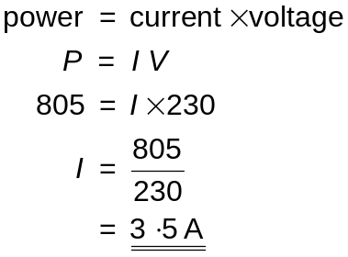

Linking power, current and resistance:

power = current2 × resistance P = I 2 R

where P = power measured in watts (W)
I = current measured in amperes (A)
R = resistance measured in ohms (Ω)

Worked example
The element of an electric iron has a resistance of 76 Ω. Calculate the current drawn by the iron if it has a power rating of 690 W

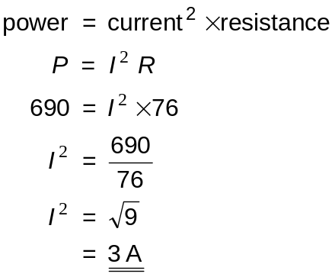

Power, voltage and resistance are linked with the formula:

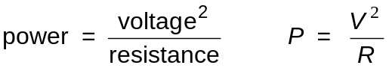

where P = power measured in watts (W)
V = voltage measured in volts (V)
R = resistance measured in ohms (Ω)

Worked example
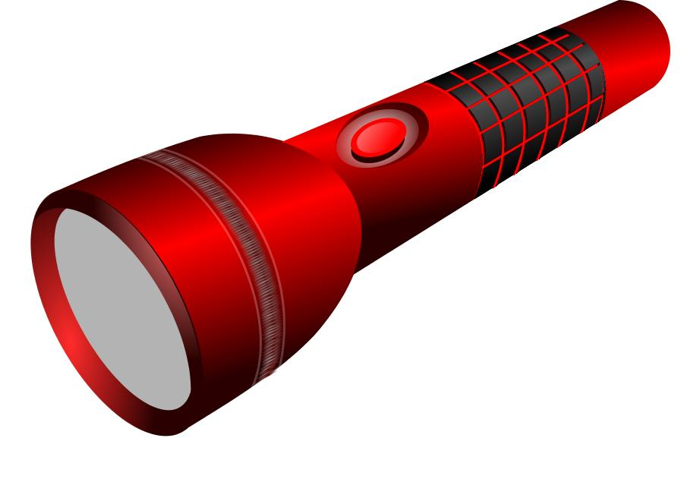
A torch contains an LED lighting circuit with a resistance of 18 Ω and an output power of 2 W. Calculate the voltage of the torch power supply.

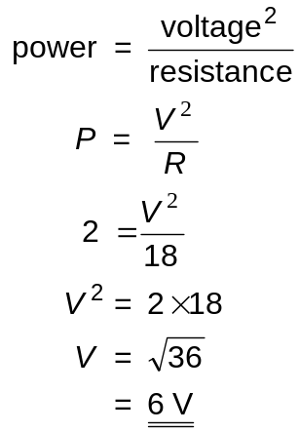

Fuses
A fuse can be found in every mains plug.
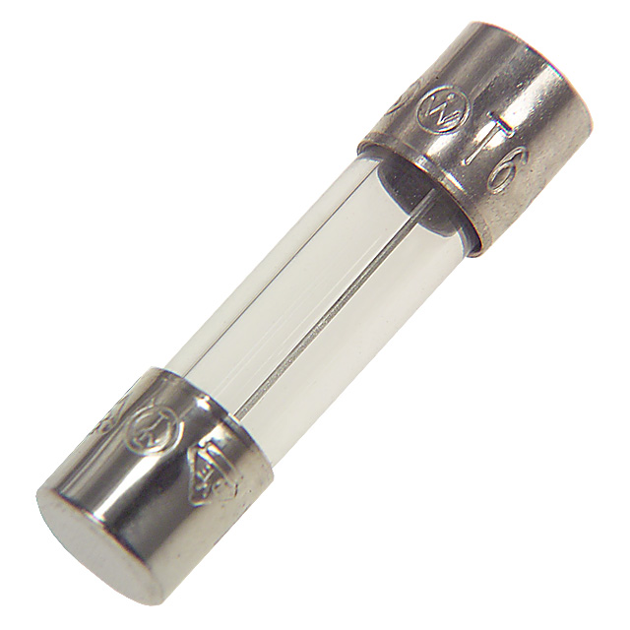
fuse

It consists of a thin strand of wire between two electrical contacts at each end. Fuses in mains plugs are usually in a ceramic tube so the wire cannot be seen. The function of the fuse is to protect the flex to the appliance. If too high a current flows through the flex due to a fault in the appliance, the fuse will ‘blow’ and cut off the supply of electricity. This prevents the flex overheating and possibly catching fire.
It is important that the correct size of fuse is fitted to the plug. It should normally be the next value of fuse above the normal current of the appliance. The current can be calculated using the formula P = I V. If an appliance normally drew 3 A then a 5 A fuse would be the best value to fit.

Conservation of energy
All the energy that exists in the universe is already there. It cannot increase or decrease. The law of Conservation of Energy states that energy cannot be created or destroyed, only changed from one form into another or transferred from one object to another.

There are lots of everyday examples of this.

If a snooker ball collides with a second snooker ball, the kinetic energy of the first ball is transferred to the second ball.


A cat that has climbed up a tree has gained potential energy. If it falls out of the tree the potential energy will be changed into kinetic energy.

Energy can be changed into useful forms e.g. an electric drill changes electrical energy into kinetic energy. Energy is often changed into non-useful forms. In the electric drill some of the electrical energy is wasted due to friction between the moving components which generates heat energy.

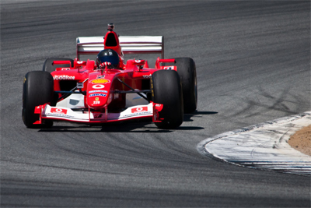
In a Formula 1 racing car, the chemical energy from the fuel is changed into kinetic energy but some is also wasted as heat. There will also be friction in the engine and other moving parts of the car such as the wheel axles and between the tyres and the road. Every time the driver brakes the kinetic energy of the car is changed into heat in the brakes.
Some friction we try to reduce. Air resistance is made smaller by making cars a more streamlined shape or by using oil and grease in the engine. Some friction is useful and we try to increase it. It is important to have maximum grip between the tyres and the road surface so the friction is increased by having a deep tread in the tyre.

Work

Work takes place when an object is moved by a force, the force transferring energy to the object.

If an archer pulls back the string on a bow and arrow, the work done on stretching the string and bow will be transferred to the arrow when it is fired.

The work done by a weightlifter in applying an upward force to the weights is transferred into the potential energy they gain.

When work is done against friction the energy will be transferred into heat.

Work can be calculated using the formula below.

work = force × distance in direction of force Ew = F d

where Ew = work measured in joules (j)
F = force measured in newtons (N)
d = distance measured in metres (m)

Worked example
A wheelbarrow is pushed a distance of 20 m by applying a force of 50 N. Calculate the work transferred.

Work = force × distance
Ew = F d
Ew = 50 × 20
= 1000 J
Gravitational potential energy
If an object is lifted above the ground or above its normal rest position it gains gravitational potential energy. The gain in energy is equal to the work done in lifting it.

The formula for gravitational potential energy is:

gravitational potential energy = mass × gravitational field strength
× height raised

Ep = m g h

where Ep = potential energy measured in joules (J)
m = mass measured in kilograms (kg)
g = gravitational field strength and on Earth is 9·8 N kg‒1
h = height measured in metres (m)

Worked example
A bucket of water is raised from a well. Calculate the depth of the well if the mass of the bucket and water is 15 kg and it gains 882 joules of potential energy.

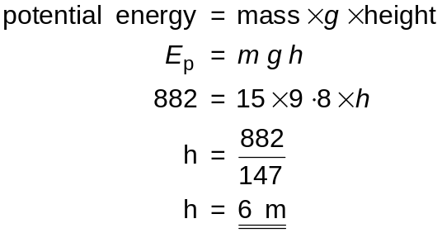

Kinetic energy
Any moving object will have kinetic energy. The greater the mass of the object or the higher its speed, the greater will be its kinetic energy. Kinetic energy can be calculated using the formula:

kinetic energy = ½ × mass × velocity2 Ek = ½m v 2

Note that it is only the velocity which is squared.

where Ek = kinetic energy measured in joules (J)
m = mass measured in kilograms (kg)
v = speed measured in m s‒1
Worked example

A cyclist has a mass of 60 kg. Calculate her speed if she has 2430 J of kinetic energy.
Picture by Stijn Desmedt

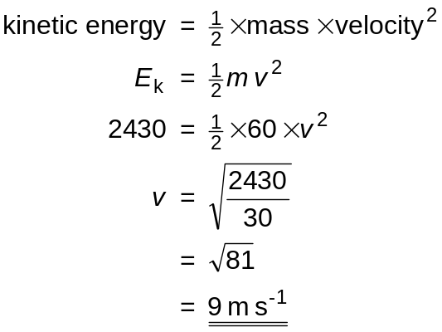

Ep
Ep + Ek
Ek
Conservation of Energy
On page 13 the conservation of energy was discussed. It is possible to use this principle in making calculations.

A pendulum bob has gravitational potential energy when pulled back. This changes to kinetic energy as it swings downwards becoming all kinetic energy at the lowest point of the bob

Worked example
A pendulum with a mass of 0·2 kg is pulled back so it is 0·1 m above its rest position. Calculate the speed of the pendulum at its lowest point.

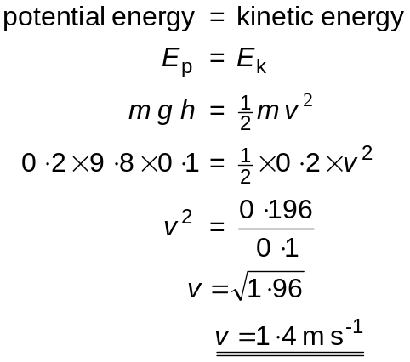
Gas Laws and the Kinetic Model

Pressure, Force and Area
Pressure in a gas is caused by the particles of gas colliding with a boundary such as a container wall. Pressure is also caused by a force pushing against something e.g. the pressure under your foot when you stand on the ground.

Pressure is defined as the force per unit area. It can be calculated using the formula

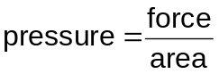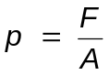

where p = pressure in pascals (Pa) or newtons per square
metre (N m–2)
F = force in newtons (N)
A = area in square metres (m2)

Worked example
A hammer hits a nail with a downwards force of 300 N. Calculate the pressure under the point of the nail if the point of the nail has an area of 1 × 10–6 m2.
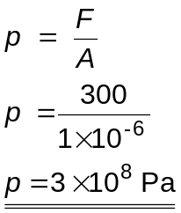
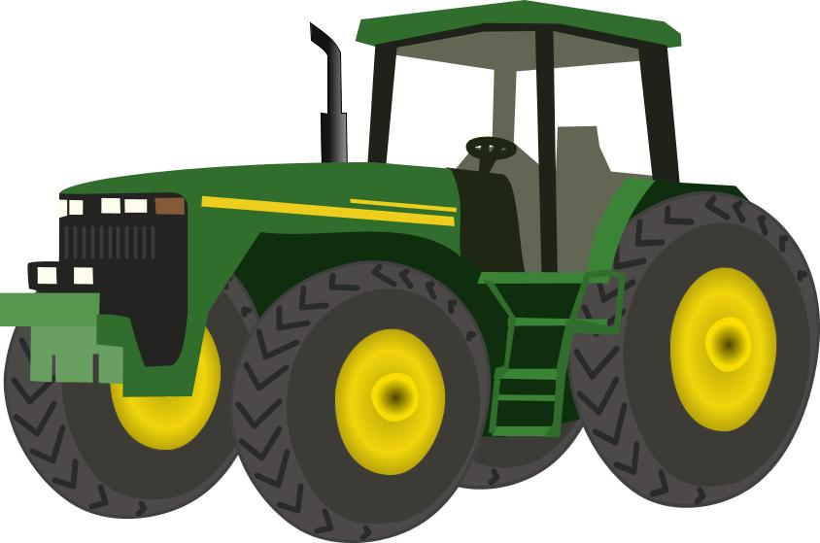
The pressure under objects can be deliberately reduced. Tractors working on soft ground have large wide tyres. The weight of the tractor is spread over a larger area which reduces the pressure under the tyres and prevents the tractor sinking into the ground.

The Gas Laws―Pressure and Volume
The relationship between the pressure and the volume of a gas can be found experimentally using the apparatus shown below.
Air pumped into apparatus to increase pressure on oil and hence trapped air.
Bourdon gauge to measure pressure on the gas.
gas trapped in glass tube

The length of the trapped column of air is proportional to its volume so the numbers on the scale can be used for volume.
0
5
10
15
20
25
30
35
40
45
50
55
60
oil

The mass of gas in the tube remains the same. Readings of the length of the gas column are taken from the scale at the side of the tube. Length readings can be used for volume as the volume of the gas is proportional to its length.

Between readings, air is pumped into the apparatus above the oil. Its pressure is recorded on the Bourdon gauge and the pressure on the oil is transferred to the trapped gas, compressing it.

pressure
volume

The results obtained from the experiment produce a graph of pressure against volume

As the pressure increases the volume decreases.

If a graph of pressure against 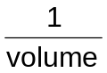 is plotted then a straight line through the origin is produced showing that pressure is inversely proportional to pressure.
pressure

volume
1
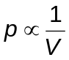

If a gas has initial conditions p1 and V1 and the pressure and volume are altered to p2 and V2 these are related by the equation

p1V1 = p2V2

Worked example
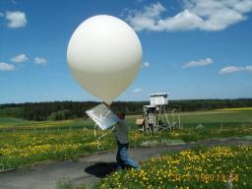
A weather balloon has a volume of 2·5 m3 when inflated at sea level where atmospheric pressure is 100 kPa. What will be the volume of the balloon when it has risen to a height where atmospheric pressure is only 40 kPa?

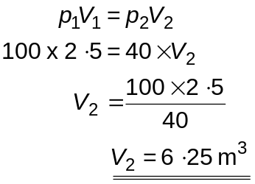

The Gas Laws―Pressure and Temperature
The relationship between the pressure and temperature of a gas can be investigated using the apparatus shown below.
water bath
heater
thermometer
pressure
gauge
air

The flask containing a fixed mass of gas is submerged in a water bath and the temperature slowly increased using an immersion heater. This in turn raises the temperature of the gas within the flask. The pressure of the gas is measured using a Bourdon pressure gauge and the temperature of the gas is measured using a thermometer placed in the flask. The volume of the gas remains constant.

If a graph of pressure against temperature in °C is plotted from the results it is found that increasing the temperature of the gas increases the pressure. However, the relationship is not one of direct proportion.

temperature/°C
pressure/Pa
0

The graph can be extended backwards to the point where pressure is zero.

temperature/°C
pressure/Pa
0
–273 °C

The temperature at which this happens is –273 °C. This is known as absolute zero and is the starting point or origin for a new temperature scale called the kelvin scale. (Absolute zero is the temperature at which the gas particles will cease to move and so exert no pressure.)

Plotting a graph of pressure against temperature in kelvin will produce a straight line through the origin.
temperature/K
pressure/Pa
0

The results of the experiment above show that pressure is directly proportional to the temperature in kelvin for a fixed mass of gas with constant volume.

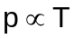in kelvin

If a gas has initial conditions p1 and T1 and the pressure and temperature are altered to p2 and T2 these are related in the equation

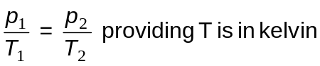
Any gas law problem involving temperature must have the temperature in the kelvin scale. The size of the units are the same―1 °C is the same size as 1 K.
The temperature scales simply have a different starting point. (Note the lack of the degree (°) symbol before K.)
100 °C
273 K
0 °C
–273 °C
0 K
Celsius scale
Kelvin scale
373 K

To convert from the celsius scale to the kelvin scale add 273 e.g. –10 °C = 263 K.

To convert from the kelvin scale to the celsius scale subtract 273 e.g. 373 K = 100 °C.

Worked example
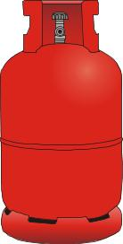
A calor gas cylinder is at a temperature of 17 ºC. The gas inside is at a pressure of 6 × 105 Pa. The cylinder is left in direct sunshine on a hot day and the temperature of the gas rises to 47 ºC. Calculate the new pressure of the gas inside.

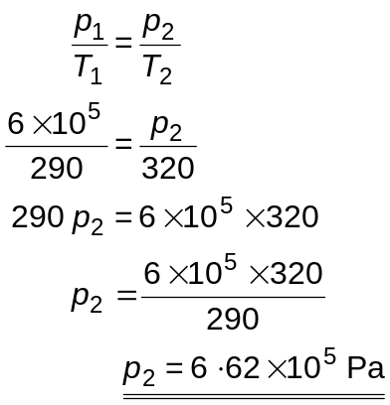
The Gas Laws―Volume and Temperature
An experiment can be carried out to investigate the relationship between the volume and temperature of a gas using the apparatus shown below. A fixed mass of gas is trapped in a glass tube by a bead of mercury which is free to move up and down the tube. This keeps the pressure of the gas constant.

ruler
mercury bead in open ended glass tubing
water bath
trapped air
heater
thermometer

As the water is heated the trapped gas expands and pushes the mercury up the tube. The length of this trapped gas is taken as a measure of its volume (since the length of the gas is proportional to volume in a tube with a uniform cross section).

A graph of the results from this experiment show that as the temperature increases the volume increases.
temperature/°C
volume/as length in cm
0

However, the relationship is not one of direct proportion.

The graph can be extended backwards to the point where the volume of the gas becomes zero.

temperature/°C
volume/as length in cm
0
–273 °C

The temperature at which this happens is –273 °C. This is known as absolute zero and is the starting point or origin for a new temperature scale called the kelvin scale. (Absolute zero is the temperature at which the gas particles will, in theory, have no volume.)

Plotting a graph of volume against temperature in kelvin will produce a straight line through the origin.
temperature/K
volume/as length in cm
0

The results of the experiment above show that volume is directly proportional to the temperature in kelvin for a fixed mass of gas at constant pressure:

in kelvin

If a gas has initial conditions V1 and T1 and the volume and temperature are altered to V2 and T2 these are related in the equation

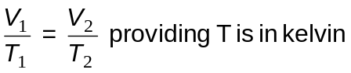

Worked example
A sealed syringe contains 20 cm3 of air at a temperature of 27 °C. The plunger of the syringe is able to move freely. The syringe is placed into a water bath at 100 °C. Calculate the new volume of the gas if pressure remains constant.

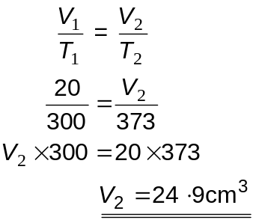

The General Gas Equation
We now have three equations linking together the pressure, volume and temperature (in kelvin) of a gas.
p1V1 = p2V2 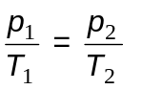 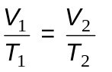

These three equations can be combined into a single equation known as the general gas equation. This can be used with more complex situations where pressure, temperature and volume all change.

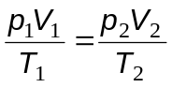

Remember, when using this equation always convert the temperature into Kelvin before carrying out any calculations.

Worked example
A weather balloon is released at ground level where the temperature is 27°C and the pressure is 100 kPa. The balloon has a volume of 3 m3. What will be the volume of the balloon when it rises to a height where the pressure is 26 kPa and the temperature is –53°C?

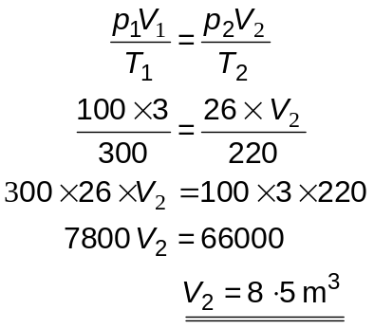
Kinetic Model of Gases
The particles of a gas can be thought of as being in constant motion. When they collide with the walls of a container they provide a small outwards force. The many, many collisions of the gas particles with the walls of a container which causes the pressure of a gas.

Pressure and temperature
At a high temperature the gas particles have a lot of kinetic energy and move quickly. There are many collisions with the container walls, each collision producing more force on the wall.
If the temperature of the gas is reduced the gas particles move more slowly with less kinetic energy. There are fewer collisions with the container walls and with less force than before so the pressure is less.

Pressure and volume
If a container holding a gas is sqeezed or compressed the pressure inside increases e.g. placing your finger over the end of a bicycle pump and pushing down the handle.
In a container with a large volume there are relatively fewer collisions with the container walls as the gas particles have further to travel between walls.
If the volume of the container is reduced there are more collisions with the container and so the pressure is greater.

Volume and temperature
Heating a container of gas will make it expand till the pressure inside is equal to the pressure outside the container.

The gas particles collide with the walls of the container pushing it outwards. Air particles outside push the walls inwards so a balance is achieved.

If the temperature of the gas is raised the gas particles have more kinetic energy and hit the walls more often and with more force. This pushes the container walls outwards till the pressure inside the container equals the pressure outside once more.

Specific Heat Capacity
When talking about heat and temperature it is important that the meaning of these words is clearly understood.

• heat is a form of energy transferred between objects at different temperatures. The greater the temperature difference between objects, the faster the transfer will take place.
• temperature is a measure of the hotness or coldness of an object and is defined as the mean or average kinetic energy of its particles⎯the hotter an object the more kinetic energy its particles will have.

Temperature is measured in degrees celsius or in kelvin. Heat is measured in joules.

Adding energy to materials will cause them to heat up. The rise in temperature will depend upon a number of factors however. The amount of energy added, the material the energy is added to and the mass of the material, will all have an effect.

For any material, the amount of energy required to increase the temperature of one kilogram by one degree Celsius is called its specific heat capacity (c).
These factors are linked together in the formula below.

heat energy = specific heat capacity × mass × change in temperature

Eh = c m ΔT

where Eh = heat energy measured in joules (j)
c = specific heat capacity measured in joules per kilogram degree celsius (J kg‒1 °C‒1)
m = mass measured in kilograms (kg)
ΔT = change in temperature measured in degrees celsius (°C)

Worked example
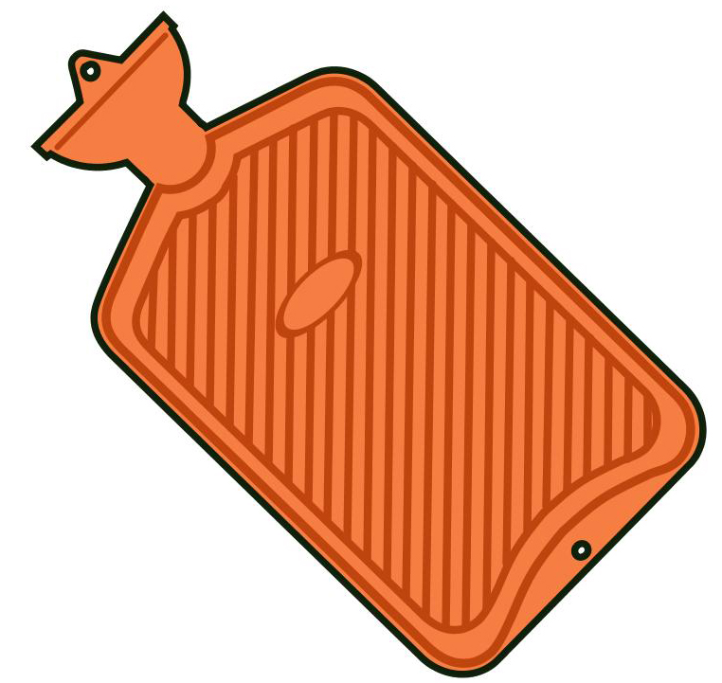
A hot water bottle contains 1·5 kg of water at a temperature of 80 °C. Calculate the energy it will lose if the water cools to 35 °C.
Specific heat capacity of water, c = 4180 J kg‒1 °C‒1.

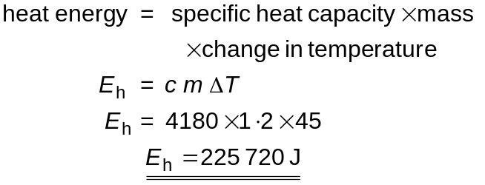

Energy conversions
Electrical energy is often converted into heat energy e.g. an electrical heater can be used to heat up a block of aluminium. Calculations can be carried out on the conversion of electrical energy into heat energy.

Worked example
A 1 kg aluminium block is heated using a 200 W heater for 5 minutes. Calculate the expected rise in temperature of the block if the specific heat capacity of aluminium is 902 J kg‒1 °C‒1.

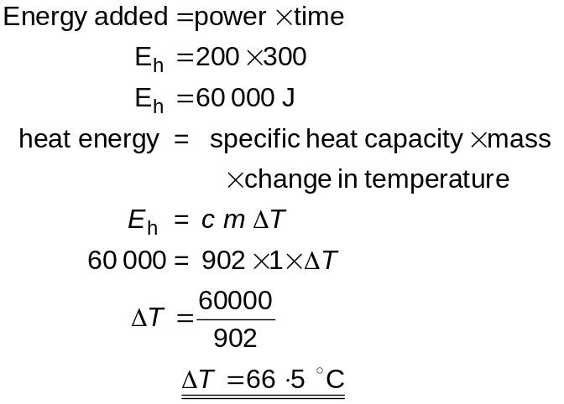
The actual rise in temperature would be less than that calculated above as there is no insulation around the metal block so it will lose heat.

