Summer WORK for N5 PHYSICS

# Units, Prefixes and Scientific Notation

## Contents Statements

|  |  |
| --- | --- |
| **0.1** | **I know the units for all of the physical quantities used in this unit.** |
| **0.2** | **I can use the prefixes: micro ( μ ), milli (m), kilo (k), mega (M) and Giga (G)** |
| **0.3** | **I can give an appropriate number of significant figures when carrying out calculations (This means that the final answer can have no more significant figures than the value with least number of significant figures used in the calculation).** |
| **0.4** | **I can use scientific notation when large and small numbers are used in calculations.** |

## SI Units

In Physics we always use the International System of Units (SI Units for *Système International d'Unités*) which is the standard across the globe (aside from the United States because they have to be special –[see the story about the time NASA lost a billion dollar Mars orbiter because a contractor used Imperial units instead of SI units](http://edition.cnn.com/TECH/space/9909/30/mars.metric/)).

There are only 7 base units/quantities in SI units. All other units are derived from these base units, which are as follows.

|  |  |  |  |
| --- | --- | --- | --- |
| Quantity | Quantity Symbol | Unit | Unit Symbol |
| Length | d | metre | M |
| Mass | m | kilogram | kg |
| Time | t | second | s |
| Electric Current | I | Ampere | A |
| Temperature | T | Kelvin or Celsius | K or oC |
| Luminous Intensity |  | candela | cd |
| Amount of Substance |  | mole | mol |

These SI units can be used in conjunction with the prefixes and scientific notation to express very big or very small values.

## Prefixes & Scientific Notation

Throughout the course, attention should be given to units, prefixes and scientific notation.

|  |  |  |  |
| --- | --- | --- | --- |
| Prefix | Symbol | Power | Multiplier |
| Tera | T | 1012 | x 1,000,000,000,000 |
| Giga | G | 109 | x 1,000,000,000 |
| Mega | M | 106 | x 1,000,000 |
| Kilo | k | 103 | x 1,000 |
| Centi | c | 102 | /100 |
| Milli | m | 10-3 | /1,000 |
| Micro | µ | 10-6 | /1,000,000 |
| Nano | n | 10-9 | /1,000,000,000 |
| Pico | p | 10-12 | /1,000,000,000,000 |

In this section the prefixes you will use most often are milli (m), micro (µ), kilo (k), mega (M) and giga (G). It is essential that you use these correctly in calculations.

In Physics, the standard unit for time is the second (s) and therefore if time is given in milliseconds (ms) or microseconds (µs) it must be converted to seconds. **Do not confuse milliseconds (ms) with the unit of speed (ms-1)!.. and remember there are no SECS in Physics.**

## Examples

1 A car takes 2 ms to pass a point in the road. Express this in seconds.

**Solution**: 2 ms = 2 milliseconds = -3 s = 2/1000 = 0.002 seconds.

In Physics, the standard unit for distance is the metre (m) and therefore if distance is given in kilometres (km) it must be converted to metres.

2. A car travels 15.6 km in ten minutes. Determine the distance in metres. **Solution**: 15.6 km = 15.6 kilometres = $15.6×{10}^{3}$ m = $15.6×1000$ = 15 600 metres.

b) What is this time expressed in seconds?

**Solution**: 10 mins = 10 $×60$ s = 600 = 600 seconds.

3. An object experiences a force of 15 kN. Express this in Newtons.

**Solution:** 15 kN = 15 kiloNewtons = $15×{10}^{3}$ N = $15×1000$ = 15 000 Newton

## Practice

Convert the following numbers into their prefixes.

|  |  |  |  |
| --- | --- | --- | --- |
|  | 4x107 m |  | 3.2 x107 ms-1 |
|  | 7.25 x10-10  kg |  | 9.356x102 V |
|  | 23500000 Hz |  | 0.000234 s |
|  | 0.0304 m |  | 6.9 x10-6 A |

It is OK (in Physics) to write numbers as 45 ×103 kg. You do not need to convert it to 4.5×104 kg as you would have to in Maths, although it is probably better if you do. Your calculators can do this for you. Check that you know how using the SCI menu.

Convert the following to 3 significant figures.

|  |  |  |
| --- | --- | --- |
| 1. 23 760 000 V | e. | 78 945 379.97 Hz |
| 1. 7 600 043.7 ms-1 | f. |  |
| 1. 1 254 879 V | g. |  |
| 1. 67 593 268.0076 m | h. | 1 214 687 A |

# Summary

The following are the outcomes that you ought to have covered in this section.

|  |  |
| --- | --- |
|  | I know the units for all of the physical quantities used in this unit. |
|  | I can use the prefixes: micro ( μ ), milli (m), kilo (k), mega (M) and Giga (G) |
|  | I can give an appropriate number of significant figures when carrying out calculations (This means that the final answer can have no more significant figures than the value with least number of significant figures used in the calculation). |
|  | I can use scientific notation when large and small numbers are used in calculations. |

|  |  |
| --- | --- |
|  |  |

# Speed

## Content Statements

|  |  |
| --- | --- |
| 1.6 | I can perform calculations involving the relationship between speed, distance and time (d=vt) |
| 1.8 | I can determine average and instantaneous speed. |
| 1.9 | I can describe experiments to measure average and instantaneous speed. |

## Speed =distance ÷ time

**Speed** is described by the equation below.

$speed=\frac{distance}{time} v= \frac{d}{t}$

Speed is the distance travelled in unit time (distance travelled per second)

|  |  |  |  |
| --- | --- | --- | --- |
| Symbol | Definition | Unit | Unit Symbol |
| *v* | speed | metres per second | ms-1 |
| *d* | distance | metre | m |
| *t* | time | second | s |

We use the letter *v* to represent speed as it is used for the similar term **velocity**, although these terms are **different.** *s* is also used for the quantity displacement, which we will meet later.

**d**

$$t$$

$$\overline{v}$$

*But don’t use the triangle unless you absolutely have to.*

To rearrange, you can use the following triangle:

# Average Speed

The **average** speed of an object is defined as the total distance travelled divided by the time for the journey, or the rate of covering a distance.

This is shown by the equation: $$\overline{v}=\frac{d}{t}$$

The bar over any quantity in Physics denotes that it is an average value.

### Examples

Tony walks 40m in 30s what is his average speed?

ms-1

You could write 1.3ms-1 or 1.33ms-1 or 1.333ms-1 and get the mark. If you write 1.33. ms-1 or 1 ms-1 or 1.333333 ms-1  you lose the mark for the answer! This is because you have used **too many significant figures**. Mrs H calls this “calculator diarrhoea” and you can **fix it** by always ensuring that the number of significant figures you have are no more than the number of sigfig in the quantities you calculated the answer from.

## Measuring Average Speed

To measure the average speed you need to **measure the distance for the whole journey** and measure **the time taken for the whole journey**. The distance can be measured with a trundle wheel, tape measure etc., and the time can be measured with a stop watch. Use the formula: $$\overline{v}=\frac{d}{t}$$

…to calculate the average speed for the journey.

distance

Measure the **distance travelled** by the car using a **trundle wheel**/tape measure etc. Measure the **time for the journey** with a **stopwatch**. Use

**speed=distance/time**

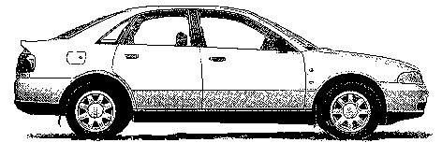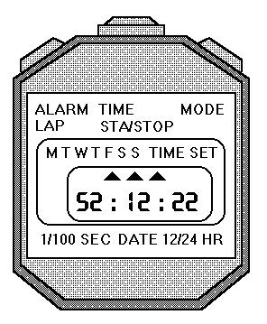

# Instantaneous Speed

The **instantaneous** speed of a vehicle at a given point can be measured by finding the average speed during a **very short time** as the vehicle passes that point. Average speed and instantaneous speed often have very different magnitudes (size) e.g. the average speed of a runner during a race will be less than the instantaneous speed as the winning line is crossed, due to the need to accelerate at the beginning of the race, or if you are on a car journey and need the services, your instantaneous speed when parked up, will be different from your average speed for the whole journey.

$$v=\frac{∆d}{∆t}$$

The symbol Δ is used in physics to denote a small change in. For example, the change in time is very short as is the distance measured. Or use the symbol l to represent the length of the vehicle, and Δt as the time to pass a point.

$v=\frac{l}{∆t}$

The **instantaneous** speed of an object is defined as the length of the vehicle divide by the time to pass a point.

## Measuring Instantaneous Speed

To measure instantaneous speed, it is necessary to be able to measure **very** short times. With an ordinary stopclock, human reaction time introduces large errors. These can be avoided by using electronic timers. The most usual is a light gate**.**

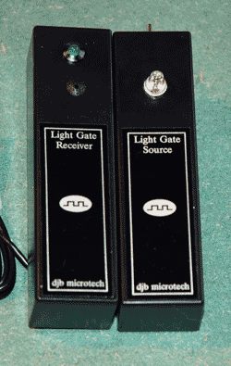 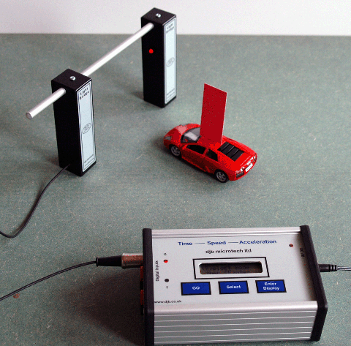

A light gate consists of a light source aimed at a photocell. The photocell is connected to an electronic timer or computer. The timer measures how long an object takes to cut the light beam. The distance travelled is the length of the object which passes through the beam. Often a card is attached so that the card passes through the beam. The length of the card is easy to measure using a rule. The instantaneous speed as the vehicle passes through the light gate is then calculated using:

$$v=\frac{d}{t}$$

|  |  |  |  |
| --- | --- | --- | --- |
| Definition | Symbol | Unit | Unit symbol |
| speed of vehicle | $$v$$ | metre per second | ms-1 |
| length of card | $$d$$ | metre | m |
| time | *t* | second | s |

### Example

A vehicle moves through a light gate as shown in the diagram. Using the data from the diagram, calculate the instantaneous speed of the vehicle as it passes the light gate.

**Solution**

$$v=\frac{d}{t}$$

$$v=\frac{0.025}{0.25}$$

$$v=0.1 ms^{-1}$$

Light gate connected to interface & computer

0.25 s

2.5 cm

# Required Experiments for National 5

|  |
| --- |
| Measuring the Average Speed of a Vehicle |
| Aim: Measurement of average speed of a trolley |
| Apparatus: Runway, trolley with single mask, light gate, computer timer, metre rule |
|  |
|  |
| Instructions   1. Measure distance, d, between the two light gates. 2. Set the computer to measure the time between the trolley passing through the light gates. 3. Release the trolley and record the time, t. 4. Calculate average speed ṽ = d / t 5. Repeat several times and calculate an average. |
| Evaluation  Look over your results and comment on the accuracy and precision |

|  |
| --- |
| Measuring the Instantaneous Speed of a Vehicle |
| Aim: Measuring the instantaneous speed of a vehicle |
| Apparatus Runway, trolley with single mask, light gate, computer timer, ruler. |
|  |
|  |
| Instructions   1. Measure distance, d, between the two light gates. 2. Set the computer to measure the time between the trolley passing through the light gates. 3. Release the trolley and record the time, t. 4. Calculate average speed ṽ = d / t 5. Repeat several times and calculate an average. |
| Evaluation  Look over your results and comment on the accuracy and precision |

## Speed, Distance and Time Calculations

1. A runner completes a 200 m race in 25 s. What is his average speed in ms-1?
2. A friend asks you to measure his average cycling speed along flat road. Describe which measurements you would take and the measuring instruments you would use.
3. An athlete takes 4 minutes 20 s to complete a 1500 m race. What is the average speed?
4. On a fun run, a competitor runs 10 km in 1 hour. What is her average speed in
   1. kmh-1  b) ms-1?
5. Describe how you could measure the average speed of a car as it passes along the road outside your school/college.
6. Concorde can travel at 680 ms-1 (twice the speed of sound). How far will it travel in 25 s at this speed?
7. A girl can walk at an average speed of 2 ms-1. How far will she walk in 20 minutes?
8. How long will it take a cyclist to travel 40 km at an average speed of 5 ms-1?
9. How long (to the nearest minute) will the Glasgow to London shuttle take if it flies at an average speed of 220 ms-1 for the 750 km flight?
10. How long, to the nearest minute, will a car take to travel 50 km if its average speed is 20 ms-1?
11. Look at this timetable for a train between Edinburgh and Glasgow:

|  |  |  |
| --- | --- | --- |
| Station | Time | Distance from Glasgow |
| Glasgow | 08:00 | 0 km |
| Falkirk | 08:20 | 34 km |
| Linlithgow | 08:28 | 46 km |
| Edinburgh | 08:50 | 73 km |

a) What was the average speed for the whole journey in ms-1?

b) What was the average speed in ms-1 between Glasgow and Falkirk?

c) Explain the difference in average speeds in a) and b).

1. Describe how you would measure the instantaneous speed of a vehicle as it reached the bottom of a slope.
2. In an experiment to measure instantaneous speed, these measurements were obtained:-

|  |  |  |  |
| --- | --- | --- | --- |
| Reading on timer | = | 0.125 | s |
| Length of car | = | 5 cm |  |

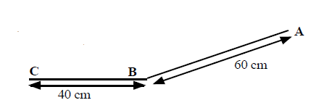Calculate the instantaneous speed of the vehicle in ms-1.

1. A trolley with a 10 cm card attached to it is released from A and runs down the slope, passing through a light gate at B, and stopping at C.

Time from A to B = 0.8 s.

Time on light gate timer = 0.067 s

a) What is the average speed between A and B?

b) What is the instantaneous speed at B?

## Speed Homework

1. A top class sprinter covers the 100m in a time of 10 seconds. Calculate the sprinter's average speed.

2. How long will it take a Formula 1 car to travel one lap around a 5 km long circuit if it is travelling at an average speed of 180 kmh-1?

3. A physics pupil tries to calculate his friend’s instantaneous speed when running by timing how long it takes her to cross a line. He uses a stopclock to measure the time.

(a) Explain why this method will give poor results for the instantaneous speed.

(b) Suggest the equipment needed to make the experiment more accurate.

4. Calculate a car’s acceleration if its speed increases by 12 ms-1 in a time of 3 s.

5. A physics pupil running away from a wasp accelerates from rest to 5 ms-1 in a time of 1.25 s. Calculate the pupil’s acceleration.

6. Read this passage on *Thinking and Braking* and then answer the questions that follow it.

*You are travelling at 30 mph in a car in good road conditions when you suddenly see children crossing the road. By the time you react and apply the brakes, the car has travelled a total distance of 23 m. If the car had been travelling at 60 mph the stopping distance would have been 73 m.*

*The stopping distance consists of two parts: the thinking distance and the braking distance. The thinking distance is the distance travelled in the time between seeing a hazard on the road and pressing the brake pedal. This time is called the reaction time.*

*thinking distance = speed x reaction time*

*Reaction times vary from person to person. An average driver has a reaction time of about 0.8 seconds. A professional racing driver has a reaction time of about 0.2 seconds. Your reaction time is likely to be much longer if you have taken drugs or alcohol. Even a small amount of alcohol can greatly increase your reaction time.*

(a) What is meant by the term ' thinking distance'?

(b) What will happen to the thinking distance if the car is going faster?

(c) If a car is going faster will the reaction time alter? Explain your answer.

# Summary

The following are the outcomes that you ought to have covered in this section. We’ve also covered quite a few from other sections too.

|  |  |
| --- | --- |
|  | I can perform calculations involving the relationship between speed, distance and time (d=vt) |
|  | I can determine average and instantaneous speed. |
|  | I can describe experiments to measure average and instantaneous speed. |

# Scalars & Vectors

## Content Statements

|  |  |
| --- | --- |
| 1.1 | I can define the terms scalars and vectors |
| 1.2 | I can identify vector and scalar quantities such as: force, speed, velocity, distance, displacement, acceleration, mass, time and energy. |
| 1.3 | I can calculate the resultant of two vector quantities in one dimension or at right angles. |
| 1.4 | I can determine displacement and/or distance using scale diagram or calculation. |
| 1.6 | I can make use of appropriate relationships to calculate velocity in one dimension (s=vt). |

## What are Scalars & Vectors?

Physical quantities, such as the ones below can be divided into two groups:

|  |  |  |  |  |
| --- | --- | --- | --- | --- |
| Acceleration | Area | Current | Displacement | Distance |
| Energy | Force | Frequency | Gravitational field strength | Mass |
| Momentum | Pressure | Resistance | Weight/ friction etc | Temperature |
| Time | Velocity | Voltage | Volume | Speed |

a **scalar** quantity is completely described by stating its **magnitude** (size) & **unit.**

a **vector** quantity is completely described by stating its **magnitude, unit** and **direction**

The following is a list of scalar and vector quantities. The table lists some of the scalars and vectors quantities that will be encountered in this course.

| Scalars | Vectors |
| --- | --- |
| Energy | Velocity |
| Temperature | Acceleration |
| Pressure | Displacement |
| Time | Momentum |
| Mass | Force |
| Current | (Weight/ friction etc) |
| Speed | Gravitational field strength |
| Volume |  |
| Voltage |  |
| Distance |  |
| Area |  |
| Resistance |  |
| Frequency |  |



Distance = “how far we’ve travelled”

* symbol *d*



**B**

**A**

* units metres, m
* scalar quantity

Displacement = “how far we’ve travelled in a straight

line (from A to B)” (include your direction)

* symbol *s*
* units, metres, m
* Vector quantity
* Must quote the direction



Speed is a scalar quantity

$$\overline{v}=\frac{d}{t}$$

Velocity is a vector quantity so quote a direction.





$$\overline{v}=\frac{s}{t}$$

# Vector Addition

A vector is often drawn with an arrow to indicate its size and direction. The starting point of the arrow is called the “**tail**” and the arrow end is called the “**head**”.

head

tail

## Resultant Forces

When several forces act on one object, they can be replaced by one force which has the same effect. This single force is called the resultant or unbalanced force.

## Combining forces in a straight line

Draw a diagram of the object and mark in all the forces acting, using an arrow to represent each force. (Do not forget weight, which is often not specifically mentioned in the question).

Use arithmetic to find the resultant:

• ***add together forces which act in the same direction***

12 N

8 N

**e.g F1 + F2 = Fu 12 + 8= 20 N**

• ***subtract forces which act in the opposite direction***

12 N

8 N

**e.g F1 + F2 = Fu 12 + -8 = 4 N**

A diagram like this is called a free body diagram.

## Example

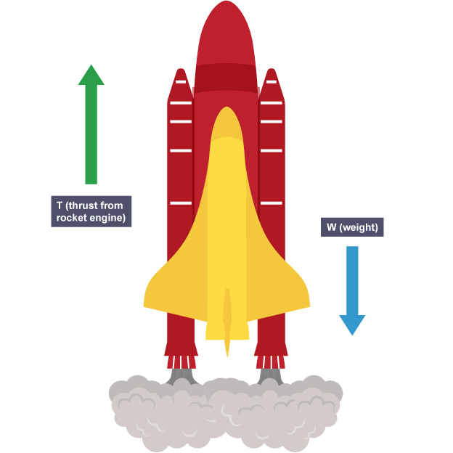

air resistance

30 000 N

weight

980000 N

thrust

350000 N

A short time after take-off, a rocket of mass 10 000 kg has a thrust of 350 000 N and experiences air resistance of 30 000 N. Draw a free body diagram and find the resultant force acting on the rocket.

Total upward force = 350 000 N

Total downward force = 980 000 N + 30 000 N = 128 000 N

Resultant force upwards = 350 000 – 130 000 = 220 000 N

## Combining forces at right angles

There are two possible methods for finding the size and direction of the resultant of two forces acting at right angles to each other.

• ***Draw a scale diagram:***

***• Use Pythagoras and trig functions.***

### Example

What is the resultant force produced by two forces of 10 N and 30 N which act on an object as shown in the diagram?

*Method 1: Choose Scale and record it on the paper: 1 cm = 5 N*

*Draw vectors head to tail, complete triangle, then measure resultant size and direction.*



*Resultant measures 6.3 cm angle is measured as 72* 

*Resultant = 6.3*  *5 = 31.5 N at an angle of 72* *to the 10 N force.*

*Method 2: Draw sketch of vector diagram, but not to scale.*

**

*Using Pythagoras*

$$R^{2}=a^{2}+b^{2}$$

$$R^{2}={30}^{2}+{10}^{2}$$

$$R=31.6 N$$

$$tanθ=\frac{opp}{adj}, tanθ=\frac{30}{10}$$

$$\tan^{-1}θ=3,θ =72°$$

In some cases that means that the two vectors have to be redrawn so that they are being added “head to tail”. See example below.

becomes

Then join a line from the tail of the first vector to the head of the second vector. This is the resultant vector.

resultant

### Examples

Two forces are applied to a box as shown below:

12 N

8 N

Solution: Resultant = 12 – 8 = 4 N to the right

2. If there are two forces pulling a sledge (see diagram below) then calculate the resultant force acting on the sledge.

20 N

15 N

**N**

sledge

### Solution:

**Step 1**

Redraw the diagram with the vectors ‘tip to tail’. The first way to do this is below.

15 N

Resultant force

S

20 N

F

x

15 N

20 N

S

F

x

S = Start  
F = Finish

Resultant force

**OR**

**Step 2**

Do the calculation using Pythagoras to find the resultant force.

Resultant = √ (152 + 202 ) = √ (225 + 400 ) = 25 N

**Step 3**

BUT resultant force must have a direction. This can be found by drawing a scale diagram.

**Rules for Drawing A Scale Diagram**

* Select a scale which will allow you to draw a diagram that fits on about half a page.
* Mark North and the starting point.
* Draw the two vectors and the resultant.
* Measure the angle between the first vector and the displacement.  
  This is the direction.

**Angle *x* = 530**

(Trigonometry can also be used tan x = 4/3 ⇒ x = tan-1(4/3) = 53.1o)  
Displacement is 5 m in a direction of 53 o East of North or at a bearing of 053o.

**Step 4**

Write down the full answer.

**Resultant force is 25 N at 530 North of East or at a bearing of (037).**

**3.** A strong wind blows at 30 ms-1 Eastward. What is the resultant velocity of a plane flying due North at 10 ms-1?

10 ms-1

30 ms-1

becomes

10 ms-1

30 ms-1

Solution 3: **Scale Diagram**

**N**

10 ms-1

30 ms-1

**x**

**Velocity = 31.6 m/s 180 north of east or at bearing of (072).**

**Trigonometry**

Velocity = √(302 + 102) = 31.6 ms-1

tan x = 10/30 => x = tan-1(10/30) = 180 => direction is 180 north of east or at a bearing = (072)

**Velocity = 31.6 ms-1 at bearing of (072) or 180 north of east**

**NB A vector direction of NE is a specific angle of 45° E of N. You cannot just refere to something between N and E as NE! It is as much a comass point as N or E!**

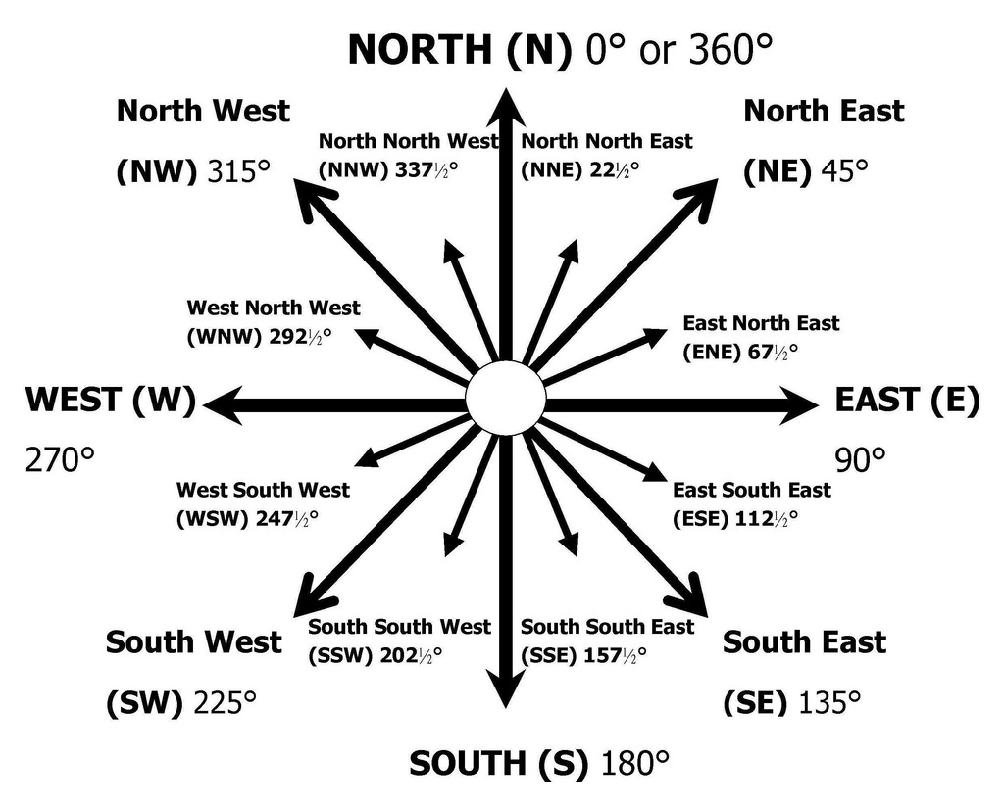

## Displacement and Distance

**Distance** is a measure of how far a body has actually travelled in any direction.   
**Distance** is a scalar as it only requires a magnitude and unit.

**Displacement** is the measurement of how far an object has travelled in a straight line from the start to the finish of its journey.   
**Displacement** is a vector and so a magnitude, unit and direction is required.

### Example

**1.**

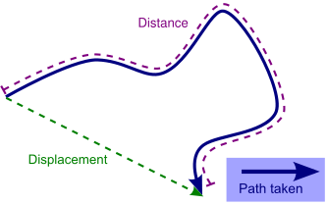

A walker has followed a path through a forest as shown. The distance travelled is much larger than their displacement from the starting position.

A skateboarder travels 3 m due North, then turns and travels due East for 4 m

They have travelled a distance of 3 + 4 = 7 m

3 m

4 m

displacement

X

The displacement is calculated as follows:

(Displacement)2 = 32 + 42 = 25 ⇒ displacement = √25 = 5 m

**BUT displacement must have a direction.** This can be found by drawing a scale diagram.

Angle x = 530

**Trigonometry can also be used**

tan x = 4/3 ⇒ x = tan-1(4/3) = 53.1o

**Displacement is 5 m in a direction of 53 o East of North or at a bearing of 053o.**

## Velocity $s=vt$

**Velocity** is described by the equation below. Velocity is a **vector** quantity. The direction of the velocity will be the same as the direction of the displacement.

$$velocity=\frac{displacement}{time}$$

$$v= \frac{s}{t}$$

|  |  |  |  |
| --- | --- | --- | --- |
| definition | symbol | Unit | unit symbol |
| velocity | $$v$$ | metre per second | ms-1 |
| average velocity | $$\overline{v}$$ | metre per second | ms-1 |
| displacement | $$s$$ | metre | m |
| time | t | second | s |

If the velocity is measured over the whole journey then it is known as **average velocity**, with the symbol $\overline{v}$**.**

$$\overline{v}=\frac{s}{t}$$

### Example

1. A remote control toy car goes 6 m due South and then 8 m due East. It takes two minutes to do this journey.

a) Find the distance it travelled and its displacement.

b) Calculate its average speed and velocity.

#### **Solution**

First draw a diagram to help.

6 m

8 m

displacement

X

1. Distance = 6 + 8 = 14 m  
   (Displacement)2 = 62 + 82 = 100 ⇒ displacement = √100 = 10 m  
     
   **Direction:** Angle x can be calculated using trigonometry  
   tan x = 8/6 => x = tan-1(8/6) = 53 0  
     
   or by scale diagram  
     
   **Displacement is 10 m in a direction of 53o East of South or at a bearing of (127)**
   1. **Average Speed**

|  |  |
| --- | --- |
| d = 14m t = 2 minutes = 2 x 60= 120s v = ? |  |

* 1. **Velocity**

|  |  |
| --- | --- |
| s = 10m t = 2 minutes = 2 x 60 =120s v = ? | $$v =s/t \\ v =10/120$$ $$v =0.08 ms^{-1}$$ |

## Vectors and Scalars Tutorials

1. Explain the difference between a vector quantity and a scalar quantity.
2. ****Use your answer to the question above to explain the difference between distance and displacement.
3. A man walks from X to Y along a winding road.

a) State his displacement at the end of his walk.

b) State the distance has he walked.

If the walker in *question 3* took 40 minutes for his walk, determine

c) his average speed

d) his average velocity?



1. One complete lap of a running track is 400m.

An athlete completes one lap in 48 s in the 400 m race. State his

1. distance travelled
2. displacement

c) determine her average speed

d) determine her average velocity.

1. Repeat Q4 for a runner in the 800 m race whose winning time was 1 min 54s.
2. A car travels 40 km north, then turns back south for 10 km. The journey takes 1 hour.

Detemine

a) the displacement of the car

b) the distance the car has travelled

c) the average velocity of the car in km h-1

d) the average speed of the car.

1. A car drives 60 km north, then 80 km east, as shown in the diagram. The journey takes 2 hours. Calculate the

a) distance travelled

b) displacement

c) average speed

d) average velocity.

# Summary

The following are the outcomes that you ought to have covered in this section.

|  |  |
| --- | --- |
|  | I can define the terms scalars and vectors |
|  | I can identify vector and scalar quantities such as: force, speed, velocity, distance, displacement, acceleration, mass, time and energy. |
|  | I can calculate the resultant of two vector quantities in one dimension or at right angles. |
|  | I can determine displacement and/or distance using scale diagram or calculation. |
|  | I can make use of appropriate relationships to calculate velocity in one dimension (s=vt). |

# Acceleration

## Content Statements

|  |  |
| --- | --- |
| 3.1 | I can define acceleration as the final velocity subtract the initial velocity divided by the time for the change, or change in velocity divide by the time for the change. |
| 3.1 | I can define the acceleration as **rate of change of velocity.** |
| 3.2 | I can use the relationship involving acceleration, change in speed and time (a = ∆v/t). |
| 3.3 | I can use appropriate relationships to solve problems involving acceleration, initial velocity (or speed) final velocity (or speed) and time of change (a = (v – u)/t ). |
| 3.5 | I can describe an experiment to measure acceleration |

## Introduction to Acceleration

Have you ever looked closely at advertisements for cars? Most of them will say something like this: *0 – 60 mph in 8 seconds*. What does this tell you?

It’s not how fast the car can go – cars can manage more than 60 miles per hour. It’s not how fast the car can go – cars can manage more than 60 miles per hour.

It’s how quickly the car gains speed – the car’s acceleration. The less time a car takes to gain speed, the greater its acceleration.

When a driver of a car puts her foot down on the accelerator (throttle or right pedal), the car goes faster - it accelerates!

Imagine two drivers side by side at a set of traffic lights, the lights are on red. Hollie is in a very fast sports car, and Callum is sitting in his lorry. The lights turn green and both vehicles set off. Both vehicles accelerate; the speed of both vehicles increases.

After a while both vehicles reach the same velocity. But we can tell that the sports car will have a greater acceleration than the lorry. Acceleration is not just about the increase in your velocity, it takes account of how quickly your velocity changes. The time it takes your velocity to change must be in the equation.

Acceleration describes **how quickly** velocity changes. Acceleration is a **vector** quantity. Only the acceleration of vehicles travelling in straight lines will be considered in this course. Because in Physics at National 5 we talk about accelerations in straight lines then we can be a little lax about using the term speed to mean velocity as their magnitudes would be the same in a straight line. Acceleration is really the **rate of change of velocity** and not speed.

Red car takes 20s to go from 0mph to 60mph.

Blue car takes 6s to go from 0mph to 60mph.

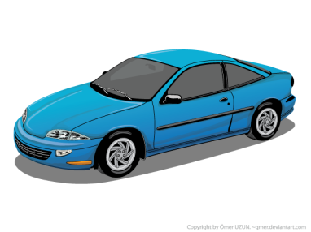Both the red car and the blue car have the same change in velocity but not the same acceleration as the blue car makes this change in less time, so it has a greater acceleration.

Red car acceleration is (60-0)/20=3mph/s

Blue car acceleration is (60-0)/6=10mph/s

Acceleration is the change in **velocity** in unit time.

The units of acceleration are the units of velocity (metres per second) divided by the units of time (seconds). The result is **metres per second per second**. This is usually called **metres per second squared** and is written **ms-2**.

Acceleration is the change in **velocity** per unit time.

**An acceleration of 2 ms-2****means the velocity increases by 2 ms-1 every second**

$$a=\frac{v-u}{t}=\frac{∆v}{t}$$

$$∆v=v-u$$

**Note**If a vehicle is slowing down, the final velocity will be smaller than the initial velocity, and so the acceleration will be negative. **A negative acceleration is a deceleration**. Most vehicles do not travel at the same velocity all the time. If their velocity increases, they are said to accelerate. If they slow down, they decelerate or have a negative acceleration.

An acceleration of 2 ms-2 means the velocity increases by 2 ms-1 every second. If the vehicle was at rest when the clock is started, then after the first second it will be going at 2 ms-1, after the second second it will be travelling at 4 ms-1, and after ten seconds the car will be travelling at 20 ms-1. What will be the speed of the car after sixty seconds?

|  |  |  |  |
| --- | --- | --- | --- |
| Definition | Symbol | Unit | Unit symbol |
| change in velocity | $$∆v$$ | metre per second | ms-1 |
| final velocity | $$v$$ | metre per second | ms-1 |
| initial velocity | $$u$$ | metre per second | ms-1 |
| acceleration | $$a$$ | metre per second squared | ms-2 |
| time | *t* | second | s |

### Examples

1. A train accelerates from rest to 40 ms-1 in a time of 60 s. Calculate the acceleration.

|  |  |  |
| --- | --- | --- |
| a | = | $$\frac{\text{v} \text{-} \text{u}}{\text{t}}$$ |
| a | = | $$\frac{\text{40-0}}{\text{60}}$$ |
| **a** | **=** | **0.67 ms-2** |

u = 0 ms-1

v = 40 ms-1

t = 60 s

1. A car is moving at 15 ms-1, when it starts to accelerate at 2 ms-1. What will be its speed after accelerating at this rate for 4 seconds?

u = 15 ms-1

|  |  |  |
| --- | --- | --- |
| 2 | = |  |
| v | = | 8 + 15 |
| **v** | **=** | **23 ms-1** |

a = 2 ms-2

t = 4 s

1. A car, travelling along a straight road, speeds up from 6 ms-1 to 24 ms-1 in a time of 32s. What is its acceleration?

 

1. A car slows down from 16 ms-1 to 0 ms-1 in 8s. Find the acceleration

 

***the negative signs tells us the car is slowing down***

## Formula for Acceleration

|  |  |
| --- | --- |
| $$acceleration=\frac{change of velocity}{time for the change}$$ | where |
|  | *(ms-1) (ms-1)* |
|  |  |
|  |  |

where

Acceleration is the “rate of change of velocity”, that is how quickly you change your velocity *Or* change of velocity per second

## Measuring Acceleration

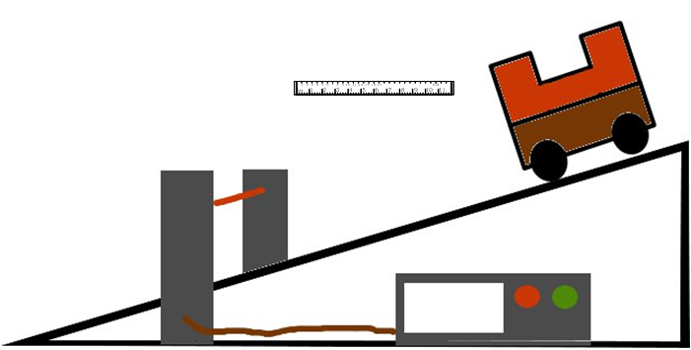You can measure acceleration in the lab with EITHER one single mask and two light gates OR a double mask and one light gate.

Whichever way the experiment is conducted the measurements that need to be made are:

* **Width of the mask or masks.**
* **Time for first light beam to be broken.**
* **Time for second light beam to be broken.**
* 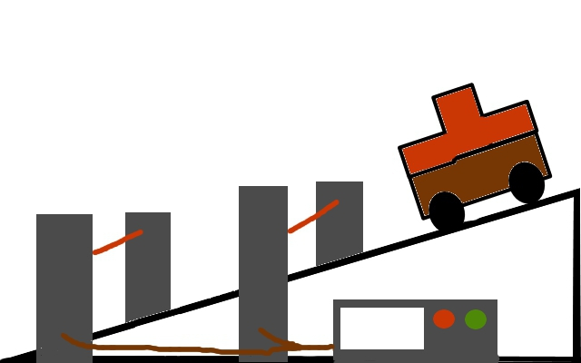**Time between the breaks in the light beam to be measured**.

The formula to use is:

where;

u = starting velocity

v = final velocity

t = time for change in velocity.

To find the velocity

|  |  |
| --- | --- |
| **Measurements** | **Calculations** |
| t1 time to pass first light gate |  |
| t2 time to pass second light gate |  |
| t3 time between light gate |  |
| Length of mask | *l* |

$$a=\frac{v-u}{t}=\frac{∆v}{t}$$

$$∆v=v-u$$

# Prescribed Pratical 3

|  |
| --- |
| Measuring the Acceleration of a Vehicle |
| Aim: Measuring the acceleration of a vehicle |
| Apparatus: Runway, trolley with double mask, light gate, computer timer, ruler |
| Use either a single mask and two light gates, or a single light gate and a double mask |
|  |
| Instructions for double mask method   1. Measure the length of the two parts of the double mask, d. 2. Set the computer to measure acceleration, and input d. 3. Release the trolley and record the acceleration, a. 4. The computer measures the time for each part of the double mask to pass through 5. the light gate, and the time between the two parts. It then uses these to calculate acceleration a = (v – u) / t. 6. Repeat several times and calculate an average. |
| Instructions for single mask method   1. Measure the length of the mask, d. 2. Set the computer to measure acceleration, and input d. 3. Release the trolley and record the acceleration, a. 4. The computer measures the time for each for the mask to pass through each light gate 5. the light gate, and the time between the two light gates. It then uses these to calculate acceleration a = (v – u) / t. 6. Repeat several times and calculate an average. |
| Evaluation  Look over your results and comment on the accuracy and precision.  Is there any benefit to using one of the methods rather than the other? Construct a table giving the positive and negatives of each method.  Does it matter where you put the two light gates as the final velocity will be greater if the light gates are further apart. |

.

### Questions

1. A Jaguar can reach 27 ms-1 from rest in 9.0 s. What is its acceleration?
2. The space shuttle reaches 1000 ms-1, 45 s after launch. What is its acceleration?
3. A car reaches 30 ms-1 from a speed of 18 ms-1 in 6 s. What is its acceleration?
4. A train moving at 10 ms-1 increases its speed to 45 ms-1 in 10 s. What is its acceleration?
5. A bullet travelling at 240 ms-1 hits a wall and stops in 0.2 s. What is its acceleration?
6. A car travelling at 20 ms-1 brakes and slows to a halt in 8 s.
   1. What is the acceleration of the car?
   2. What is the deceleration of the car?
7. Describe how you would measure the acceleration of a small vehicle as it runs down a slope in the laboratory.
8. On approaching the speed limit signs, a car slows from 30 ms-1 to 12 ms-1 in 5 s. What is its deceleration?
9. A bowling ball is accelerated from rest at 3 ms-2 for 1.2 s. What final speed will it reach?
10. How long will it take a car to increase its speed from 8 ms-1 to 20 ms-1 if it accelerates at 3 ms-2?
11. A cyclist can accelerate at 0.5 ms-2 when cycling at 4 ms-1. How long will she take to reach 5.5 ms-1?
12. The maximum deceleration a car’s brakes can safely produce is 8 ms-2. What will be the minimum stopping time if the driver applies the brakes when travelling at 60 mph (27 ms-1).
13. The table below gives some performance figures for cars.

|  |  |  |
| --- | --- | --- |
| **Car** | **Time for 0 - 60 mph** | **max. speed in mph** |
| [Porsche 918 Spyder](https://en.wikipedia.org/wiki/Porsche_918_Spyder) | 2.2 s | 217 |
| [Tesla Model S](https://en.wikipedia.org/wiki/Tesla_Model_S) P100D w/Ludicrous+ Update | 2.5 s | 155 |
| smart EQ fortwo | 9.5 s | 90 |
| Ford Mondeo TDCi | 7.6 | 140 |
| VW Polo | 10.8 | 110 |

1. Which car has the smallest acceleration?
2. Which car has the largest acceleration?
3. Assuming that the acceleration remained constant, how long would it take for the following cars to reach their top speed?

i) Mondeo ii) Porsche

# Summary

The following are the outcomes that you ought to have covered in this section.

|  |  |
| --- | --- |
|  | I can define acceleration as the final velocity subtract the initial velocity divided by the time for the change, or change in velocity divide by the time for the change. |
|  | I can define the acceleration as **rate of change of velocity.** |
|  | I can use the relationship involving acceleration, change in speed and time (a = ∆v/t). |
|  | I can use appropriate relationships to solve problems involving acceleration, initial velocity (or speed) final velocity (or speed) and time of change (a = (v – u)/t ). |
|  | I can describe an experiment to measure acceleration |