**2018**

J. A. Hargreaves

Lockerbie Academy

28/08/2018

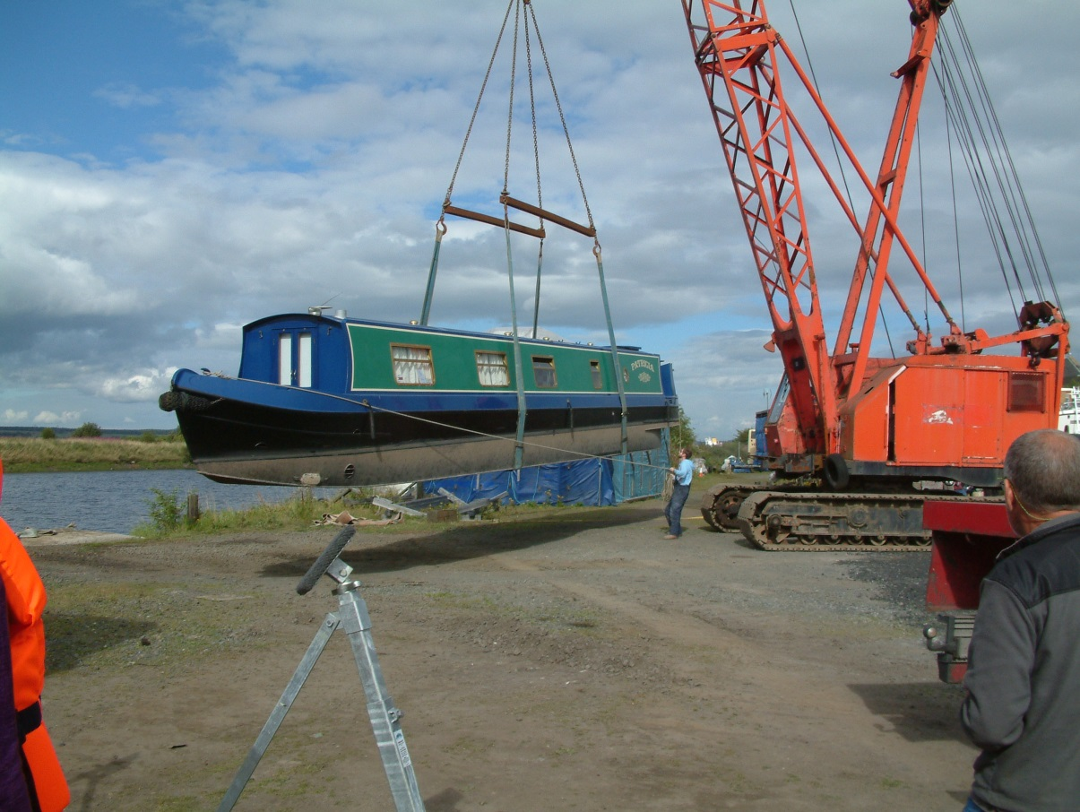****

N5 Dynamics: ANSWERS

Summer WORK for N5 PHYSICS

# Units, Prefixes and Scientific Notation

## Contents Statements

|  |  |
| --- | --- |
| **0.1** | **I know the units for all of the physical quantities used in this unit.** |
| **0.2** | **I can use the prefixes: micro ( μ ), milli (m), kilo (k), mega (M) and Giga (G)** |
| **0.3** | **I can give an appropriate number of significant figures when carrying out calculations (This means that the final answer can have no more significant figures than the value with least number of significant figures used in the calculation).** |
| **0.4** | **I can use scientific notation when large and small numbers are used in calculations.** |

## Practice

Convert the following numbers into their prefixes.

|  |  |  |  |  |  |
| --- | --- | --- | --- | --- | --- |
|  | 4x107 m | **40 Mm or 40 000 km** |  | 3.2 x107 ms-1 | **32 Mms-1** |
|  | * 1. 10-10  kg | **725ng** |  | 9.356x102 V | **0.9356 kV** |
|  | 23500000 Hz | **2.35 MHz** |  | 0.000234 s | **234 μs** |
|  | 0.0304 m | **30.4 mm** |  | 6.9 x10-6 A | **6.9 μA** |

Convert the following to 3 significant figures.

|  |  |  |  |  |  |  |
| --- | --- | --- | --- | --- | --- | --- |
| 1. 23 760 000 V | | | **23 800 000 V** | e. | 78 945 379.97 Hz | **78 900 000 Hz** |
| 1. 7 600 043.7 ms-1 | | | **7 600 000 ms-1** | f. |  | **45.7** |
| 1. 1 254 879 V | | | **1 250 000 V** | g. |  | **0.102** |
| 1. 67593268.0076 m | | | **67 600 000 m** | h. | 1 214 687 A | **1 210 000 A** |
|  |  | | | | |

# Speed

## Speed, Distance and Time Calculations

1. A runner completes a 200 m race in 25 s. What is his average speed in ms-1? **(3)**
2. A friend asks you to measure his average cycling speed along flat road. Describe which measurements you would take and the measuring instruments you would use.

* **measure the distance for the whole journey with a trundle wheel/ tape measure. (1)**
* **measure the time for the bike to travel the distance using a stopwatch(1)**
* **use $v=\frac{d}{t}$ (1)**

1. An athlete takes 4 minutes 20 s to complete a 1500 m race. What is the average speed?

4 mins 20s = (4 x 60) + 20 = 260 s

$$v=\frac{d}{t}=\frac{1500}{260}=5.8ms^{-1}$$

1. On a fun run, a competitor runs 10 km in 1 hour. What is her average speed in
   1. kmh-1  b) ms-1?

**10 km = 10 000 m, 1 hour= 3600 s**

$$v=\frac{d}{t}=\frac{10 000}{3600}=2.8ms^{-1}$$

1. Describe how you could measure the average speed of a car as it passes along the road outside your school/college.

* measure the distance between two points along the outside of the school with a trundle wheel/ tape measure. (1)
* measure the time for the car to travel the distance using a stopwatch(1)
* use $v=\frac{d}{t}$ **(1)**

1. Concorde can travel at 680 ms-1 (twice the speed of sound). How far will it travel in 25 s at this speed?
$$v=\frac{d}{t}$$

$$680=\frac{d}{25}$$

$$d=680 ×25=17 000 m$$

2. A girl can walk at an average speed of 2 ms-1. How far will she walk in 20 minutes?

**t = 20 mins = 20 x 60 =1200 s**

$$v=\frac{d}{t}$$

$$2=\frac{d}{1200}$$

$$d=2 ×1200=2400 m$$

1. How long will it take a cyclist to travel 40 km at an average speed of 5 ms-1?

**d=40 km= 40 000 m**

**v= 5 ms-1**

1. How long (to the nearest minute) will the Glasgow to London shuttle take if it flies at an average speed of 220 ms-1 for the 750 km flight?

**d =75 km= 750 000 m**

**v = 220 ms-1**

**This is 57 minutes to the nearest minute**

1. How long, to the nearest minute, will a car take to travel 50 km if its average speed is 20 ms-1?

**This is 42 minutes to the nearest minute**

1. Look at this timetable for a train between Edinburgh and Glasgow:

|  |  |  |
| --- | --- | --- |
| Station | Time | Distance from Glasgow |
| Glasgow | 08:00 | 0 km |
| Falkirk | 08:20 | 34 km |
| Linlithgow | 08:28 | 46 km |
| Edinburgh | 08:50 | 73 km |

1. What was the average speed for the whole journey in ms-1?

***d=73 km = 73 000 m, t = 50 mins = 50 × 60 = 3000 s***

***d=73 km, t = 50 mins = 50 ÷ 60 = 0.83 h***

$$v=\frac{d}{t}=\frac{73}{0.83}=88 kmh^{-1}$$

$$v=\frac{d}{t}=\frac{73 000}{3 000}=24 ms^{-1}$$

1. What was the average speed in ms-1 between Glasgow and Falkirk?

***t = 20 min = 20 x 60s = 1200s***

$$v=\frac{d}{t}=\frac{34 000}{1200}=28.3 ms^{-1}$$

1. Explain the difference in average speeds in a) and b).

**There are no stops between Glasgow and Falkirk. A stop will bring down the average speed of the train.**

1. Describe how you would measure the instantaneous speed of a vehicle as it reached the bottom of a slope.

**Fix a mask at the top of the vehicle and measure the width of the mask that passes through the light gate**

**Use a light gate ATTACHED TO A TIMER to determine the time for the mask to pass through the light gate. Use**

$$v=\frac{d}{t}$$

**to calculate the instantaneous speed of the vehicle.**

1. In an experiment to measure instantaneous speed, these measurements were obtained:-

|  |  |  |  |
| --- | --- | --- | --- |
| Reading on timer | = | 0.125 | s |
| Length of car | = | 5 cm |  |

Calculate the instantaneous speed of the vehicle in ms-1.

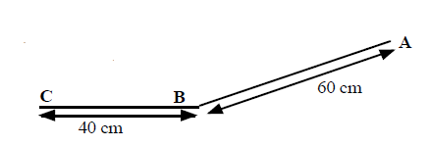

1. A trolley with a 10 cm card attached to it is released from A and runs down the slope, passing through a light gate at B, and stopping at C.

Time from A to B = 0.8 s.

Time on light gate timer = 0.067 s

1. What is the average speed between A and B?
$$v=\frac{d}{t}=\frac{0.60}{0.8}=0.75 ms^{-1}$$

2. What is the instantaneous speed at B?

***d =10 cm = 0.10 m***

$$v=\frac{d}{t}=\frac{0.10}{0.067}=1.49 ms^{-1}$$

## Speed Homework

1. A top class sprinter covers the 100m in a time of 10 seconds. Calculate the sprinter's average speed.
$$v=\frac{d}{t}=\frac{100}{10}=10 ms^{-1}$$

2. How long will it take a Formula 1 car to travel one lap around a 5 km long circuit if it is travelling at an average speed of 180 kmh-1?

***d= 5 km v = 180 kmh-1***

3. A physics pupil tries to calculate his friend’s instantaneous speed when running by timing how long it takes her to cross a line. He uses a stopclock to measure the time.

(a) Explain why this method will give poor results for the instantaneous speed.

***A student would have a reaction time when starting and stopping the stopwatch, so it is likely to be very inaccurate***

(b) Suggest the equipment needed to make the experiment more accurate.

**Use a light gate ATTACHED TO A TIMER**

1. Calculate a car’s acceleration if its speed increases by 12 ms-1 in a time of 3 s. **Sorry this shouldn’t be in this section**
$$a=\frac{v-u}{t}= \frac{12-0}{3}=4 ms^{-2}$$

2. A physics pupil running away from a wasp accelerates from rest to 5 ms-1 in a time of 1.25 s. Calculate the pupil’s acceleration.

5. Read this passage on *Thinking and Braking* and then answer the questions that follow it.

*You are travelling at 30 mph in a car in good road conditions when you suddenly see children crossing the road. By the time you react and apply the brakes, the car has travelled a total distance of 23 m. If the car had been travelling at 60 mph the stopping distance would have been 73 m.*

*The stopping distance consists of two parts: the thinking distance and the braking distance. The thinking distance is the distance travelled in the time between seeing a hazard on the road and pressing the brake pedal. This time is called the reaction time.*

*thinking distance = speed x reaction time*

*Reaction times vary from person to person. An average driver has a reaction time of about 0.8 seconds. A professional racing driver has a reaction time of about 0.2 seconds. Your reaction time is likely to be much longer if you have taken drugs or alcohol. Even a small amount of alcohol can greatly increase your reaction time.*

1. What is meant by the term ' thinking distance'?

***The distance travelled during the time taken for someone to react to an hazard.***

1. What will happen to the thinking distance if the car is going faster?

***It will increase.***

1. If a car is going faster will the reaction time alter? Explain your answer.

***The reaction time is fixed, it is a time. It does not depend on the speed of the vehicle, but the person’s life style.***

# Scalars & Vectors

**

*Using Pythagoras*

$$R^{2}=a^{2}+b^{2}$$

$$R^{2}={30}^{2}+{10}^{2}$$

$$R=31.6 N$$

$$tanθ=\frac{opp}{adj}, tanθ=\frac{30}{10}$$

$$\tan^{-1}θ=3,θ =72°$$

A skateboarder travels 3 m due North, then turns and travels due East for 4 m

They have travelled a distance of 3 + 4 = 7 m

3 m

4 m

displacement

X

The displacement is calculated as follows:

(Displacement)2 = 32 + 42 = 25 ⇒ displacement = √25 = 5 m

**BUT displacement must have a direction.** This can be found by drawing a scale diagram.

Angle x = 530

**Trigonometry can also be used**

tan x = 4/3 ⇒ x = tan-1(4/3) = 53.1o

**Displacement is 5 m in a direction of 53 o East of North or at a bearing of 053o.**

## Vectors and Scalars Tutorials

1. Explain the difference between a vector quantity and a scalar quantity.

***A scalar quantity is fully described by a magnitude and a unit***

***A vector quantity is fully described by a magnitude, unit and direction***

1. Use your answer to the question above to explain the difference between distance and displacement.

**Distance is the whole journey and is a scaler quantity**

**Displacement is the shortest distance between the start and the end of the journey. It is a vector quantity.**



1. A man walks from X to Y along a winding road.
2. State his displacement at the end of his walk.

***The man walks from X to Y so his displacement is 2 km West***

1. State the distance has he walked.

***The man walks along the road 3.6 km***

If the walker in *question 3* took 40 minutes for his walk, determine

***t= 40 mins = 40 x 60 = 2400 m***

1. his average speed
$$v=\frac{d}{t}=\frac{3600}{2400}=1.5 ms^{-1}$$

2. his average velocity?
$$v=\frac{s}{t}=\frac{2000}{2400}=0.83 ms^{-1}$$

3. One complete lap of a running track is 400m.

An athlete completes one lap in 48 s in the 400 m race. State his

1. distance travelled ***400 m***
2. displacement ***0 m***
3. determine her average speed
$$v=\frac{d}{t}=\frac{400}{48}=8.3 ms^{-1}$$

4. determine her average velocity.
$$v=\frac{s}{t}=\frac{0}{48}=0 ms^{-1}$$

5. Repeat Q4 for a runner in the 800 m race whose winning time was 1 min 54s.

***t= 1 min 54s = (1 x 60) + 54 = 114 s***

1. **800 m**
2. **0 m**

$$v=\frac{d}{t}=\frac{800}{114}=7.0 ms^{-1}$$

$$v=\frac{s}{t}=\frac{0}{114}=0 ms^{-1}$$

2. A car travels 40 km north, then turns back south for 10 km. The journey takes 1 hour.

Detemine

1. the displacement of the car.

***40 km North – 10 km South = 30 km due North (must have a direction)***

1. the distance the car has travelled

***40 km +10 km = 50 km***

c) the average velocity of the car in km h-1

1. the average speed of the car.
$$v=\frac{d}{t}=\frac{50}{1}=50 kmh^{-1}$$

2. A car drives 60 km north, then 80 km east, as shown in the diagram. The journey takes 2 hours. Calculate the
3. distance travelled ***80+60 = 140 km***
4. displacement

**(Displacement)2 = 802 + 602 = 1 000 ⇒ displacement = √1000 = 100 km**

The displacement is calculated as follows:

**s2 = 802 + 602 = 1 000 ⇒ displacement = √1000 = 100 km**

**BUT displacement must have a direction.** This can be found by drawing a scale diagram.

Angle x = 530

**Trigonometry can also be used**

**tan x = 80/60 ⇒ x = tan-1(80/60) = 53.1o**

**Displacement is 100 km in a direction of 53 o East of North or at a bearing of 053o.**

1. average speed

$$v=\frac{d}{t}=\frac{140}{2}=70 kmh^{-1}$$

d) average velocity.

$$v=\frac{s}{t}=\frac{100}{2}=50 kmh^{-1}$$

**BUT velocity must have a direction.** This can be found by drawing a scale diagram. It will also be at the same angle as the displacement

Angle x = 530

**Velocity is 50 kmh-1 in a direction of 53 o East of North or at a bearing of 053o.**

# Acceleration

1. A train accelerates from rest to 40 ms-1 in a time of 60 s. Calculate the acceleration.

|  |
| --- |
| $$a=\frac{\text{v} \text{-} \text{u}}{\text{t}}$$ |
| $$a=\frac{\text{40-0}}{\text{60}}$$ |
| **a = 0.67 ms-2** |

u = 0 ms-1

v = 40 ms-1

t = 60 s

1. A car is moving at 15 ms-1, when it starts to accelerate at 2 ms-1. What will be its speed after accelerating at this rate for 4 seconds?

u = 15 ms-1

|  |  |  |
| --- | --- | --- |
| 2 | = |  |
| v | = | 8 + 15 |
| **v** | **=** | **23 ms-1** |

a = 2 ms-2

t = 4 s

1. A car, travelling along a straight road, speeds up from 6 ms-1 to 24 ms-1 in a time of 32s. What is its acceleration?

 

1. A car slows down from 16 ms-1 to 0 ms-1 in 8s. Find the acceleration

 

***the negative signs tells us the car is slowing down***

## Formula for Acceleration

|  |  |
| --- | --- |
| $$acceleration=\frac{change of velocity}{time for the change}$$ | where |
|  | *(ms-1) (ms-1)* |
|  |  |
|  |  |

where

### Questions

1. A Jaguar can reach 27 ms-1 from rest in 9.0 s. What is its acceleration?
2. The space shuttle reaches 1000 ms-1, 45 s after launch. What is its acceleration?
3. A car reaches 30 ms-1 from a speed of 18 ms-1 in 6 s. What is its acceleration?
4. A train moving at 10 ms-1 increases its speed to 45 ms-1 in 10 s. What is its acceleration?
5. A bullet travelling at 240 ms-1 hits a wall and stops in 0.2 s. What is its acceleration?
6. A car travelling at 20 ms-1 brakes and slows to a halt in 8 s.
   1. What is the acceleration of the car?
   2. What is the deceleration of the car?
7. Describe how you would measure the acceleration of a small vehicle as it runs down a slope in the laboratory.
8. On approaching the speed limit signs, a car slows from 30 ms-1 to 12 ms-1 in 5 s. What is its deceleration?
9. A bowling ball is accelerated from rest at 3 ms-2 for 1.2 s. What final speed will it reach?
10. How long will it take a car to increase its speed from 8 ms-1 to 20 ms-1 if it accelerates at 3 ms-2?
11. A cyclist can accelerate at 0.5 ms-2 when cycling at 4 ms-1. How long will she take to reach 5.5 ms-1?
12. The maximum deceleration a car’s brakes can safely produce is 8 ms-2. What will be the minimum stopping time if the driver applies the brakes when travelling at 60 mph (27 ms-1).
13. The table below gives some performance figures for cars.

|  |  |  |
| --- | --- | --- |
| **Car** | **Time for 0 - 60 mph** | **max. speed in mph** |
| [Porsche 918 Spyder](https://en.wikipedia.org/wiki/Porsche_918_Spyder) | 2.2 s | 217 |
| [Tesla Model S](https://en.wikipedia.org/wiki/Tesla_Model_S) P100D w/Ludicrous+ Update | 2.5 s | 155 |
| smart EQ fortwo | 9.5 s | 90 |
| Ford Mondeo TDCi | 7.6 | 140 |
| VW Polo | 10.8 | 110 |

1. Which car has the smallest acceleration?
2. Which car has the largest acceleration?
3. Assuming that the acceleration remained constant, how long would it take for the following cars to reach their top speed?

i) Mondeo ii) Porsche

# Summary

The following are the outcomes that you ought to have covered in this section.

|  |  |
| --- | --- |
|  | I can define acceleration as the final velocity subtract the initial velocity divided by the time for the change, or change in velocity divide by the time for the change. |
|  | I can define the acceleration as **rate of change of velocity.** |
|  | I can use the relationship involving acceleration, change in speed and time (a = ∆v/t). |
|  | I can use appropriate relationships to solve problems involving acceleration, initial velocity (or speed) final velocity (or speed) and time of change (a = (v – u)/t ). |
|  | I can describe an experiment to measure acceleration |