

**N5 Physics**

[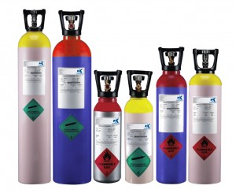](http://www.ckspecialgases.com/special-gas-mixtures/gas-mixtures/specialgas_cylinders_pic2/)

[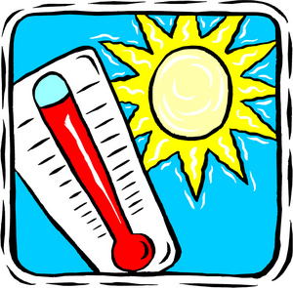](http://weblogs.sun-sentinel.com/news/weather/hurricane/blog/hot-sun-thermometer.jpg)

Properties of Matter

Name_________Class __

### At National 5 level, by the end of this section you should be able to:

🔾 1. State that different materials require different quantities of heat to raise the temperature of unit mass by one degree Celsius.

🔾 2. State that the temperature of a substance is a measure of the mean kinetic energy of its particles.

🔾 3. Use the appropriate relationship to carry out calculations involving mass, heat energy, temperature change and specific heat capacity.

🔾 4. Use conservation of energy to determine heat transfer

Water boils at 100 °C.

Normal body temperature is 37 °C.

Water freezes at 0 °C.

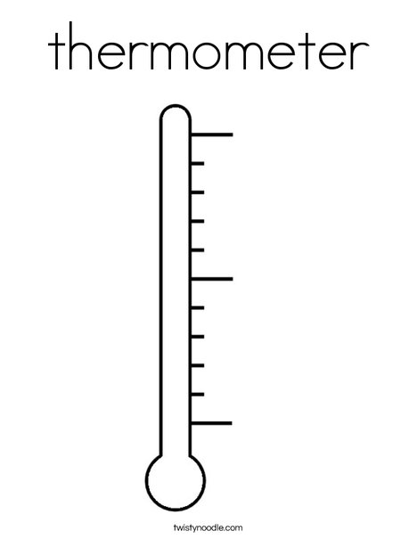

Temperature is a measure of how hot or cold something is.

We measure temperature using a thermometer.

There is more than one temperature scale. The Celsius temperature scale is a very common scale where temperatures are given as degrees Celsius (°C)

**Common Temperatures**

Other temperature scales are the Kelvin scale (used when carrying out calculations with gases) and the Fahrenheit scale (an older scale sometimes used to describe weather temperature)

We can describe temperature as a measure of the mean kinetic energy of the particles making up an object.

Heat is a form of energy, measured in Joules (J).

The particles that make up any object have kinetic energy.

The greater the heat energy the greater the kinetic energy of the particles.

Power supply

Joule Meter

heater

thermometer

Metal

block

**Measuring Specific Heat Capacity**

A heater is used to raise the temperature of a metal block. A joule meter measures how much energy is supplied, while a thermometer is used to measure the temperature rise. The mass of the metal block can be measured using a set of scales.

The specific heat capacity can be calculated using

c = Total energy added

mass x change in temperature

The value is inaccurate because heat energy is lost to the surroundings.

The specific heat capacity of different metals can be calculated by repeating the experiment with a different type of metal block.

SAFETY – be careful with hot materials.

The specific heat capacity is the amount of energy required to raise the temperature of 1kg of a material by 1°C.

The symbol for specific heat capacity is ‘c’ and the units are J kg-1 °C-1.

Specific Heat Capacity (Jkg-1 °C-1)

Copper – 386, Aluminium – 902 Water – 4180 Oil - 2130

Example 4

1.5 kg of oil at 20 °C is heated in a pan.

143775J of energy is added. What is the final temperature?

Eh = mcΔT => ΔT = Eh/ mc

= 143775/ (1.5x2130)

= 45 °C

Final temperature = 20 + 45 = 65 °C

Example 3

The temperature of some water is raised 10°C when 12540J of energy is added. How much water was used?

Example 2

6765 J of energy is supplied to 0.5kg of Aluminium. What is the change in temperature?

Eh = mcΔT => ΔT = Eh/mc

= 6765/(902 x 0.5)

= 15 °C

Example 1

A 2kg block of Copper is heated from 20°C to 50°C. How much energy is required?

Eh = mcΔT = 2 x 386 x [50 – 20]

= 23160J

Eh = Heat energy (J)

Eh = mcΔT m = mass (kg)

c = specific heat capacity (Jkg-1 °C-1)

ΔT = change in temperature (°C)

Example 5

An experiment was carried out to determine the specific heat capacity of water. The energy supplied to the water was measured by a joulemeter.

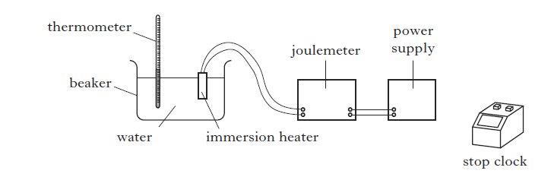

The following data was recorded.

Initial temperature of the water = 21 ⁰C

Final temperature of the water = 33 ⁰C

Initial reading on the joulemeter = 12 kJ

Final reading on the joulemeter = 120 kJ

Mass of water = 2.0 kg

Time = 5 minutes

1. (i) Calculate the change in temperature of the water

(ii) Calculate the energy supplied by the immersion heater

(iii) Calculate the value for the specific heat capacity of water obtained from this experiment.

SQA Int 2 2011 Q24

Example 5 (continued)

1. (i) The accepted value for the specific heat capacity of water is quoted as 4180 J kg-1 ⁰C-1 in the table in the Data Sheet. Explain the difference between the accepted value and the value obtained in the experiment.

(ii) How could the experiment be improved to reduce this difference?

1. Calculate the power rating of the immersion heater.

Example 6

A towel rail contains 2.5 kg of water. Calculate the minimum energy required to raise the temperature of the water by 50 ⁰C. (c for water = 4180 J kg-1 ⁰C-1)

SQA SG Gen 2013 Q9b

Example 7

An experimental geothermal power plant uses heat energy from deep underground to produce electrical energy. A pump forces water at high pressure down a pipe. The water is heated and returns to the surface. At this high pressure the boiling point of water is 180⁰C.

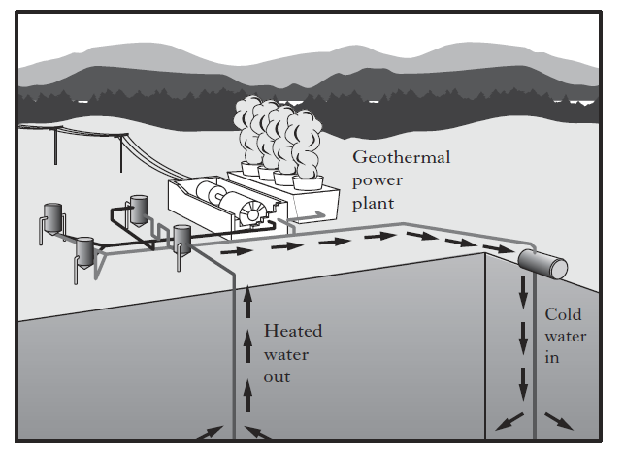

The plant is designed to pump 82kg of heated water, to the surface, each second. The specific heat capacity of this water is 4320 J kg-1 ⁰C-1.

The water enters the ground at 20⁰C and emerges at 145⁰C.

Calculate the heat energy absorbed by the water each second.

SQA SG Credit 2013 Q12 a

Heat and Gas Laws question booklet P3 Q 1 – 15, P6 Q 1 – 9

Leckie and Leckie P246, Ex 4.14.1 Specific Heat Capacity Q 1 - 6

Assumptions made when carrying out experiments

1. All the electrical energy is converted to heat energy.
2. All the heat energy is used to heat the metal block.

The heat loss to the air and surroundings could be minimised by using insulation.

Method 2

Measure the voltage across the heater and the current through it to calculate the power

P = IV

If we also know the time taken

E = Pt = IVt

In the experiment showing how to calculate specific heat capacity the energy change was electrical energy to heat energy.

The electrical energy used was measured directly using a joulemeter.

This could also have been calculated.

Method 1

Use the power rating of the heater and the time it is switched on for.

E = Pt

There are many situations where you may be asked to calculate conservation of energy which might have heat energy. They all use the same set of equations even though the situations may be very different.

Example 8

A student reproduces Galileo’s famous experiment by dropping a solid copper ball of mass 0.50 kg from a balcony on the Leaning Tower of Pisa.

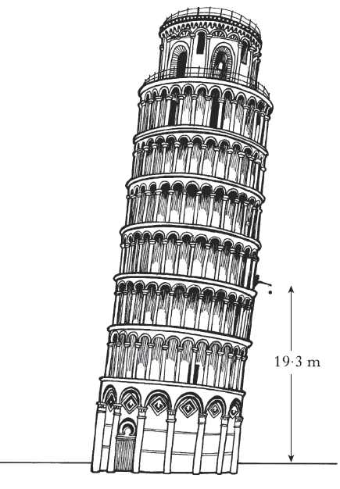

SQA Int2 2012 Q 23 a.

1. The ball is released from a height of 19.3 m.

Calculate the gravitational potential energy lost by the ball using the equation

Ep = mgh, where g = 9.8ms-2.

1. Assuming that all of this gravitational potential energy is converted into heat energy **in the ball,** calculate the increase in the temperature of the ball on impact with the ground.
2. Is the actual temperature change of the ball greater than, the same as or less than the value calculated in part (a) (ii) ?

You **must** explain your answer.

1. , the same as or less than the value calculated in part (a) (ii) ?

You **must** explain your answer.

Heat and Gas Laws question booklet P8 Q 1 – 10, P10 Q 1 – 8, P11 Q 1 – 10, P15 Q 1 - 7

Leckie and Leckie P250, Ex 4.14.2 Heat transfer and energy conservation, P257 Ex 4.15.2 Re-entry

Example 9

A blacksmith cools a hot iron horse-shoe of mass 0.75 kg by dropping it into water. The mass of the water is 15 kg and its initial temperature is 17⁰C. Heat energy from the iron warms the water until both iron and water are at 23⁰C.

1. Calculate the heat energy absorbed by the water
2. Calculate the initial temperature of the horseshoe
3. State **one** assumption required for the calculation in part (b)
4. What would happen to the temperature rise of the liquid of the blacksmith had replaced the water with the same mass of oil? You **must** explain your answer.

(c for water = 4180 J kg-1 ⁰C-1, c for oil = 2130 J kg-1 ⁰C-1, c for iron = 480 J kg-1 ⁰C-1)

### At National 5 level, by the end of this section you should be able to:

🔾 1. State that different materials require different quantities of heat to change the state of unit mass.

🔾 2. State that the same material requires different quantities of heat to change the state of unit mass from solid to liquid (fusion) and to change the state of unit mass from liquid to gas(vapourisation).

🔾 3. Use the appropriate relationship to solve problems involving mass, heat energy and specific latent heat.

$E_{h}=ml$

Temperature constant during

Change in state

When a material changes state the temperature remains constant

temperature

The solid material is heated until it is a liquid. The temperature is monitored while it cools and sets.

Datalogger

0 time

Stearic acid

The particles in a solid are tightly packed and held together.

If we add heat energy the particles vibrate more and the bonds begin to break. The solid changes in to a liquid (melts).

The particles in a liquid are closely packed but can move around.

If we add heat energy the particles move round more and the liquid begins to change into a gas.

The particles in the gas move around quickly and are spaced far apart.

Solid heat out liquid heat out gas

Solid heat in liquid heat in gas

When materials change state the temperature stays constant.

There are **two** possible changes in state –

1. Change between solid and liquid (or vice versa)

– specific latent heat of fusion

1. Change between liquid and gas (or vice versa)

– specific latent heat of vapourisation

Eh = ml Eh = heat energy (Joules – J)

m = mass (kg)

l = specific latent heat (J kg-1)

Example 11

How much energy does it take to melt 5kg of lead?

Latent heat of fusion of lead

= 0.25 x 105Jkg-1

Eh = ml

= 5 x 0.25 x 105

= 1.25 x 105 J

Example 10

How much water would evaporate if you supplied 25000J of energy to water at 100oC?

Latent heat of vapourisation for water = 2.26 x 106 Jkg-1

Eh = ml

=> m = Eh  = 25000

l 2.26 x 106

+0.011kg

Example 13

A solid is placed in an insulated flask and heated continuously with an immersion heater. The sketch graph below shows how the temperature of the contents of the flask changes with time.

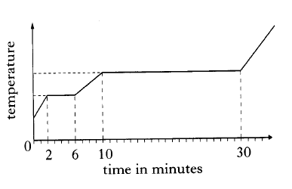

After 5 minutes the contents of the flask are

1. In the solid state
2. In the liquid state
3. A mixture of solid and liquid
4. In the gaseous state
5. A mixture of liquid and gas SQA Int 2 2002 Q8

Example 12

A ball is made by melting 0.50 kg of copper at its melting point. Calculate the amount of heat energy required for this

SQA Int 2 2012 Q23 b

Heat and Gas Laws question booklet P17 Q 1 – 15, P20 Q 1 – 5

Leckie and Leckie P254, Ex 4.15.1 Latent Heat

Example 14

An icecream maker has a refrigeration unit which can remove heat at 120 Js-1. Liquid ice-cream, of mass 0.6 kg at a temperature of 20⁰C, is added to the container.

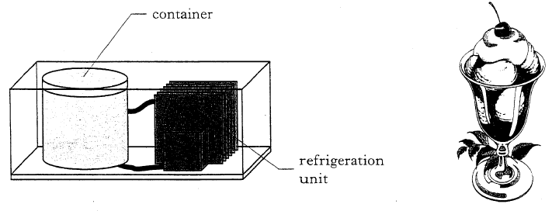

1. Calculate how much energy must be removed from the mixture to cool it to its freezing point of -16⁰C. (Specific heat capacity of ice cream = 2100 J kg-1 ⁰C-1.)
2. Calculate how much heat energy must be removed to freeze the ice cream at this temperature. (Specific latent heat of fusion of ice cream = 2.34 x 105 J kg-1 )
3. (i) Calculate the time taken to cool and freeze the ice cream
4. What assumption have you made in carrying out this calculation?

SQA Int 2 2005 Q24

### At National 5 level, by the end of this section you should be able to:

1. State that pressure is the force per unit area exerted on a surface.

2 Carry out calculations involving the relationship between pressure, force and area.

3. Describe how the kinetic model accounts for the pressure of a gas.

4. State that pressure is measured in Pascals (Pa).

5. Describe the relationship between Kelvin and degrees Celsius and the absolute zero of temperature.

6. Explain the pressure-volume law qualitatively in terms of a kinetic model

7. Explain the pressure-temperature law qualitatively in terms of a kinetic model

8. Explain the volume-temperature law qualitatively in terms of a kinetic model

1. Use the relationship between the pressure and volume of a fixed mass of gas at constant temperature in terms of the kinetic theory of gases to solve problems.
$$p_{1}V_{1}=p_{2}V_{2}$$

2. Use the relationship between the pressure and temperature of a fixed mass of gas at constant volume in terms of the kinetic theory of gases to solve problems.
$$\frac{p_{1}}{T_{1}}= \frac{p_{2}}{T_{2}}$$

3. Use the relationship between the volume and temperature of a fixed mass of gas at constant pressure in terms of the kinetic theory of gases to solve problems.

12. Recognise that the gas equations can also be expressed in the form

13. Describe an experiment to verify the pressure-volume law (Boyle’s Law)

14. Describe an experiment to verify the pressure-temperature law (Gay-Lussac’s Law)

15 . Describe an experiment to verify the volume-temperature law (Charles’ Law)

0.4m

0.3m

0.2m

W = mg = 3 x 9.8 = 26.4N

Example 1

The mass of the box is 3kg.

Calculate the pressure exerted on the surface when it is placed on each of the three different sides.

p1 = F

A

= 26.4

0.06

= 443 Pa

p2 = F

A

= 26.4

0.08

= 330 Pa

Pressure is caused when particles collide with a surface.

The more collisions there are per second the greater the pressure.

If the particles causing the collision have greater energy (by adding energy) they move faster, which means they hit the surface with greater force. This causes

If you spread the weight (force) over a larger area the pressure goes down.

Practical applications – show shoes

- wide tyres on tractors to stop them sinking in mud

p = Pressure (Pascal – Pa)

p = F F = Force (Newton – N)

A A = Area (metres squared – m2)

AHS notes

Example 3

A diver is measuring the pressure at different depths in the sea using a simple pressure gauge. Part of the pressure gauge consists of a cylinder containing gas trapped by a moveable piston.

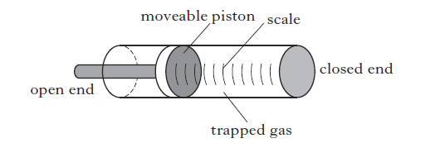

At sea level the atmospheric pressure is 1.01 x 105 Pa and the trapped gas exerts a force of 262 N on the piston.

Calculate the area of the piston.

SQA H 2013 Q 24

Example 2

How much pressure is exerted by a

50kg woman standing on your toe

with the 1cm heel of a stiletto?

p = F = 50 x 9.8 = 490 = 4,900,000 Pa

A 0.012 0.0001

Example 4

One pascal is equivalent to

1. 1 N m
2. 1 N m2
3. 1 N m3
4. 1 N m-2
5. 1 N m-3 SQA H 2008 Q 7

Example 5

An aircraft cruises at an altitude at which the external air pressure is 0.40 x 105Pa. The air pressure inside the aircraft cabin is maintained at 1.0 x 105 Pa. The area of an external cabin door is 2.0 m2.

What is the outward force on the door due to the pressure difference?

1. 0.30 x 105 N
2. 0.70 x 105 N
3. 1.2 x 105 N
4. 2.0 x 105 N
5. 2.8 x 105 N

SQA H 2XXX Q X

Heat and Gas Laws P21 Q 1 – 12, Leckie and Leckie P262, Ex 4.16.1 Defining Pressure, P263 Ex 4.16.2 Pressure in action

Example 6

The weight of a box is 30N. The dimensions of the box are

0.20m x 0.15m x 0.10m.

The box rests on one of its faces on a level surface. The greatest pressure which the box can exert while resting on this surface is

1. 204 Pa
2. 1000Pa
3. 1500 Pa
4. 2000 Pa
5. 19600Pa

SQA H 20 Q5

``

Large volume

small volume

**Pressure and Temperature (constant Volume)**

``

The molecules in a gas move around at random, hitting one another and the sides of the container with a certain force.

Pressure = force/area

hot

cold

``

If the temperature of the gas increases the kinetic energy of the particles increases and they move with greater velocity.

This causes them to collide with the walls of the container more often per second, which increases the pressure inside the container.

The molecues in a gas move at a certain velocity, due to their kinetic energy.

When they collide with the walls of the container they exert a force, which causes a certain pressure.

``

If the size of the container is reduced the molecules hit into one another and the walls of the container more often per second. This increases the force.

Since Pressure = Force/Area the pressure goes up.

**Pressure and Volume (constant Temperature)**

cold

hot

**Volume and Temperature (constant Pressure)**

The molecules in a gas move at a certain velocity, due to their kinetic energy.

When they collide with the walls of the container they exert a force, which helps keep the volume of the container.

``

**Temperature Scales**

The temperature scale often used is the Celsius scale.

0°C is the temperature where water freezes.

The Kelvin temperature scale is often used when dealing with gases.

0K (note there is no ° symbol used) is called ‘Absolute Zero’. This is because the particles of all materials have no kinetic energy at this point.

0K is found at -273 °C.

The size of one degree Celsius is the same as one degree Kelvin.

*To convert between the two temperature scales* –

Celsius to Kelvin Kelvin to Celsius

Add 273 Subtract 273

If the temperature of the gas decreases the kinetic energy of the molecules decreases and they move with less velocity.

The molecules collide with the walls of the container less often per second and the volume decreases.

``

Leckie and Leckie P266 Ex 4.16.3 The Kelvin temperature scale

Example 7

A solid at a temperature of -20⁰C is heated until it becomes a liquid at 70⁰C.

The temperature change in kelvin is

1. 50K
2. 90 K
3. 343 K
4. 363 K
5. 596 K

SQA H 2005 Q6

This can also be written as

p1V1 = p2V2 (provided temperature is constant)

Where p1  = Pressure 1 (Pascal – Pa)

p2  = Pressure 2 (Pascal – Pa)

V1 = Volume 1 (cubic metres – m3)

V2 = Volume 2 (cubic metres – m3)

When pressure is plotted against 1/volume you get a straight line graph which passes through the origin.

This shows that pressure is proportional to 1/volume

- if pressure goes up, volume gets less.

OR

* Pressure x volume = constant

The graph of pressure against volume gives a curve.

0 volume

pressure

The equipment above is connected together with the volume of the syringe set to 60ml. The pressure is increased by pushing on the end of the syringe. The volume is read from the scale on the side of the syringe and the pressure is read from the screen on the datalogger.

As volume decreases the pressure increases.

The results from the experiment are plotted in a graph.

0 1/volume

pressure

syringe

Pressure Sensor

Datalogger

Example 8

A student is training to become a diver.

1. The student carries out an experiment to investigate the relationship between the pressure and volume of a fixed mass of gas using the apparatus shown.

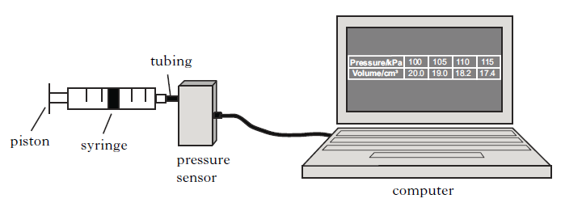

The pressure of the gas is recorded using a pressure sensor connected to a computer. The volume of the gas is also recorded. The student pushes the piston to alter the volume and a series of readings is taken.   
The temperature of the gas is constant during the experiment.

|  |  |  |  |  |
| --- | --- | --- | --- | --- |
| Pressure (kPa) | 100 | 105 | 110 | 115 |
| Volume (cm3) | 20.0 | 19.0 | 18.2 | 17.4 |

1. Using **all** the data, establish the relationship between the pressure and volume of the gas.
2. Use the kinetic model to explain the change in pressure as the volume of gas decreases.
3. At a depth of 12.0m the diver fills her lungs with air from her breathing apparatus. She then swims to the surface.

Explain why it would be dangerous for her to hold her breath while doing this.

SQA H 2009 Q23

.

Heat and Gas Laws P22 Q 1 – 7, Leckie and Leckie P270 Ex 4.16.4 Boyle’s Law

Example 8 (continued)

Example 9

Which of the following graphs shows the relationship between the pressure, P and the volume, V of a fixed mass of gas at constant temperature?

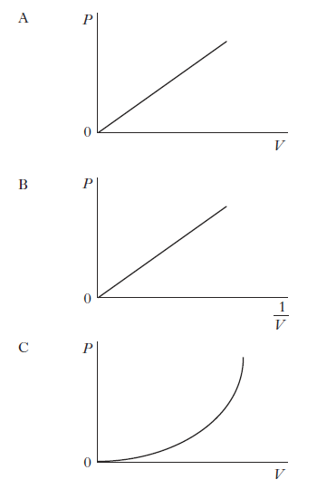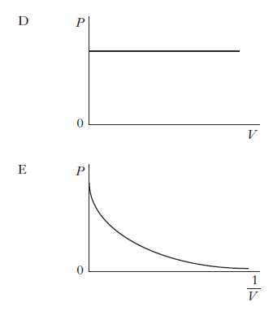SQA H 2012 Q7

If the line is extrapolated backwards it cuts the temperature axis at - 273°C – absolute zero.

0 temperature °C

pressure

-273

The graph is a straight line graph, but does not pass through the origin.

0 temperature °C

pressure



The gas inside a flask is heated using a water bath. The pressure and temperature are recorded at regular intervals, then plotted on a graph.

water

Pressure sensor

heater

Temperature sensor



The graph is redrawn using the Kelvin temperature scale on the x-axis.

This gives a straight line graph which passes through the origin.

Pressure (Pa)

0 temperature (K)

This shows that pressure is proportional to temperature

– if the temperature goes up the pressure also goes up

OR $\frac{pressure}{temperature}=constant$

BUT – only if the temperature is measured in **Kelvin**

This can also be written as

$\frac{p_{1}}{T_{1}}= \frac{p_{2}}{T_{2}}$ (provided volume is constant)

Where p1  = Pressure 1 (Pascal – Pa)

p2  = Pressure 2 (Pascal – Pa)

T1 = Temperature 1 (degrees Kelvin – K)

T2 = Temperature 2 (degrees Kelvin – K)

Example 10

A student carries out an experiment to investigate the relationship between the pressure and temperature of a fixed mass of gas. The apparatus used is shown

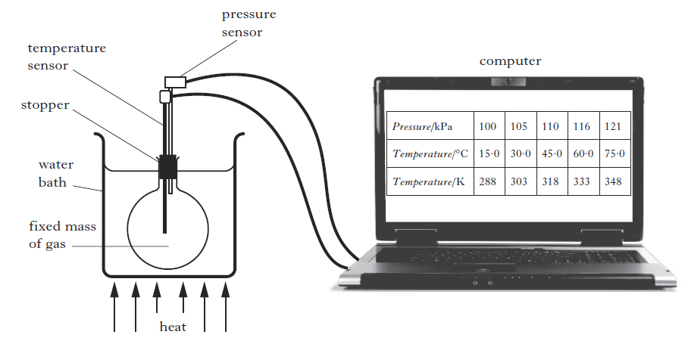

The pressure and temperature of the gas are recorded using sensors connected to a computer. The gas is heated slowly in the water bath and a series of readings is taken.

The volume of the gas remains constant during the experiment.

The results are shown.

|  |  |  |  |  |  |
| --- | --- | --- | --- | --- | --- |
| Pressure (kPa) | 100 | 105 | 110 | 116 | 121 |
| Temperature (⁰C) | 15.0 | 30.0 | 45.0 | 60.0 | 75.0 |
| Temperature (K) | 288 | 303 | 318 | 333 | 348 |

1. Using **all** the relevant data, establish the relationship between the pressure and the temperature of the gas.
2. Use the kinetic model to explain the change in pressure as the temperature of the gas increases.
3. Explain why the level of water in the water bath should be above the bottom of the stopper.

SQA H 2012 Q24

Heat and Gas Laws P23 Q 1 – 8, Leckie and Leckie P276 Ex 4.16.6 Gay-Lussac’s Law

Example 10 (continued)

0 temperature °C

volume



Air is sealed in a capillary tube using a small bead of mercury.

The fixed mass of gas is heated in a water bath, with the tube above the mercury left open to the atmosphere. This allows the pressure to remain constant on either side of the bead.

The capillary tube has a constant cross sectional area, so we can use the length of the column of air as a measure of the volume.

The volume of air is recorded as the temperature changes and the results plotted on a graph.

V ∝ 

V/T = constant

V1/T1 = V2/T2 (provided pressure is constant)

REMEMBER T IS IN KELVIN!

Temperature MUST be in KELVIN

Atmospheric pressure

Trapped air

water

Temperature sensor

heater

If the line is extrapolated backwards it cuts the temperature axis at - 273°C – absolute zero.

volume

0 temperature °C

-273

The graph is a straight line graph, but does not pass through the origin.

volume

0 temperature K

The graph is redrawn using the Kelvin temperature scale on the x-axis.

This gives a straight line graph which passes through the origin.

This shows that volume is proportional to temperature

– if the temperature goes up the volume also goes up

OR $\frac{volume}{temperature}=constant$

BUT – only if the temperature is measured in **Kelvin**

This can also be written as

$\frac{V_{1}}{T_{1}}= \frac{V_{2}}{T_{2}}$ (provided volume is constant)

Where V1 = Volume 1 (cubic metres – m3)

V2 = Volume 2 (cubic metres – m3)

T1 = Temperature 1 (degrees Kelvin – K)

T2 = Temperature 2 (degrees Kelvin – K)

Example 11

The apparatus used to investigate the relationship between the volume and temperature of a fixed mass of air is shown.

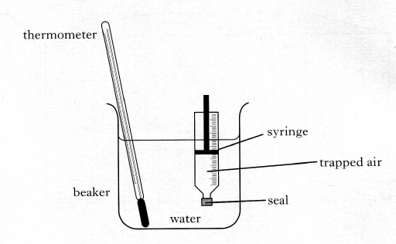

The volume of the trapped air is read from the scale on the syringe.

The temperature of the trapped air is altered by heating the water in the beaker it is assumed that the temperature of the air in the syringe is the same as that of the surrounding water. The pressure of the trapped air is constant during the investigation.

1. Readings of volume and temperature for the trapped air are shown.

|  |  |  |  |  |
| --- | --- | --- | --- | --- |
| Temperature (⁰C) | 25 | 50 | 75 | 100 |
| Volume (ml) | 20.6 | 22.6 | 24.0 | 25.4 |

1. Using **all** the data, establish the relationship between temperature and volume for the trapped air.
2. Calculate the volume of the trapped air when the temperature of the water is 65 ⁰C
3. Use the kinetic model of gases to explain the change in volume as the temperature increases in this investigation.

Heat and Gas Laws P25 Q 1 – 7, Leckie and Leckie P273 Ex 4.16.5 Charles’ Law

Example 11 (continued)

Note – volume may be given in other units – ml, cm3. As long as both volumes use the same units this is ok.

The three gas equations can be combined to give one equation.

p1V1 = p2V2 p1 = p2 V1 = V2 p1V1 = p2V2

T1 T2 T1  T2 T1  T2

Where p1  = Pressure 1 (Pascal – Pa)

p2  = Pressure 2 (Pascal – Pa)

V1 = Volume 1 (cubic metres – m3)

V2 = Volume 2 (cubic metres – m3)

T1 = Temperature 1 (degrees Kelvin – K)

T2 = Temperature 2 (degrees Kelvin – K)

Heat and Gas Laws P26 Q 1 – 15, Leckie and Leckie P281 Ex 4.16.7 The combined gas equation

Updated Jun 2019 NH

Example 14

3 litres of hydrogen gas exert a pressure of 40kPa on a balloon at a temperature of 300K. If the temperature is reduced to 250K what is the new pressure?

p1V1 = p2V2 Volume is p1 = p2 => 40 x 103 = p2 => p2 = 33.3kPa

T1  T2 constant T1  T2 300 250

Example 12

100 cm3 of oxygen is stored at a pressure of 40kPa. If the pressure is reduced to 20kPa what is the new volume?

p1V1 = p2V2 Temperature is

T1  T2 constant

Equation becomes

p1V1 = p2V2

40 x 103 x 100 = 20 x 103 x V2

V2 = 200cm3

Example 13

100 cm3 of air is stored at a temperature of 27°C. The temperature in the room rises to 57°C. What is the new volume?

27°C = 300K 20°C = 330K

p1V1 = p2V2 Pressure is

T1  T2 constant

V1 = V2 =>100 = V2

T1  T2 300 330

V2 = 110 cm3