

**N5 Physics**

Radiation

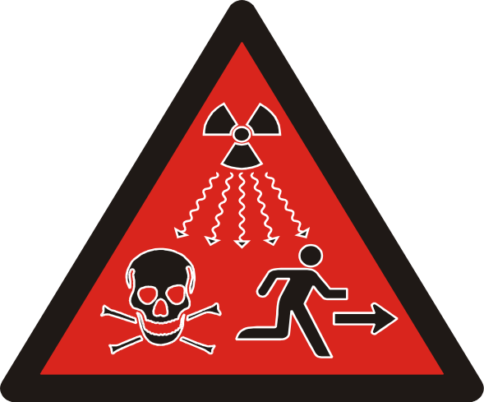

Nuclear Radiation

Name___________________Class _____

**Nuclear Radiation**

**At National 5 level, by the end of this section you should be able to:**

1. Describe the nature of alpha (α), beta (β) and gamma (γ) radiation
2. State what is meant by ‘ionisation’ and describe the effect of ionisation on neutral atoms.
3. Describe, for each of alpha, beta and gamma radiation
   1. The relative ionizing effect of each type of radiation.
   2. The relative penetration of each type of radiation.
4. Define activity as the number of nuclear disintegrations per second
5. State that the unit of activity is the Bequerel (Bq)
6. Use an appropriate relationship to solve problems involving activity, number of nuclear disintegrations and time.
$$A= \frac{N}{t}$$

7. State possible sources of background radiation.
8. Describe the dangers of ionisation radiation to living cells.
9. Explain the need to measure exposure to radiation.
10. State that the unit for absorbed dose is the Gray (Gy)
11. State that the unit for equivalent dose is the Sievert (Sv).
12. Use an appropriate relationship to solve problems involving absorbed dose, equivalent dose, energy, mass and weighting factor.

$D= \frac{E}{m}$ $H=Dw_{r}$

1. State that the unit for equivalent dose rate is the Sievert per unit time e.g. Sieverts per second (Sv s-1) (use an appropriate time unit based on the information provided)
2. Use of an appropriate relationship to solve problems involving equivalent dose rate, equivalent dose and time.
$$\dot{H}= \frac{H}{t}$$

3. Compare the equivalent dose due to a variety of natural and artificial sources.
4. State the equivalent dose rate and exposure safety limits for the public and for workers in the radiation industries in terms of annual effective dose rate.
   1. Average annual background radiation in UK: 2.2 mSv
   2. Annual effective dose limit for member of the public: 1 mSv
   3. Annual effective dose limit for radiation worker: 20 mSv
5. Describe applications of nuclear radiation:
   1. Electricity generation
   2. Cancer treatment
   3. Other medical uses
   4. Other industrial uses.
6. Define half-life as the time taken for the activity of a radioactive source to fall to half of its previous value
7. Use graphical or numerical data to determine the half-life of a radioactive material.
8. Describe an experiment to measure the half-life of a radioactive material.
9. Describe qualitatively how fission occurs, including chain reactions and their role in the generation of energy
10. Describe qualitatively how fusion occurs, plasma containment and their role in the generation of energy.

Nuclear radiation comes from the nucleus, which is inside an atom

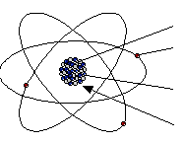

Neutron – neutral (no) charge

Electron – negatively charged

Proton – positively charged

Nucleus – contains protons and neutrons.

If alpha, beta and gamma radiation pass through an electric field they move in different directions.

Alpha is attracted to the negative terminal.

Beta is attracted to the positive terminal.

Gamma is undeflected.

Gamma



Beta



Alpha



A beta particle is an electron.

It is negatively charged.

Electrons are very small and light.

Gamma radiation is an electromagnetic wave. It has high frequency and high energy.

It travels at 3 x 108 ms-1.

An alpha particle is a Helium nucleus.

It is positively charged.

Compared to beta radiation it is large.

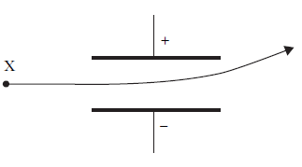

An atom is neutral because the number of protons and number of electrons is equal.

Ionisation is when electrons are added to or lost from an atom and the atom is then called an ion.

When an electron is added a negatively charged ion is created.

When an electron is lost a positively charged ion is created.

Nuclear radiation can cause ionisation.

Relative Ionisation

Alpha radiation causes the most ionisation.

Beta radiation causes less ionisation than alpha, but more ionisation than gamma radiation.

Detecting Radiation

A Geiger-Muller tube is used to detect radiation.

When it is connected to a counter the amount of radiation can be measured. It does this by detecting ionisation of the gas inside the tube.

Photographic film is exposed by radiation.

This is described as the film becoming ‘fogged’ or ‘cloudy’.

When radiation passes through a material the energy of the radiation is absorbed by the material







Alpha radiation is absorbed by a few cm of air or a piece of paper/thin card.

Beta radiation is absorbed by a few mm of Aluminium.

Aluminium will also absorb alpha radiation.

Gamma radiation is absorbed by a few cm of Lead or several metres of concrete.

Lead will also absorb alpha and beta radiation.

|  |  |  |  |  |  |
| --- | --- | --- | --- | --- | --- |
| **Radiation** | **Range (cm)** | **Ionising power** | **Can pass through paper?** | **Can pass through 5mm aluminium?** | **Can pass through 5cm of lead?** |
| Alpha | 3 – 5 | Highly ionizing | No | No | No |
| Beta | About 15 | Ionising | Yes | No | No |
| Gamma | Much longer | Weakly ionizing | Yes | Yes | No – although a small amount will still get through |

Activity is the number of nuclear disintegrations per second.

$A=\frac{N}{t}$ Where A = activity (Bequerel – Bq)

N = number of nuclear disintegrations (no unit)

t = time (seconds – s)

The activity of a radioactive source decreases over time.

Example 2

The source used in an experiment has an activity of 3 MBq.

Explain what is meant by this statement.

*An activity of 3MBq means that*

*3 x 106 nuclear disintegrations occur per second.*

Example 1

Calculate the number of decays in a sample in two minutes when the activity of the sample is 1.2 kBq.

$$A=\frac{N}{t} ⇒N=At$$

= 2 x 60 x 1.2 x 103

= 14400 decays

Example 3

A radioactive source has an activity of 300 kBq. In the source 9 x 106 nuclei disintegrate during an experiment. Calculate the time the source was used for during the experiment.

$A=\frac{N}{t} ⇒t=\frac{N}{A}$

*= 9 x 10 6 = 30s*

*300 x 103*

Background radiation is radiation from our surroundings – it is normally at a very low level.

Natural sources of radiation

Radon gas – this is a radioactive gas given off by some rocks.

Buildings and the ground – other rocks emit radiation

Soil and Plants -Plants absorb their nutrients from the soil. This means that they are very slightly radioactive.

Animals – all animals absorb radiation from their food and the atmosphere. This means that they are very slightly radioactive.

Cosmic rays – this is radiation which reaches Earth from outer space.

Artificial Sources of Radiation

Artificial sources of radiation are ones which have been created by humans.

Medical radiotherapy and diagnostics – this comes from treatments such as x-rays and treatments for cancer. These are kept to a minimum to protect your health.

Nuclear power – small amounts of radiation have been released from nuclear power stations.

Nuclear missiles – when nuclear bombs are exploded radiation is released into the surroundings. This radiation can be detected a long way from the explosion.

Radiation can kill or damage cells.

This can be useful if the cells are cancer cells or bacteria.

The amount of radiation we are exposed to is measured to try to prevent unnecessary damage. This is why you do not have lots of x-rays taken.

If someone works in an environment where radiation is used regularly they must wear a badge which monitors the level of different types of radiation they have been exposed to.

[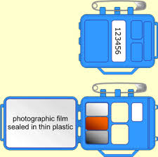](http://www.google.co.uk/imgres?q=radiation+monitoring+badge&um=1&safe=active&sa=N&rls=com.microsoft:en-gb:IE-SearchBox&rlz=1I7ADSA_enGB408&hl=en&biw=1005&bih=560&tbm=isch&tbnid=eNrZyqnZNXQ8vM:&imgrefurl=http://www.frankswebspace.org.uk/ScienceAndMaths/physics/physicsGCSE/detecting.htm&docid=TVdqQokZwDpvNM&imgurl=http://www.frankswebspace.org.uk/ScienceAndMaths/physics/physicsGCSE/bytesize%20images/detecting1.gif&w=340&h=337&ei=wjaKUYeIEYaZ0QWG0YDgDg&zoom=1&iact=hc&vpx=315&vpy=66&dur=5156&hovh=224&hovw=225&tx=167&ty=167&page=1&tbnh=142&tbnw=144&start=0&ndsp=17&ved=1t:429,r:7,s:0,i:106) [](http://www.google.co.uk/imgres?q=radiation+monitoring+badge&um=1&safe=active&sa=N&rls=com.microsoft:en-gb:IE-SearchBox&rlz=1I7ADSA_enGB408&hl=en&biw=1005&bih=560&tbm=isch&tbnid=eNrZyqnZNXQ8vM:&imgrefurl=http://www.frankswebspace.org.uk/ScienceAndMaths/physics/physicsGCSE/detecting.htm&docid=TVdqQokZwDpvNM&imgurl=http://www.frankswebspace.org.uk/ScienceAndMaths/physics/physicsGCSE/bytesize%20images/detecting1.gif&w=340&h=337&ei=wjaKUYeIEYaZ0QWG0YDgDg&zoom=1&iact=hc&vpx=315&vpy=66&dur=5156&hovh=224&hovw=225&tx=167&ty=167&page=1&tbnh=142&tbnw=144&start=0&ndsp=17&ved=1t:429,r:7,s:0,i:106)

Example 4

Some hospital staff wear film badges to monitor their exposure to radiation. The film is contained in a plastic holder with windows of different materials as shown in the diagram. Light cannot reach the film.

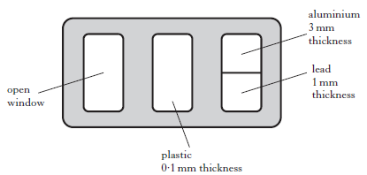

*Shade the window or windows where the film would be affected if the wearer is exposed to Iodine -123 emitting gamma radiation.*

Where D = absorbed dose (Gray – Gy)

$D= \frac{E}{m}$ E = energy absorbed by material (Joule – J)

m = mass of absorbing material (kg)

Example 6

A sample of tissue absorbs 1.3mJ of energy and receives an absorbed dose of 2mGy. Calculate the mass.

m = E/D

= 1.3 x 10-3/2 x 10-3

= 0.65kg

Example 5

Calculate the absorbed dose taken in by 5kg of tissue when 0.30J of energy is absorbed.

D = E/m

= 0.3/5

= 0.6Gy

Example 7

A sample of tissue is exposed to 50 mGy of gamma radation. The mass of the sample is 0.55 kg. Calculate the energy that the sample receives.

D = E/m => E = Dm = 50 x 10-3 x 0.55 = 0.0275 = 0.03J

Where H = equivalent dose (Sievert – Sv)

$H= Dw_{r}$ D = absorbed dose (Gray – Gy)

wr = radiation weighting factor

|  |  |
| --- | --- |
| Radiation | Weighting factor |
| Beta β, gamma γ,  x- rays | 1 |
| Slow neutrons | 3 |
| Proton p, fast neutrons n. | 10 |
| Alpha α | 20 |

Different types of radiation have different effects on tissue. A ‘weighting factor’ is used to allow comparisons to be made. The information is supplied in a table

Example 8

A sample of tissue receives an absorbed dose of 5μGy ofalpha particles. Calculate the equivalent dose

H = DWR

= 5 x 10-6 x 20

= 1 x 10-4Sv

Example 9

During exposure to fast neutrons, some tissue receives an equivalent dose of 100 μSv. Calculate the absorbed dose

D= H/WR = 100 x 10-6/10

= 10 x 10-6 Gy

Example 10

A worker in a power plant is exposed to 10μGy of alpha radiation and 50 μGy of gamma radiation. The radiation weighting factors for alpha radiation and gamma radiation are 20 and 1 respectively. What was his total equivalent dose?

For alpha radiation For gamma radiation

H = DWR H = DWR

= 10 x 10-6 x 20 = 5 x 10-6 x 1

= 2 x 10-4Sv = 5 x 10-6Sv

Total equivalent dose = 2 x 10-4 + 5 x 10-6 = 205 x 10-6Sv

Example 11

Information about a radioactive source is given in Table 1.

|  |  |  |
| --- | --- | --- |
| Activity | Energy absorbed per kilogram of tissue | Radiation weighting factor |
| 500 MBq | 0.2 μJ | 10 |

Which row in Table 2 gives the correct information for the radioactive source?

|  |  |  |
| --- | --- | --- |
|  | Absorbed dose | Equivalent dose |
| A | 0.2 μGy | 2 μSv |
| B | 500 MGy | 10 Sv |
| C | 10 Gy | 0.2 μSv |
| D | 20 μGy | 50 MSv |
| E | 2 μGy | 0.2 μSv |

(space for calculations)

D = E/m = 0.2 x 10-6 /1 = 0.2 μGy H = DWR = 0.2 x 10-6 x 10 = 2 μSv

A

Example 12

Human tissue can be damaged by exposure to radiation.

On which of the following factors does the risk of biological harm depend?

1. The absorbed dose
2. The type of radiation
3. The body organs or tissue exposed?

A I only

B I and II only

C II only

D II and III only

E I, II and III

E

Example 13

A technician handling an **alpha-emitting** source estimates that his hand receives an absorbed dose of 5 x 10-5 Gy. The mass of the technician’s hand is 500g.

1. Calculate the total energy absorbed by the technician’s hand.
2. Using information from the table below, calculate the equivalent dose received by his hand.

|  |  |
| --- | --- |
| Type of radiation | Radiation weighting factor |
| Alpha | 20 |
| Beta | 1 |
| Gamma | 1 |
| X rays | 1 |
| Slow neutrons | 2.3 |

D = E/m => E = Dm = 5 x 10-5 x 0.5 = 2.5 x 10-5J

H = DWR = 2.5 x 10-5 x 20 = 5 x 10 -4 Sv

Example 14

The oil industry uses radioactive sources to monitor the flow of liquids in pipes. The complete detection system is attached to the outside of the pipe as shown.

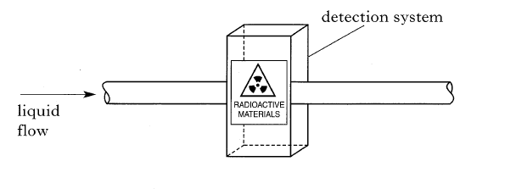

1. The source used has an activity of 1.11 G Bq. Explain what is meant by this statement.
2. A sample of tissue exposed to this radiation receives an absorbed dose of 0.13 mGy. The radiation weighting factor is 9.

Calculate the equivalent dose for this sample.

1. The system is surrounded by a large cage as shown in the diagram.

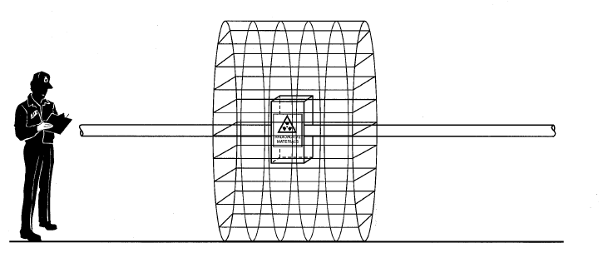

What is the purpose of this cage?

a)There are 1.11 x 109 nuclear disintegrations per second.

b) H = DWR = 0.13 x 10-3 x 9 = 1.17 x 10-3 Sv

c) Safety – to prevent people getting too close to the radioactive source.

Where $\dot{H}$ = equivalent dose rate (Sieverts per time unit)

$\dot{H}= \frac{H}{t}$ H = equivalent dose (Sievert – Sv)

t = time (unit depends on question)

Example 16

A workman receives an equivalent dose of 2 mSv over an 8 hour shift.

Calculate the equivalent dose rate.

$$\dot{H}= \frac{H}{t}$$

= 2 x 10-3 = 0.25 mSv hr-1

8

Example 17

A research worker receives 10 Gy of gamma radiation and 50 Gy of fast neutrons during an experiment lasting 8 hours .

Calculate:

(a) her effective dose in Sv;

(b) the equivalent dose rate in Svh-1

H = DWR = 10 x 10-6 x 1 = 10 μ Sv

H = DWR = 50 x 10-6 x 10 = 500 μ Sv

Total equivalent dose = 510 μ Sv

$\dot{H}= \frac{H}{t}$

= 510 x 10-6 = 64 μ Sv hr-1

8

Example 15

A doctor receives an equivalent dose rate of 120 mSv over a 3 year period.

Calculate the equivalent dose rate

$\dot{H}= \frac{H}{t}$

= 120 x 10-3 = 40 x 10-3Sv y-1

3

Example 18

The recommended equivalent dose limit for exposure to the hands of a worker is 500 mSv per year.

On average the worker is exposed to 2.0 mGy of gamma radiation, 400 μGy of thermal neutrons and 80 μGy of fast neutrons each hour when working in this area.

The radiation weighting factors for these radiations are shown.

|  |  |
| --- | --- |
| *Radiation* | *Weighting factor* |
| Gamma | 1 |
| Thermal neutrons | 3 |
| Fast neutrons | 10 |

The recommended equivalent dose limit must not be exceeded.

Calculate the maximum number of working hours in one year permitted in this area.

H = DWR = 2 x 10-3 x 1 = 2000 μ Sv

H = DWR = 400 x 10-6 x 3 = 1200 μ Sv

H = DWR = 80 x 10-6 x 10 = 800 μ Sv

Total equivalent dose = 2000 + 1200 + 800 = 4000 μ Sv = 4mSv

$\dot{H}= \frac{H}{t}$ => $t= \frac{H}{\dot{H}}$ = 500/4 = 125 hours

The government sets equivalent dose rate and exposure safety limits for the public and for workers in the radiation industries in terms of annual effective dose rate.

* + Average annual background radiation in UK: 2.2 mSv
  + Annual effective dose limit for member of the public: 1 mSv
  + Annual effective dose limit for radiation worker: 20 mSv

To minimise the dangers of radiation

* Radioactive materials should be stored securely in lead lined containers.
* The time of exposure to ionising radiation should be limited.
* Sources should be shielded and handled using tongs.
* The radioactive source should be kept away from the body and never brought close to your eyes.
* The distance between the source and yourself should be as large as possible in the circumstances.
* Safety equipment should be worn by the person doing the experiment.
* Radiation exposure can be monitored using film badges.
* The radiation hazard symbol should be displayed.

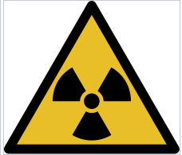

Radiation hazard symbol

heat exchanger

turbine

generator

reactor core

control rods

fuel elements

A

# B

C

B

When a nuclear reaction takes place in the reactor core (A) energy is released in the form of heat. This heat is used to convert water into steam in a heat exchanger.

The steam is used to turn a turbine (B).

The turbine is connected to a generator (C) which converts kinetic energy into electrical energy.

An example of nuclear fuel is Uranium. One kilogram of uranium can produce 5,000,000 MJ of energy while one kilogram of coal can produce about 30 MJ of energy. This is one reason why nuclear power is used. Nuclear fuel is a non – renewable resource and will eventually run out.

Nuclear power stations produce radioactive waste which has to be stored safely for a very long period of time. People have concerns about nuclear power generation because of this and because they are worried about accidents which might occur.

To make a decision about whether to use nuclear power or not both sides of the argument must be considered.

Cancer is an abnormal growth of cells. Doctors and scientists have developed a range of treatments to help people who have a diagnosis of cancer. Many types of cancer can be cured but in all treatments the aim is to help the person have a better quality of life.

Radiotherapy is the use of radiation to treat cancer. There are two main types – external and internal radiotherapy.

External radiotherapy is where several small doses of radiation are directed at the tumour from different directions. This means that tissue and organs near the tumour should not be damaged since they receive a lower dose of radiation.

Radiation from different angles

Internal radiotherapy

This targets the cancer cells by either implanting radioactive material into the tumour (brachytherapy) or by giving the patient injections of radioactive liquid which is absorbed by the cancer cells.

In both external and internal radiotherapy the aim is to kill as many cancer cells as possible without damaging the other cells in the body. The particular treatment chosen will depend on the type of cancer and where it is in the body. Patients will often be given other types of treatment and medicine to help.

NOTE – Chemotherapy is the use of drugs to kill cancer cells – this is NOT a form of radiotherapy.

Medical applications

Radioactive material can be used to help diagnosis by helping doctors analyse whether organs are working properly or not.

A small amount of radioactive material is given to the patient (intravenously or by mouth) and is then monitored by specialist equipment e.g. a Gamma Camera.

An example of where this is used is in checking whether there is normal blood flow through the kidneys or whether there is a blockage.

Which radioactive material is used for an application depends on the type of radiation emitted and the half-life of the material. The half-life is a compromise between being long enough to allow the procedure to take place and short enough to avoid unnecessary exposure to radiation.

Example 19

A radioactive substance is to be injected into a patient so that blood flow can be monitored.

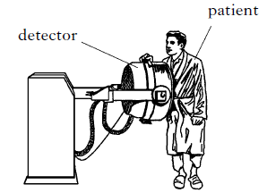

|  |  |  |
| --- | --- | --- |
| Substance | Radiation emitted | Half life |
| A | $$β$$ | 2 days |
| B | $$β$$ | 2 years |
| C | γ | 2 seconds |
| D | γ | 2 days |
| E | γ | 2 years |

A number of different substances which emit either $β$ or γ radiation are available.

The substances have different half lives.

Which substance A, B,C,D or E is the most suitable?

Industrial applications

Gauging devices

The amount of radiation passing through a material can be measured. This gives an indication of the thickness of the material and or how much moisture it contains.

Non -destructive testing

A radioactive source can be placed on the inside of a pipe where a weld has been made. Photographic film on the outside can detect any defects in the weld.

Sterilisation

Gamma radiation can be used to sterilise supplies used in hospital or be used to kill bacteria on food.

Scanning

People and luggage are scanned at airports to prevent dangerous items being carried on board a plane.

Example 20

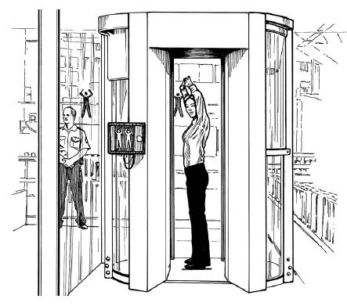

D

5000 x 0.03 x 10-6  = 150 μ Sv

A person going through the scanner receives a radiation dose of 0.03μSv every time it is used.

A person could have 5000 scans a year before there would be any risk to their health.

Calculate the total radiation dose value that would create a health risk to passengers.

Definition

The half life is the time taken for the activity of a radioactive source to fall to half of its previous value.

Note – this time can vary from fractions of a second to millions of years.

Experiment to calculate half life.

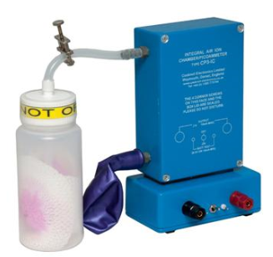

Connection to data logger

Balloon to collect Radon-220 for analysis

clip

Radon- 220 source

The equipment above is set up with a data logger connected to the output terminals.

The clip is opened and the bottle containing the Radon-220 source is squeezed a few times to allow Radon into the balloon for analysis. The clip is then closed. An ionization chamber inside the apparatus detects the activity of the source and this is measured by the data logger. The experiment is allowed to run for five minutes. At the end of the experiment a graph is plotted of activity against time. The half life can be calculated from this graph.

Safety considerations – The amount of radiation generated is very small and the experiment is a ‘closed system’ which means that no radioactivity should be released into the atmosphere.

Calculating half life from a graph

Method

1. Pick a point on the graph - is it on the gridlines? Can you divide it by two? Is half of the value on the gridlines as well? Then you can start drawing in the co-ordinates.
2. Draw across to the point on the graph.
3. Draw down from the point on the graph to the time axis.
4. Divide the activity by half.
5. Repeat drawing the lines on the graph.
6. The difference in time between the two points on the time axis is the half life.
7. Repeat at least one more time to check your values.
8. For this example the half life is 2minutes.

*Avoid points which need you to estimate the middle of a square on the graph*

Calculating half life from numerical data

Example 21

When prepared the initial activity of a source is 10,000 kBq. After 24 hours the activity has fallen to 625kBq. Calculate the half life of the source.

Activity(kBq) Half lives

10,000 O

5,000 1

2,500 2

1,250 3

625 4

24hrs = 4 half lives => half life = 6hrs

Example 22

A radioactive sample has a half-life of 20 minutes. The initial activity of the source is 2200Bq. Calculate its activity after one hour.

Activity (Bq) Time

2200 0

1100 20 minutes

550 40 minutes

275 60 minutes

Activity after 1 hour = 275Bq

Example 23

Living things such as plants and animals absorb Carbon-14 from the atmosphere Archeologists are able to estimate the age of the things they excavate by comparing the activity of C14 in bones, wood or seeds etc to the amount in the present day.

The half life of C14 is about 5730 years. A man cutting peat discovers a body in the peat bank which looks to have been murdered - the police are called. A sample of tissue from the body has an activity of 50Bq. The activity in an identical modern sample of tissue is 100Bq.

Do the police need to look for a murderer? Explain your answer.

Activity Number of half lives

100 0

50 1

1 half life = 5730 years, so the body has been there a long time. There would be no point in trying to find out who committed the crime.

Example 24

A graph of activity against time for a sample of a product released during a fission reaction is shown below.

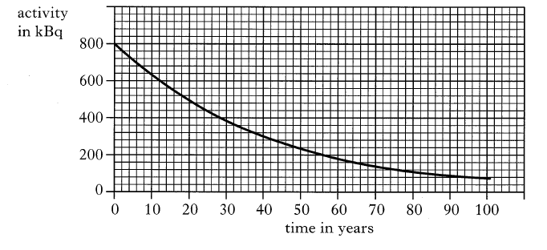

1. From the graph, determine the half life of the fission product.
2. A scientist state that the sample will be safe only when the activity falls to 120 kBq. How long will it take for the activity to fall to this level?

Half life = 28 years (from graph)

74 years

Example 25

Companies delivering radioactive sources have to follow strict safety rules.

One rule is that sources must be labeled. The following information is displayed on a label on a radioactive source.

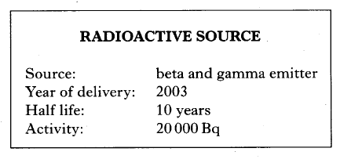

1. i) What is meant by the activity of a source?

ii) Calculate the activity of the source in the year 2043.

1. After delivery, the source is placed in a thick walled aluminium storage box. Which type of radiation from the source, if either, could penetrate the storage box, You must explain your answer.
2. i) The number of nuclear disintegrations per second

ii)

1. Gamma – Beta radiation is absorbed by several mm of Aluminium

There are two types of fission reaction

* Spontaneous fission
* Induced fission

Fission occurs when a heavy nucleus disintegrates leaving two or more smaller pieces plus two or three neutrons.

Spontaneous fission happens when the nucleus is unstable.

Induced fission is where the reaction is triggered when a fast neutron collides with the nucleus, making it unstable. This is used in nuclear power stations.

When the nucleus splits some of the mass is ‘lost’ – it has been converted directly into energy. This is in the form of heat.

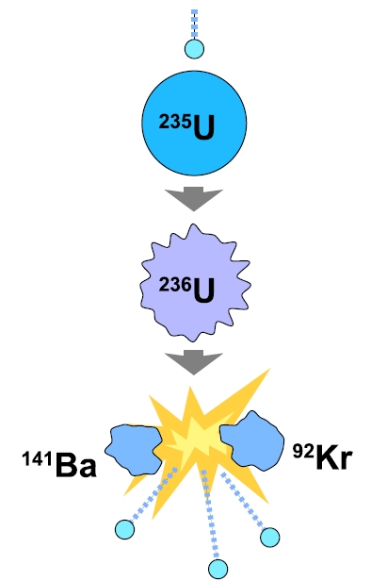

Chain Reaction

The neutrons released by the fission reaction are fast moving and go on to collide with more nuclei (1).

A material such as graphite is used to slow them down and increase the chance of further reactions happening.

The reaction is managed using other materials e.g. boron, which absorb some of the slow neutrons.

If the reaction is not kept under control it will become larger and larger – potentially creating a bomb.!

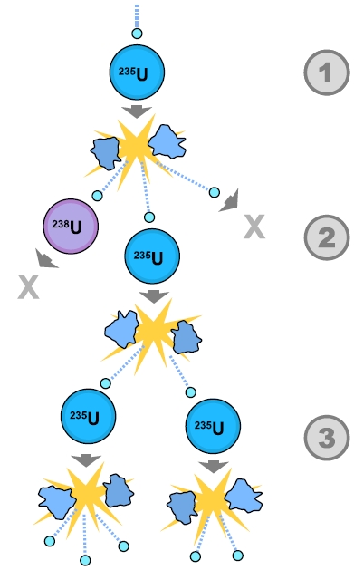

Nuclear fusion is where two or smaller nuclei combine to form a larger nucleus.

This is the opposite of nuclear fission.

Fusion takes place in the Sun and other stars.

When the nuclei fuse some of the mass is ‘lost’ – it has been converted directly into energy. This is in the form of heat.

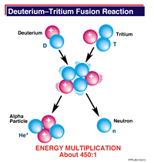

(www.windows2universe.org)

Nuclear fusion and power generation

Nuclear fusion could also be used to generate electricity. It would be safer than nuclear fission because there is no chain reaction and there would be little or no nuclear waste and no greenhouse gases. The fuel costs would also be low.

When a fusion reaction takes place a plasma is created which is extremely hot – 150 million °C. This must be contained by a doughnut shaped magnetic field to prevent it coming into contact with anything. This is a complex process.

Very high energy is also needed to reach these high temperatures.

Scientists are developing fusion reactors but they are still at an experimental stage. In the future we may be able to use fusion reactors to generate electricity.

**E**

Example 27

A student reads the following article about nuclear power.

*“In a nuclear reactor, uranium nuclei in fuel rods are bombarded with neutrons. A uranium nucleus may absorb a neutron and then break up into two smaller nuclei releasing further neutrons and energy”*

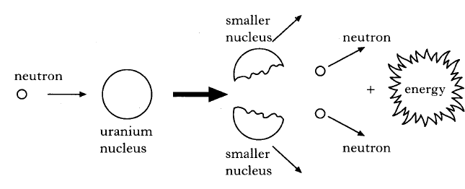

1. A **nucleus** contains two types of particle. Name these particles
2. What is the name given to the process shown in the diagram
3. Explain why fuel rods have to be replaced after a certain time.
4. Neutrons and protons
5. Induced fission reaction
6. The activity decreases over time.

Example 26

In a nuclear reactor a chain reaction releases energy from nuclei.

Which of the following statements describes the beginning of a chain reaction?

A An electron splits a nucleus releasing more electrons.

B An electron splits a nucleus releasing protons.

C A proton splits a nucleus releasing more protons.

D A neutron splits a nucleus releasing electrons.

E A neutron splits a nucleus releasing more neutrons.