Component Name | Circuit Symbol | Function
Cell | 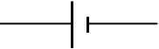 | Supplies electrical energy to a circuit, the longer line shows the positive side.
Battery | 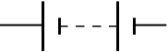 | A battery of cells means 2 or more cells.
DC Supply |  | Supplies electrical energy to a circuit in the form of a direct current.
AC Supply |  | Supplies electrical energy to a circuit in the form of an alternating current.
Lamp | 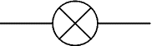 | A lamp lights when current flows through it, converting electrical energy to light energy.
Switch |  | A switch allows you to complete or break a circuit.
Resistor |  | A resistor restricts the flow of current, this may be to protect other components.
Variable Resistor | 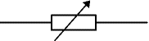 | A resistor, the resistance of which can be varied in the circuit, could be used for a dimmer switch.
LDR  (Light Dependent Resistor) | 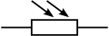 | Can be used to control a circuit. The resistance goes down as the light increases.
Thermistor |  | The resistance of a thermistor will increase as the temperature increases.
Fuse |  | A fuse is a safety device – the metal core will melt when too much current is flowing in the circuit.
Voltmeter | 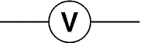 | Measures potential difference. Must be placed in parallel to measure the difference in electrical potential between two points.
Ammeter | 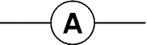 | Measures current. Must be placed in series to measure the current flowing in a circuit.
Ohmmeter | 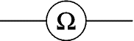 | Measures resistance. Must be placed in parallel with the component(s) which are to be measured.
Capacitor | 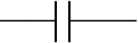 | Used to store electrical charge, can be used to create a simple timing circuit, or in the flash in a camera.
Diode | 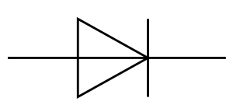 | Only allows current to flow in one direction.
Photovoltaic Cell |  | Converts light energy to electrical energy, can be used as the power source in a circuit. More light will mean a greater p.d. across the cell.
LED  (Light  Emitting Diode) | 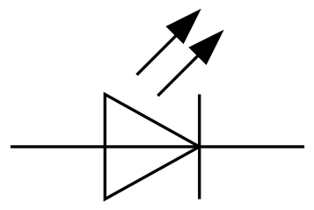 | Emits light when a current flows but only allows current to flow in one direction. Requires less energy than a lamp.
Motor | 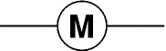 | Converts electrical energy into kinetic energy by turning.
Loudspeaker | 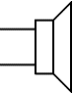 | Converts electrical energy into sound energy.
NPNTransistor |  | Acts as a swith when a voltage of 0.7 V is applied across the base and emitter
N-channel enhancement MOSFET |  | Acts as a switch when a voltage of approximately 2 V is applied across the gate and the source.

