ELECTRICITY SUMMARY NOTES
Voltage (potential difference) is the energy transferred to each coulomb of charge.  It is measured in volts (V). 1 V = 1 J per C  Current is the charge transferred per second.  It is measured in amps (A). 1A = 1 C per s |  |  |  | Mains Voltage: 230V, 50 Hz  Factors that increase resistance  Increase:  Temperature  Length of wire  Thickness of wire
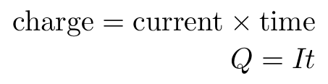  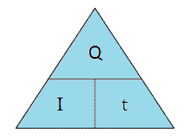 |  |  |  | 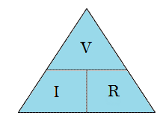
 |  |  |  | 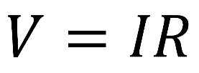
A.C. - alternating current  - changes direction and magnitude  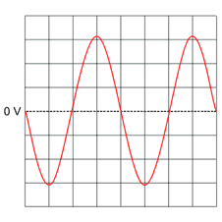  - from the mains |  |  | D.C. - direct current - one direction only  - from a battery  Same magnitude  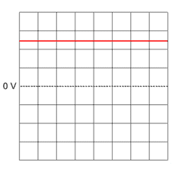 | Ohms Law Experiment  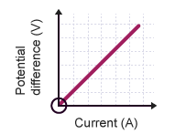  Adjust resistance of variable resistor and take readings of V & I  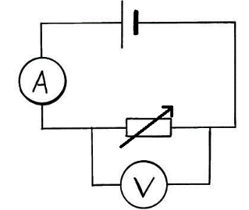 |  | Ohms Law Graph
If the polarity of D.C. trace is reverse (the connections are swapped) the trace goes below the line by the same amount |  |  |  | Resistance opposes the flow of current (Ω) |  | Gradient,  m = V/ I = R  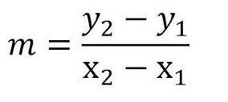
Series Rules  Is = I₁ = I₂…  Vs = V₁ + V₂…  R_{T} = R₁ + R₂…  Adding R = R_{T} | Parallel Rules  Is = I₁ + I₂…  Vs = V₁ = V₂…  1/R_{T} = 1/R₁ + 1/R₂… |  |  | 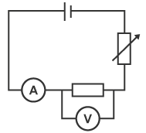  Connecting meters  Ammeters -> series  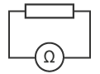  Voltmeters -> Parallel  Ohmmeters -> no power supply
Transistors are electronic switches |  |  |  | The input voltage controls the switch.
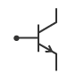  npn transistor  Input voltage must be 0.7V  or above to switch on the output device. |  |  |  | 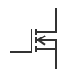  n channel enhancement MOSFET  Input voltage must be 2V  or above to switch on the output device
Output Devices
All the components below change electrical energy into another form of energy
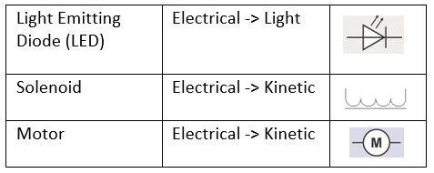 |  |  |  | 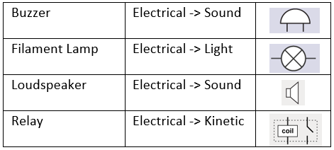
Input devices
All the components below change another form of energy into electrical energy

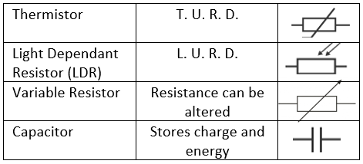 |  |  |  | 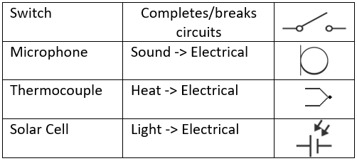
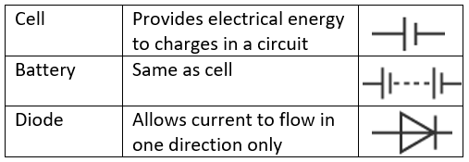  Other components |  |  |  | More about LEDs  Series resistor protects LED from high current  Current flows in opposite direction the arrow
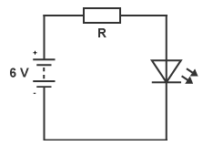
To calculate R:
- V_{R} = V_{S} – V_{LED}
- Use R = V_{R}/ I

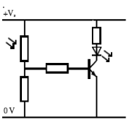
 |  | High Light sensor  Voltage across transistor increases above 0.7V, transistor switches ON  LED switches ON |  | 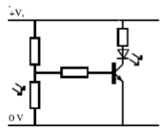 | Low Light sensor  Voltage across transistor increases above 0.7V, transistor switches ON  LED switches ON
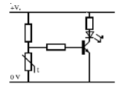  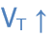 |  | Switch on Low Temperature  Voltage across transistor increases above 0.7V, transistor switches ON  LED switches ON |  | 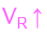  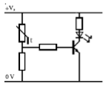 | Switch on High Temperature  Voltage across transistor increases above 0.7V, transistor switches ON  LED switches ON
Voltage (potential) dividers  These divide a supply voltage between 2 resistors  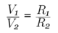  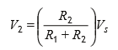 |  | 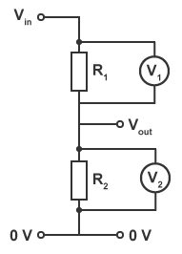 |  | Power is the energy transferred per second  It is measured in Watts (W). 1W = 1 J per s | $$E_{w}=QV$$  Energy supplied to the charges  = Charge × voltage  Ew  Q  V
A fuse melts to break the circuit if the current is too high.
Power rating less than 720W – 3A fuse
Power rating above 720W – 13A fuse
Some appliances with a power rating less that 720W require a 13A fuse as they have a high current on switch on.
Power = current x voltage  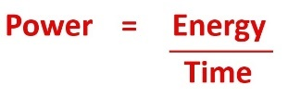  Power = current ² x resistance  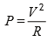  Power = voltage ² /resistance  Greater current/voltage = greater power developed |  |  |  | 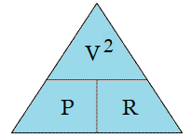  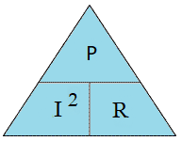  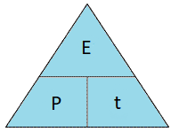  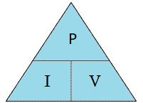
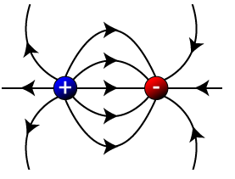  Charges and Electric fields  - Opposites ATTRACT  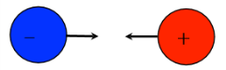  - Like/Similar REPEL |  |  |  | 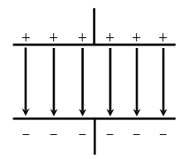  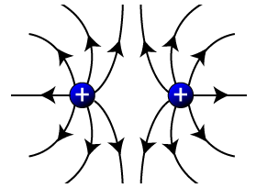  A charged particle experiences a force in an electric field
Capacitors store charge on their plates. Capacitance, C, is measured in farads (F). Capacitors can be used with resistors in series as timing devices.
The bigger the value of the resistance and the bigger the value of the capacitor, the longer it takes to charge to Vs
