GAS LAWS SUMMARY
1. Pressure and Temperature |  |  | (**Volume constant, mass constant)
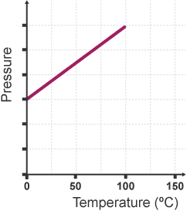  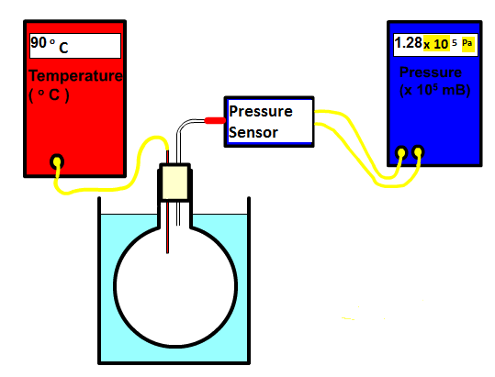 |  |  |  | 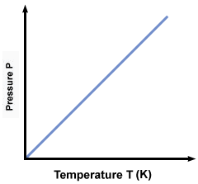 |  |  | ** TEMP MUST BE IN KELVIN  $$\frac{p_{1}}{T_{1}}=\frac{p_{2}}{T_{2}}$$
Kinetic theory
- Temp ↑ particles have greater speed, and greater Ek
- Particles collide with container walls more often and with greater Force, - since P = F/A, Pressure ↑
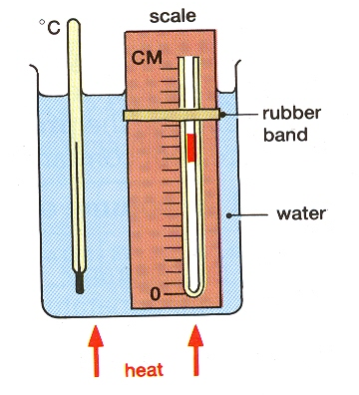  2. Volume and Temperature |  |  | (**Pressure constant, mass constant)
 |  | 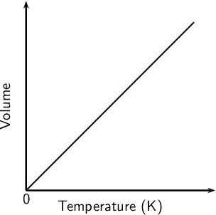  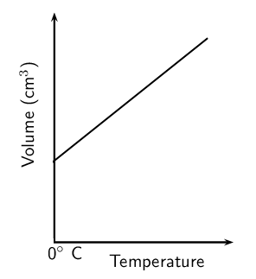 |  |  |  | ** TEMP MUST BE IN KELVIN  $$\frac{V_{1}}{T_{1}}=\frac{V_{2}}{T_{2}}$$
Kinetic theory
- Volume ↓ particles collide with container walls more often-
Overall force increases, - since P = F/A, Pressure ↑
3. Pressure and Volume | (**Temperature constant, mass constant)
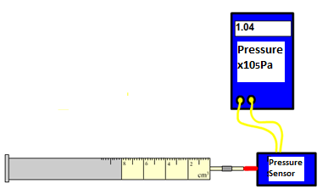 | 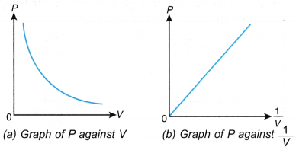 |  |  |  |  | $$p_{1}V_{1}=p_{2}V_{2}$$
Kinetic theory
- Volume ↓ particles collide with container walls more often
- Overall force increases - since P = F/A, Pressure ↑
Pressure is the force per unit area  $$p=\frac{F}{A}$$  p : (Pa or Nm⁻²) F : (N) A : (m²) | Combined Gas Equation  $$\frac{pV}{T} = constant$$  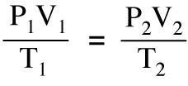 |  |  |  | Degrees Celsius to Kelvin: + 273  Kelvin to degrees Celsius: - 273  Absolute Zero: -273 ºC / 0 K  There is no negatives on the kelvin scale  Temperature is a measure of the mean kinetic energy of particles

Specific heat capacity (c): Heat energy required to raise the temperature of 1kg of a substance by 1ºC |  | Specific heat capacity values are different for all materials  – values found in data sheet
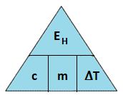  E_{H} = c m ∆T |  | $E=P t$ can be used to find heat energy supplied by appliances  Heat energy will usually be lost to the surroundings – not all will be transferred to the substance being heated
E_{H} : Heat energy (J)
c : specific heat capacity (J kg⁻¹ ºC⁻¹)
m : mass (kg)
∆T : change in Temperature (ºC)
Low specific heat capacity –
not much energy to heat (heats up quickly for constant power) but loses heat quickly
High specific heat capacity –
lots of energy to heat (heats up slowly for constant power) but loses heat slowly (retains heat better)
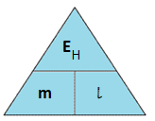  Specific latent heat (l): Heat energy required to change the state of 1kg of a substance at the same temperature |  | Specific latent heat values are different for all materials – values found in data sheet
E_{H} = m l |  | Specific Latent heat of fusion, l_{f} :  Solid -> Liquid
E_{H} : heat energy (J)  m : mass (kg) |  | Specific Latent heat of vaporisation l_{v} :  Liquid -> Gas
l : specific latent heat of fusion / vaporisation
The same material requires different quantities of heat to change the state of unit mass from solid to liquid (fusion) and to change the state of unit mass from liquid to gas (vaporisation).
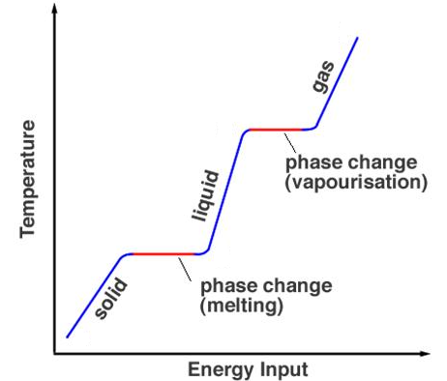  Melting  point  boiling  point |  | During change of state  – temperature remains constant
For change of temperature:
E_{H} = c m ∆T
For change of state:
E_{H} = m l
 |  | “specific”= per kilogram

