Prelim revision
A student sets up an experiment, as shown below, to investigate the motion of a trolley moving down a slope.
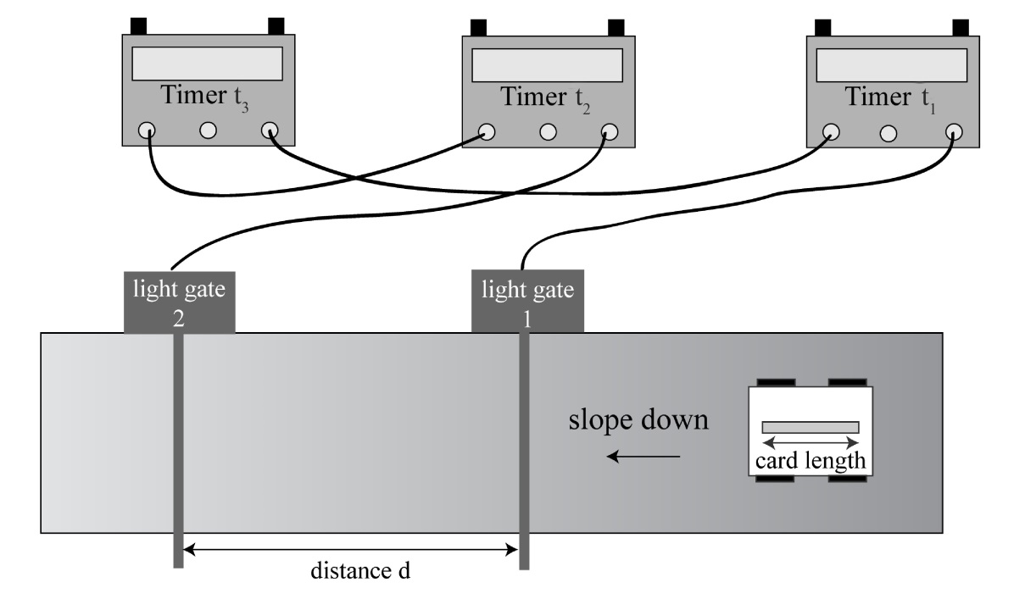
t₁ is the time taken for the card to pass through light gate 1.
t₂ is the time taken for the card to pass through light gate 2.
t₃ is the time taken for the trolley to move between the two light gates.

- State the measurements the student should use in order to calculate the average speed of the trolley between the light gates.
- State the measurements the student should use in order to calculate the instantaneous speed of the trolley at position
  - Light gate 1
  - Light gate 2

(c ) State the measurements the student should use in order to calculate the acceleration of the trolley down the slope.

 |  | P&N 2016
 |  | A student sets up an experiment to investigate the relationship between the pressure and temperature of a fixed mass of gas as shown below.
pressure gauge  thermometer |  | gas  water
 |  | State two ways in which the experimental set-up could be improved to give better results.
 |  | After improving the experimental set-up, the student heats the water slowly with a Bunsen burner and records the following pressure and temperature readings.
temperature/°C | 20 | 38 | 55 | 72 | 95
pressure / kPa | 103 | 109 | 115 | 122 | 130
temperature /K

 |  | Using all of the readings determine the relationship between pressure and temperature. 4
 |  | Space for working and answer
 |  |  | 2
 | (b) | Nitrogen in a gas cylinder has a temperature of 17 °C and a pressure of 4·2 × 105 Pa.
 | (i) | The temperature of the gas cylinder increases to 32 °C.
 |  | Calculate the pressure of the nitrogen in the cylinder.
 |  | Space for working and answer | 3
 | (ii) | Describe the change in pressure in terms of the movement of the nitrogen molecules in the gas cylinder | 2
 | (iii) | The gas cylinder then springs a leak and nitrogen gas escapes from the cylinder.  Use your knowledge of physics to explain why some nitrogen gas will always remain in the cylinder. | 2

SG Credit 2007 Q5

SG Credit 2008 Q11

SG Credit 2010 Q3

SG Credit 2007 Q5

SG Credit 2011 Q3

SG Credit 2013 Q14

Try the following learning outcome questions
1.9.4
1.9.5.
2.1.1.
7.4.1
7.9.2
8.5.4.
8.7.3
11.2.5
11.2.6
12.2.13
12.6.13
12.7.8
13.4.1
16.2.9
16.5
16.7.5
17.10.1
18.1.5

