|  |  |  |  |  |
| --- | --- | --- | --- | --- |
| Acceleration | Area | Current | Displacement | Distance |
| Energy | Force | Frequency | Gravitational field strength | Mass |
| Momentum | Pressure | Resistance | Weight/ friction etc | Temperature |
| Time | Velocity | Voltage | Volume | Speed |

N5 Dynamics S3 Revision

distance = 50 m

**quantity magnitude unit** **direction**

Displacement = 50 m South

Speed = 50 ms-1

**quantity magnitude unit** **direction**

Velocity = 50 ms-1 East

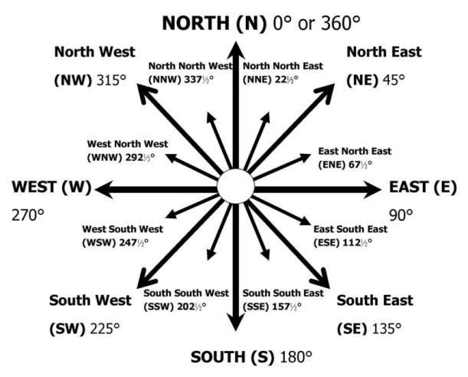



**B**

**A**

$$speed=\frac{distance}{time}$$

$$velocity=\frac{displacment}{time}$$

*Method 2: Draw sketch of vector diagram, but not to scale.*

*Using Pythagoras*

$$R^{2}=a^{2}+b^{2}$$

$$R^{2}={30}^{2}+{10}^{2}$$

$$R=31.6 N$$

$$tanθ=\frac{opp}{adj}, tanθ=\frac{30}{10}$$

$$\tan^{-1}θ=3,θ =72°$$

In some cases that means that the two vectors have to be redrawn so that they are being added “head to tail”. See example below.

becomes

Then join a line from the tail of the first vector to the head of the second vector. This is the resultant vector.

resultant

Acceleration is the change in **velocity** per unit time.

**An acceleration of 2 ms-2****means the velocity increases by 2 ms-1 every second**

$$a=\frac{v-u}{t}=\frac{∆v}{t} ∆v=v-u$$

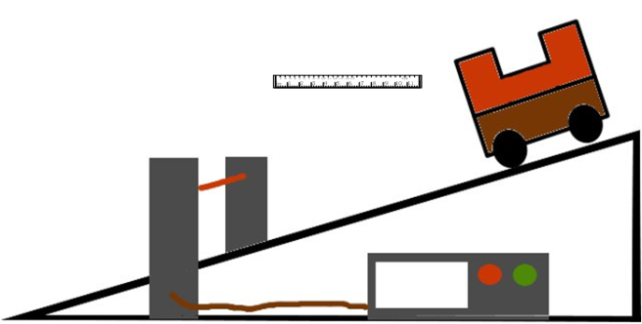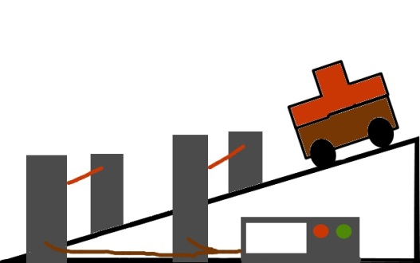

Constant velocity

Increasing velocity

(acceleration)

Decreasing velocity

(deceleration)

time

velocity

time

velocity

time

velocity

Time (s)

Velocity (m/s)

**u**

**v**

0

***Gradient= rise/run***

***Or v/h***

***In our case that is***

***vertical = (v-u)***

***horizontal = t***

***gradient =(v-u)/t***

***gradient = acceleration***

#### Solution using gradient

$$m=\frac{y_{2}-y_{1}}{x_{2}-x_{2}}$$

$$m=a=\frac{18-6 }{10-0}=1.2 ms^{-2}$$

6

18

10

time (s)

velocity (ms-1)

#### Solution

*v=18; u=6; t=10*

$$a=\frac{v-u }{t}$$

$$a=\frac{18-6 }{10}=1.2 ms^{-2}$$

Calculate the acceleration shown in the graph below:

Speed (m/s)

16

4

10

0

12

Time   
(s)

**1**

**2**

**3**

It is best to split the area under the graph into rectangles and triangles. Calculate the area of each and then add them together. [Area of a triangle is ½ base x height]

Distance travelled = area 1 + area 2 + area 3

Distance travelled = (½ × 12 × 4) + (12 × 6) + (½× 6 ×12)

Distance travelled =24 + 72 + 36 = 132 m

**Mass is a measure of the amount of matter (stuff) in an object. It is measured in kilograms (kg). Weight is a force and it is the pull of gravity acting on an object. It is measured in Newtons. on Earth g is equal to 9.8 Nkg-1**

$$Weight =mass gravitational field strength$$

$$W = m g$$

**“g” is the gravitational field strength. It is measured in NEWTONS PER KILOGRAM. It is the WEIGHT PER UNIT MASS (force of gravity on every kilogram)**

A force can change an object’s:

* direction of motion (an acceleration)
* shape
* speed (cause an acceleration)
* start a mass moving (cause an acceleration)

**Newton’s First Law** : A body will remain at rest or travel at a constant speed in a straight line, unless acted upon by an unbalanced force.

**Newton’s Second Law** we normally write as a formula:





**Newton’s Third Law states**: For every action there is an equal but opposite reaction.

Or If A exerts a force on B, B exerts an equal but opposite force on A.

Difference between N1 and N3 Laws



the same

so *a* and *g* must be the equivalent

1. A car of mass 1 000 kg experiences friction equal to 500 N. If the engine force is 1 300 N, what will be the car’s acceleration?



Engine force = 1300 N

Friction = 500 N

Resultant or unbalanced force = 1300 – 500 = 800 N

|  |  |  |
| --- | --- | --- |
| F | = | ma |
| 800 | = | 1000 x a |
| a | = |  |
| a | = | 0.8 ms-2 |

# Difference between Newton’s first and third laws

Skydiving

Parachute opens

V/m s-1

Terminal velocity

acceleration decreases as velocity increases

New terminal velocity

t /s

Landing