Notes on Radiation

The Atom
Everything that has mass is made up of ________________ .

The centre part of an atom is called the _______________.

The ___________ contains ___________ and _______________.

Outside the nucleus are __________ or orbits, these contain _______________________.

An _______________ is negatively charged.

A ________________ is positively charged.

A _____________________ is uncharged, has zero charged or is said to be neutral.

The overall charge on an atoms is _____________________, because the number of ________________ in the nucleus is the same as the number of _____________ in the shells.

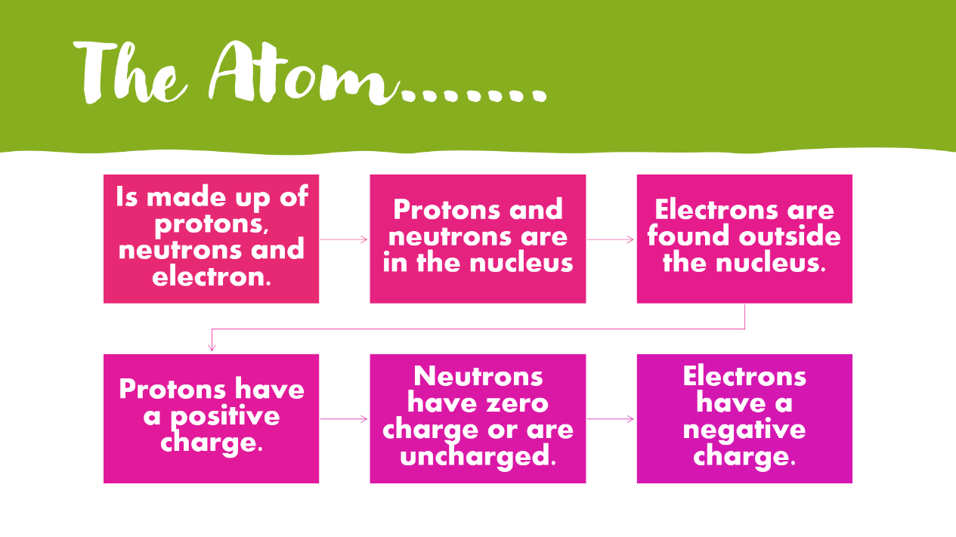

Ionisation

Sometimes atoms can lose or gain electrons. We call this ________________________

Ionisation is the process where atoms ___________________

Atomic and Mass Number

Each element is identified by the number of protons in the nucleus, for example any atom with 3 protons will always be lithium, 92 protons is uranium. You can find this out by using your periodic table.
The atomic number is the name given to the number of protons in an atom.
The mass number is the number of nucleons, parts of a nucleus and this tells us the number of protons and neutrons
We also give each element a symbol which is made up of one or two letters. If it is one letter it is always a capital and if it is two letters the first is a capital and the second is lower case, this way you don’t muddle up if it is two elements or one. We record this information like in the diagram below.
$${}_{Z}^{A}X$$ | Where A= mass number  Z=Atomic number  X= chemical symbol

You can work out the number of neutrons by subtracting the atomic number (the number of protons) from the mass number (the number of nucleons, or protons + neutrons)
Atoms of the same element can have different mass numbers but always the same atomic number (number of protons). Different atoms of the same element can have different number of neutrons. We call these isotopes.

Types of Ionising Radiation
Add notes under each picture to explain what it represents. Put some notes in the box between the atom and the ionising radiation.

Original Atom |  | Ionising Radiation Diagram
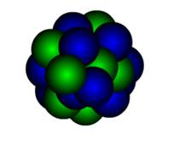 |  | 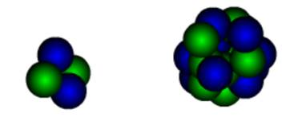
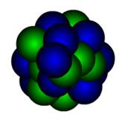 |  | 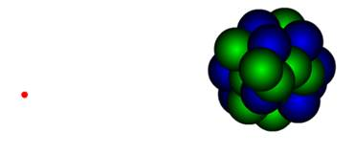
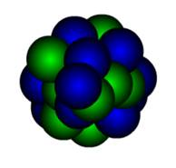

From <https://glowscotland-my.sharepoint.com/personal/gw08hargreavesjennie_glow_sch_uk/Documents/2020%20N5%20Physics/Radiation/images%20of%20radiation.docx>
Below summarise the three types of ionising radiation include the structure, symbol, what they are made of plus any other details you can find

An alpha particle is
A beta particle is
Gamma Radiation is

