Nat
5

National 5 Assignment
Acceleration on a slope: Guide Sheet A

Variation of angle of slope with acceleration.

Apparatus
Runway, light gate(s), interface and computer, mask (single or double), rule, protractor, or metre stick.

Instructions:

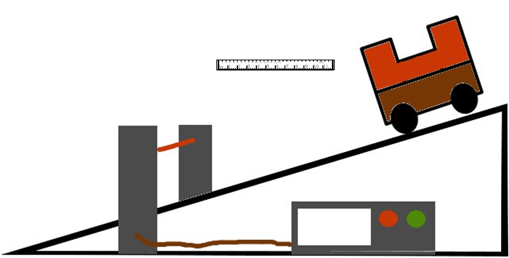
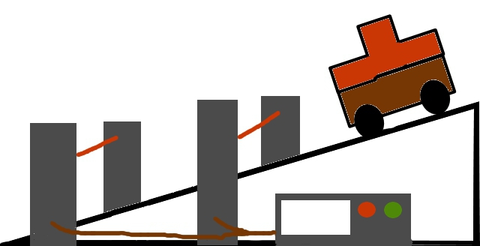

- Organise the light gates and interface to measure the acceleration of the vehicle as the vehicle passes through the light gate(s). This can be using one light gate and a double mask or two light gates and a single mask.
- Set the runway up at an angle.
- Measure the angle of the slope.
- Place the light gate so that the mask cuts the beam as the vehicle passes.
- Release the vehicle and measure the acceleration as it passes through the light gate(s).
- Change the angle of the slope, often books can be useful to achieve this.
- Present your results.

Risk Assessment
- Placing a buffer at the end of the ramp or something soft for the trolley to land in is suggested so not to damage equipment.
- Do an electrical safety check by observing all the wires of the interface and light gates.
- Make sure the vehicle cannot become a trip hazard or land on feet, toes etc.
- Be observant to those around you.
- Do not block exits with the apparatus.

