National 5 Assignment

LDR and lamp voltage Guide Sheet: B

Nat
5

Investigating LDR and voltage across the light source

Equipment:
LDR, multi-meter (to use as an ohmmeter), ammeter, voltmeter, 12 V filament lamp in holder , power supply, leads/wires, black card, scissors, Sellotape.
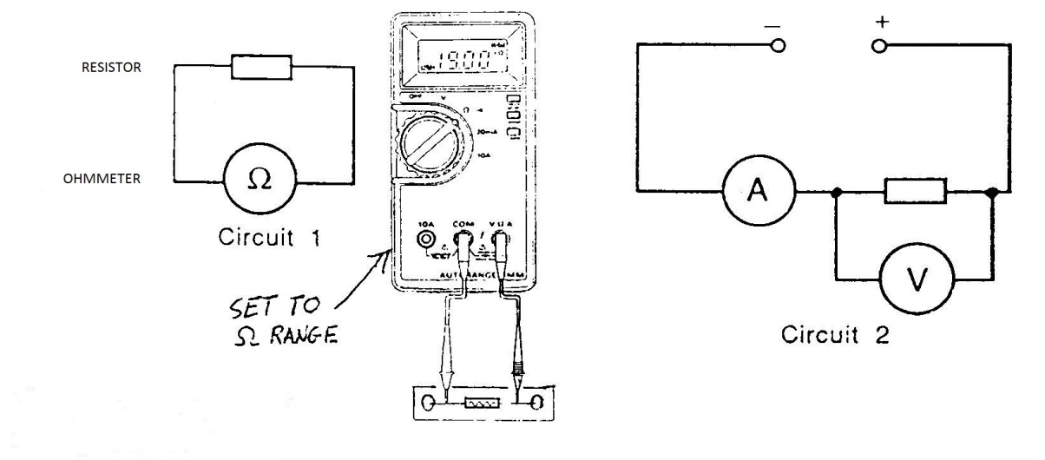

Instructions:
- Make a light box by rolling black card into a tube and seal this with Sellotape.
- Set up a 12 V lamp on the bench to act as a light source. Connect a voltmeter across the lamp and ammeter in series.
- Connect the multimeter to the LDR and adjust it to a suitable resistance range.
- Place the LDR and ohmmeter at one end of the black tube and the lamp and power supply at the other. Ensure they are all aligned.
- Place the lamp into the tube and set the lamp onto 1V on the power supply
- Record the voltage across the lamp and the resistance of the LDR.
- Change the power supply voltage without changing the distance between the lamp and LDR and record the new resistance of the LDR and voltage across the lamp.

Risk Assessment
- Check all the wires and ensure that the wires are not frayed
- The lamp being used may get hot, do not touch a hot lamp.
- Care should be taken to let it cool before packing away.
- Switch off the equipment when it is not in use.
- Do not make the black tube so tight that air cannot get in to cool the lamp

