Nat
5

National 5 Assignment
Ohm’s Law – non Ohmic conductor: Guide Sheet B

Variation of current with voltage (lamp)

Equipment: 12V lamp, variable power supply, ammeter, voltmeter, leads

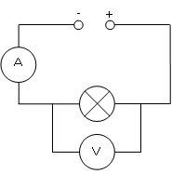
Instructions:
- Set up the circuit as in the diagram.
- Connect the 12V lamp to the power supply and connect an ammeter in series and a voltmeter in parallel across the lamp in the circuit.
- Set the power supply to 1 V and read the current and voltage readings from the ammeter and voltmeter respectively.
- Record the current through, and voltage across the lamp in your table.
- Increase the voltage of the power supply, taking current and voltage readings for each power supply setting.

Risk Assessment
- Check all the wires and ensure that the wires are not frayed
- The lamp could get hot, so avoid contact with this.
- Switch off the equipment when it is not in use.
- Ensure the ammeter and voltmeter are on the correct settings, check with your teacher before switching on your circuit.
- Allow the lamp to cool before putting it away.

