Nat
5

National 5 Assignment
Pressure / Gay-Lussac's Law: Guide A

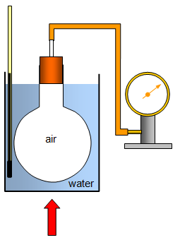
Variation of pressure and temperature. for a fixed mass of gas

Apparatus
Round bottom flask containing screwed up aluminium foil, stopper, Bourdon Guage or pressure sensor, thermometer, ice, kettle, water, large containment beaker, heat source.

Background
According to the kinetic theory, the average speed of the gas particles increases with increasing temperature. The hotter the gas, the faster the gas particles are moving. NB Why should the pipe from the round bottom flask to the Bourdon Guage be as small as possible? When planning the experiment think about the speed of cooling. Research whether the thermometer should be in the beaker of air or the water.

Instructions
- Add boiling water to the beaker, and note the temperature of the thermometer and corresponding pressure on the bourdon gauge.
- Allow the water and air in the flask to cool to room temperature.
- As the air cools, collect values for temperature and pressure.
- If required replace the water with ice when the temperature is low and take further readings.
- Change the temperature of the air slowly.

Risk Assessment
- Wear safety googles when carrying out this experiment.
- The water can be hot, be careful with hot equipment and always move the hot water from the kettle to the beaker. Do not attempt to move hot beakers.
- Secure all equipment with clamps if necessary so that it cannot fall.
- The ice will be cold, handle with care.
- Water and ice on your hands will cause your hands to be slippery.

