Nat
5

National 5 Assignment
Pressure and Depth: Guide Sheet A
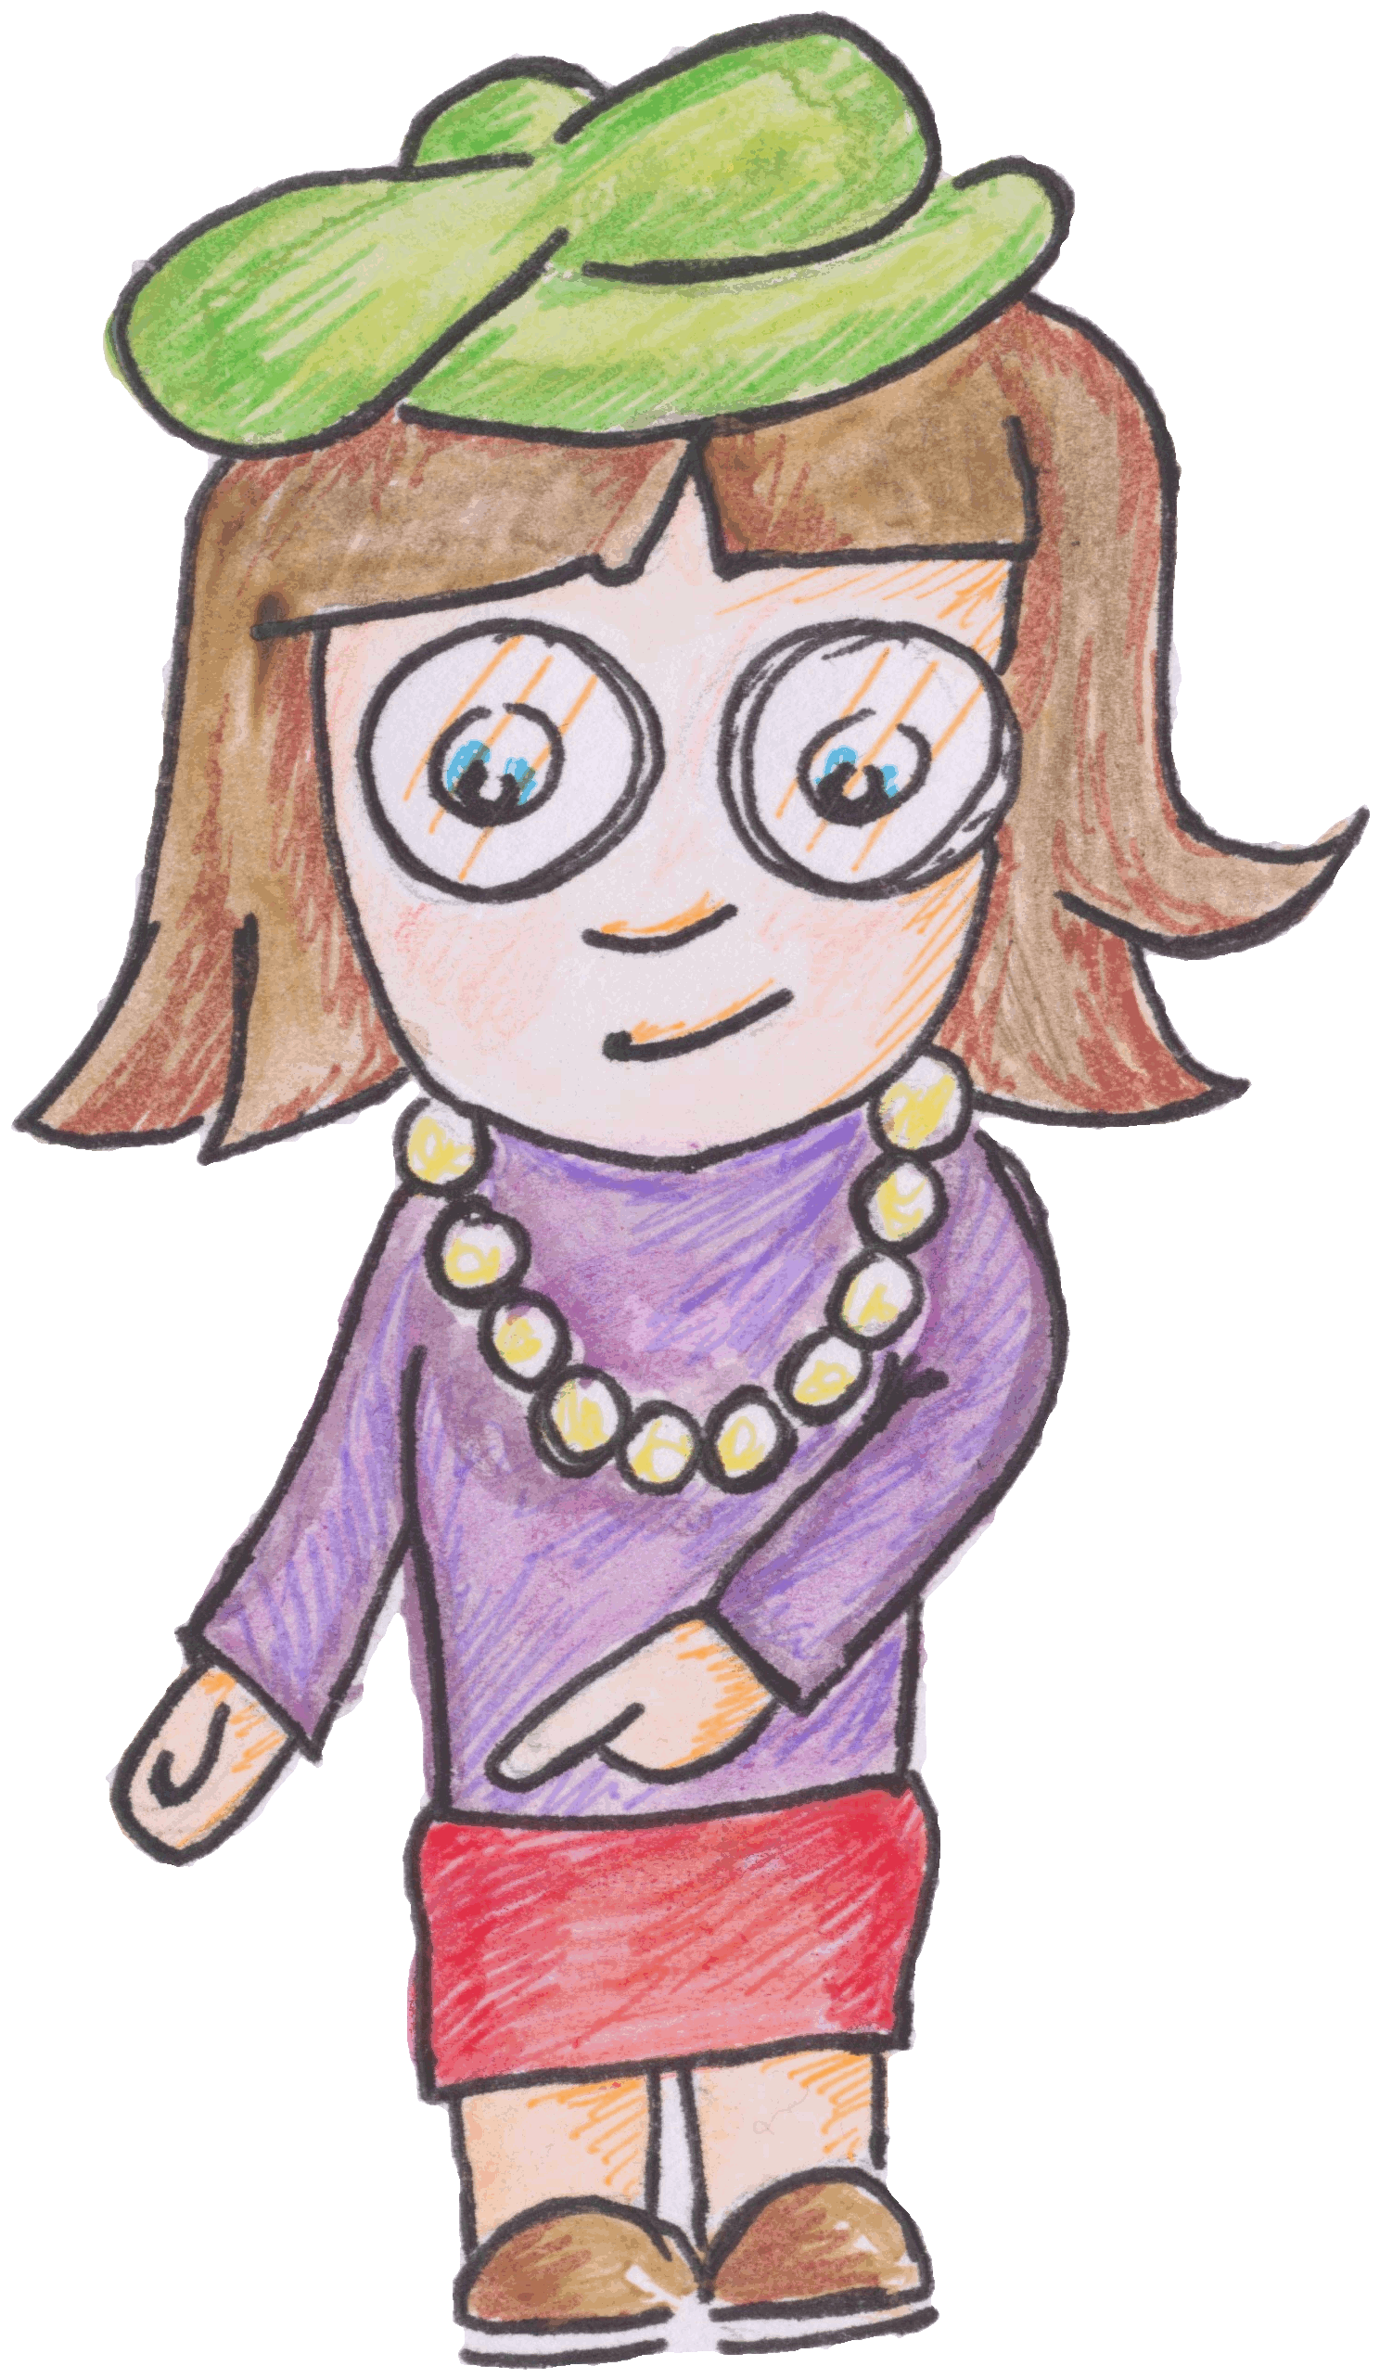

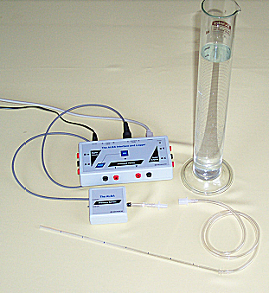
Variation of pressure and depth in a liquid.

Apparatus
ALBA pressure sensor tube, measuring cylinder with water. (Other data loggers are available)

Background
A small black device protrudes from the right hand side of the ALBA Pressure sensor. This is the pressure transducer and it converts pressure into voltage. The voltage it produces is very small and it is amplified before ALBA reads it.
The greater the pressure, the greater the voltage.

Instructions
- Connect the ALBA Pressure Sensor to either channel 3 or 4 on the ALBA Interface and Logger.
- Switch the pressure sensor to the 0 – 10 kPa range.
- Fill the measuring cylinder to the top graduation with water.
- Check that the solid plastic tube is marked off in equal intervals.
- Measure the distance between marks. Using the connector join the flexible tubing to the pressure sensor
- Record the pressure at different depths in the water. The software will direct you.
- The software will ask you to take the pressure when the depth is zero. To get this reading you should hold the tube just above the surface of the liquid.
- Always hold the solid acrylic tubing. You may introduce errors if you hold the clear flexible tubing.

Risk Assessment
- Wear safety googles when carrying out this experiment.
- Ensure that all apparatus is away from the edge of benches.
- Try to keep the container of water as far from any electrical equipment as possible.
- Check all the electrical wiring.

