National 5 Assignment
Solar Cell- distance: Guide Sheet B
Nat
5

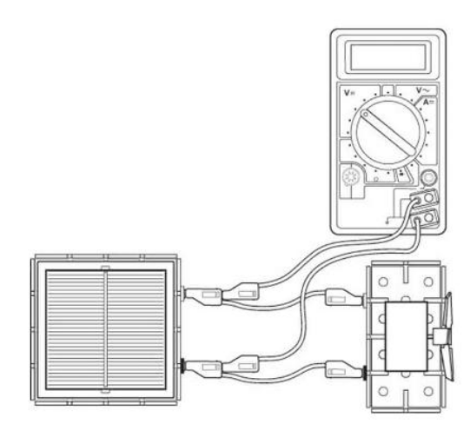
Investigating Solar Cells (distance).

Apparatus
Solar cell unit, small motor unit (or other load), desk lamp (40 or 60 W tungsten lamp), digital multimeters (ammeter and/or voltmeter), 4 mm leads, metre stick, piece of cardboard, clamp stand, protractor

Instructions:
- Make a cardboard tube so that it removed background light. Connect a solar cell to an electric motor.
- Shine a desk lamp through the cardboard tube onto the solar cell so that the motor turns, other loads can be used.
- Connect a voltmeter across the solar cell also connect an ammeter in series in the circuit.
- The voltmeter and/ or ammeter can be used to get an idea about the output of the solar cell or the power can be determined.
- Adjust the distance between the lamp and solar cell moving the lamp closer and further away from the solar cell.
- Maintain the angle between the solar cell and the lamp.

Risk Assessment
- Check all electrical wiring.
- Desk lamps with metal shades can get very hot. Take care when moving them.
- Be careful if considering other types of lamp such as halogen lamp and fluorescents because they can emit significant UV.

