National 5 Assignment
Solar Cell- cloudy days: Guide Sheet C
Nat
5

Investigating Solar Cells (translucent).
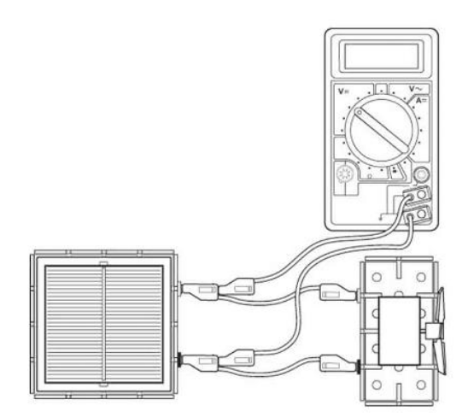
Apparatus (for cloudy days)
Solar cell unit, small motor unit (or other load), desk lamp (40 or 60 W tungsten lamp), digital multimeters (ammeter and/or voltmeter), 4 mm leads, metre stick, piece of cardboard, translucent sheets (e.g. tracing paper) cut a suitable size to cover the solar cell, protractor, clamp stand

Instructions:
- Connect a solar cell to an electric motor. Shine a desk lamp on the solar cell so that the motor turns, other loads can be used.
- The voltmeter and/ or ammeter can be used to get an idea about the output of the solar cell or the power can be determined.
- Connect a voltmeter across the solar cell also connect an ammeter in series in the circuit (not shown).
- Place a translucent sheet between the lamp and the solar cell, take a voltage and/ or current reading.
- Place another translucent sheet on top of the first and take further readings of the number of sheets of translucent paper and ammeter and voltmeter readings.

Risk Assessment
- Check all electrical wiring.
- Desk lamps with metal shades can get very hot. Take care when moving them.
- Be careful if considering other types of lamp such as halogen lamp and fluorescents because they can emit significant UV.

