National 5 Assignment
Solar Cell- Area: Guide Sheet D
Nat
5

Investigating Solar Cells (translucent).
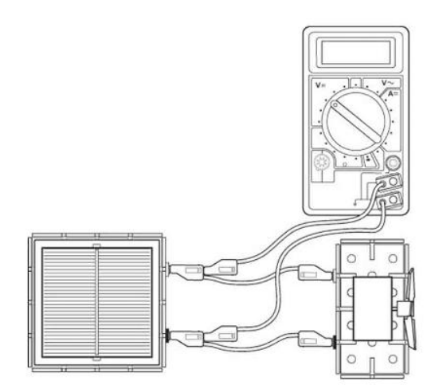
Apparatus (for cloudy days)
Solar cell unit, small motor unit (or other load), desk lamp (40 or 60 W tungsten lamp), digital multimeters (ammeter and/or voltmeter), 4 mm leads, metre stick, pieces of matt black cardboard, protractor.

Instructions:
- Connect a solar cell to an electric motor. Shine a desk lamp on the solar cell so that the motor turns, other loads can be used.
- The voltmeter and/ or ammeter can be used to get an idea about the output of the solar cell or the power can be determined.
- Connect a voltmeter across the solar cell also connect an ammeter in series in the circuit (not shown).
- Ensure light from the lamp covers all of the solar cell, and that light cannot pass through the matt black card.
- Place black card over part of the solar cell to reduce the area of the solar cell exposed to the light. Note the new area of the solar cell exposed to the light.
- Take further readings of the area of the solar cell exposed and ammeter and voltmeter readings.

Risk Assessment
- Check all electrical wiring.
- Desk lamps with metal shades can get very hot. Take care when moving them.
- Be careful if considering other types of lamp such as halogen lamp and fluorescents because they can emit significant UV.

