National 5 Assignment
Speed of Sound: Guide Sheet A
Nat
5

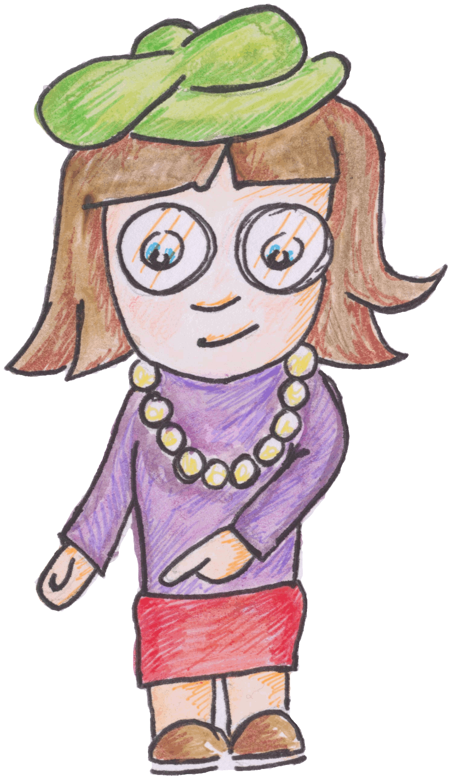

Investigating the speed of sound.

Apparatus
Sound switches, ALBA or other interface, computer, tape measure, two wooden blocks to make a short sharp sound.
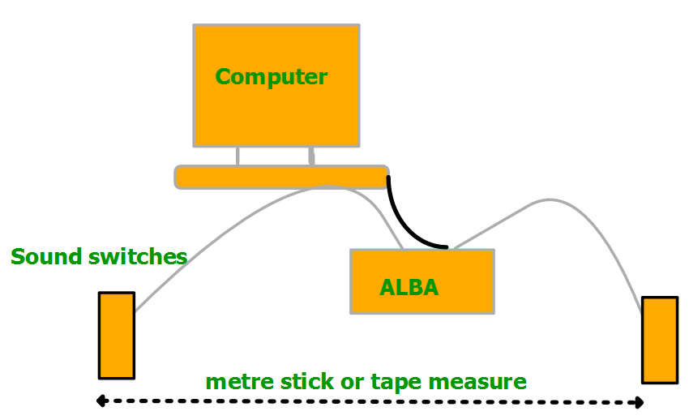
Instructions:
- Connect two sound switches to the ALBA and the ALBA to a computer.
- Set the sound switches a known distance apart, record this distance.
- Make a loud short, sharp sound to the side of one of the sound switches.
- Record the distance between the sound switches and the time for the sound to travel between the sound switches.
- Adjust the distance between the sound switches and take another reading for the distance and time.

Risk Assessment
- Check all electrical wiring.
- Do not exceed 80 dB when making the sound, a short clap will suffice.
- Do not trap fingers between the two wooden blocks

