National 5 Assignment

Projectile-release speed Guide Sheet: B

National 5 Assignment

LDR distance Guide Sheet: A

Nat

5

**Variations in range of a projectile with launch speed**

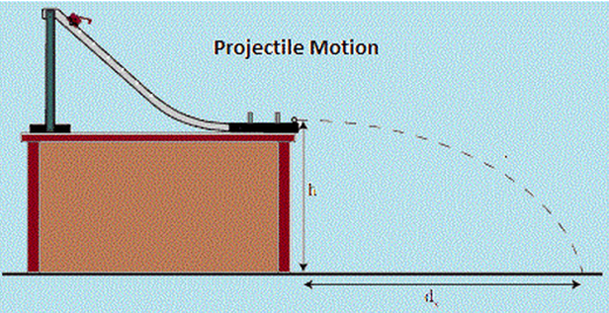

**Equipment**

Ball, projectile launcher, ALBA or other interface, metre stick or tape measure, sand, tray, carbon paper or timing plate, additional set of instructions for the PET timing device.

**Instructions**

* Set up the apparatus as shown in the diagram above.
* Clamp the track securely to the bench or piece of wood that can be raised and lowered.
* Measure the release height of the projectile track above the sand tray, or timing plate.
* Release the ball from a known position up the slope.
* Measure the height of the ball on the slope from the height the projectile is released from the desk.
* Note the time it takes for the ball to cross the two timing gates so that the release speed of the ball can be measured.
* Adjust the position of the sand tray /carbon paper or timing plate so that the ball lands in the sand / carbon paper /on the timing plate and leaves a clear mark.
* Measure the range of the ball from the release position.
* Set the projectile launcher at different heights up the slope. For each measurement of range you should have a launch height up the slope, a release time/ speed and range of the ball.
* Choose which of these variables you wish to investigate.

**Risk Assessment**

* Check that the launch area is free of people who could get hit.
* Ensure no projectile is left unattended where it could become a trip hazard.
* Wear safety goggles as the projectiles are likely to be smaller than the eye socket, and may not always be very well aimed!