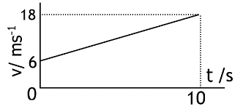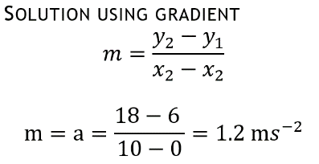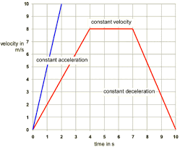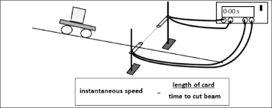**

**Vectors and Scalars**

A scalar quantity has a magnitude/size only.

Examples: time, mass, speed

A vector quantity has magnitude/size AND direction

*Using equation v=18; u=6; t=10 $a=\frac{v-u }{t}$, $a=\frac{18-6 }{10}=1.2 ms^{-2}$*

**Shape tells you about the motion** (see labels on graph)

**Acceleration:** gradient of slope on a v-t graph

**Displacemen**t/distance: Area under v-t graph

**Average speed/velocity**: calculate the area under the graph divided by the total time from the x-axis

**Velocity-time graphs**

v

t

t

*d*

*v*

*t*

*s*

$$\overline{v}$$

t

***d***

$$s=vt$$

$$d=\overline{v}t$$

$$d=vt$$

**Speed and Velocity Calculations**

d = distance (m), v = speed (ms-1),

t = time (s), s = displacement (m)

$\overline{v}$ = average speed (ms-1)

*Using Pythagoras for vector addition*

**Average and Instantaneous Velocity**

Average velocity is calculated by dividing the length of entire journey by total time taken.

Instantaneous velocity is calculated by dividing a very small distance (often ‘length of mask’) by the time taken for that small distance to pass.

**Measuring Instantaneous and Average speed**

To measure average speed, the distance for the journey would be measured using a tape measure/metre stick/trundle wheel. The time for the whole journey would be measured using a stopwatch, use

$\overline{v}=\frac{d}{t}$

$$use v=\frac{length mask}{time taken}$$

To measure instantaneous speed, measure the length of mask using a ruler. Time the mask to pass through light gate, as human reaction time is too slow

**Vector Quantities @N5: Velocity, displacement, acceleration, force (e.g weight, thrust, friction), gravitational field strength**

distance = 50 m

**quantity magnitude unit** **direction**

Displacement = 50 m South

Speed = 50 ms-1

**quantity magnitude unit** **direction**

Velocity = 50 ms-1 East

**Combining vectors** Two vectors should be added ‘tip to tail’!

A straight line from the tail of the first vector to the head of the last= the resultant. Use scale drawings or Pythagoras to calculate magnitude

Calculate direction by using $\tan{θ}=\frac{F_{2}}{F_{1}}$

Direction should be given as a three figure bearing measured from North. A bearing of 90° would be written as (090).

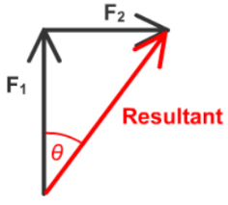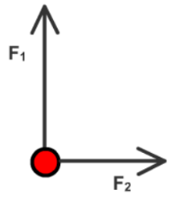

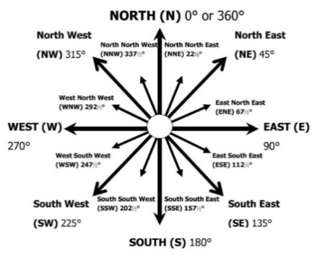

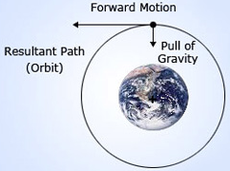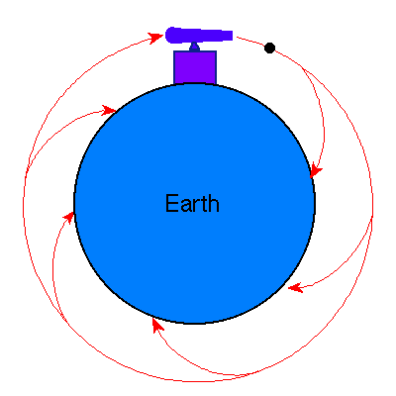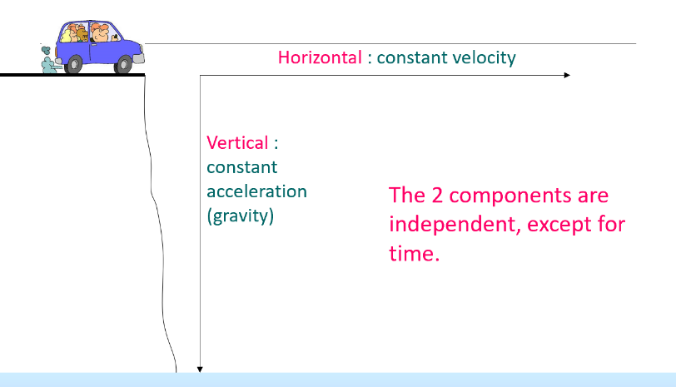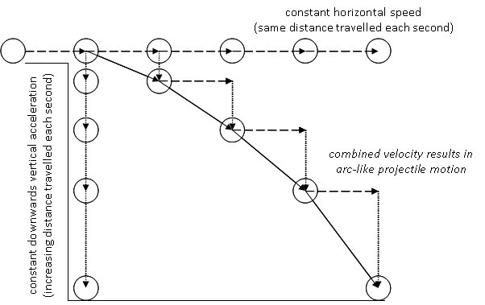

**Vh, Horizontal velocity ms-1**

t, Time (s)

Horizontal distance (range) can be found using area under graph (equivalent to $d_{h}=v_{h}t$)

**Just need $d=v_{h}t$**

Projectile motion occurs when an object has both a constant horizontal velocity and a constant vertical acceleration

To calculate horizontal velocity, use: v = dt

To calculate vertical velocity, use: v = u + at

Too slow and it will spiral to earth, to high and it will leave the orbit.

**Explain how gravity keeps a satellite in orbit.**

The force of gravity provides the force needed to maintain the stable orbit of both planets around a star and also of moons and artificial satellites around a planet. For an object to remain in a steady, circular orbit it must be travelling at the right speed.

**Newton’s cannon -thought experiment**

Explain why a satellite needs a horizontal motion and a vertical motion to stay in orbit.

If a projectile has enough speed, it will move through space constantly falling towards the Earth in free fall. With the high constant horizontal speed the projectile falls around the curvature of the Earth.

Without a horizontal speed the satellite would fall to Earth.

Without the vertical motion (constant acceleration) the satellite would move away from the Earth at constant speed, leaving the gravitational field.

**Vv, vertical**

**velocity ms-1**

t, Time (s)

but u = 0 ms-1

distance = area under v-t graph or

distance (height) = average speed x time

$$average speed =\frac{v+u}{2}$$

or ½ vt (if u is 0)

on Earth acceleration and hence gradient = 9.8 ms-2

**Vertical motion – constant acceleration, increasing velocity**

**Horizontal motion – constant velocity**

$$E_{w}=Fd { E}_{p}=mgh OR E_{k}=\frac{1}{2}mv^{2}$$

**Projectiles**

*E,* *Ew, Ep, Ek* = Energy (J) *m* = mass (kg) *v* = velocity (ms-1)

*F* = Force (N) g = gravitational field strength (N/kg) on Earth g = 9.8 N kg-1

*d* = distance (m)

**F**

**d**

**Ew**

**m**

**g**

**Ep**

**h**

**m**

**Ek**

**v2**

**m**

**2Ek**

**v2**

**Energy equations**

**Distance/displacement from v-t graph**

is the area under v-t graph

Distance travelled = area 1 + area 2 + area 3

Distance travelled = (½ × 12 × 4) + (12 × 6) + (½× 6 ×12)

Distance travelled =24 + 72 + 36 = 132 m

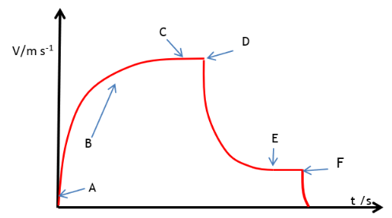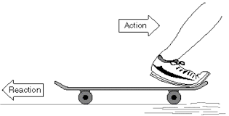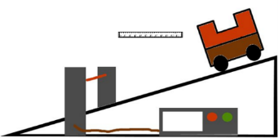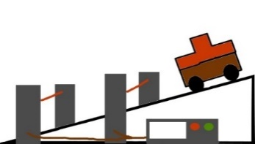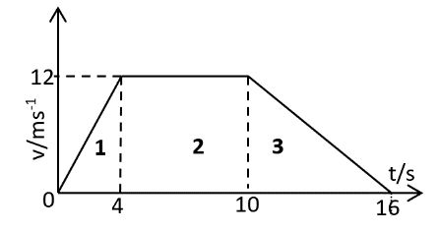

**Balanced forces are Equal forces but acting in opposite directions** Forces are always balanced if an object is travelling at constant height or at constant speed in a straight line.

**Free fall/Terminal velocity**

Terminal velocity is the velocity something will travel at when **forces acting upon it are balance**d (e.g. Weight and air resistance for a being in a parachute).

| Point | Forces and Motion |
| --- | --- |
| A | Initial velocity in the vertical direction is zero, the object accelerates under the force of gravity at 9.8ms-2. Initially no drag force. |
| B | As vertical speed increases air resistance acting against the parachutist increases. At B weight is greater than drag so the skydiver accelerates with a reduced acceleration than at the start. |
| C | At B Weight = drag so the skydiver falls at constant speed, terminal velocity. |
| D | The parachute is opened. At E drag forces are much greater than the weight (the parachute has been opened) so there is a high deceleration (or negative acceleration) |
| E | At E Weight = drag so the skydiver falls at constant speed, terminal velocity |
| F | The parachutists touches the ground large forces cause a great negative acceleration (slowing down) |

F = unbalanced force (N)

m = mass (kg)

a = acceleration (ms-2)

is a form of this equation

**Newtons 3rd Law -** Skateboard moving

**Newtons 3rd Law**

A person sits on a chair which rests on the Earth. The person exerts a downward force on the chair. The reaction force is the chair exerts an upwards force on the person.

**m**

**a**

**F**

**Newton’s Laws**

**I**: An object will remain at rest or same speed/direction unless acted on by an unbalanced force

**II**: If mass remains constant, an object’s acceleration is directly proportional to the unbalanced force applied F=ma

**III:** Every action has an equal and opposite reaction

**a**

***t***

***(v-u)***

a = acceleration (ms-2)

v = final velocity (ms-1)

u = initial velocity (ms-1)

t = time

(s)

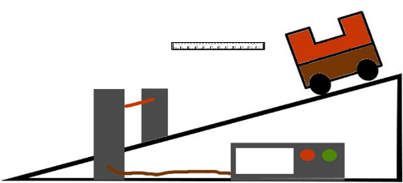

*Method 3*: If u= 0 ms-1, then measure v at the bottom of the slope and a stopwatch to time it takes for the vehicle to start and the mask reach the end of the light gate.

*Method 2*: Double mask, single light gate

**Acceleration experiments** *Method 1*: Single mask, double light gate

**Acceleration: the rate of change of velocity**

$$a=\frac{v-u}{t}=\frac{∆v}{t}$$

$$∆v=v-u$$