Waves Summary Notes
Waves transfer energy
The higher the amplitude the greater the energy of the wave.
f=no. of waves produced per second
T= time for 1 wave to pass a point

Transverse Wave: The particles of the medium transmitting the wave travel at right angles to the direction of energy travel. e.g. E.M. waves |  |  |  |  | Longitudinal Wave: The particles of the medium carrying the wave move parallel to the direction of energy travel. e.g. sound
direction of energy travel  Particle motion |  |  |  |  | direction of energy travel  direction of energy travel  particle motion
Properties of waves = reflection, refraction, diffraction
1  f  T | d  v  t  v  f  λ |  |  |  |  | wave speed = frequency × wavelength  v = f λ
Law of reflection, angle of incidence = angle of reflection where all angles are measured from the normal |  |  |  |  |  |  |  | $$f=\frac{d}{N} \frac{N}{t}=\frac{d}{t}$$
N  t  f  d  N  λ |  | $$f=\frac{N}{t} , frequency=\frac{no of waves}{time to pass a point}$$  $$=\frac{d}{N}, wavelength = \frac{distance}{no. of waves}$$
Refraction occurs when light enters a material which is more optically dense the wave speed and wavelength reduce but frequency remains the same. Usually this is accompanied by a change in direction of the wave.Diffraction –bending of waves passing through a gap or around a barrier, when waves diffract there is no change to the wavelength. |  |  |  |  | normal  angle of refraction  angle of incidence  light ray  glass block  air
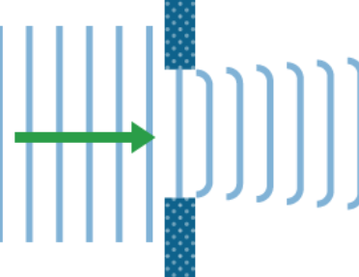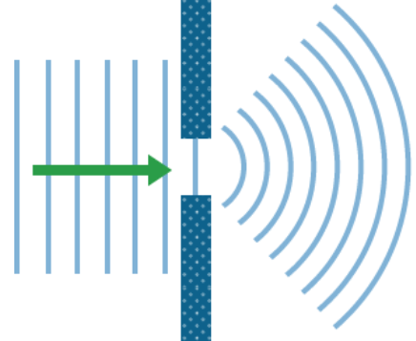 |  |  |  | waves  barrier |  |  | Long waves diffract more than short waves.
When waves diffract through a large gap only the edges of the waves change bend | Through a narrow gap, smaller than 1λ the waves emerge as semi-circles |  |  |  | Long waves diffract more than short waves which is why long wave radio signals can be detected at the bottom of a hill, but shorter wavelength signals cannot be detected.

All members of EM-spectrum are transverse waves and travel at 3 × 10⁸ m s⁻¹ in straight lines in air. EM spectrum waves can be refracted, reflected and diffracted.
Light colours, red, orange, yellow, green, blue, indigo, and violet;
red light long λ and low f blue light short λ and high f.
Type of EM Waves | Application | Detector | Source
Radio & TV | communication (under the sea, in space, radio and TV)Watching TV programmes, films, listening to the news, | Aerial | transmitter, outer space, electronic circuits
Microwaves | Heating food through microwave ovens, communications | Aerial | electronic circuits magnetron, transmitters, outer space
Infra Red | detector in security lighting, remote controls (e.g. TV) | Photodiode,thermocouple, thermistor, heat-sensitive papers, black-bulb thermometer | warm objects, sun,
Visible | humans vision, photography, laser surgery, | Photodiode / photographic film/ diode/ CCD | Stars , candles, light bulbs, electronic devices (eg LED), sun
Ultra violet | detecting forged bank notes, causing white shirts to look cleaner? Sterilising medical instruments | Human skin / causes fluorescence (glowing) in some objects/ fluorescent materials | Fluorescent tubes, very hot objects, sun, gas discharge, lamps
X-Ray | detecting broken bones, checking suitcases at the airport, | Photodiode / photographic film | X-ray machines, stars, very fast electrons hitting a metal target
Gamma  Rays | medical tracers to detect cancer, killing bacteria, sterilizing instruments, detecting broken pipes underground | / photographic film / Geiger Muller Tube and counter/ Photodiode | Radioactive nuclei, outer space (colliding neutron stars)
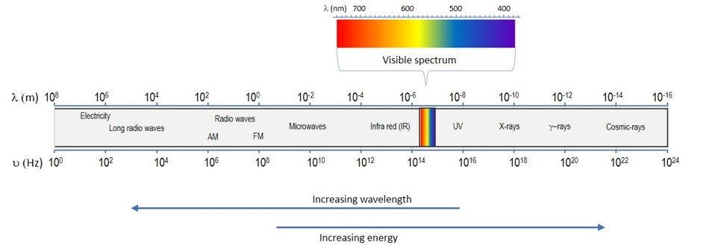
https://www.youtube.com/watch?v=bjOGNVH3D4Y
Low Energy
Low frequency
Long wavelength
High Energy
High frequency
Short wavelength

