Ionisation—
Activity—
What is the relative ionising effort of each type of radiation?

Define...
Relationship to calculate activity
Units of activity

Describe the nature of α, β and γ radiations

Natural sources of background radiation

Artificial sources of background radiation

List applications of nuclear radiation

Units of absorbed dose

Nuclear Radiation (Part A)

Relationship to calculate absorbed dose

Define...

Describe the relative penetration and absorption of each type of radiation.

What are the dangers of ionising radiation to living things?

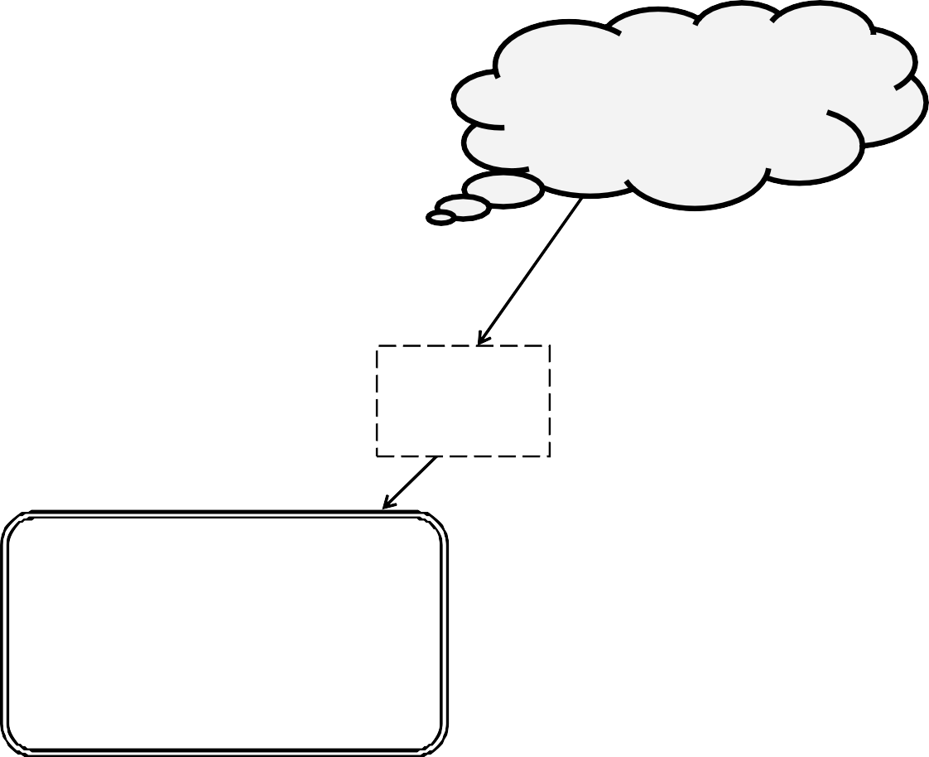

Absorbed Dose

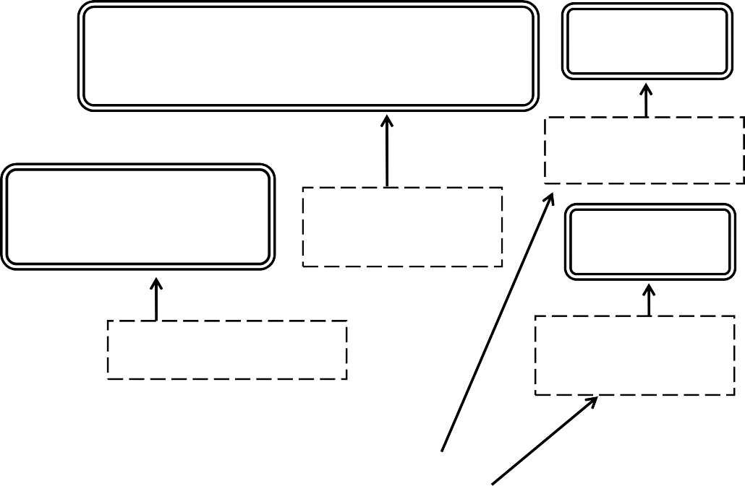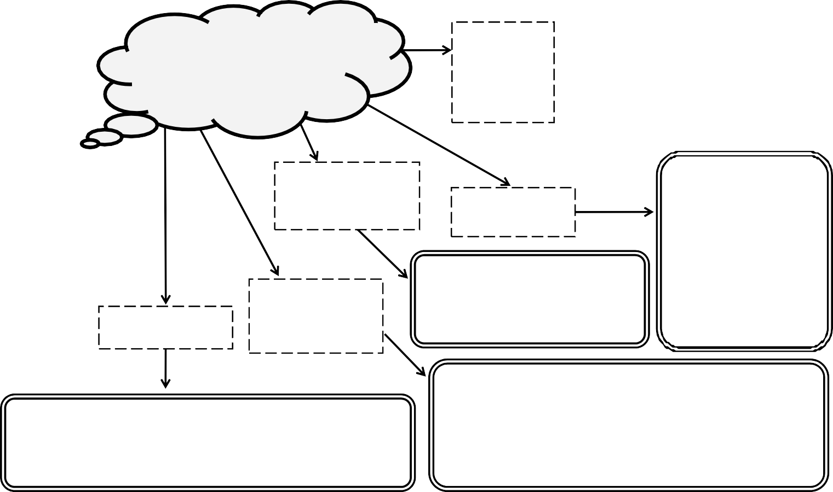

Relationship for Equivalent Dose Rate
Define Equivalent Dose

Define Equivalent Dose Rate
What is nuclear fission?

Unit of Equivalent Dose
Relationship for Equivalent Dose

What is the radiation weighting factor?
State the radiation weighting factors for different types of radiation.

Nuclear Radiation (Part B)

Describe how fission is used to generate electricity

List the annual exposure safety limits for the public and for workers in the radiation industries.

Define half life
What are some of the challenges of nuclear fusion?

Describe an experiment to measure half-life

What is nuclear fusion

