RADIATION SUMMARY NOTES
Structure of the atom  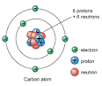  Stable atoms contain positively charge protons and neutral charged neutrons in the nucleus, surrounded by negatively charged electrons.  In an atom the number of protons = number of electrons  Unbalanced no. of p and e = ion  Overall charge on atom = 0 | Background Radiation  Sources of background radiation include radon gas, rocks and buildings (such as granite), food and drink, cosmic rays, medical uses and a very small percentage from nuclear power and weapons.  Average annual background radiation dose of member of public is 2.2mSv.  The average annual effective dose limit for radiation workers is 20 mSv (ie 20 mSv/y)  Average annual effective dose limit for a member of public 1.0mSv. (ie 1.0 mSv/y)  Ionisation  Ionisation is the loss or gain of electrons from a stable atom  Activity  An activity of 70 kBq means 70 thousand disintegrations occur.  Ionising Radiation kills or changes the nature of living cells.
Activity  N  A  t  Activity is the number of nuclear disintegrations per second A = Activity (Bq)  N = Number of disintegrations  t = time (s)  Activity  An activity of 70 kBq means 70 thousand disintegrations occur each second.  Ionising Radiation kills or changes the nature of living cells. | Types of ionising radiation  Type Made of speed Mass Ionising Absorbed by  Alpha α 2p, 2n Slower Heaviest Most Paper/skin  Beta β Fast moving e from nucleus Faster Lighter Lesser Few mms aluminium  Gamma γ High energy em wave fastest Negligible Least Most absorbed by few cms lead/graphite or metres of lead
Half – life  Half life is the time taken for the activity of a source to decrease by half e.g. Calculate the half life of Francium. The initial activity was 20 MBq and after 24 days the activity was 2.5 MBq  A_{i}: 20 MBq A_{f}: 2.5 MBq t: 24 days  20 → 10→ 5→ 2.5 (count the arrows)  3t_{1/2} = 24 days  t_{1/2} = 8 days |  |  | 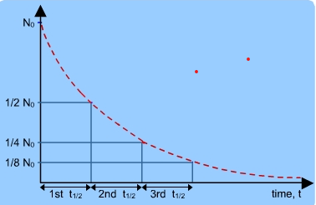
Dosage
H
$$\dot{H}$$
t
H
D
W_{r}
E
D
m

$$\dot{\dot{H}=equivalent dose rate Svh^{-1}}$$
The dose a mass of tissue receives can be calculated by
D = Absorbed dose (Gy), E = Energy received (J), m – mass of tissue (kg)
The equivalent dose received depends on the type of radiation, exposure time, biological harm.
H = equivalent dose (Sv), D – absorbed dose (Gy), Wr = radiation weighting factor (given on data sheet).
2.2 mSv Average Annual Background Radiation in UK.
1 mSv average annual effective dose limit for a member of the public in UK
20 mSv average annual effective dose limit for radiation workers in UK
Safety
Ionising radiation can cause harm to living cells and exposure should be monitored. Radiation workers often wear film badges/personal dosimeters
Radiation can also be detected by Geiger Müller tubes, spark wires and scintillation counters
Fission and Fusion
Fission: A large nucleus splits into smaller nuclei, usually emitting some neutrons and energy
Fusion: Two small nuclei combine to make a big nucleus and release energy.
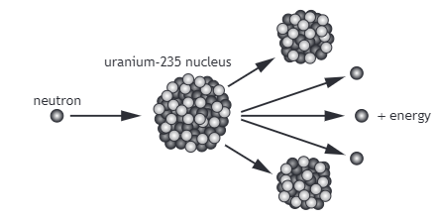  Nuclear Reactor  Moderator: slows the neutrons  Control Rods: absorbs the neutrons  Fuel rods: contain the fuel, provide the energy  Containment vessel: prevents neutrons and radioactive material from leaking out  Coolant: Takes the heat energy from the reactions to the heat exchanger. |  | Chain Reaction:  The neutrons from the fission of one nucleus go on and may split other uranium nuclei if conditions are right. These fissions then produce more neutrons that split more nuclei and so on.  Fission: produces lots of energy, highly radioactive waste. No greenhouse gases, reliable, high build and decommissioning costs.  Fusion Lots of cheap energy once the reaction started. Hard to contain (magnetic fields) have to overcome electrostatic forces pushing ions apart. No harmful waste, large energies produced per reaction. No greenhouse gases.
Applications of Nuclear Radiation
Electricity generation, cancer treatment, gamma cameras (investigation internal organ function), monitoring the thickness of paper and foil production, smoke detectors.

